**Signing of Memorandum Of Understanding**

**Between KDK college of Engineering & Astral Informatics Pvt. Ltd.**

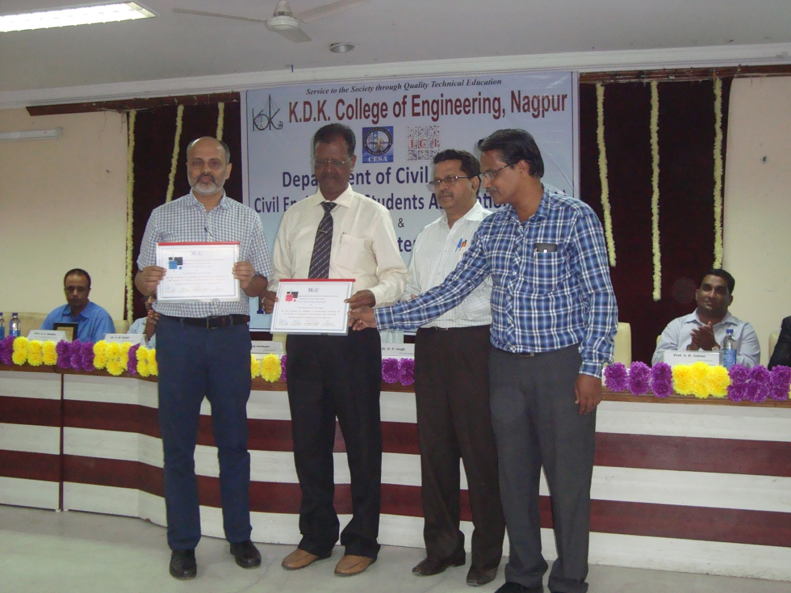

Looking to share the ideas, resources, technologies & actual field challenges, KDK College of Engineering had signed a memorandum of understanding (MoU) with Astral Informatics (P) Ltd.A memorandum of understanding (MoU) is an agreement between two ([bilateral](https://en.wikipedia.org/wiki/Bilateralism)) or more ([multilateral](https://en.wikipedia.org/wiki/Multilateralism)) parties on 7th September 2017. It expresses a convergence of will between the parties, indicating an intended common line of action.

As per the MoU the KDK College of Engineering & Astral Informatics (P) Ltd will share the advanced software technologies, expert lectures for students & faculties, field knowledge, recent development in designing, planning & construction technology.

On this precious occasion, Dr.D.P.Singh, Principal, Dr.A.M.Badar, Vice-Principal & Dr.Valsson Varghese, Head of Civil Engg. Department of KDK college of Engineering & Mr. Prafulla Baid, Director, Astral Informatics (P) Ltd Nagpur had signed the MoU

Mr.Rajendra Mulak, Secretary & Yashraj Mulak, Treasurer appreciate for taking the effort for the said activity.

**Parent Teacher Meet at KDKCE**

The parent teacher meeting was held at KDK College of Engineering. The main purpose of meet was to create a common platform, where teacher & parents came together to enrich the student educational experiences & discuss various issues, regarding all round development of students. Parents were provided with the information about various student oriented activities & scheme run by college & also suggestion from the parents were taken. The parents were informed of performance of their wards. The parent were appreciated the various activities being conducted by the department for the benefit of students

During the meeting Dr.D.P.Singh, Principal, Dr.A.M.Badar, Vice-Principal & Dr.Valsson Varghese, Head of Civil Engg. Department, Dr.N.R.Dhamge, Prof.S.R.Satone, Prof.M.N.Umare, Prof.P.S.Randive, Prof.V.D.Vaidya, Dr.B.S.Ruprai, Prof.A.R.Nikhade, Prof.D.B.Awachat, Prof.C.S.Danjode, Prof.R.R.Gadpande, Prof.D.S.Padole, Prof.S.P.Tembhurkar, Prof.A.D.Shende, Prof. A.G.Deshmukh, Prof.R.S.Dhone were present