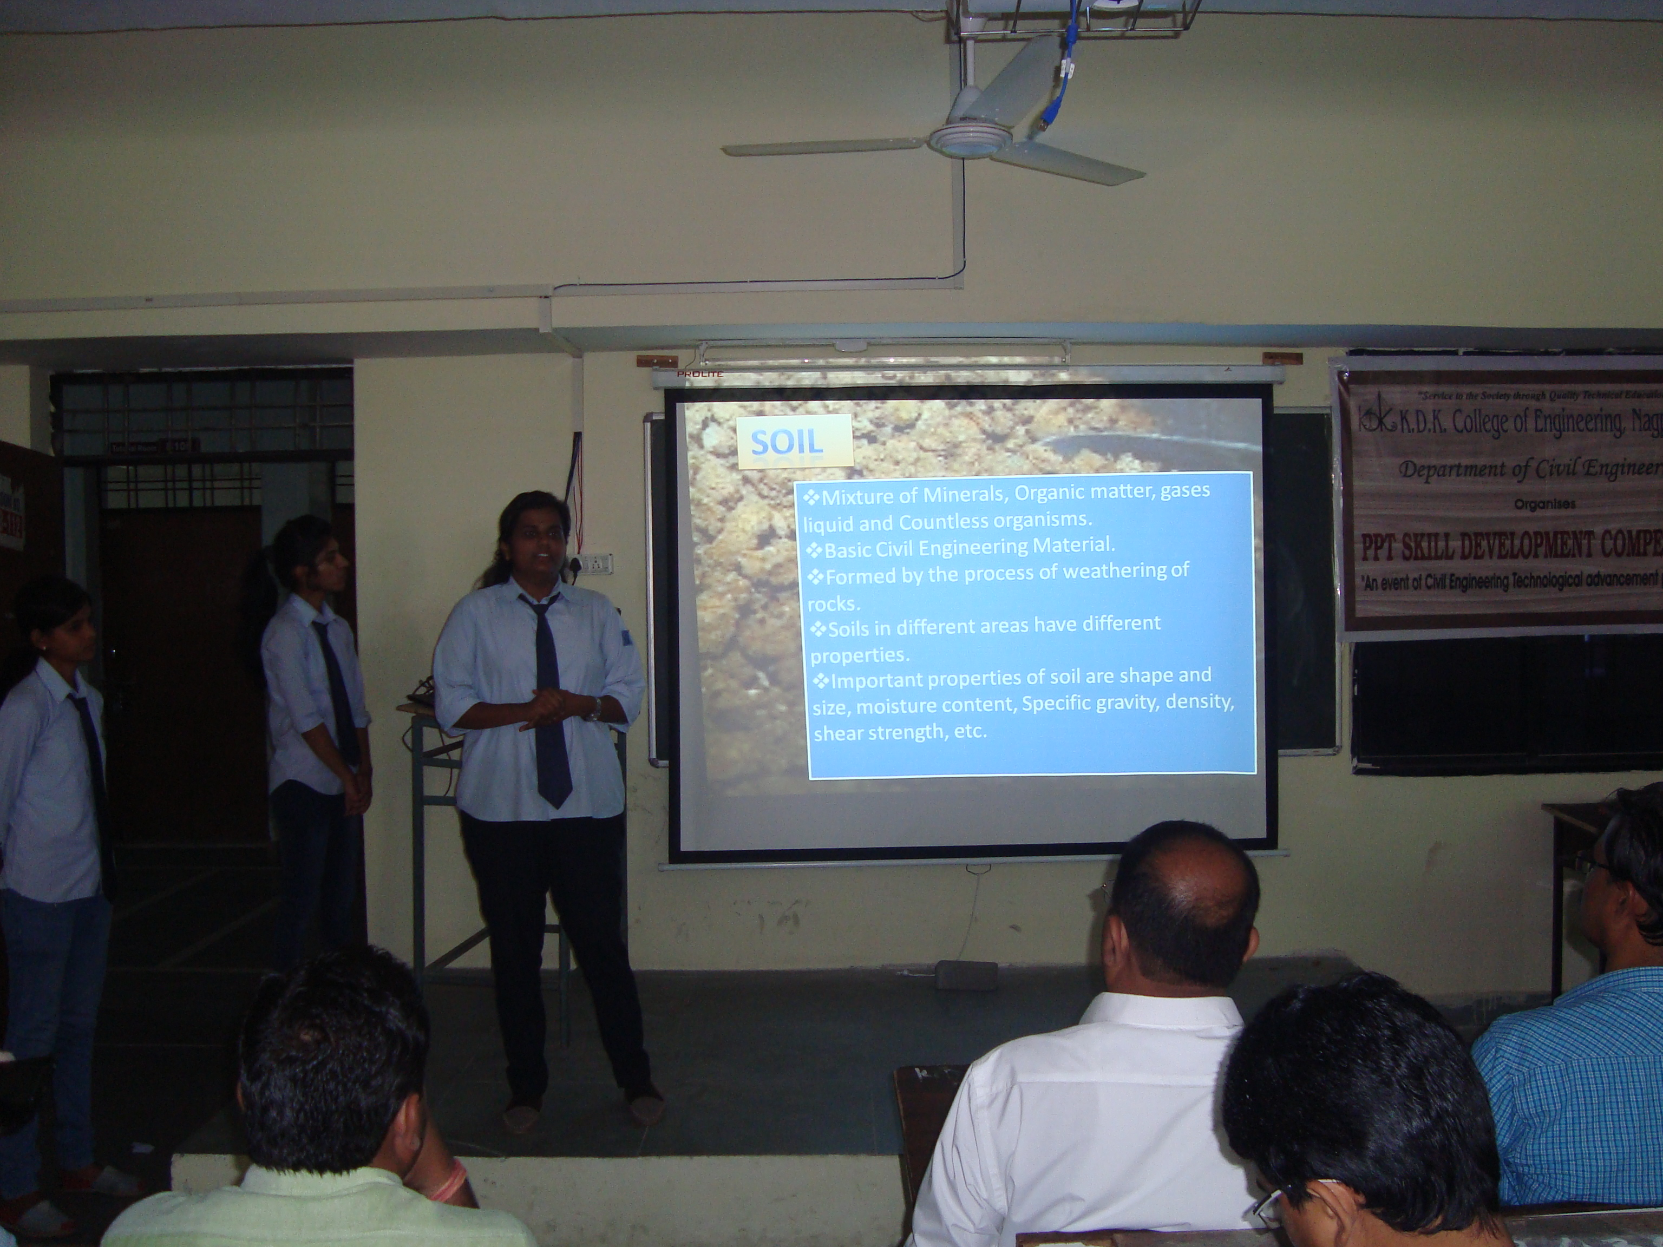
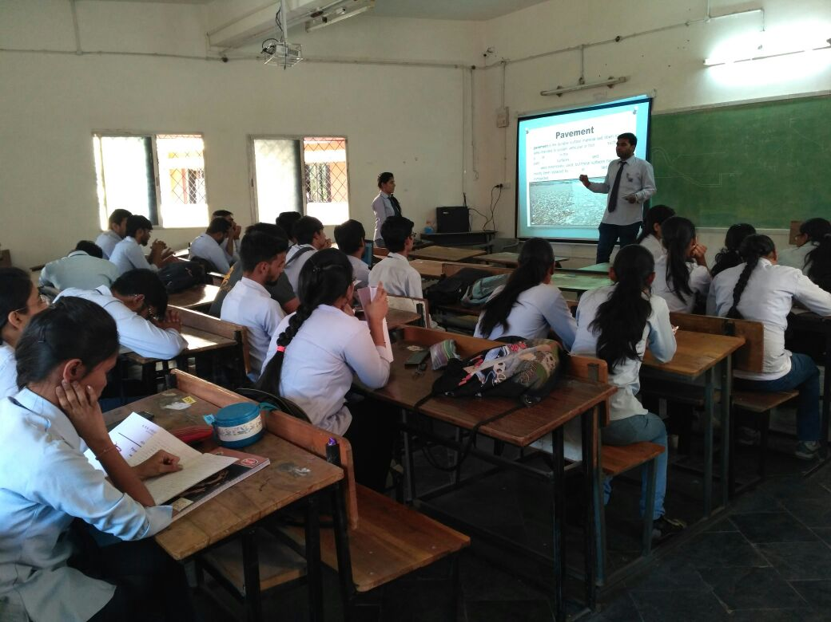
PPT SKILL DEVELOPMENT PROGRAME

Department of Civil Engineering had organized PPT Skill Development Competition for Second & third year students of K.D.K College of Engineering on 3rd to 7th July 2017. These competitions help in enhancing the soft skills amongst students, to develop the art of speaking & to simulate their thinking process. These PPT competitions also enhance the confidence & capabilities which would certainly boost up their employability character.
Students actively participated in competition. The competition was performed in groups and each group was free to choose the any topics of Civil Engineering field. The most of the groups chose advanced topics of Civil Engineering such as “Smart Building Materials”, “Ecological Planning in Green building”, “River Linking & its Effects”, “GIS & GPS applications” and many more. Such kind of presentations gives wider insight towards technological advancements in the construction field. Students have largely benefitted with the participation in the competition and have insisted similar kind of programs on wider Civil Engineering Applications in future.

Prof. D. S. Padole Dr. V. Varghese
I/C Guest Lec. Head CED, KDKCE

