K.D.K. COLLEGE OF ENGINEERING, NAGPUR

**“Our Mission”**

“Service To The Society Through Quality TechnicalEducation Education

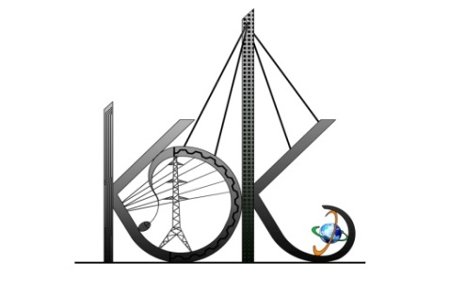

DEPARTMENT OF COMPUTER TECHNOLOGY

SESSION**:** 2019-20

**Student Activity Centre (SAC)**

## 

**Activity Report**

Date:16-08-2019

**Name of Activity :**Police andSoldiers Awareness

**Name of Club :**Community and Activity Club

**Date :**15/08/2019

**Time :**11:00am to 02:00 Pm

**Venue :**FutalaTalaw&Various Squares in Nagpur City

**Details of activity:**

Student Activity Centre Committee members visited FutalaTalaw&various squares to promote awareness of Indian Police on15th Aug., 2019. We have conducted following activities.

* Conducted awareness campaign for school children
* We involved all the visitor’s passing by the roads to know the importance of our Indian Police
* Ex-Air Force Officer Mr.Sudhakar Tapas Sir influenced in spreading awareness among people
* After completion of all the activities we have celebrated 73rdIndependence Day at college.

**Photos:**

