K.D.K. COLLEGE OF ENGINEERING, NAGPUR

**“Our Mission”**

Service To The Society

Through Quality Technical Education Education

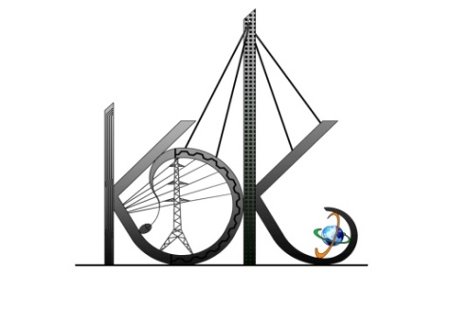

DEPARTMENT OF COMPUTER TECHNOLOGY

SESSION : 2019-20

**Student Activity Centre (SAC)**

## Activity Report

Date:16-08-2019

**Name of Activity :**Public Awareness Campaign for Rain Water Harvesting

**Name of Club :**Community and Activity Club

**Date :**15/08/2019

**Time :**08:00am to 11:00 am

**Venue :**Various Schools & Squares in Nagpur City

**Details of activity:**

Student Activity Centre Committee members visited various Schools & squares to promote awareness of Rain Water harvesting on 15th Aug., 2019. We have conducted following activities.

* Conducted awareness campaign for school children at nearby schools.
* We involved all the visitor’s passing by the roads to know the importance of our Rain Water Harvesting
* Efforts appreciated by our Hon’ble Secretary **Shri. Rajendra B. Mulak** and Principal Dr. D. P. Singh
* After completion of all the activities we have celebrated 73rdIndependence Day at college.

**Photos:**

