K.D.K. COLLEGE OF ENGINEERING, NAGPUR

**“Our Mission”**

Service To The Society

Through Quality Technical Education Education

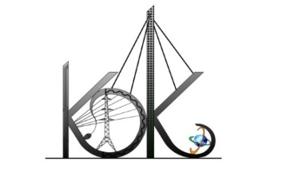

DEPARTMENT OF COMPUTER TECHNOLOGY

SESSION**:** 2019-20

**Student Activity Centre (SAC)**

**Date:** 26-09-2019

**Activity Report**

**Name of Activity :** Sports competition

**Name of Club :** Sports Club

**Date :** 26/09/2019

**Time :** 8:30am to 10:30am

**Venue :** Sports Department, Block B

**Details of activity:**

Under Student Activity Week-2019, Student Activity Centre (SAC) organized the sports activity which included **“*Chess and Carrom competition”*** for the students of K.D.K. college of Engineering which was held in the Sports Department of Block B in the morning to circumvent regular academics. Total 71 students have participated in this competition and shown their sportsmanship.

**Photos:**

