K.D.K. COLLEGE OF ENGINEERING, NAGPUR

**“Our Mission”**

Service To The Society

Through Quality Technical Education Education

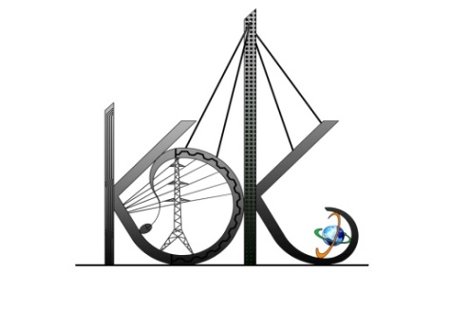

DEPARTMENT OF COMPUTER TECHNOLOGY

SESSION**:** 2019-20

**Student Activity Centre (SAC)**

Date: 28-09-2019

**Activity Report**

**Name of Activity :** Online Technical Test -Tesseract

**Name of Club :** Technical Club

**Date :** 26/09/2019

**Time :** 3:30pm to 05:00 pm

**Venue :** Seminar Hall, Dept. of CT

**Details of activity:**

Under Student Activity Week-2019, Student Activity Centre (SAC) organized an online technical test- **“Tesseract”** competition for the students of computer technology which was to be held in the computer labs of Department of Computer Technology on 26/09/2019. After the test is over, a special session on questions evaluation and doubt clearing for the participants is arranged in the seminar hall by the technical club heads Mr. Mohd. Aquib and Mr. Deepak Atrahe along with other team members. Total 26 students had actively participated in the test. .

**Photos:**

