K.D.K. COLLEGE OF ENGINEERING, NAGPUR

**“Our Mission”**

Service To The Society

Through Quality Technical Education

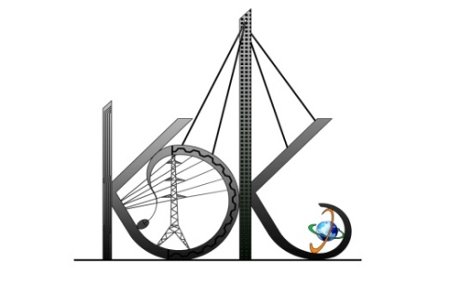

DEPARTMENT OF COMPUTER TECHNOLOGY

SESSION**:** 2019-20

**Student Activity Centre (SAC)**

Date: 25-09-2019

**Activity Report**

**Name of Activity :** Digital Marketing Seminar

**Name of Club :** Technical Club

**Date :** 23/09/2019

**Time :** 3:30pm to 05:00 pm

**Venue :** Seminar Hall, CT Dept.

**Details of activity:**

Under Student Activity Centre (SAC), Technical Club members organized a seminar on “Digital Marketing” for the 2nd & 3rd Year students of the department on 23/09/2019. The seminar was delivered by the SAC members & students of Third Year, CT Mr. Mohd. Sohil and Mr. Anmol Hinge.

The following important topics were covered:-

* Introduction to Digital Marketing
* Components of Digital Marketing
* Google Analytics
* Social Media Marketing
* Website Development/Blogging
* Email Marketing
* Search Engine Optimization (SEO)
* Scope/Careers in Digital Marketing
* Sources to Learn Digital Marketing

**Photos:**

