K.D.K. COLLEGE OF ENGINEERING, NAGPUR

**“Our Mission”**

“Service To The Society Through Quality TechnicalEducation Education

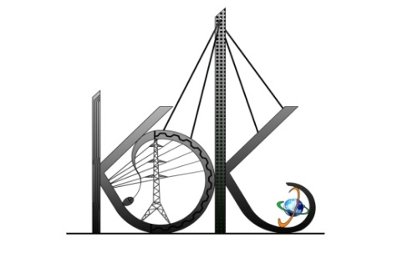

DEPARTMENT OF COMPUTER TECHNOLOGY

SESSION**:** 2019-20

**Student Activity Centre (SAC)**

**Date:** 25-09-2019

**Activity Report**

**Name of Activity :** LitArt - Poetry and Narrative Sketching competition

**Name of Club :** Literature and Arts Club

**Date :** 25/09/2019

**Time :** 3:30pm to 05:00pm

**Venue :** Department of Computer Technology

**Details of activity:**

Under Student Activity Week-2019, Student Activity Centre (SAC) organized *Lit-Art completion (Poetry and Narrative Sketching competition*) for the students which was held in the Department of Computer Technology.

Total **54** students participated in this event and submitted their thoughtful poems and situational sketches to the ARTS and Literature club activity. Following topics are given to the students:

**Spill The Ink:**

1. Me and My selfie
2. The Ghost
3. Someone To admire

**Sketch It:**

1. Elegance Of Nature
2. Seascape And Dawn
3. Unfavorable Nature

**Photos:**

