K.D.K. COLLEGE OF ENGINEERING, NAGPUR

**“Our Mission”**

Service To The Society

Through Quality Technical Education Education

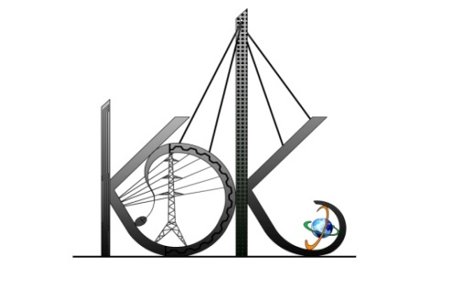

DEPARTMENT OF COMPUTER TECHNOLOGY

SESSION**:** 2019-20

**Student Activity Centre (SAC)**

**Date:** 28-09-2019

**Activity Report**

**Name of Activity :** Open Mic Competition

**Name of Club :** Films and Music Club

**Date :** 27/09/2019

**Time :** 3:30pm to 05:30 pm

**Venue :** Seminar Hall, CT Department

**Details of activity:**

Under Student Activity Week-2019, Student Activity Centre (SAC) organized *Open Mic competition* for the students of K.D.K. college of Engineering which was held in the Department of Computer Technology on 27/09/2019.

At the event Mr. Gavrav Shrirang (famous as RJ Shrirang) and Mr. Chintamani Rajat (Popular Flutist) was present as chief guests, to judge the event. Students have shown their inherent talents by showcasing through fabulous performances on the day. Total **25** students participated in the activity.

**Photos:**

