K.D.K. COLLEGE OF ENGINEERING, NAGPUR

**“Our Mission”**

Service To The Society Through Quality TechnicalEducation Education

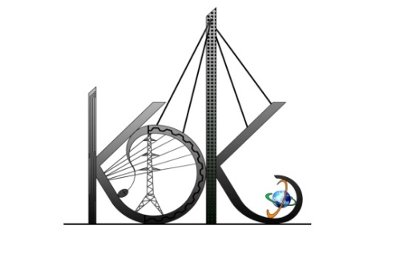

DEPARTMENT OF COMPUTER TECHNOLOGY

SESSION**:** 2019-20

**Student Activity Centre (SAC)**

**Date:**28-09-2019

**Activity Report**

Name of Activity :Basic Robotics Seminar

Name of Club : Technical Club

Date :26/09/2019

Time :3:30pm to 05:00 pm

Venue :Seminar Hall of Dept. of CT

Details of activity:

Student Activity Centre Committee members in association with e-Yantra Robotics Lab at KDKCEorganizeda seminar on Basic Roboticsfor the 2nd Year students of Computer Technology, Information Technology and Electronics and Telecommunications on 26th Sept. 2019. The seminar was conducted byone of our alumina of 2017-18 passed out batch, Mr. SaurabhManwatkar, working at Makxenia Engineering Resource Pvt. Ltd., Nagpur.Students have enjoyed the activity with positive ardor.

The following topics werediscussed in the seminar-

* Introduction to Basic Robotics
* Importance of Robotics
* Programming of Arduino
* Industrial importance of Robotics
* Scope/Careers in Robotics
* Sources to learn Robotics at E yantra

**Photos:**

