K.D.K. COLLEGE OF ENGINEERING, NAGPUR

**“Our Mission”**

Service To The Society

Through Quality Technical Education Education

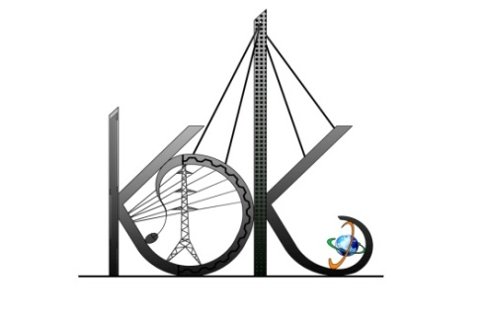

DEPARTMENT OF COMPUTER TECHNOLOGY

SESSION**:** 2019-20

**Student Activity Centre (SAC)**

Date: 25-09-2019

**Activity Report**

**Name of Activity :** Passport Making Drive

**Name of Club :** Community and Service Club

**Date :** 24/09/2019 and 25/09/2019

**Time :** 11:00am to 05:00 pm

**Venue :** Department of Computer Technology

**Details of activity:**

Student Activity Centre Committee members organizeda Passport Making Drive for the students of Computer Technology which was to be held in Department of Computer Technologyon24/09/ 2019 and 25/09/2019. This campaign was done by the TSC Company. The TCS company employee helped students in registrations process of passport making drive.

**Photos:**

