K.D.K. COLLEGE OF ENGINEERING, NAGPUR

**“Our Mission”**

Service To The Society

Through Quality Technical Education Education



DEPARTMENT OF COMPUTER TECHNOLOGY

SESSION**:** 2019-20

**Student Activity Centre (SAC)**

**Date**: 28-09-2019

**Activity Report**

**Name of Activity :** Photo for a Cause

**Name of Club :** Photography Club

**Date :** 28/09/2019

**Time :** 11:00 am to 05:00 pm

**Venue :** Dept. of Computer Technology

**Details of activity:**

Photography Club of Student Activity Centre organized a photography competition for all the students of KDKCE. The theme of this competition was ***“Water Scarcity”.*** The aim of this competition was to use the photography skills of the students for a cause and spread awareness among the other students. Total **42** students have actively participated in this competition. The basic aim of this activity is to spread awareness about the wastage of water in the college campus. Through his innovative idea, a sincere appeal to the college management is sent to cure the cause of water wastage with the respective photographs and the college management gave assurance to fix the problems.

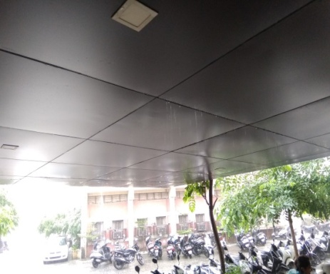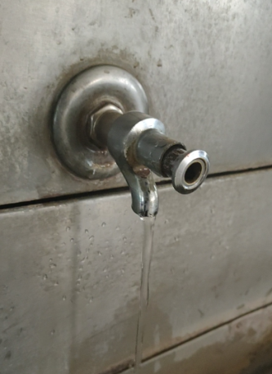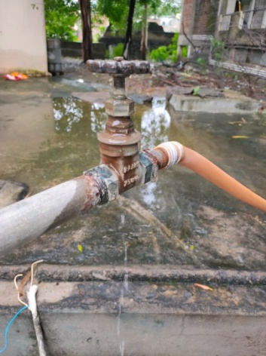**Photos:**

Photo 1 Photo 2 Photo 3

Water Leakage thr. Tap Water cooler Tap leakage Water spilling thr. Wall silling at Block B