

**K D K College of Engineering, Nandanvan, Nagpur**

**Department of Information Technology**

**An Awareness Program on**

**High Performance Computing (HPC)**

**Activity Report**

**Dated: 16 August 2024**

**Venue: Auditorium Hall, KDK College of Engineering, Nagpur.**



**Submitted by-**

**Dr. H. V. Gorewar**

**Program Co-ordinator**

**Index**

| **Sr. No** | **Particulars** | **Page No.** |
| --- | --- | --- |
| 1 | Objective & Description | 3 |
| 2 | Outcome | 4 |
| 3 | Notice | 5 |
| 4 | One page report | 6 |
| 5 | Report | 7 |
| 7 | Attendance Sheet | 8-17 |
| 8 | Poster/ Banner | 18 |
| 9 | Feedback Analysis | 19 |
| 10 | Photographs | 20-23 |

**An Awareness Program on**

**High Performance Computing (HPC)**

**Date: 16 August 2024**

**Activity Report**

**Objective** – To educate students and faculty about HPC technologies and their applications to enhance academic and research capabilities.

**Description**- The Department of Information Technology at KDK College of Engineering, in association with the Institution’s Innovation Council (IIC) and the Internal Quality Assurance Cell (IQAC), successfully held “An Awareness Program on High Performance Computing (HPC)”. The event, part of the AICTE Sankalp initiative, was led by Dr. Pradnya Borkar, an esteemed AICTE HPC Master Trainer.

The primary goal of the awareness program was to introduce and familiarize students and faculty with the concepts and applications of High Performance Computing (HPC). HPC is crucial in solving complex computational problems across various fields, including engineering, scientific research, and data analysis. This program aimed to bridge the knowledge gap and highlight the importance of HPC in advancing technological and research capabilities.

Dr. Pradnya Borkar began with an overview of HPC, explaining its significance in accelerating computational tasks and its impact on modern research and industry. The session covered the fundamentals of HPC systems, including hardware components, software, and network architectures. The program illustrated real-world applications of HPC, showcasing how it is utilized in diverse fields such as climate modeling, molecular research, financial simulations, and artificial intelligence. Examples included case studies and success stories from various industries. She also highlighted emerging trends and innovations in the field, offering insights into future developments and potential research opportunities.

The program included an interactive Q&A session where students and faculty could ask questions, discuss challenges they face, and seek advice on integrating HPC into their research and academic projects.

The event saw enthusiastic participation from both students and faculty. Students from various engineering disciplines were particularly interested in how HPC can enhance their academic projects and research endeavors. Faculty members appreciated the in-depth knowledge shared and the practical insights that could be applied to their teaching and research activities.

**Outcome –**

At the end of this event students will be able to:

1. Enhancing understanding of HPC among participants.

2. Providing valuable hands-on experience with HPC tools.

3. Fostering a greater appreciation of the role of HPC in advancing research and technology.

4. Encouraging further exploration and utilization of HPC resources in academic and research settings.

**Notice**



**KDK College of Engineering, Nagpur**

**Department of Information Technology**

**Notice**

**Date:** **13/08/2024**

All the students are informed that the Department of Information Technology in association with IIC and IQAC is organizing **“An Awareness Program on High Performance Computing (HPC)”** under AICTE SANKALP on 16/08/2024.

All the students and faculty are requested to attend the program.

 

**Dr. H. V. Gorewar Dr. Mrs. S. P. Khandait   
 Event Co-ordinator (HOD, IT)**

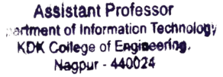 

**One Page Report of IYC**

**KDK College of Engineering Nagpur**

**Activity Report (Session: 2024-2025)**

**Information Technology Department**

**Department/Committee**

| Name of Activity: An Awareness Program on High Performance Computing (HPC) | | | |
| --- | --- | --- | --- |
| Date | Department | College/Department/Committee | Name of Co-ordinator |
| 16/08/2024 | Information Technology | Department | Dr. H.V. Gorewar |
| Time | Venue | No. of Participants  Male: 106 Female: 93 | In Campus/ Out Campus |
| 3:00 PM to 4:30 PM | Auditorium Hall, KDK College of Engineering | Total: 199 | Indoor |
| Assisting Faculty: | Asst. Prof. D.W. Wakde  Asst. Prof. J.D. Thakre | | |

**Brief Information about the Activity: Criterion No: 6**

| Topic of Activity | An Awareness Program on High Performance Computing (HPC) |
| --- | --- |
| Objectives | i**)** Educate participants on the basic concepts of High Performance Computing, including what HPC is, its significance, and how it differs from traditional computing.  ii) Encourage and provide resources for participants to develop their skills in HPC, including programming, system management, and data analysis. |
| Methodology | Design & Development |
| Outcome | 1. Participants will gain a foundational understanding of HPC, including key terms and concepts.  2. Participants will be aware of opportunities for further learning and skill development in HPC. |

**Proofs & Documents Attached (Tick Mark the Appropriate)**

| 1. Notice | 2. List of Participants | 3. Report of Activity | 4. Photographs | 5. Feedback Forms |
| --- | --- | --- | --- | --- |
| 6. Feedback Analysis | 7. News Clips | 8. Certificate | 9. Any Other |  |

| Name & Signature of Co-ordinator | Name & Signature of HOD/ Committee In-Charge | Signature of Principal | Name, Signature & Seal of IQAC Co-ordinator |
| --- | --- | --- | --- |
| Dr. H.V. Gorewar | Dr.S.P.Khandait | Dr.Valsson Varghese | Dr.Mrs. N.R. Dhamge |

**Report**

The Department of Information Technology at KDK College of Engineering, in association with the Institution’s Innovation Council (IIC) and the Internal Quality Assurance Cell (IQAC), successfully held “An Awareness Program on High Performance Computing (HPC)”. The event, part of the AICTE Sankalp initiative, was led by Dr. Pradnya Borkar, an esteemed AICTE HPC Master Trainer.The primary goal of the awareness program was to introduce and familiarize students and faculty with the concepts and applications of High Performance Computing (HPC). HPC is crucial in solving complex computational problems across various fields, including engineering, scientific research, and data analysis. This program aimed to bridge the knowledge gap and highlight the importance of HPC in advancing technological and research capabilities.

Students had actively participated and were fully involved in the activities. This activity is beneficial for created great awareness among students and faculty members. Dr. Mrs. S. P. Khandait, Head of Department of Information Technology presided the program with faculty members from all the other departments. Dr. Valsson Varghese, Principal, and Dr. A. M. Badar, Vice-Principal praised efforts taken by Dr. H.V. Gorewar, Event Co-ordinator Prof. D.W. Wakde and Prof. J.D. Thakre, Event Co-coordinator for organizing this program.

**Participants (IT)**

**Attendance Sheet**

| **Sr. No.** | **Name of Participant** | **Student ID/ ERP ID** | **Year/Semester** | **Department** | **Gender** | **Email ID** | |
| --- | --- | --- | --- | --- | --- | --- | --- |
| 1 | Shashank Mankar | Kdk22it008 | 7 | IT | Male | shashanknmankar.it22d@kdkce.edu.in | |
| 2 | NAGESH KADAM | KD22IT006 | 7 | IT | Male | nageshvkadam.it22d@kdkce.edu.in | |
| 3 | Tanaji Dhage | KD22IT007 | 7 | IT | Male | tanajidhage2003@gmail.com | |
| 4 | Ganesh Narharee Dhere | KF22AI046 | 5 | AIDS | Male | dhereganesh9022@gmail.com | |
| 5 | Chinmay R. Pathak | KF22AI028 | 5 | AIDS | Male | chinmaypathak2004@gmail.com | |
| 6 | Samyak Lohakare | KF21IT039 | 7 | IT | Male | samyaklohakare171@gmail.com | |
| 7 | Avantika Maske | KF22AI050 | 5 | AIDS | Female | avantikamaske11@gmail.com | |
| 8 | Shruti Dattu Urkude | KF23AI017 | 3 | AIDS | Female | shrutidurkude.aids23f@kdkce.edu.in | |
| 9 | Mahi Prashant Nakhate | KF22AI011 | 5 | AIDS | Female | nakhatemahi@gmail.com | |
| 10 | Jyotsna Thakre | IT630 | Faculty | IT | Female | jyotsna.thakre@kdkce.edu.in | |
| 11 | Shishir kailas mane | KF22AI036 | 5 | AIDS | Male | shishirmane34@gmail.com | |
| 12 | Gaurav Kakde | KF23AI026 | 3 | AIDS | Male | gauravukakde.aids23f@kdkce.edu.in | |
| 13 | Rahul chavhan | KF23IT066 | 3 | It | Male | rahuljchavhan.it23f@kdkce.edu.in | |
| 14 | Palak. Dinesh. Gujarkar | KF23AI04 | 3 | AI&DS | Female | palakdgujarkar.aids23f@kdkce.edu.in | |
| 15 | Twinkle Ghangare | KF23AI033 | 3 | AIDS | Female | twinklemghangare.aids23f@kdkce.edu.in | |
| 16 | Pravesh Chintaman Patil | AIDS06 | Faculty | AIDS | Female | pravesh.patil@kdkce.edu.in | |
| 17 | Rahul Devdatt Chavhan | KF23IT028 | 3 | IT | Male | rahuldchavhan.it23f@kdkce.edu.in | |
| 18 | Bhupendra Marbate | KF23IT036 | 3 | IT | Male | bhupendradmarbate.it23f@kdkce.edu.in | |
| 19 | Atharva Shrote | KF21IT010 | 7 | IT | Male | atharvasshrote.it21f@kdkce.edu.in | |
| 20 | Khushal deogade | KF23IT061 | 3 | IT | Male | khushalmdeogade.it23f@kdkce.edu.in | |
| 21 | HARSH WANWE | KF21IT024 | 7 | IT | Male | harshwanwe@gmail.com | |
| 22 | Sumit vinod narule | KF23IT023 | 3 | IT | Male | sumitvnarule.it23f@kdkce.edu.in | |
| 23 | Sameer Chandrakant Lambat | KF23IT065 | 3 | IT | Male | sameerclambat.it23f@kdkce.edu.in |
| 24 | Shreyash Bhaiyyaji Thaware | KF21IT044 | 7 | IT | Male | shreyashthaware284@gmail.com |
| 25 | Devayanee chaliram Ghatolkar | KF23IT057 | 3 | IT | Female | devayaneecghatolkar.it23f@kdkce.edu.in |
| 26 | Vaishnavi B. Kotrange | KF22IT007 | 5 | IT | Female | vaishnavibkotrange.it22f@kdkce.edu.in |
| 27 | Devayanee Chaliram Ghatolkar | KF23IT057 | 3 | IT | Female | devayaneecghatolkar.it23f@kdkce.edu.in |
| 28 | Sameer Chandrakant Lambat | Kf23it065 | 3 | IT | Male | sameerlambat88@gmail.com |
| 29 | Dr. Mrs. Sangita P. Wankhede | Faculty | First year | First Year | Female | spwankhede20@kdkce.edu.in |
| 30 | Bhuvneshwari Ashok Janbandhu | KF22IT011 | 5 | It | Female | bhuvneshwariajanbandhu.it22f@kdkce.edu.in |
| 31 | Tejas Dhomne | KF21IT043 | 7 | IT | Male | tejasdhomne978@gmail.com |
| 32 | Avesh Pathan | KF21IT001 | 7 | IT | Male | aveshpathan432@gmail.com |
| 33 | Darshan Mendhe | KF23IT046 | 3 | IT | Male | mendhedarshan26@gmail.com |
| 34 | Sarthak Ramkrushna Rasal | sarthakrrasal.it22d@kdkce.edu.in | 7 | IT | Male | sarthakrasal998@gmail.com |
| 35 | Chanakshi Godbole | KF21IT009 | 7 | IT | Female | chanakshiggodbole.it21f@kdkce.edu.in |
| 36 | Mamale Rupali Laxman | KD22IT004 | 7 | IT | Female | rupalilmamale.it22d@kdkce.edu.in |
| 37 | Himanshu V Pande | KF21IT022 | 7 | IT | Male | himanshuvpande.it21f@kdkce.edu.in |
| 38 | Devanshu kishor dhote | KF23IT058 | 3 | IT | Male | devanshukdhote.it23f@kdkce.edu.in |
| 39 | ROHIT SANTOSH LANJEWAR | KF21IT012 | 7 | IT | Male | rohitslanjewar.it21f@kdkce.edu.in |
| 40 | Akash Jadhav | KD22IT009 | 7 | IT | Male | akashjadhav.1106@gmail.com |
| 41 | Shravani kedar | KF23IT020 | 3 | IT | Female | shravanimkedar.it23f@kdkce.edu.in |
| 42 | Karan Arjun Chavhan | KF21IT007 | 7 | IT | Male | karanschavhan2@gmail.com |
| 43 | Bhavesh Rajendra Dhabale | KF22IT060 | 5 | IT | Male | bhaveshdhabale14122004@gmail.com |
| 44 | Khushal | KF23IT013 | 3 | IT | Male | khushalv247@gmail.com |
| 45 | Kurnisha Dinkar Bhisikar | KF23IT055 | 3 | IT | Female | kurnishabh8@gmail.com |
| 46 | Om kakde | KF23AI019 | 3 | AIDS | Male | ommkakde.aids23f@kdkce.edu.in |
| 47 | Pooja P.Babre | AIDS07 | Faculty | AIDS | Female | pooja.babre@kdkce.edu.in |
| 48 | Apurva Rode | KF23IT032 | 3 | IT | Female | apurvarode05@gmail.com |
| 49 | Prajwal Sunil chandankhede | KF21IT033 | 7 | IT | Male | prajwalchandankhede842@gmail.com |
| 50 | Sahil Barsagade | KF22IT056 | 5 | IT | Male | Sahil.barsagade30@gmail.com |
| 51 | Swara Sawarkar | KF23IT051 | 3 | It | Female | swarassawarkar.it23f@kdkce.edu.in |
| 52 | Shriya Ghumare | KF23EE033 | 3 | EE | Female | shriyapghumare.ee23f@kdkce.edu.in |
| 53 | Rajesh Pramod Raut | KF21IT038 | 7 | IT | Male | rajeshraut0121@gmail.com |
| 54 | Pranali Rajendra padlamwar | KF22IT035 | 5 | IT | Female | pranalirpadlamwar.it22f@kdkce.edu.in |
| 55 | Dr. HarishV. Gorewar | IT609 | Faculty | IT | Male | harish.gorewar80@kdkce.edu.in |
| 56 | Dhanshri Wakde | IT628 | Faculty | IT | Female | dhanshri.wakde@kdkce.edu.in |
| 57 | Abhishek Nachankar | CT746 | Faculty | CSE | Male | abhishek.nachankar@kdkce.edu.in |
| 58 | Harshal Donarkar | KF21CS115 | 7 | CSE | Male | harshaldonarkar@gmail.com |
| 59 | Prof. Yogeshri D. choudhari | IT604 | Faculty | IT | Female | yogehsri.choudhari@kdkce.edu.in |
| 60 | Anuj mishra | Kf21cf123 | 7 | Cse | Male | anujsmishra.cse21f@kdkce.edu.in |
| 61 | Nikita Bhumesh Borkar | KF21CS077 | 7 | CSE | Female | nborkar560@gmail.com |
| 62 | Mohit Pandurang Nakhate | KF22CS174 | 5 | Cse | Male | mpnakhate@gmail.com |
| 63 | Sonali shejule | KDKCSE2010 | 5 | CSE | Female | sonalilshejule.cse23d@kdkce.edu.in |
| 64 | SURAJ RAJENDRA WANGE | KF23CS208 | 3 | CSE | Male | surajrwange.cse23f@kdkce.edu.in |
| 65 | Rasika Kawadkar | KF21CS042 | 7 | CSE | Female | rasikamkawadkar.cse21f@kdkce.edu.in |
| 66 | Jidnyasa Thakre | KF21CS066 | 7 | CSE | Female | jidnyasadthakre.cse21f@kdkce.edu.in |
| 67 | Saurabh garat | 237 | 7 | Cse | Male | saurabhsgarat.cse21f@kdkce.edu.in |
| 68 | Shruti Santosh Kaitikwar | KF21CS037 | 7 | CSE | Female | shrutikaitikwar2003@gmail.com |
| 69 | Priyank Dilip Moon | KF22CS016 | 7 | CSE | Male | priyankmoon124@gmail.com |
| 70 | Lucky Ali | KF21CS076 | 7 | CSE | Male | luckysali.cse21f@kdkce.edu.in |
| 71 | Aparna Yashwant Badhe | KD23CS001 | 5 | CSE | Female | aparnaybadhe.cse23d@kdkce.edu.in |
| 72 | Akash. R. Patvekar. | KF22CSE026 | 5 | Cse | Male | akashnathrpatvekar.cse22f@kdkce.edu.in |
| 73 | Priyanshu Ninawe | KF21CS073 | 7 | CSE | Male | priyanshuninawe26@gmail.com |
| 74 | Yogesh Ravindra Jadhao | KF21CS018 | 7 | Cse | Male | yogeshrjadhao.cse21f@kdkce.edu.in |
| 75 | Kaushik Jagdish Shetkar | KF22CS128 | 5 | CSE | Male | kaushikshetkar2@gmail.com |
| 76 | shreyashi kamkar | KF23CS061 | 3 | cse | Female | shreyashirkamkar.cse23f@kdkce.edu.in |
| 77 | Sahil Yadav | Kf21cse109 | 7 | CSE | Male | sahilmyadav.cse21f@kdkce.edu.in |
| 78 | Shantanu lad | KF21CS078 | 7 | Cse | Male | shantanumlad.cse21f@kdkce.edu.in |
| 79 | Anand kaurase | KF23CS205 | 3 | CSE | Male | anandakaurase.cse23f@kdkce.edu.in |
| 80 | Madan kagne | KF23CS073 | 3 | CSE | Male | madanmkagne.css23f@kdkce.edu.in |
| 81 | Atul Ashok Tandekar | KF23CS062 | 3 | CSE | Male | atultandekar10@gmail.com |
| 82 | Damini Sanjay Khopde | daminiskhopde.cse23f@kdkce.edu.in | 3 | CSE | Female | daminikhopde22@gmail.com |
| 83 | Khushal | KF23IT013 | 3 | IT | Male | khushalgsarode.it23f@kdkce.edu.in |
| 84 | Sejal gahane | KF23IT047 | 3 | It | Female | sejaltgahane.it23f@kdkce.edu.in |
| 85 | Pranay Mule | KF23CS199 | 3 | Cse | Male | pranaydmule.cse23f@kdkce.edu.in |
| 86 | Sanika Raut | KF23CS154 | 3 | Cse | Female | sanikaraut1405@gmail.com |
| 87 | Ethen wankhede | KF23IT043 | 3 | IT | Male | ethenrwankhede.it23f@kdkce.edu.in |
| 88 | Vedant Narendra Mendhule | KF23IT022 | 3 | IT | Male | vedantnmendhule.it23f@kdkce.edu.in |
| 89 | Vedangi Londhe | KF23CS029 | 3 | Cse | Female | vedangiblondhe.cse23f@kdkce.edu.in |
| 90 | Sameer Nayak | KF23IT019 | 3 | I.T | Male | sameerrkumar.it23f@kdkce.edu.in |
| 91 | Rohan Dhanraj Sakore | KF23IT068 | 3 | IT | Male | sakorerohan1555@gmail.com |
| 92 | Kirti Dhenge | No |  | EE | Male | kirti.dhenge@kdkce.edu.in |
| 93 | Gaurav vinod goge | KF23IT034 | 3 | IT | Male | gauravvgoge.it23f@kdkce.edu.in |
| 94 | Nikita Bhusari | KF23IT024 | 3 | It | Female | nikitasbhusari.it23f@kdkce.edu.in |
| 95 | Anagha Kishor namaste | KF23IT053 | 3 | IT | Female | anaghakgawande.it23f@kdkce.edu.in |
| 96 | Dhiraj Rajendra Barekar | KF23IT050 | 3 | It | Male | dhirajrbarekar.it23f@kdkce.edu.in |
| 97 | Snehal Vinayak Bhanarkar | KF23IT059 | 3 | IT | Female | snehalvbhanarkar.it23f@kdkce.edu.in |
| 98 | Asmita Meshram | KF22CS116 | 5 | CSE | Female | asmitarmeshram.cse22f@kdkce.edu.in |
| 99 | Karan Gopal Vaidya | KF23IT063 | 3 | IT | Male | karangvaidya.it23f@kdkce.edu.in |
| 100 | Kurnisha Dinkar Bhisikar | KF23IT055 | 3 | IT | Female | kurnishadbhisikar.it23f@kdkce.edu.in |
| 101 | Purva Rajendra Hardiya | KF23IT054 | 3 | IT | Female | purvarharddiya.it23f@kdkce.edu.in |
| 102 | Prajakta Prashant Ghike | KF23IT031 | 3 | IT | Female | prajaktapghike.it23f@kdkce.edu.in |
| 103 | Apurva Rode | KF23IT032 | 3 | IT | Female | apurvaprode.it23f@kdkce.edu.in |
| 104 | Shivani kumbhare | KF23IT012 | 3 | IT | Female | shivanirkumbhare.it23f@kdkce.edu.in |
| 105 | bhupendrad marbate | KF23IT036 | 3 | IT | Male | bhupendradmarbate.it23f@kdkce.edu.in |
| 106 | Sandesh Pimpalkar | KF23IT042 | 3 | IT | Male | sandeshgpimpalkar.it23f@kdkce.edu.in |
| 107 | Pawan Deepak Gupta | KF23IT015 | 3 | IT | Male | pawandgupta.it23f@kdkce.edu.in |
| 108 | Tushar s. Padal | KF23EE086 | 3 | EE | Male | tusharspadal.ee23f@kdkce.edu.in |
| 109 | Jyotsna Thakre | IT630 | Faculty | IT | Female | jyotsna.thakre@kdkce.edu.in |
| 110 | Aditi Gawande | KF23IT052 | 3 | IT | Female | aditikgawande.it23f@kdkce.edu.in |
| 111 | Saniya palandurkar | KF23IT033 | 3 | IT | Female | saniyaspalandurkar.it23f@kdkce.edu.in |
| 112 | Laxit Ramdas kohale | Kf23EE005 | 3 | EE | Male | laxitrkohale.ee23f@kdkce.edu.in |
| 113 | Shreyash Gondane | KF21EE001 | 5 | EE | Male | shreyashmg2003@gmail.com |
| 114 | Sneha Natthuji Bhusari | KF22CS049 | 5 | CSE | Female | bhusarisneha83@gmail.com |
| 115 | Krishna Thakare | KF22CS067 | 3 | Cse | Male | krishnathakare676@gmail.com |
| 116 | Himani Jayendra Pardhi | KF23EE025 | 3 | EE | Female | himanijpardhi.ee23f@kdkce.edu.in |
| 117 | Saniya bhadke | KF23ee039 | 3 | EE | Female | saniyabhadke.ee23f@kdkce.edu.in |
| 118 | Pooja chandanpatre | Kd22EE202 | 7 | EE | Female | poojaschandanpatre.ee22d@kdkce.edu.in |
| 119 | Krish Tiwari | KF23CS164 | 3 | Cse | Male | krishytiwari.cse23f@kdkce.edu.in |
| 120 | Atharva | KF23CS095 | 3 | CSE | Male | atharvasgaddalwar.cse23f@kdkce.edu.in |
| 121 | Rohit Diliram patle | KF22AI023 | 5 | AIDS | Male | rohitdpatle.aids22f@kdkce.edu.in |
| 122 | Aishwarya Purushottam Tekode | KD23CS007 | 5 | CSE | Female | aishwaryatekode@gmail.com |
| 123 | Tejas Gopal Meshram | KF21EE024 | 7 | EE | Male | tejasgmeshram.ee21f@kdkce.edu.in |
| 124 | Misha Thakre | KF22CS190 | 5 | CSE | Female | mishathakre@gmail.com |
| 125 | Pravesh C. Patil | AIDS06 | Faculty | AIDS | Female | pravesh.patil@kdkce.edu.in |
| 126 | Harshal panchal | harshalgpanchal.aids22f@kdkce.edu.in | 5 | AIDS | Male | harshalgpanchal.aids22f@kdkce.edu.in |
| 127 | Kanchan Namdeorao Yuwanate | KF21EE033 | 7 | EE | Female | kanchanyuvanate@gmail.com |
| 128 | Khushi yuvraj Bhivgade | KF23lT011 | 3 | It | Female | khushiybhivgade.it23f@kdkce.edu.in |
| 129 | Atharva Bhoyar | KF23AI035 | 3 | Aids | Male | atharvadbhoyar.aids23f@kdkce.edu.in |
| 130 | Pranjali S. Hajare | KF23IT026 | 3 | IT | Female | pranjalishajare.it23f@kdkce.edu.in |
| 131 | Vaidehi Rakas | KF22AI031 | 5 | AIDS | Female | vaidehidrakas.aids22f@kdkce.edu.in |
| 132 | Ekta Sandeep Satghare | KF 22AI066 | 5 | AIDS | Female | ektassatghare.aids22f@kdkce.edu.in |
| 133 | Rohit Hiralal ji farde | KF22AI062 | 5 | AIDS | Male | rohithfarde.aids22f@kdkce.edu.in |
| 134 | Om kakde | KF23AI019 | 3 | AI&SD | Male | omkakde35@gmail.com |
| 135 | Prof.Pooja P. Babre | AIDS07 | Faculty | AI & DS | Female | pooja.babre@kdkce.edu.in |
| 136 | Parth parasmode | KF22AI014 | 5 | AIDS | Male | parthsparasmode.aids22f@kdkce.edu.in |
| 137 | Chetan bhagat | KD23AI003 | 5 | AI&DS | Male | chetandbhagat.aids23d@kdkce.edu.in |
| 138 | lokesh vaidya | KF23AI057 | 3 | AIDS | Male | lokeshavaidya.aids23f@kdkce.edu.in |
| 139 | DAMINI UGRASEN TEMBHARE | KF23AI062 | 3 | AIDS | Female | daminiutembhare.aids23f@kdkce.edu.in |
| 140 | Aman Padmakar Burbure | KF22AI008 | 5 | AIDS | Male | amanpburbure.aids22f@kdkce.edu.in |
| 141 | Siddhesh dhande | KF22AI005 | 5 | AIDS | Male | siddheshcdhande.aids22f@kdkce.edu.in |
| 142 | Vaishnavi Gahlod | KF22AI068 | 5 | AIDS | Female | vaishnavirgahlod.aids22f@kdkce.edu.in |
| 143 | Ayush Narendra Nagargade | KF22AI055 | 5 | AIDS | Male | ayushnnagargade.aids22f@kdkce.edu.in |
| 144 | Abhay Lokare | KD23AI007 | 5 | AIDS | Male | abhaylokare123@gmail.com |
| 145 | Akanksha Pramod Satdeve | KF22AI048 | 5 | AIDS | Female | akankshapsatdeve.aids22f@kdkce.edu.in |
| 146 | Sahil Bhimrao Dhanvij | KF22AI004 | 5 | AIDS | Male | sahilbdhanvij.aids22f@kdkce.edu.in |
| 147 | Ketaki Raju. Nimje | ketakirnimje.aids23d@kdkce.edu.in | 5 | AIDS | Female | ketakirnimje.aids23d@kdkce.edu.in |
| 148 | HARSHAL PANCHAL | KF22 AI 060 | 5 | AIDS | Male | harshalgpanchal.aids22f@kdkce.edu.in |
| 149 | Ekta Sandeep Satghare | KF22AI066 | 5 | AIDS | Female | ektassatghare.aids22f@kdkce.edu.in |
| 150 | Prinsal Shende | KF23AI016 | 3 | AIDS | Female | prinsalshende@gmail.com |
| 151 | Sahili Hiraman Gabhane | KF22AI020 | 5 | AIDS | Female | sahilihgabhane.aids22f@kdkce.edu.in |
| 152 | Nandini Sitalsingh Thakur | KF22CS068 | 5 | CSE | Female | nandinithakur2004@gmail.com |
| 153 | Devayanee Ghatolkar | KF23IT057 | 3 | IT | Female | devayaneecghatolkar.it23f@kdkce.edu.in |
| 154 | Pranay kawale | KF21EE032 | 7 | EE | Male | Pranayjkawale.ee21f@kdkce.edu.in |
| 155 | Krutika Lambe | KF21CS008 | 7 | Cse | Female | krutikalambe9@gmail.com |
| 156 | Twinkle Manoj Ghangare | KF23AI033 | 3 | AIDS | Female | twinklemghangare.aids23f@kdkce.edu.in |
| 157 | Ayush Suresh Zade | KF22AI052 | 5 | AIDS | Male | zayush998@gmail.com |
| 158 | Gaurav Kakde | KF23AI026 | 3 | AIDS | Male | kakdegaurav876@gmail.com |
| 159 | Dipak Bhausaheb pawar | KD23EE015 | 5 | EE | Male | dpavara438@gmail.com |
| 160 | Ravi Shripad | KF22AI021 | 5 | AIDS | Male | ravishripad6@gmail.com |
| 161 | Minal V. Chole | AIDS03 | Faculty | AIDS | Female | minal.thawakar@kdkce.edu.in |
| 162 | Sushil borkar | KF22CS168 | 5 | CSE | Male | sushilborkar8554@gmail.com |
| 163 | Rahul | KFWEAI046 | 3 | Aids | Male | rahulpkulkarni.aids23f@kdkce.edu.in |
| 164 | Uday Shende | udaykumarpshende.ee22f@kdkce.edu.in | 5 | EE | Male | udaykumarpshende.ee22f@kdkce.edu.in |
| 165 | Sejal Jadhao | KF23CS145 | 7 | Cse | Female | Sejaljadhav2510@gmail.com |
| 166 | Yash Sharad belkhode | KD22EE006 | 7 | EE | Male | ysbelkhode@gmail.com |
| 167 | Aman Prakash Dhanorkar | KF21CS102 | 7 | CSE | Male | amandhanorkar602@gmail.com |
| 168 | Piyush Burde | KF21CS136 | 7 | CSE | Male | piyushburde24@gmail.com |
| 169 | Akshad Dambhare | KF23CS144 | 3 | CSE | Male | Akshaddambhare773@gmail.com |
| 170 | Movarsh Khulshinge | KF23CS113 | 3 | CSE | Male | movarshmkhulshinge.cse23f@kdkce.edu.in |
| 171 | Aditya Madhav Kothare | Kf22EE026 | 5 | EE | Male | adityamkothare.ee22f@kdkce.edu.in |
| 172 | Sahil Kale | KF23AI028 | 3 | AIDS | Male | sahilkale992817@gmail.com |
| 173 | Khushi Harinkhede | KF22EE014 | 5 | EE | Female | khushiharinkhede09@gmail.com |
| 174 | Harsh kinekar | KF21EE050 | 7 | EE | Male | harshrkinekar.ee21f@kdkce.edu.in |
| 175 | Sunanda P. Khandait | IT601 | Faculty | IT | Female | sunanda.khandait@kdkce.edu.in |
| 176 | Akanksha Pramod Asutkar | KF23CS064 | 3 | CSE | Female | akankshapasutkar.cse23f@kdkce.edu.in |
| 177 | Anushka Sanjay Banait | KF23AI030 | 3 | AIDS | Female | anushkasbanait.aids23f@kdkce.edu.in |
| 178 | ROHINI SHIVSHANKAR KATKAR | KF23EE010 | 3 | EE | Female | rohiniskatkar.ee23f@kdkce.edu.in |
| 179 | Dhanshree Khedgarkar | KF22EE094 | 5 | EE | Female | dhanshreeakhedgarkar.ee22f@kdkce.edu.in |
| 180 | Khushi Nandeshwar | KF21CS030 | 7 | CSE | Female | khushibnandeshwar.cse21f@kdkce.edu.in |
| 181 | Sonakshi Gourishankar Tiwari | KF22CS191 | 5 | CSE | Female | sonakshigtiwari.cse22f@kdkce.edu.in |
| 182 | Khushi Shambharkar | KF23CS141 | 3 | CSE | Female | khushiashambharkar.cse23f@kdkce.edu.in |
| 183 | Abhay Sanjay Sahani | KF21EE052 | 7 | EE | Male | abhayssahani.ee21f@kdkce.edu.in |
| 184 | Mahi Prashant Nakhate | KF22AI011 | 5 | AIDS | Female | mahipnakhae.aids22f@kdkce.edu.in |
| 185 | Nandini Prakash Bhosale | KF21CS138 | 7 | CSE | Female | nandinipbhosale.cse21f@kdkce.edu.in |
| 186 | Radhika Santosh Ghangale | KD23EE013 | 5 | EE | Female | radhikasghangale.ee23d@kdkce.edu.in |
| 187 | Mansi kailash Gajbhiye | 2.0231E+13 | 5 | EE | Female | mansigajbhiye682@gmail.com |
| 188 | Prajwal chandankhede | KF21IT033 | 7 | IT | Male | prajwalchandankhede842@gmail.com |
| 189 | AKANSHA DIWAKAR CHIMURKAR | KF22EE031 | 5 | EE | Female | akanshadchimurkar.ee22f@kdkce.edu.in |
| 190 | Minal Dinesh Choudhari | AIDS02 | Faculty | AIDS | Female | minal.choudhari@kdkce.edu.in |
| 191 | Trishna tikar | Kf23It009 | 3 | IT | Female | trushnagtikar.it23f@kdkce.edu.in |
| 192 | Laxmi Gautam | KF23AI029 | 3 | AIDS | Female | laxmimgautam.aids23f@kdkce.edu.in |
| 193 | Monali Anil Khapekar | KF23AI055 | 3 | AIDS | Female | monaliakhapekar.aids23f@kdkce.edu.in |
| 194 | Nikita Vijay Yende | KF22AI044 | 5 | AIDS | Female | nikitavyende.aids22f@kdkce.edu.in |
| 195 | Vedprakash sawarkar | KF23AI053 | 3 | AIDS | Male | vedprakashlsawarkar.aids23f@kdkce.edu.in |
| 196 | Puja Chinore | kF23EE016 | 3 | EE | Female | pujachinore.ee23f@kdkce.edu.in |
| 197 | Anjali Tambade | KF23IT001 | 3 | IT | Female | anjalitambade.it23f@kdkce.edu.in |
| 198 | Annaji M. Kuthe | CT754 | Faculty | CSE | Male | annaji.kuthe@kdkce.edu.in |
| 199 | Roshan R. Kolte | CT709 | Faculty | IT | Male | roshan.kolte@kdkce.edu.in |

   

Dr. H.V. Gorewar Dr. Pradnya Borkar Dr.Mrs.S.P.Khandait Dr. Valsson Varghese

Event Co-ordinator Master Trainer/Speaker HOD Principal

K.D.K.C.E., Nagpur K.D.K.C.E., Nagpur 

 

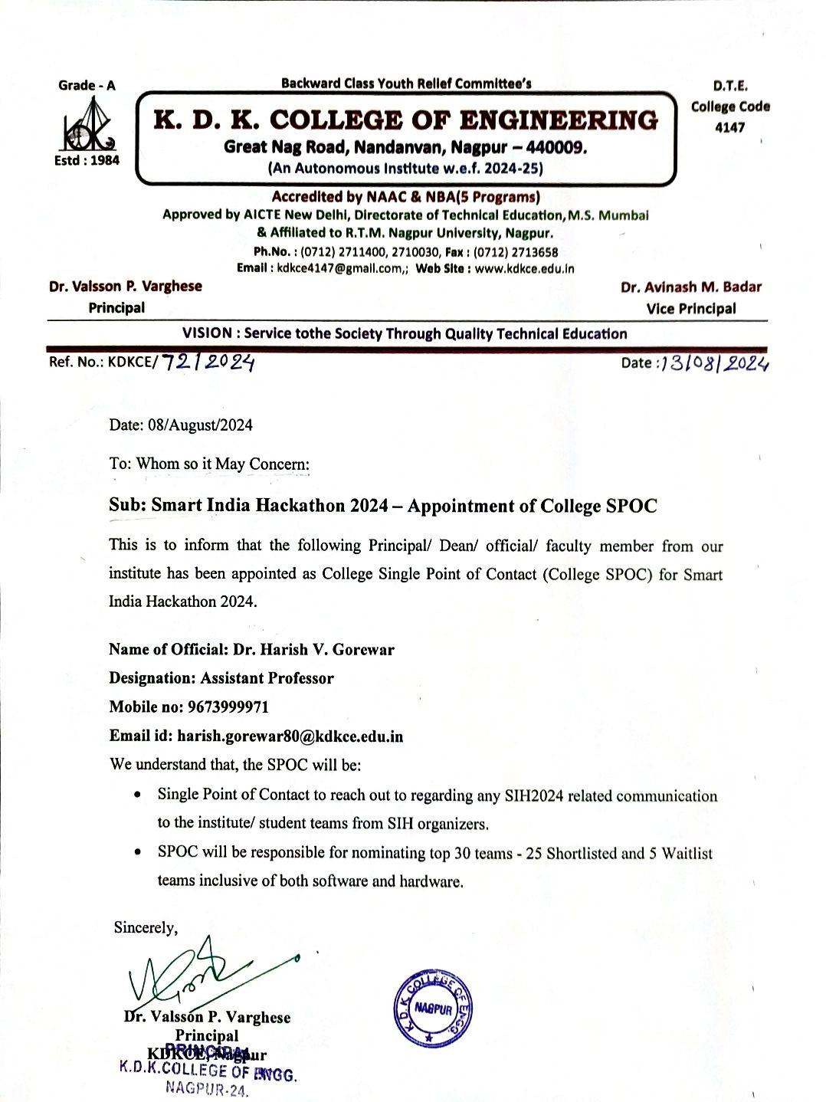

**Poster/Banner**

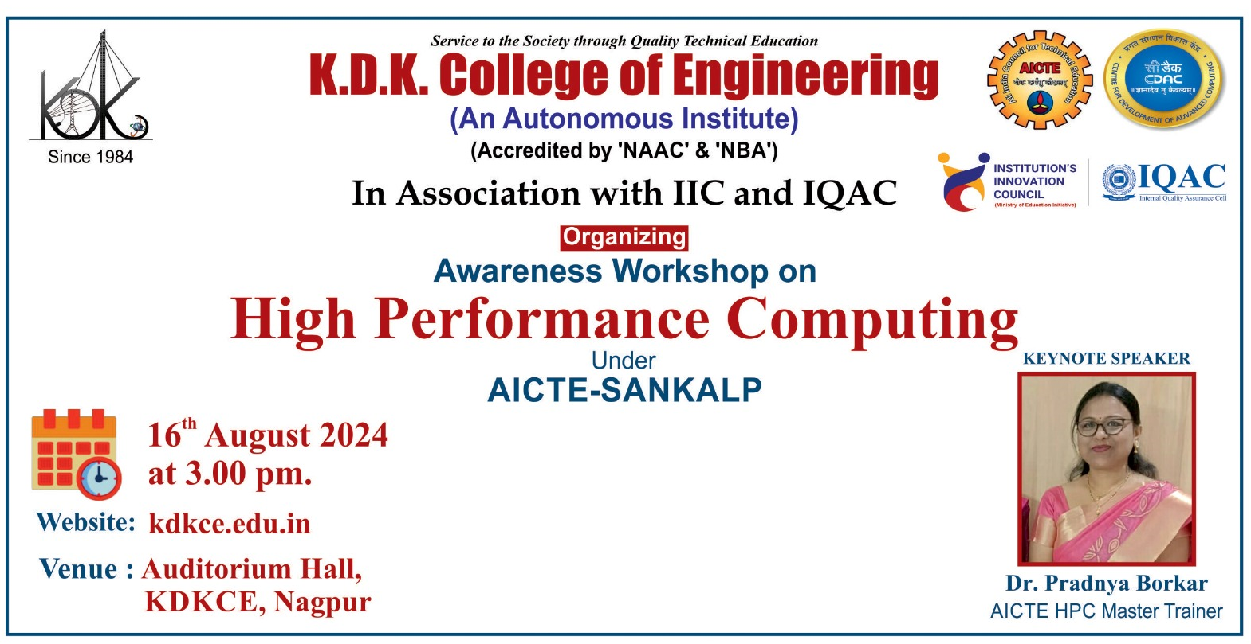

**Feedback Analysis**

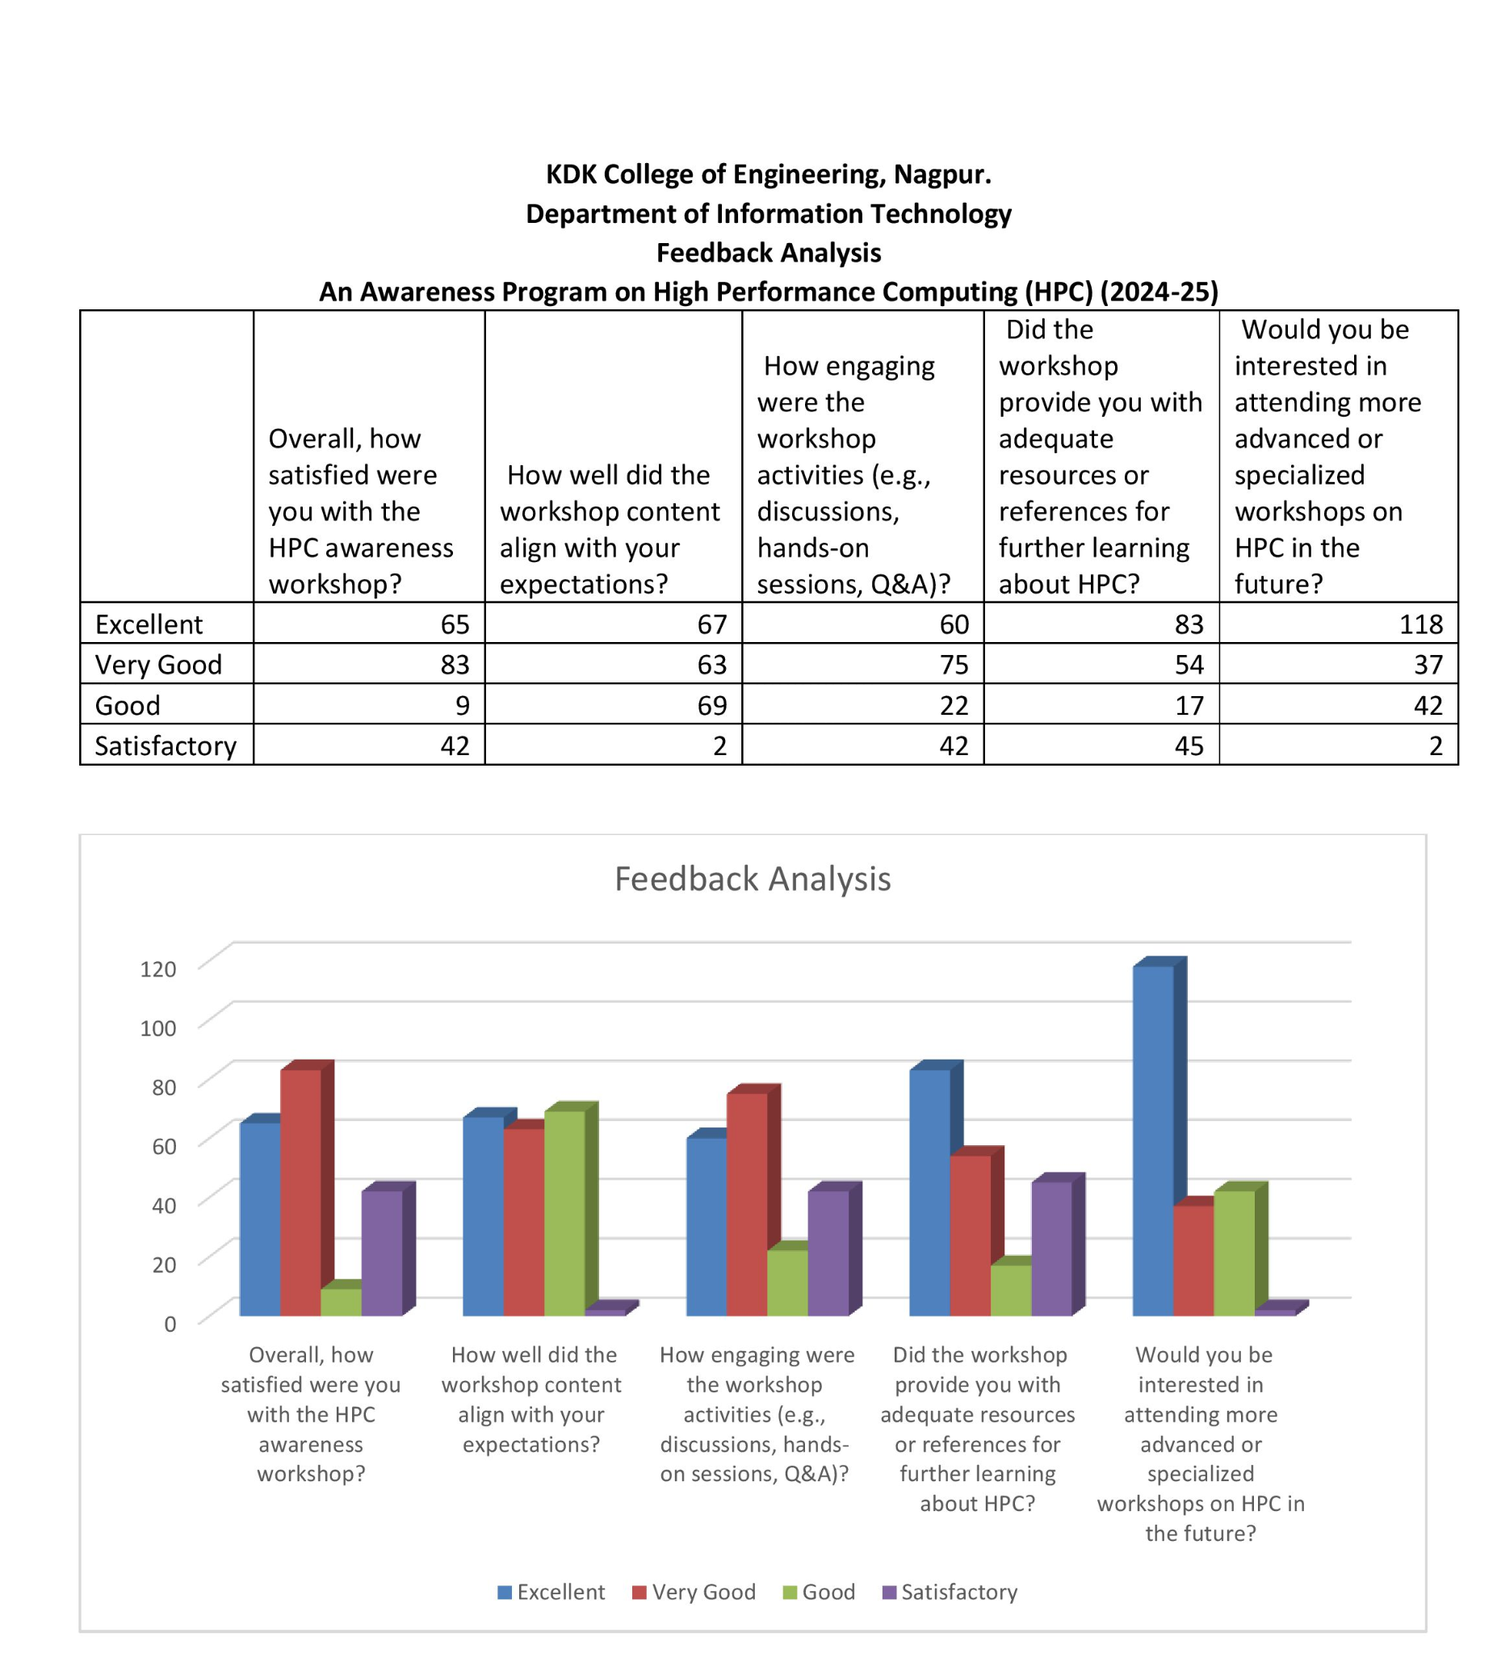

 

**Dr. H. V. Gorewar Dr. Mrs. S. P. Khandait   
 Event Co-ordinator (HOD, IT)**

 

**Photographs**

