Microsoft Office 2000®
Using Microsoft Office 2000 as a Front-End for BackOffice

Published: April 1999
For the latest information, please see http://www.microsoft.com/office

Introduction
Based on actual customer experiences, this document contains some of the technical aspects of Microsoft® Office 2000 deployment and deployment planning. This is a work in progress and will be updated as information becomes available.

This document details how Microsoft Excel 2000 was used to provide a solution for publishing sales information to end-users throughout a telecommunications company.

In Focus

Enterprise
A phone book company with listings in traditional hard copy, Internet, and CD ROM.

Network/Applications
Windows NT®-based servers/Microsoft Office 2000

Challenge
This organization focuses on its customer base through a decentralized model tailored to their customers’ specific needs. This decentralized model presents the challenge of creating an easy to use and fast reporting tool. This tool has the goal of proving information about sales results throughout the corporation.

Solution
Use the Microsoft Excel 2000 PivotTable® and PivotChart™ dynamic views to produce end-user customizable sales reporting tools. These tools provide end-users with the sales summaries of key areas on a daily and weekly basis. End-users will have the ability to drill down on the sales results of individual groups and sales persons.

Overview
Office 2000 provides the capability to develop solutions with familiar interfaces like Word, Excel, PowerPoint®, and Microsoft Access. Earlier versions of Office have provided users with the increasing ability to work with information from a variety of locations. Integrating information between a spreadsheet and a word processing document used to be difficult. Today, users drag and drop documents such as Excel charts, PowerPoint presentation graphics program slides, and word documents easily. Office 2000 takes this integration to the next level by providing a familiar interface to powerful BackOffice® applications, providing better solutions for integrating information into Office.

This document provides insight into the process of developing Office 2000 solutions that take advantage of its integration with the BackOffice family. You will learn about the following topics:

- Excel PivotTable views
- Access and Microsoft SQL Server™ 7.0 tables
- Accessing SQL Server 7.0 Online analytical processing (OLAP) Cubes

About the Enterprise
This document is based on experiences with the development of a solution for an Office 2000 rapid deployment customer. The project involved creating a solution for users to access information out of BackOffice-based servers using Office 2000’s native BackOffice features.

Business Problem
Management within the organization has no means of obtaining daily sales information. The current processes are non-standardized and involve manual assembly of this information on an individual basis. Most groups place this information on a whiteboard within the office. Summary information is obtained through clerks who provide it by fax or email. Users throughout the organization then manually assemble this information. The current system has the following challenges:
- There is no standardized system for reporting sales information.
- Frequent re-entering of sales information occurs at multiple levels, with each step introducing possibilities of errors in data entry.
The organization needs an automated process for posting sales information and making it available to users throughout the company.

User Roles
The following types of users have been identified:
- Sales Support Clerk– enters the information.
- Sales Representative – Provides Sales information.
- Sales Coach (Sales Team) – Needs access to details and summary of sales team.
- Regional Sales Manager – Needs access to details and Region Summary
- Regional Vice President (RVP) – Needs access to details and Summaries for all Regions
- VP Sales – Requires access to all data

Project Vision
Streamline the process of reporting daily call-in sales results within the sales organization.

Project Scope
- There needs to be a method for entering daily sales information into a central database.
- Salesmen need the ability to add/change/delete sales information within the current week.
- Sales information needs to be made available on a daily basis showing current day’s call-in results.
- Sales information needs to be provided for each sales representative organized by coach.
- Sales information should be organized in the form of daily sales results as well as a weekly summary.
- Coaches will need the ability to add/change/delete/move sales personnel.

Project Goals
The project’s goals focused on three major needs within the organization.
- Reduce effort involved in publishing sales information.
- Reduce time involved in publishing sales information.
- Share all the information throughout the organization.

Assessing End-User Requirements and Constraints

Assessing End-user Environment
Two user environments were identified. Sales and Management Sales users consist of the Sales Support clerks and Sales representatives. Management users are those needing access to detailed and summarized information at different levels. Each group has certain requirements and constraints that will be discussed below.

Sales Requirements
- Users need the ability to enter sales information for a day.
- Users need ability to change sales information for a day within the same week.

Sales Constraints
- All sales users have laptops and computers using earlier versions of the Windows® 3.x operating system with less capable 486 hardware.
- Not all desktops have 32-bit platforms.
- Users are limited to Microsoft Internet Explorer 3.x (recommended) or Netscape 4 (supported).

Management Requirements
- Users need access to summarized sales information.
- Users need ability to further analyze summaries to get details about different groups.

Management Constraints
- Not all managers have 32-bit platforms.
- Some users are limited to Internet Explorer 3.x or Netscape 4.

Assessing Server Environment
This project required two Windows NT-based servers. Since there were no servers available to support this project, two Windows NT-based servers were purchased and built, as outlined in the following sections.

Server #1: Database
This project required a database to store sales information. The information is to be in SQL Server 7.0 tables with requirements as follows:
- Windows NT Server 4.0
- SQL Server 7.0
- OLAP Services

What is OLAP?
OLAP stands for online analytical processing. This is a middle-tier service that provides data in the form of multi-dimensional cubes of information. These cubes of data are helpful in doing data analysis using the Microsoft Excel PivotTable and PivotChart features

Server #2: Web Server
This project requires a Web server to provide a Web presentation to users for two purposes: to allow users to review sales information without needing Office 2000, and to provide a Web data entry system that does not require the application to be installed on individual machines.
- Internet Information Server (part of Windows NT 4.0)
- Office 2000 Server Extensions

Why two servers?
To ensure optimal performance, business solutions that use BackOffice products should have the goal of having only one server dedicated to each BackOffice product. In the current project, SQL Server 7.0 and Internet Information Server (IIS) 4.0 were placed on separate machines. This plan also allowed for additional servers to be clustered and added as needed for the application change.

Planning and Implementing a Solution
Assessing project requirements revealed that, for several reasons, users did not have a clear idea of what was needed or feasible. First, the Sales users were novice users and did not have an understanding of basic computer operation. Second, there was a perception with the sales teams that the current manual system was adequate and did not need to be changed. The team therefore resolved to build a prototype to give the users an idea of what was possible. The following section outlines the pilot that became the template used for the solution.

Microsoft Excel 2000 Template models
The project began with a simple Excel workbook. This template represented what the Management users received, showing sales information for each sales representative organized by sales team coach. The workbook contained a worksheet for each day (Figure 1) as well as a summary for the week. A workbook was provided for each week of the year. This workbook served as the model for assembling the pilot project.
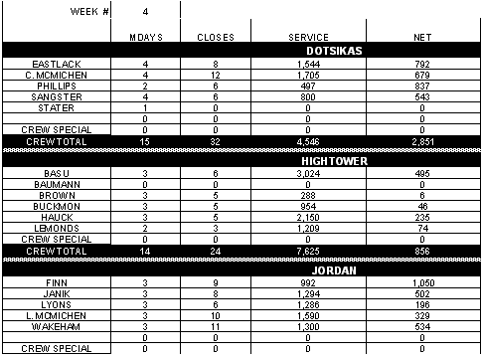
Figure 1: Organization Sales Information: Spreadsheet Example

Building the supporting SQL Server database
Using the worksheet shown in Figure 1, the team created a series of five tables representing the categories shown. The process of translating the spreadsheet into a series of database tables began with identifying of the primary purpose of the data: to display Sales information. From this starting point, the supporting tables fell into place. The following table shows the final design for the pilot.

Table | Field Name
Sales | * Week
 | * Year
 | * Day
 | Sales Day
 | Salesman
 | Sales Days
 | Closes
 | Service
 | Net Gross
Manager | * Email
 | FirstName
 | LastName
Employee | * Email
 | FirstName
 | LastName
 | Coach
Week | * Week
 | * Year
 | StartDate
 | EndDate
Day | * Day
*Primary Key
Table 1

Choosing the display interface
Excel was identified as the preferred interface for this project for two main reasons. First, users already were familiar with Excel and were comfortable with its interface. Second, the Microsoft Excel 2000 PivotTable feature enabled users to manipulate information for further analysis.

Providing sample data
To make the prototype as real a test as possible, sample data was created. To make it possible to regenerate the data on an as-needed basis, a project was written in Visual Basic® to provide this data. This choice allowed for easy adjustment of the table structure throughout the project. With each change, converting the data to the new data structure required at most only making simple code changes.

Sample data that has little variability does not provide a representative example of what might occur in the solution. For this reason the Visual Basic-based application used the RND function to provide random numbers for the sample values.

Linking Microsoft Excel 2000 PivotTable views to SQL Server 7.0 Tables
The next task was to generate the PivotTable views. The pilot explored three possible kinds of PivotTable views.
- Days of Week PivotTable views (Monday, Tuesday, Wednesday, Thursday, Friday)
- Salesman summary PivotTable view(Shows information by Salesman)
- Coach summary PivotTable view(Shows information by Coach)
The user can choose one of three ways to link data to a pivot table. First, if another PivotTable view is already linked to the desired data source, the pivot table may be linked to that PivotTable view. Second, a new pivot table may use a previously saved Microsoft Query. Third, the user may choose to link to an existing Data Source.

Linking PivotTable views to Data

Linking to External Data Source
The user sees the step 2 dialog box of the PivotTable and PivotChart Wizard when the External Data Source option is selected in step 1. The Next and Finish buttons will be grayed in this example, because the data has not been retrieved. To proceed, the user must press the command button labeled “Get Data…”, as shown in figure 2.
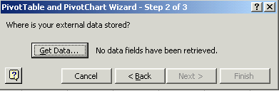
Figure 2: Getting data.

Linking to Database
A user may link to a database through an existing data source or by creating a new Data source (“Choose Data Source”). To link to an existing data source, the user selects the name from the list and clicks on OK. To create a new data source, the user selects “<New Data Source>” from the top of the list and clicks on OK (figure 3).

Figure 3: Choosing data source.

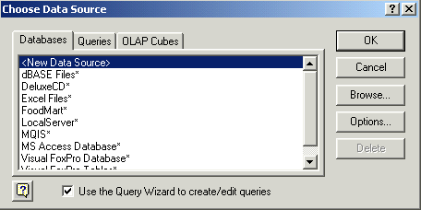
Creating a New Data Source
The next step in setting up a data source is to identify the type of database and name the data source. Notice that step 4 is disabled on the “Create New Data Source” dialog. It will remain disabled until the user provides the connection information by clicking the connect command button (figure 4).
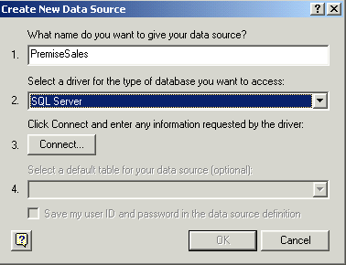
Figure 4: Creating a data source.

Providing Connection Information
The user is then prompted to enter connection information for the new data source. This dialog appears when the user clicks the connect button in the “Create New Data Source” dialog box. An expanded version of this dialog box appears by choosing Options. The Server drop-down list contains a list of the SQL Server database servers available. One may be labeled “(local)”, representing the SQL Server on the current. Enter the login id and password that provide access to the SQL Server rather than Windows NT Domain user name and password. Be sure to select the default database to use for this connection, or the default will be set to Master. See figure 5. Click OK to return to the “Choose Data Source” dialog box, then click OK to accept this new data source.
Figure 5: Providing connection information.

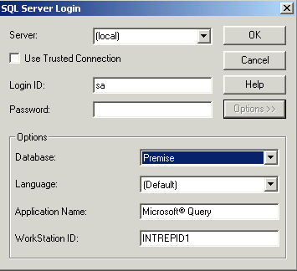
Choosing Columns
The next major Dialog that displays prompts the user to choose the columns to use in the pivot table. Many table names in the list on this dialog, which include Tables, Views, System Tables, and synonyms, may seem confusing and unfamiliar. Users may remove unnecessary categories by clicking the Options button and unchecking them. Use the command buttons to the right of the list to select the table(s) containing the columns to use in the pivot table (figure 6).
Figure 6: Choosing columns for pivot table.

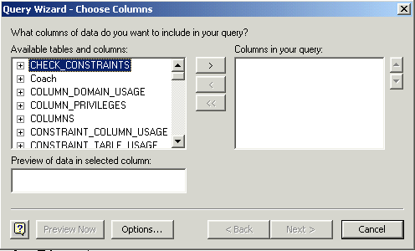
Filtering Data
The next dialog provides the user with the ability to filter the data returned. Users may select up to 3 columns to filter on. To make this dialog work, first select a column in the list box on the left side of the dialog. Next, select the type of comparison to make and the value. Filters may include all data matching any one of the filters or limited to the criteria in all or some combination of these choices. Use the “And” and “Or” option buttons to determine the best mix. See figure 7.
Figure 7: Configuring data filters.

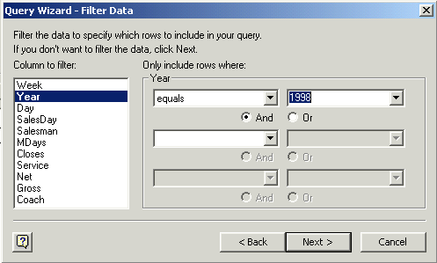
Determining Sort Order
The Sort Order dialog enables the user to have the data returned back in a particular sort order. Returned data may be sorted on 3 different columns, in either Ascending or Descending order, as shown in figure 8.
Figure 8: Determining sort order.

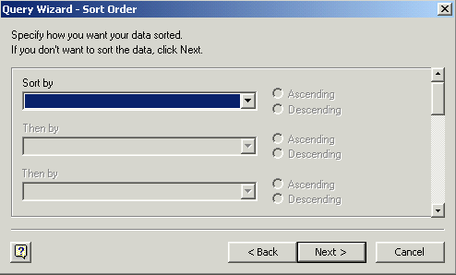
Finishing Data Retrieval
With all the decisions complete, the user now must decide what to do with the identified database information. It may be returned to a spreadsheet, or viewed, or the user may generate an OLAP Cube (see “Building an OLAP Cube” later in this document). Selecting Save Query permits the user to save the existing query for future use. Once the user has made a choice, clicking Finish completes the process (figure 9).
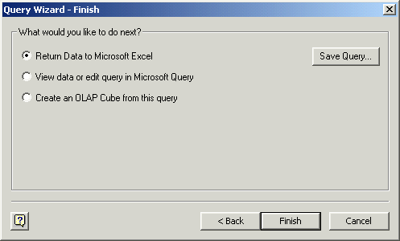
Figure 9: Completing the data retrieval process.

Linking to Microsoft Query
PivotTable dynamic views may be linked to a data source through the use of a pre-created Microsoft Query. Users may access the pre-created queries on their machine by selecting the second tab in the Choose Data Source dialog box (figure 10). By choosing a query on this tab, a user can bypass all the decisions needed to link to a database.
Figure 10: Using pre-created queries to link to a data source.

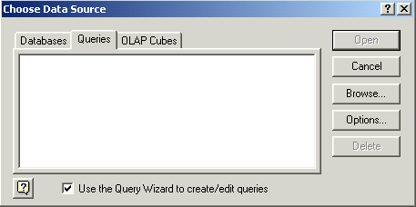
Linking to an OLAP Data Source
A user may link to an OLAP cube through an existing data source or by creating a new data source. To link to an existing data source, the user selects the name from the list and clicks OK. To create a new data source, select <New Data Source> from the top of the list and click OK, as shown in figure 11.
Figure 11: Linking to an OLAP data source.

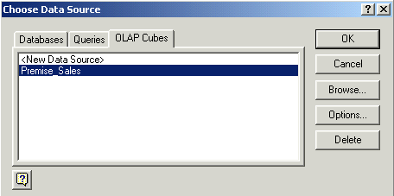
Creating a New Data Source
The next step in the process of setting up a data source is to identify the type of OLAP Cube and provide the data source with a name. Notice that step 4 is disabled. It will remain disabled until the user provides the connection information by clicking the connect command button. See figure 12.
Figure 12: Creating a new data source.

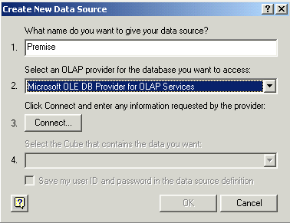
Setting up a Multidimensional Connection
A button labeled “Connect” appears on the “Create new Data Source” dialog box. After pressing this button, the user must either provide the name of the OLAP server or the physical location of the Cube file to use in the dialog box that appears next (figure 13).
Figure 13: Identifying multidimensional data source.

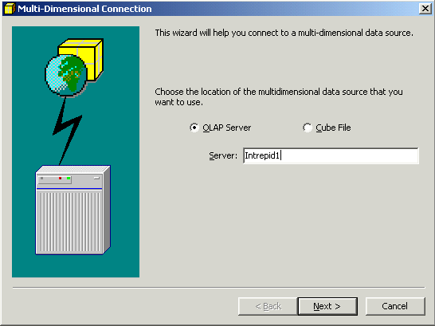
Identifying OLAP Database
Next, the user must select the name of the OLAP database on the Server that has just been selected identified (figure 14). Click Finish to complete identifying the OLAP database and click OK to finish setting up the OLAP data source.
Figure 14: Identifying the OLAP database.

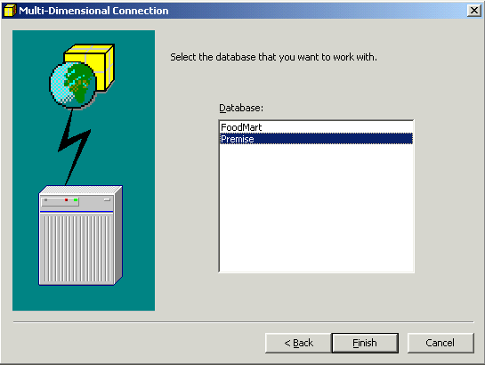
Linking to Microsoft Excel List or Database
A PivotTable view may be linked to rows and columns of information on a worksheet by selecting the range on the worksheet in question, then and clicking “Next” to continue (figure 15).
Figure 15: Linking to data in a spreadsheet.

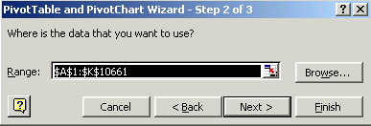
Linking to Multiple Consolidation Ranges
A PivotTable or PivotChart view may be linked to more than one range of information. To do this, select the “Multiple Consolidation Ranges” option. Figure 16 shows the first dialog box. The user is then prompted for the page field information to use for this PivotTable view. The page field defines the current location of the database information to be used.
Figure 16: Linking to multiple consolidation ranges.

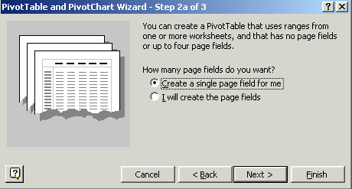
Single Page Field
The single page field option allows the user to select the range(s) where the data resides (“Create a single page field for me” option) shown in Figure 16. After the range has been selected, the Wizard generates a PivotTable view based upon this data. Figure 17 shows what this dialog looks like. Choosing this option allows the user to proceed without making any choices for setting up the PivotTable view.

Multiple Page Fields
The Multiple Page field option allows the user to identify which fields are available to the PivotTable view (“I will create the page fields” option). These fields will appear as choices under the Page combo list boxes at the top of the generated PivotTable view. To select the name to use, indicate how many page fields to use and type the names into the individual boxes labeled Field one through Field four (figure 17). The names entered into this combo represent the fields by which the user will be able to limit the data displayed in the PivotTable view. Entering more than one field will not provide the user with a selection of choices. Note that the range indicated in the “All ranges” list box has no relation to the fields entered into the field combos below them.

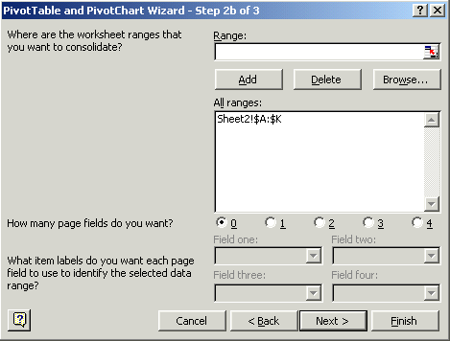
Figure 17: Identifying available fields.

Linking to PivotTable or PivotChart
When the user chooses to link a PivotTable view to another, Excel prompts the user with a list of the existing PivotTable views available. The user picks the desired choice and presses “Next”. Figure 18 shows what this dialog might look like.
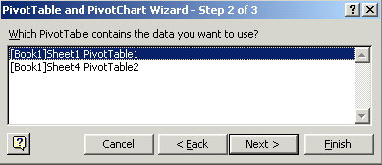
Figure 18: Linking a PivotTable view to another.

Building a PivotTable view
Formatting a PivotTable view (figure 19). The options button on the PivotTable Options dialog box shows a command button labeled Options, which permit the user to change the appearance of a PivotTable. A highlighted name appears at the top, showing the name by which the PivotTable view will be identified in code and in references to this PivotTable view. Changing the name in the text box at the top of the dialog will make it easier to distinguish between PivotTable views. Using the options on this dialog, users may add grand totals and other such formatting choices.
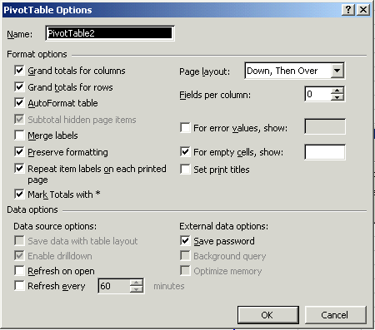
Figure 19: Building a PivotTable view.

Setting up Page Layout
The Page Layout option on the PivotTable Options dialog enables the user to change where the Page fields appear at the top of the PivotTable view. The default choice “Down, Then Over” places them on top of each other. This setting may be changed to “Over, Then Down” to place the page fields along the top of the PivotTable view. This change is useful for saving space at the top of the PivotTable view.

Data Options
The data options section at the bottom of the dialog permits the user to customize how the PivotTable view communicates with the data. To provide security for the spreadsheet, later users can be required to enter a password by unchecking the “Save Password” checkbox. The user may ensure that the data is up to date by forcing a refresh at open and/or a refresh at specified intervals.

Setting up PivotTable fields
Having already identified the source data, the PivotTable Wizard identifies the fields eligible for placement upon the PivotTable view (figure 20). There are four categories of fields: Page, Row, Column, and Data. The fields that may be added appear on the right side of the screen. To add a field to one of the four areas, drag and drop it into that area. More than one field may be added to any one area, and not all of the fields need to be filled for it to work properly. When all choices are made, click OK and then Finish to generate the PivotTable view.
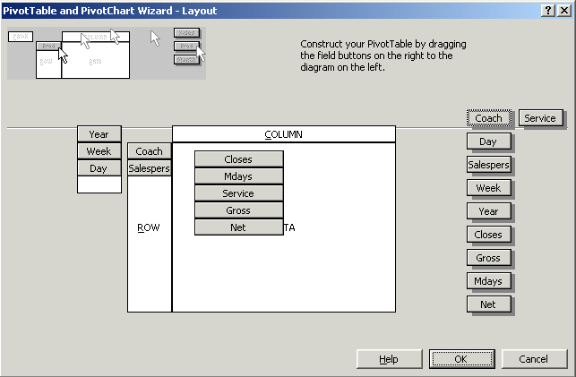
Figure 20: Setting up PivotTable fields.

Working with a PivotTable View
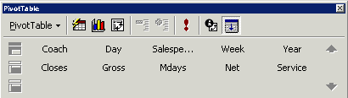
A PivotTable view has a special toolbar providing the user with the ability to modify its content and appearance (figure 21). The PivotTable Wizard may be accessed through the fourth button from the left. The content on the screen may be changed without the PivotTable Wizard by dragging and dropping the field into the PivotTable view or dragging one of the fields out of the PivotTable view. The second button from the left provides the users with a series of preset formats that the user may wish to apply to the current data. Data may be refreshed using the seventh button from the left. Users wishing to generate a PivotChart view from this PivotTable view may choose the third button from the left.
Figure 21: Modifying a PivotTable view with the PivotTable wizard.

Pilot Solution
For the pilot project, we built a series of seven Microsoft Excel 2000 PivotTable dynamic views, each on a separate worksheet. Five of the tables showed results for each day in a particular week, and two summary tables showed results for coaches and each employee. All tables used the data from the Monday pivot table (Table 1) to reduce required links. These linked pivot tables provided much of the desired functionality, enabling users to further analyze specific weeks, coaches and employees.
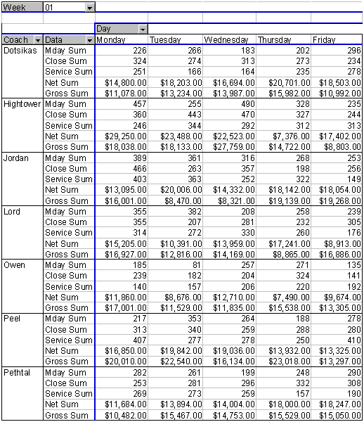
Figure 22: Linked Microsoft Excel 2000 PivotTable.
In summary, follow these steps to create a PivotTable view:
- Choose the DSN to use.
- Choose the fields and position them on the grid.
- Right-click the mouse on the generated PivotTable view to access properties.
- Rename the table to something appropriate in the properties dialog box.
- Use Format Report to change the appearance of the pivot table.
- Change field names on the PivotTable view to more meaningful ones (optional).
- If possible, link all other PivotTable views to the first PivotTable view to reduce memory usage and increase performance.

Setting up a SQL Server 7.0 OLAP data source
The linked Excel PivotTable views provided a workable solution but made further analysis more difficult. For this reason, we decided to build an OLAP data source cube from the Premise database. The process of creating an OLAP cube in an SQL Server begins with the SQL Server 7.0 OLAP Manager. DSS is not installed when SQL Server is installed and needs to be installed afterwards (for more information, see the tutorial provided with OLAP Services).

The pilot used a cube named Sales with six shared dimensions and six members. The structure of the cube was as follows:

Dimensions | Members
Coach | Sales Day
Day | Sales Days
Employee | Closes
Sales | Service
Week | Net
Year | Gross

Note
When creating a cube, make sure to add no more complexity than is needed for the solution, since each choice of dimension and member adds to the hard drive space used and memory required to support this change.

Creating a Pivot table using an OLAP data source
This section takes the reader through the process of displaying OLAP information in an Excel PivotTable view. Topics will include:
- Setting up a PivotTable view
- Creating a PivotChart view
- Formatting a PivotTable view

For more information: http://www.microsoft.com/office/


Use standard white paper © 1999 Microsoft Corporation. All rights reserved.
Microsoft, BackOffice, the Office logo, PivotChart, PivotTable, PowerPoint, Visual Basic, Windows and Windows NT are either registered trademarks or trademarks of Microsoft Corporation in the U.S.A. and/or other countries.
The names of actual companies and products mentioned herein may be the trademarks of their respective owners.

