Microsoft Office 2000
Customizing Help Files, Alerts, and Dialog Boxes

By Joel Ware, IV, Boeing Company—Seattle, Washington

Published: April 1999
For the latest information, please see http://www.microsoft.com/office/

Introduction
This document is about customizing your deployment of Office 2000 by adding local content to the Help and technical support info. You will find information about why, what, and how to customize, and how to deploy the resulting code to your users.

In Focus

Enterprise
The Boeing Company is a large, multinational Fortune 100 manufacturing and systems-integration company, located mostly in the United States, with about 200,000 desktops, mostly Pentium-based.

Network/Applications
The network contains servers running the Microsoft® Windows NT® 4.0 Server operating system. Desktops are predominantly Windows® 95 with some Windows NT 4.0 workstation. Microsoft Office is predominant, with many desktops supported with server-based software.

Challenge
To deploy Office 2000 in a way that will direct all users towards internal support resources first.

Solution
The Boeing Company plans to deploy Office 2000 with a customized Help file and menu, and dialog box content that will direct users to internal support resources when they need assistance.

Overview
Boeing is a large, diversified manufacturing and systems integration firm, with over 200,000 employees worldwide. Most employees work near one of five or six major sites in the United States. Long considered a leader in networking, the company sites are well connected with a high-speed TCP-IP-based LAN/WAN. Most knowledge workers in Boeing have a recent model desktop computer, mostly Pentium-based.
Like any large organization considering an enterprise-wide software deployment, Boeing has a number of issues to consider for its Office 2000 project. Based on past experiences, Boeing has worked out a plan that achieves numerous goals such as increased productivity and reduced cost. This plan includes customizing Office 2000 in a number of ways, which are described in detail in this chapter.

Office Deployment and Total Cost of Ownership
Boeing management has made the reduction of the Total Cost of Ownership (TCO) a key goal for computing support organizations, including those in the Shared Services Group (SSG), which provides internal IT / computing support, and in other business units with local IT organizations. Very challenging goals have been set under the banner of “better, faster, cheaper,” including a 50% reduction in overall computing cost.
Boeing has previously been slow to deploy new technology on the desktop, due to the perceived high deployment and support cost. For example, the company adopted Office 97 as a “standard” in April 1997 but now plans for full deployment to continue well through mid-1999. The actual deployment in several major business units, including Commercial Airplanes and Support Services groups, was delayed by a lack of adequate hardware platforms on the desktop. Removing this hurdle required large-scale desktop upgrades to Pentium machines running Windows 95.
Support and deployment costs are thus issues that need to be addressed by the teams working on Office 2000 deployment. One part of the TCO equation is support for problem diagnosis and resolution—getting help to end users. Although the costs for this area are not as readily apparent as acquisition costs, they are quite significant, as they include lost user productivity as well as the direct cost of diagnosis and resolution (estimated at over 50% of the overall labor cost of the workstation, aside from customer losses). Reducing these costs is the primary business problem addressed by the customizations shown in this chapter.
Boeing has a clear mandate from customers and management to reduce the number of lost workstation hours (LWSH) for end users. Actual hours lost by end users can be reduced, first, by making the hardware, operating system, and software more reliable and, second, by improving service restoration operations to make them more timely and accurate (fewer “second fixes” or “chronic problems”). The Office application suite allows Boeing to influence both of these aspects, but in this chapter we focus on the latter—improving Help and information resources available to end users at the point of use so that they can be more productive.

Internal Support Resources
Support costs for problem diagnosis and resolution—getting help to the end users—include several elements. Boeing has historically been able to reduce these costs by centralizing the “Help desk” support resources (now known as the CSRC, or “Central Service Response Center”). Under this scheme, most Boeing users have one easy-to-remember number to call for help: For example, 555-0911 works in all of Puget Sound (there is some variation by site). Boeing has found through reliability workgroup studies that when users call on other help resources, like peer consultation, or calling Microsoft directly, costs for problem diagnosis and resolution escalate. Studies have shown that getting a direct and accurate answer to a user question can be one-tenth the cost of leaving the question unresolved or of using informal means of problem resolution.
Thus, Boeing has a policy to direct users to call the internal support resources first. In the effort to minimize productivity losses, there have been multiple corporate education initiatives over the past few years designed to encourage users to call on the centralized internal resources. Losses avoided by this strategy include “cascaded productivity loss” from users calling on other users for peer support, lost time in calling Microsoft PSS and being redirected internally, and time wasted in searching for a support resource.

Internet Downloads
Boeing Corporate Computing Security (CCS) enforces a policy that prohibits users from downloading from the Internet. Instead, users can download software internally, which means that costs are minimized, and Boeing can control availability, location, and response time.
Downloaded software causes unplanned and uncontrolled local variations in software configurations. Support costs also escalate when software configurations have local variations. A very important part of the TCO equation for Boeing is the extra support cost for problem diagnosis and resolution for non-standard configurations. Reducing this cost by limiting variability in the desktop application platform is the general goal of the ongoing company product standards effort, and a big part of that effort is to discourage the uncontrolled deployment of software. There are also issues with licensing agreements in some cases that can cause additional costs to accrue when non-standard items are used.
Since Microsoft Office has several Web links which lead the user to downloadable software, there is a strong corporate mandate to either (on a link-by-link basis) disable these links, or (preferably) to redirect them to a download resource inside the Boeing Company. To minimize user frustration, the latter scheme is our general choice in the Office suite.

Disabled Direct Customer Registration
Additional desktop costs accumulate when individual users waste otherwise potentially productive time by registering their copies of Office directly with Microsoft. There is no need for Boeing users to register their software, since software registration is already accomplished through a master contract.
Individual user registration of software packages also has the distinct business downside for Boeing that the names and addresses captured in the process will be used for marketing, and that additional mail and phone calls will come in for the employees who do register their software. These non-productive phone calls and physical and electronic mail waste users’ time and reduces their potential productivity. To resolve this, Boeing decided to disable all user-registration hooks in Office prior to internal Boeing deployment.

User Roles Within the Enterprise
For a customized deployment as large as Boeing is undertaking, it is important to define tasks and the resources within the enterprise that will perform those tasks. The following sections briefly describe the groups within Boeing and the contribution that each is expected to make. Groups within Boeing fall into three main categories: central groups that handle their respective tasks across site boundaries, that is, enterprise-wide; site groups that handle their respective tasks within their sites only; end users who handle their tasks where they are.

Central: Technical Services Product Managers
The Workstation Software Technical Services group is the nexus of desktop software product management activity for Microsoft Office and other desktop software products. A team of a half-dozen senior technical people, known as “Product Managers,” performs this function for the components of Microsoft Office. This team is responsible for requirements, vendor interface, product evaluations and recommendations, and product support, including third-tier problem diagnosis and resolution. These are the company experts for the Office product. This group brings together the customer requirements with the expertise to tailor the product and develops the customized Office product. This group has the ultimate responsibility for Office product definition within Boeing.

Central: Server Administration
The Central Server Administration (CSA) group is responsible for setting procedure policy (including server installation/maintenance, emergency planning, backups, and scripts) for the administration of all supported network servers. This group also administers the company-wide network of Software Distribution Depot servers. In the deployment of the Office product, the CSA group maintains the systems and procedures that are used to establish and distribute the Boeing-customized master copy of Office.

Central: Help Desk Support
The Central Help Desk group (known as the CSRC-Central Service Response Center) is responsible for full problem-diagnosis and resolution (first and second level) including direct resolution or ticket dispatch to outside vendors. The CSRC is involved in Office customization by providing call history and trends that may point to needed custom content, and concurring on Boeing-customized Office content.

Site: Server Administration
The Site Server Administration group is responsible for implementing policy and procedure for the administration of all supported network servers. This group also administers the site-level Software Distribution Depot server at their respective sites. This group propagates the Boeing-customized Office product to end users, and may develop local variants or customizations as driven by local customer requirements.

Site: Support Work Cells
The Site Support Work Cells are responsible to the end users for workstation configuration, relocation, and first-level problem diagnosis and resolution. Workers in the Site Support Cells actually perform Office installation on customer desktops and may participate in problem diagnosis/resolution. They may also identify requirements for new custom content and are responsible for applying software updates, including service packs, bug fixes, or custom content.

End Users
Boeing end users are responsible for establishing requirements, scheduling installation and migration activities, using the Office software, and reporting problems. Boeing end users include workers from all functional areas and business units throughout the company. Some of the functional areas served include “Define” (formerly known as engineering), “Produce,” “Sales and Marketing,” “Finance,” and “Customers” (formerly the Customer Services Division).

Project Vision
In customizing Office 2000, Boeing’s vision is:
- One version of Office
- Enterprise-wide customized deployment
- Customers using internal support resources

Project Scope
- Customize Office to suit customer procedures and preferences

Project Goals
- Identify content that needs to be customized
- Develop custom content that will work for most customers
- Review content to validate applicability to customer sets
- Deploy content

Assessing: Deciding Whether to Customize or Use As Shipped
In a global sense, it is surely hard to improve on such a thoroughly-engineered product as Office. But in a local context, there may be good solid reasons to “tweak” the package a bit, which we’ll consider below. Boeing has decided to customize Office 2000 to reduce support costs in several key ways. First, by directing customers to the right support help resource the first time, the first call should be a good one. Second, for Boeing-specific problems, Boeing-specific content is provided in addition to the generic content included in the Microsoft Answer Wizards.

Benefits and Considerations of Customizing

Benefits
A major benefit of customizing is that the package can be made to fit unusual user requirements better. Making the package fit unique user requirements reduces users’ confusion in certain task performance. The result of this is greater productivity and more effective job performance and, hence, lower total cost of ownership (TCO) of the package. TCO is the cost side, and it can be decreased, and the productivity benefits increased, by getting the user better task support and help guidance. In brief, the benefits of a customized deployment are that it:
- Fits requirements better
- Reduces user confusion
- Reduces TCO

Considerations
Customizing is a great idea in many cases, but it is not without its costs. The following considerations should be kept in mind when deciding whether or not to customize in your particular case. The customizing considerations are:
- Customization requires resources. These resources must have significant product expertise, time and other resources. Doing it right will cost some money up front, even while it saves money in the longer run. Like any software development process, it should start with requirements, and lead through to design, coding, validation and verification and implementation—trying to short-cut and skip some steps is false economy.
- Once the custom code is developed, it must be delivered to the end user. This means it must be integrated into the distribution source and distributed, using one or more of the plans detailed later in this chapter. This requires some degree of planning and organization, when compared to allowing users to order their own vanilla retail distribution media direct from Microsoft. However, this is a relatively minor consideration for organizations that already maintain a central software distribution source.
- The customized product does not agree perfectly with published commercial documentation, in some respect. If the differences are immediately apparent to the end user, special custom content may also be required for the users of the customized product.

In brief, then, a custom deployment:
- Requires significant product expertise
- Takes time and other resources
- Requires distribution of custom content
- Is not as documented in trade press/tech docs

Benefits and Considerations of Using As Shipped

Benefits
Using the product “as-shipped” has some definite advantages. For one, it is easy to deploy the product—getting copies for the users of the commercial CDROM is sufficient. Another advantage of “vanilla” deployment is that the product will match any commercially available documentation the end users happen to run across.

Considerations
A major consideration of using the product “as shipped” is the fact that it does not work as well as it might for your users. Despite thousands of hours of development effort, Microsoft has not foreseen everything your users might need to see in their Help files, and they may not have explored all the pathways. There are some “blind alleys” in the Help subsystem that can be fixed to save frustration for your customers. You can discover these by over-the-shoulder observations, analysis of Help desk logs, or other means.
In other cases, specific product defects will be discovered over Office 2000’s lifecycle. As workaround / problem avoidance information becomes available, you can use the customizing capability of Office to add Help content that specifically helps users avoid or recover from these problems. If you have a way to readily distribute corrections mid-cycle between major deployments, then this is a viable stopgap until Microsoft can ship a corrective release of the code.
A final CON of “as shipped” is the lack of a local touch—if the users can find some identifiable Boeing custom content in the product, chances are good that they will feel a stronger sense of affinity for the product, and thus greater satisfaction from using it. This may not be a completely rational process, but it is real nonetheless. For many users, local content is a real plus. For Boeing, then, the cons of using Office 2000 as shipped are that it:
- May lead users down blind alleys
- Does not work as well as it could
- Does not have Boeing familiarity

Planning for the Future
Boeing has been planning for Office 2000 since before the Office 95 deployment. We try to predict the lifecycle of the product that we are deploying and inform our customers accordingly. This helps us to define how much effort needs to go into engineering, designing, and deployment of the new product. In the case of Office 2000, we expect the lifecycle to be about eighteen to twenty four months from initial availability.
Mid-cycle change is expensive, both for the internal support organization and for the end user, so there is a substantial incentive to aggregate changes into packages (known as “blockpoints”), and also to “do it right the first time.” The end user suffers the greater impact from a mid-cycle change because of the workstation touch and document conversion activities that may potentially occur in addition to the simple disruption of the user work environment. The impact for the support people is that, first, the central software distribution resources need to be updated and tested, prior customizations need to be cataloged, reassessed (possibly re-engineered) and reapplied, and, second, the new software needs to be distributed. The distribution activity does, as shown in Chapter 1, encompass several phases. These phases of distribution include: server-based software schemes (e.g. S3), Windows Terminal Server, direct install from the Software Depot Server, and customized Boeing distribution CD-ROMS.
Based on prior experience, we expect two major updates to the Office 2000 package, spaced at roughly 6 to 9 month intervals. Using our newly implemented desktop blockpoint procedure, we expect to deploy both of these releases separately using the steps above.
Assuming now that you have made the decision to customize your Office 2000 package, you should think about the planned lifecycle of Office 2000 in your company to make sure that your customization plans support those plans. In The Boeing Company, we are now pursuing a two-pronged strategy for early adopters as part of our RDP program.
The first deployment is planned as a small pilot project of 2000 desktops, with about half the users running from servers (RFS), and about half the users using a local installation. Both groups will install from a specially designated distribution server. Results will be measured for both groups, including problems encountered, resolution time required, and customer satisfaction levels. At the end of the pilot, the results will be studied and future deployment plans established.
This will give Boeing an opportunity to revisit customization issues and actual in-service performance in a structured manner, and incorporate lessons learned in future phases.
Both prior to and during the study, Help desk (CSRC) personnel are consulted regarding the support implications of Office 2000 and the specifics of custom content that is used in the study. One element of this consultation is to build custom content that will last the expected life of the product, if possible, in order to avoid a mid-cycle software update requirement. This implies the need for stable and global decisions on Help desk and other support policies and resources, since a significant policy shift or change in support responsibility could trigger a change in a Help page. Using the techniques discussed later in this chapter, however, even unexpected changes like this can be handled easily.

Why Customize?
The reasons to customize the Office product vary between customers, but they all boil down to one of two categories: general product improvement, or tailoring to suit local conditions. Both are done here at Boeing, with a strong emphasis on the latter.
Let’s take three examples from Boeing’s Office 97 and Office 2000 customizations to show the local conditions type of customization:
First, consider Product Support. At Boeing we have a Select Agreement for enterprise usage of Microsoft Office that does not allow for users to call directly into the public PSS (Product Support Services) number for support. Of course, the internal Help info in Office directs users to call PSS. So this item is customized in order to reduce user frustration when searching for help in problem diagnosis and resolution. Figure 1 shows the Boeing customized Help page for Office 2000.

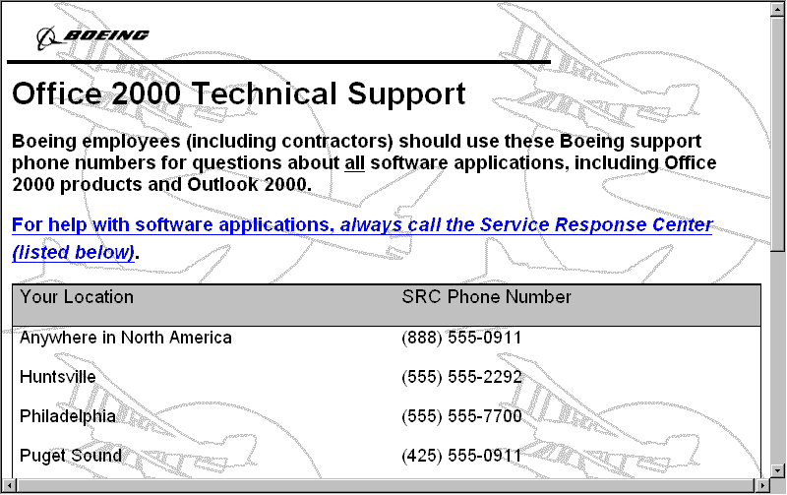

Figure 1: Customized Help page provides Boeing-specific information.
This customized page contains Boeing-specific information, including phone numbers to call for help.
In the second example of customizing for local conditions, Boeing removed Outlook® messaging and collaboration client from the Office 97 deployment package due to interoperability considerations. This requirement was coupled with a request to change the default on “WordMail” (using Microsoft Word as the default e-mail editor) to “OFF,” due to performance and reliability issues. What we do about Outlook and WordMail in Office 2000 is yet to be determined, but a two-phase deployment of Office and Outlook appears to be a strong possibility.
The third customization requirement came from users who have a restricted view of the Internet. These users have Internet access restricted by US Department of Defense/other government regulation, or corporate policy. In many cases, they cannot access any external sites at all—their “surfing” is all on their intranet! They clearly have no use for links in software products that lead to vendor Web sites on the public Internet, which are perpetually and frustratingly inaccessible. Figure 2 shows the intranet site dedicated to Office 2000, which these restricted users can access through redirected links within Office.
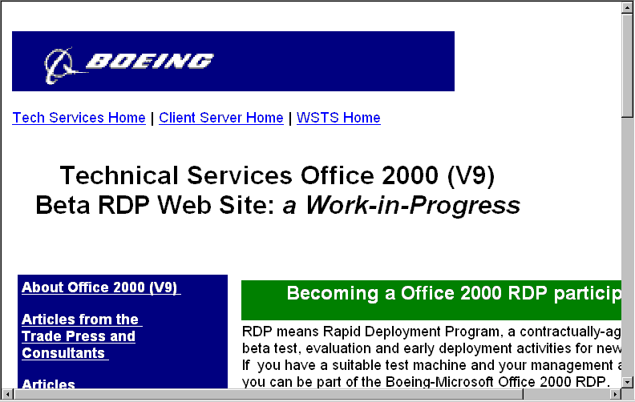

Figure 2: The Boeing intranet site for Office 2000 users.

The Collaborative Process
Boeing is made up of several divisions, and it is important to collaborate when considering a software deployment. The Information Service Directors (ISD) for different divisions appoint division representatives who collaborate weekly with a conference call, as well as through postings in a public Exchange folder.

Developing Consensus on Customizations
Boeing has learned through previous software deployment projects that if you don’t get enough people involved, or if you get the wrong people, you do not get an accurate representation of the customer base. This results in the consensus findings not being acceptable to management or users. If the team doesn’t represent a diverse enough group, the solution will ultimately be rejected.
When considering how and where to customize Office, it is very important to reach a cross-section of the intended customer base, get their opinions, and try to achieve consensus. Those who ignore this step do so at their peril—if the users are surprised with the new Office configuration, they will likely make their displeasure known rapidly and vociferously.
Developing a cross section of customer opinion, forming a team, and bringing that group to consensus are very people-oriented and political activities. As such, they take time. Be sure to allocate enough time for all the key steps, which are:
- Identifying the Key Customer “Opinion Makers” and “Decision Makers”
- Forming a Team of Key Customer Representatives
- Developing a Consensus Recommendation
- Presenting the Recommendation for Approval at Standards Teams
The team considering software customizations is made up of “Opinion Makers”. Opinion makers tend to be power users who show an interest in new software. An opinion maker is not a volunteer and must receive approval from management. These users are good communicators and software testers, and they aren’t shy about communicating what they do not like about a customization.

Resolving Conflicts
Conflicts between groups are a fact of life, and conflict resolution and mediation are a whole life’s work. In most cases, though, resolution is achieved when a group decision is made, by voting, if not by consensus, or when, as a last resort, management dictates the decision. Genuine differences in requirements that are truly inconsistent can be accommodated by multiple released versions—but beware of the potential for proliferation of versions. One Boeing campus that tracks such things actively supports literally hundreds of “standard” supported desktop software configurations.

Planning and Design
In the Planning and Design phases, you will need to consider many different factors to arrive at a good, well-engineered custom solution for your users. You will have an opportunity to use your knowledge of the problems faced by your users, together with your knowledge of the product and the business constraints in your company to decide what to customize and make it suitable for your users.

Planning: Choosing the Items to Customize
Choosing the items to customize is a key phase, perhaps the most important single phase, of your custom development project. In this phase, you will make choices on your customers / users’ behalf as to which potential custom items bring the greatest value in terms of usability, and cost avoidance. You will need to consider the case for and against each individual customization, including the cons, and estimate the effort involved to perform and to sustain or maintain the customization. Only then can you, and your users, make the critical decision of what stays “as shipped” and what gets customized.

Largest Perceived Value
The key to choosing customizations is to go for “bang for the buck.” Choosing the right items to customize, and doing it well, can save your company significant money in support. Conversely, choosing poorly can waste development money, time, and other scarce resources.
The items to choose first are clearly those that the user uses more frequently, for more critical functions, or in times of stress/confusion. You should also choose items that various folks, including product specialists, installers, reviewers, Help desk personnel, end users (or their management) have identified as troublesome, confusing, misleading, or counterproductive.

Process Oriented
Choosing to customize an application such as Office 2000 is very process oriented. The process begins with reviewing pre-existing policies and procedure already in place for Boeing.

Policy requirement
Many policies at Boeing, such as the no downloading from the Internet policy, dictate much of what needs to be customized in Office 2000. For example, Boeing has strict computer virus policies and procedures that required us to consider customizing the macro virus alert dialog box in Office. Other policies such as software distribution, laptop installations, and support call policies lead to further customization considerations.

Lessons Learned
Boeing has learned through experience what is worthwhile to customize, and what can remain unchanged. Customizing Office 2000 makes the package more suitable to end users and reduces the dead ends that they run into. An example of this is when Boeing decided to customize the Word Help file in Office 97. Instead of pointing to Microsoft Help on the web, this was customized to point to a Boeing specific Help page on an internal Web. As a result, there were more hits on Boeing support web pages (which we know means less support calls).

What Boeing Decided to Customize
At Boeing, we chose to customize several items on the Office 97 package as we released it. Boeing is customizing these items, plus a few more, in Office 2000.
First, we identified the “Help About / Tech Support” menu (which in Office 97 uses PSS8.HLP) and wrote a new Help file for that to redirect users to our internal support numbers. This Help file actually formed the basis for corresponding modifications in Office 2000. Second, we removed the “Help - Microsoft on the Web” menu items, and added two items that directed users to internal Boeing Office 97 support sites. Again, these modifications transitioned smoothly to the Office 2000 environment. Third, we redirected the HOME and SEARCH icons and the default Web browser, by installing a modified Internet Control Panel. These items also are reflected in our Office 2000 modifications.
Having identified some items that you see a policy or business reason to modify, and having reached a decision on likely content, you are now ready to do some customization. At this point, consider the scope of the intended modifications, the maintenance that will be required, and consider which of the modifications will really bear fruit in a financial sense over the life of Office 2000 in your company. Look at the benefit from improved user productivity, and reduced support cost, but also look at the costs of development, control, distribution, and maintenance. Consider the resources you have available, shelve those modifications that don’t make the critical breakeven cut, and proceed now to Design.

Design: Developing Your Custom Content
Design is the most creative phase of your customization project. In this phase you will make the critical engineering judgment calls that decide many factors, including how the custom material is presented, where and how it is hosted, and how it will be maintained.

Designing for Usability
Many good applications fail because of simple usability issues. We were careful to build good usability into all custom modifications. For some modifications, you may need to consult a usability consultant or human factors specialist. Full treatment of usability is a subject for multiple books, plus many years’ study and experience. Boeing’s years of experience have yielded the following Rules of Thumb for usability, based on what works well for Boeing.
- Be consistent with the rest of the application and the host platform
- Order items logically: Alphabetically or numerically
- Limit the number of choices or items at any one level
- Provide multiple paths to reach any item of information
- Use common, understandable, consistent terminology
- Use high-contrast, but not alarming, colors

Designing for Maintainability
Like all deployed products, customized products must be maintained in the field, over a span of time that will include multiple maintainers who will have limited access to training and documentation. The maintainers will not have access to the full toolset used to build the customizations, and they will not have as complete a knowledge of the product and the customers’ requirements. This fact raises several issues that should be addressed under maintainability:
- Documentation: Use self-documenting code whenever possible, by embedding substantial comments that show the intent and method of the code. When that is not feasible, embed or attach at least some documentation as close to the point of modification as possible. Remember that a small README or Help file can go a long way towards answering key questions.
- Robustness: Use code that will react to invalid input gracefully. Always take the extra time to check inputs for range / validity. Why is this a maintainability issue? It can simply be a matter of deferring maintenance after an environmental change. Code that fails gracefully can be tolerated for a long time, but code that causes the application to die a spectacular fiery death cannot have its maintenance deferred.
- Generality: Location and platform independence. Avoid hard-coding a location or a server name or a path name whenever possible. When choices are available, take the path of cross-platform compatibility, and interoperability between release / version levels. These choices can save you a lot of money later on when the interfacing system(s) change.
- Assume maintenance by a complete stranger. You can reasonably assume nothing about the background and experience of the maintainer of your code. You need to document everything as if the maintainer were born yesterday. In Boeing practice, we document the key decisions about the product configuration with technical implementation details in a “Design Document” and issue that document to the organizations that will be deploying the product in the field.
- Use most general possible solution. Use solutions that work for the widest range of hardware and software platform possible. Boeing needs to consider desktop users, users on Terminal Server, and mobile users.
- Create a gateway Web site to hide change. If you need to embed a Web address (URL), consider creating a gateway site as the logical entry point, and make sure that you have a long-term commitment to the availability of the domain name and the server (i.e. for the lifecycle of the product being supported).
- Use a high-level Web address as entry point. When you do embed Web addresses, use as high-level an address as is possible: for instance, use http://xyz.com/help instead of http://xyz.com/isdept/HELPDESK/VINNIE/OFFICE/OFFICE2000/OF2K.HTM.
- Use Web redirection if change is required. If the worst happens, and you lose your anchor Web site, try to negotiate with the new owner for a skeleton Web page with an automatic redirect to keep your customers from dead-ending at the old site. Most Web server managers will agree to this, if only on the basis of self-interest, because it reduces inquiries from disappointed customers who get a “404” return looking for Web pages that no longer exist there.
- Avoid dependency on directory structure or backend details. Avoid Web addresses that have embedded parameters or elements that rely on a particular scripting language, Web server technology, search engine, or other infrastructure element that could change during the product lifecycle. Observing this point will make it possible to change your Web server infrastructure dramatically without changing the code on your Office desktops, which is a very good kind of flexibility to have available to you.
- Keep a list of what was changed and how.

Customizations
The following sections describe customizations that Boeing explored for its Office 2000 deployment project. Some of these customizations were rejected for Boeing-specific reasons but are presented nonetheless for the value they might bring to another organization.

Examples 1 and 2: Redirecting Tech Support Calls to Internal Helpdesk
The first case that we will show as an example of customization is a simple matter
of redirecting support calls from a set of Microsoft PSS numbers to telephone numbers and Web resources that are supported by the Boeing CSRC (Help desk).
This means two things to end users: First, if they access the Help About Tech Support menu item, they will be directed to Boeing resources immediately.
Second, if they ask the Answer Wizard / Office Assistant a question like “Where should I call for support?” the answer will direct them to the Boeing Help desk (CSRC). This is a simple demonstration of the immense power of customizing the natural language capability of Office using the Answer Wizard Builder.
The natural language questions used in this context should reflect local knowledge of what actual users will ask when the product is installed in the field. The key is to choose the answers carefully based on your users’ terminology and experience.
Future maintenance of these answers can also be based on service-desk experience, and built from FAQ lists as they accumulate. This will help reduce the product support cost and improve user productivity over its lifecycle.

Customization Pros and Cons
The case for this customization is that when customers access Help and try to find technical support, it would be completely inappropriate to use the product as Microsoft shipped it. Due to our current Select licensing agreement, our Boeing users literally cannot get any help from the standard public PSS (Product Support Services) phone number. PSS analysts will know this immediately when they check the product ID info. This event, wherein the Boeing customer needs product assistance, calls Microsoft PSS, and is denied help is quite frustrating and a real productivity-killer for Boeing users. We thus chose to avoid this by customizing the Help info to point to the internal Boeing Help desk, the CSRC.
The case against this customization is that the Boeing users “ought to know better than to waste their time calling Microsoft,” due to their understanding of Boeing corporate software support policy. This is countered by the observation that it is almost always a good idea to give the user extra guidance to help them through a difficult situation.

Tools Used
The following tools were used:
Tool | Usage
HTML Help Workshop | Converting Help content, building .CHM files
HTML Help Image Editor | Building Web images
Answer Wizard Builder | Associating answers with Help files
Netscape Composer | Building and editing HTML / Web pages
Windows Explorer | File management
Notepad and REGEDIT | Building and inserting / updating registry keys

What the Customization Does
This customization changes the product in two ways. First, accessing the Help About Tech Support menu item, shown in figure 3, will immediately direct users to Boeing Office 2000 support resources.
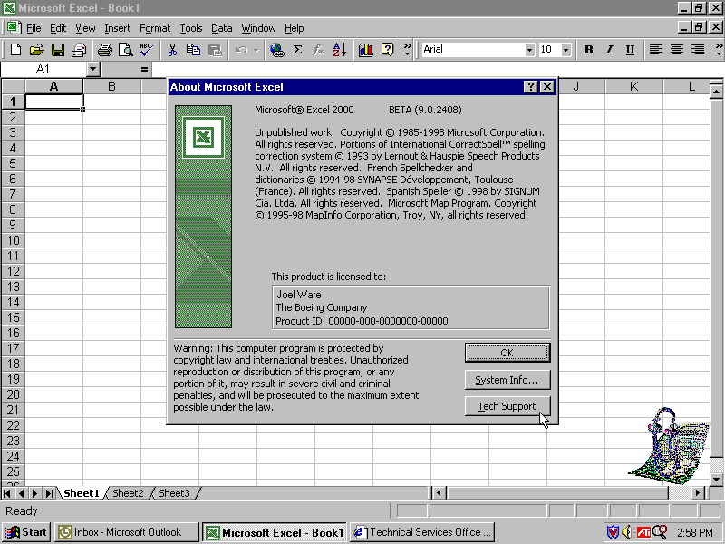
Figure 3: The Help About Tech Support menu item.
Second, if they ask the Answer Wizard / Office Assistant a question like “Where should I call for support?” the answer will direct them to the Boeing Help desk (CSRC) right away, shown in figure 4.

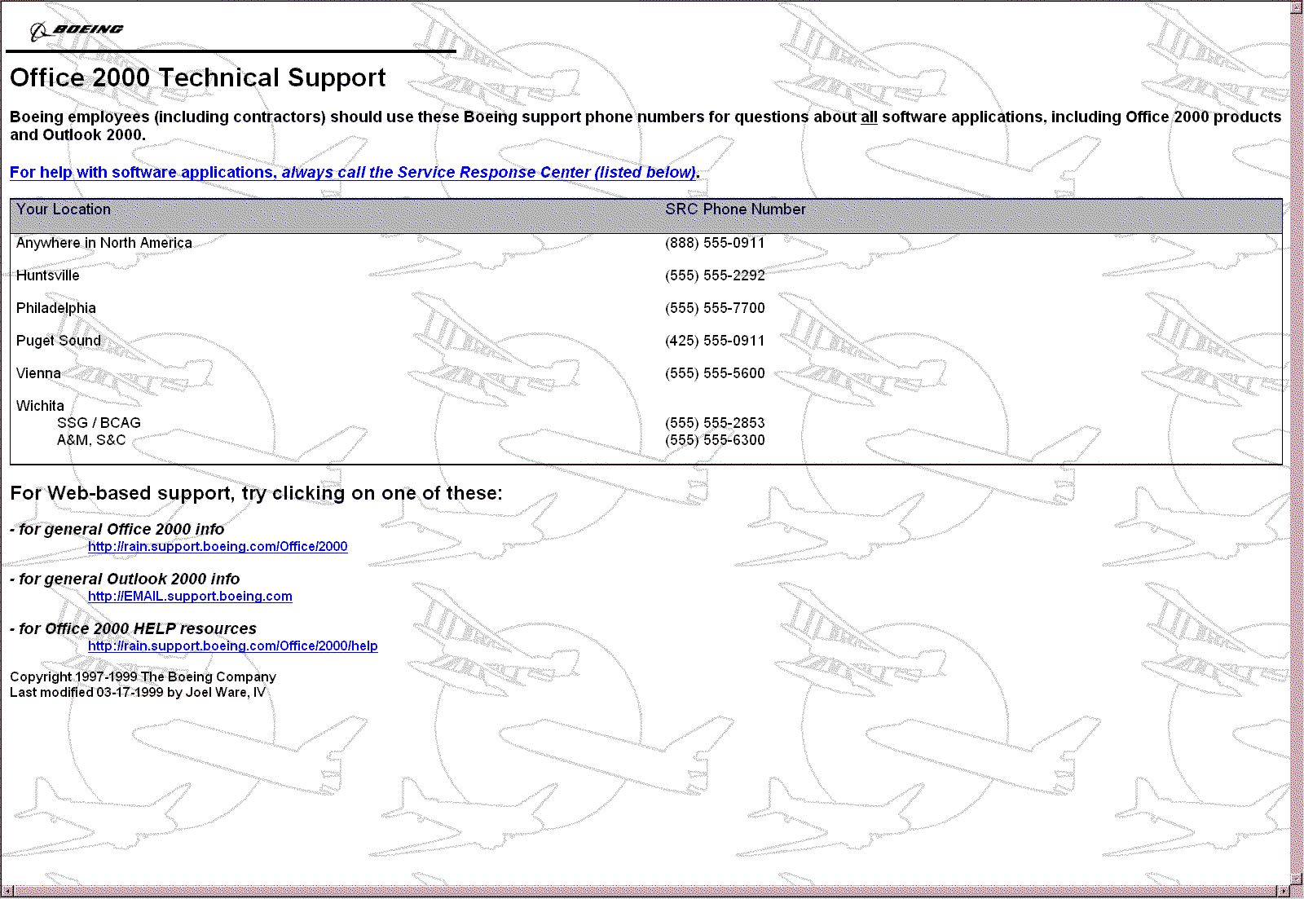

Figure 4: The Office 2000 Technical Support page.
This customization created new Help information in the file named PSS9.CHM, referenced from the Answer Wizard Project PSS9.AW. This information provided custom content that directed users to choose from a limited set of Boeing phone numbers, and access a Boeing Web site for further information if needed. One central Web site was chosen to support this function to minimize localization / site issues and reduce the number of versions of the custom changes that need to be released, tracked, and maintained.
This Web address resides on a very stable server, with support dedicated for the lifecycle of Office 2000. The original source of this content is our Boeing customization of the PSS8.HLP file, which provided an analogous function in Office 97. Using the HTML Help Workshop, we were able to convert our existing WinHelp project with minimal effort.

Converting
To convert a WinHelp project using the HTML Help Workshop, do the following:
- Open a new project (File | New Project)
- In the New Project Wizard, check the box to “Convert Existing WinHelp Project”, and click Next.
- Specify (or Browse to) the location of the existing WinHelp Project (.HPJ file).
- Specify (or Browse to) the name of the new project (.HHP file)—suggestion: PSS9.
- Click Next, then click Finish.

Editing the Project
The HTML Help Workshop (HHW) will have created some new HTML files. To incorporate new content, you should edit these files using an HTML editor.
Note: Word 2000 can edit HTML files directly.
You then build an index and compile the .CHM file using HHW by doing the following:
- Build index: You can set options in HHW to create index (.HHK) and contents files (HHC). This is a good idea.
- Compile the .CHM file: Use the Tools | Compile menu item.
- Build New Answer Wizard File using Answer Wizard Builder (AWB).
- Open AWB, and create a new answer Wizard file (.AW) using the .CHM file from the step above: Specify or browse to the .CHM file location, then click OK.
- The AWB tool will decompile the .CHM file into topics, and allow you to specify questions that will lead the user to each topic.

Adding Questions to Answer Wizard
The Answer Wizard Builder will link user questions, in natural language, with specific topics in Help files (.CHM files or URLs)
In the AWB tool, enter the “Title” (for the Help balloon), and the “Questions This Topic Answers” for each topic to be indexed in the file. Topics may be not indexed, and they may also be removed, as may questions previously entered. This table may also be edited in Microsoft Access if desired.
The questions used in this context should reflect your best understanding of what actual user queries will be when the product is installed in the field. As such, they need not be in “correct” terminology, or grammatical. They may even be profane, if you wish to respond to those questions. The important thing is to choose the answers carefully based on your organization’s terminology and experience.
The last steps are to build and test the AWB file:
- BUILD: Use the Tools | Build menu item, and specify a name/location for the AWB file.
- TEST: Using the Tools | Test menu item, test the answer/topic associations you have created in the AWB file.

Distributing Your Custom Help and AWB files
To distribute custom Help and AWB files, do the following:
- Associate Your CHM file with the Application: copy it to the correct directory for the language which it is installed:
C:\\Program files\\Microsoft Office\\Office\\1033\PSS9.CHM
- Create Registry Keys to Register Your .AW files. Here is a segment of a REG file for the Word product which registers the PSS9.AW file:
REGEDIT4
[HKEY_CURRENT_USER\Software\Microsoft\Office\9.0\Word\Answer Wizard]
@=”PSS9”
“PSS9.aw”=”C:\\Program files\\Microsoft Office\\Office\\1033\\PSS9.aw”
This key should reflect the location of the AW file as installed.
- Ship the AWB and CHM files to install with Office. The AWB and CHM files should be located together with similar files in the Office directory tree. The registry entries above should point to the final install location.

Coordination and Maintenance Requirements
Since this item directed users to call on the Central Service Response Center (CSRC) for help, coordination with that group was essential during development. Boeing needed to make sure that the CSRC phone numbers were accurate and stable and to ensure that the problem handoff would be clean for users.
Coordination was also required to ensure that the Web site referenced in the embedded link was ready before product deployment, and to receive a commitment that the Web server and site name would be stable for the expected life of the product. We consider it very important to avoid dead Web links, based on complaints we receive from our customers on how distracting “dead links” can be.
Ongoing coordination and maintenance efforts will focus on two items:
- Ensuring that the contact information in the file is current and helpful. Whenever policy changes dictate that customers should call another number for support, this file will necessarily change.
- Ensuring that the questions that should vector customers to the CSRC/Help desk are represented in the AWB file. A number of questions that could reflect the need to talk to support are included, but more may be developed by further experience, including analysis of Help desk logs, contact with customer groups, focus groups, etc.

- Example 3: Redirecting “Last Resort” Help Menu Items to Internal Helpdesk
One of the things that is most important in managing a software project successfully is to understand what the end user’s experience is. Former usability trials and focus groups helped Boeing in this goal. One vital missing dimension from the measurement tools is the actual frustration that users experience when they come to the end of the road in Help. Understanding the users’ questions and their intent at a point when they are focused on a task, frustrated, seeking help and not finding it is a very high leverage opportunity for the computing support organization. At this juncture, the support organization has the opportunity to take the user’s problem description, respond to it immediately by creating a trouble ticket, and to respond to it later by providing additional training or supplemental Help file materials. Trying to resolve the issue of how to help users when they have reached this point is what led us to consider modifying the default Help menu items in Office 2000.

Customization Pros and Cons
The “last resort” choice to find help on the Web displays when a user receives an answer from the Answer Wizard. When the user pursues the last resort, Boeing’s customization takes the question that the user just posed to the Answer Wizard and sets it up for electronic submittal on a Web site to some person or group who can help. The customization will redirect this to a Boeing Web site.
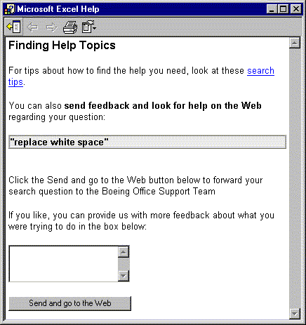
This customization saves user time, and captures problem descriptions and unanswered questions from end users by allowing them to link directly to Boeing-developed support information and Boeing internal help resources instead of going to the Microsoft Web site. Since Boeing has an existing ticketing system for problem diagnosis and resolution, the Help dialog box can be used to feed directly into that site and start a service request for problem resolution.
The case against this customization is that additional support information must be set up and maintained on the target Web site. Also, special logic must be created for disconnected or occasionally connected users who do not have immediate access to the Web.

Tools Used
The following tools were used:
Tool | Usage
Netscape Composer | Building and editing HTML / Web pages
Windows Explorer | File management
Notepad and REGEDIT | Building and inserting / updating registry keys

What the Customization Does
The “last resort” choice to find help on the Web displays when a user receives an answer from the Answer Wizard. This customization retitles the “last resort” answer to show that it has Boeing content, and sends the user’s question to internal Boeing resources. This is accomplished by creating registry keys that redirect this feature, and then by creating a Web site that will “catch” the users’ inputs and transform them into a new service request for the internal CSRC ticketing system (BARS-Boeing Action Request System).

How the Customization Was Accomplished
Custom registry entries were created that redirect the “last resort” destination to a central help resource site. These can be coded as individual keys or placed together in a REGEDIT script file, as below.
The following lines were placed in the REGEDIT file. A description of what each line does follows this list. For the usage of line 4, see the example regarding Office on the Web.
1 - REGEDIT4
2 -
3 - [HKEY_CURRENT_USER\Software\Policies\Microsoft\Office\9.0\Common\Internet]
4 - “OfficeOnTheWeb”=http://rain.support.boeing.com/Office/2000/
5 - “AWFeedbackBalloonLabel”=”None of the above, Look for more help on the Boeing web.”
6 - “AWFeedbackDialogText”=”Click the Send and go to the Web button below to forward your question to the Boeing Office Support Team”
7 - “AWFeedbackURL”=”http://rain.support.boeing.com/Office/2000/NewServiceRequest”

Descriptions:
1 - Opening Registry line.
2 - Spacing Line.
3 - Creates the key.
4 - Redirects the “Office on the Web” Help menu link to a central support site.
5 - Relabels the Assistant Balloon Help text to the organization’s name.
6 - Relabels the Help screen text with organization information.
7 - Redirects the Feedback “Send and go to the Web” button to the internal web site where a new Service Request (trouble ticket) can be created.

Coordination and Maintenance Requirements
Coordination required to implement this customization includes the CSRC/Help Desk, World-Wide Site Operations. The content of the message must be coordinated with the customer and with the support resource leads.

Example 4: Customizing Macro Virus Alert Dialog
Boeing responds to computer viruses in strict accordance with pre-defined policy and through coordination with various groups. There is no room for local creativity or deviation from established procedures in this area. Therefore, it makes sense to provide proactive guidance to end users to advise them of the relevant corporate policy at the time of immediate need. This pre-defined virus policy lead us to consider modifying the way that Office 2000 notifies a user of a potential macro virus.

Customization Pros and Cons
The Macro Virus Alert Dialog displays when a user attempts to open a document containing a suspected virus or template customization. If this event is captured and logged, Boeing can take appropriate action. This could include statistical sampling and reporting or direct follow-up assistance to the end user to ensure that proper anti-virus precautions are in place.
Also, the customized dialog box can direct the user to call on internal company support resources to assist with the possible virus infection. This will help enforce company policy on handling suspected virus infections through direct capture at the point of first detection. It can also enable Boeing to do a better job of limiting virus damage through earlier intervention.
The case against this customization is that the virus site will need to be maintained so that the link is “live” and populated with useful information. Also, some users may gain a false sense of security.

Tools Used
The following tools are necessary for this customization:
Tool | Usage
Office 2000 VBA IDE | Editing built-in File Open dialog box coding

What the Customization Does
The customization redirects the virus alert to invoke the default browser on the desktop and display a page that shows the virus response policy and procedure as it applies to end users. Users are shown clearly what they need to do to correct the problem and comply with policy. The virus page has scripting code that will capture the incident for statistical analysis. The page also offers to check the user’s anti-virus level and download and install the latest anti-virus code for the user if needed.
This is accomplished by providing a tailored virus response Web site and by coding a Help page that calls up that page. In order to provide for reasonable “disconnected” functionality, the basic static HTML from the virus Web site is provided on the users’ workstations as a .CHM file.

Why Boeing Chose Not to Modify
After evaluating the effort to customize this dialog box, Boeing determined that it was too risky of a proposition. Replacing code would be too expensive and hard to manage on the users’ desktops. Users felt that the existing macro virus warning and the Boeing web page content on viruses was sufficient.

Coordination and Maintenance Requirements
For Boeing, coordination required to implement this customization includes consultations with the Anti-Virus Product Manager, and the Computing Security organization. There is an Anti-Virus Team that must be consulted as a stakeholder. The CSRC/Help desk would need to agree to accept pre-formatted user service requests, sent on the Web through Office.
Maintenance of the links themselves is essential, since the latest anti-virus information needs to be available at all times. Similarly, the Web addresses need to be stable over the life of the product.

Example 5: Customizing Save As Dialog
During the Office 95 to Office 97 migration, when both packages were partially deployed throughout the company, the CSRC and other support organizations received a large number of calls about document conversion issues. These issues would manifest themselves as dysfunctional or corrupted documents that users had attempted to convert from previous versions, frequently with disastrous results. This high volume of problems and calls lead us to seek a solution that would provide proactive guidance for end users before they changed the document format during the File Save As operations. This would allow the end user to consider the possible downside of such an operation and potentially avert a file format disaster.

Customization Pros and Cons
The Save As Dialog displays when a user attempts to save a document in a new format or with a new name. The case for doing this is that typical Boeing business and engineering documents are frequently very complex. Boeing users need more information about “down-rev Save” than is provided in the Office Help files. This customization allows users to link directly to Boeing-developed support information on complex documents.
The case against customizing Save As is that additional support information must be set up and maintained on the target Web site. Also, special logic must be created for disconnected or occasionally connected users who do not have immediate access to the Web.

Tools Used
The following tools are necessary for this customization:
Tool | Usage
Office 2000 VBA IDE | Rewriting built-in File | Save As dialog box VBA code

What the Customization Does
The customization changes the File | Save As dialog box so that when the Word 6/0/95 file format is selected, a popup encourages the user to review the Boeing Web page that discusses problems that are encountered when user documents are “saved back” to this format.

Why Boeing Chose Not to Modify
Boeing decided that customizing the File save dialog box would be feasible, but a risky operation. Investigation showed that there were no handy “hooks” to intercept the FileSaveAs event before or during the execution of the system code for this dialog box without inhibiting its shipped function, and thus the new event handler would need to completely replace the code for the existing File Save As function. Further, the Help files associated with this function had been significantly enhanced from their Office 97 content, so the expected payback from the modification was smaller. This looked like a lot of work for a minor benefit, so the customization was not pursued further.

Coordination and Maintenance Requirements
Coordination required to implement this customization includes the CSRC/Help Desk, World-Wide Site Operations. The content of the popup would need to be coordinated with the customer.

Example 6: Removing/Rehoming “Office on the Web” Help Menu Item
Boeing provides a website known as the Office on the Web support site. The Web site provides Boeing specific information about our deployment of Office 2000. This site includes information about Boeing-specific customization, problems encountered in the Boeing environment, and Boeing specific software updates and support resources. Having crafted this custom content for Boeing users, we felt it was good business to redirect our customers to this support site first, in preference to the Microsoft site, which is broad and aimed at the general market. Our site addresses Boeing issues very closely. Redirecting also allows us to manage the website’s response time and availability considerations. The support pages on the site are dictated directly by end-user issues with Office 2000. We can dynamically change the content as we receive feedback from our users.

Customization Pros and Cons
The case for this customization is that the various “Office on the Web” (“Office Update” site) links provide some non-mission related places where users are enticed to surf when they should be working on the problem at hand. Thus, removing or redirecting these to an internal (intranet) site will reduce users’ temptation to surf and increase the amount of productive labor time.
The case against this customization is that some of the links provided in “Office on the Web” may provide useful information for the end user. Removing them does add the burden to our internal support group to identify the missing information and provide a subset of it on a locally-maintained Web server for users who need it. This information will require periodic updating, of course.

Tools Used
The following tools were used:
Tool | Usage
Netscape Composer | Composing and editing HTML / Web pages
Windows Explorer | File management
Notepad and REGEDIT | Building and inserting / updating registry keys

What the Customization Does
The customization removes or redirects the “Office on the Web” item, which is shown on the Help menu (figure 5).
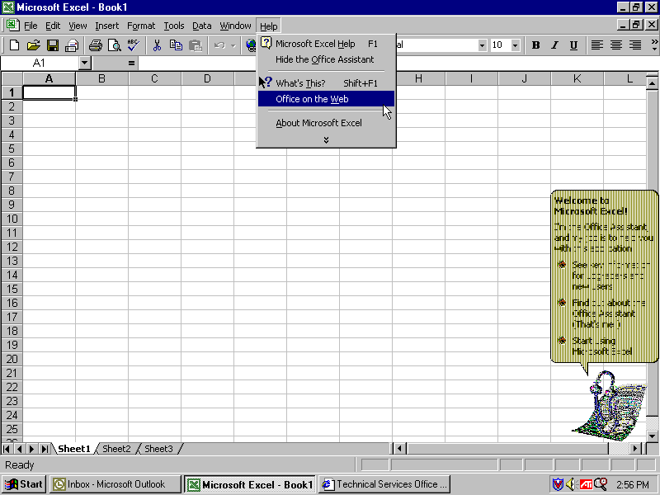
Figure 5: The Office on the Web link in Office 2000 applications.
Redirection is accomplished by replacing a few keys in the system registry file. (See also the .REG file detailed in Example 3, above. See LINE 4 in the REG file. This is an example of how two fixes can be applied in one REG file.)
1 - REGEDIT4
2 -
3 - [HKEY_CURRENT_USER\Software\Policies\Microsoft\Office\9.0\Common\Internet]
4 - “OfficeOnTheWeb”=http://rain.support.boeing.com/Office/2000

Descriptions:
1 - Opening Registry line.
2 - Spacing Line.
3 - Creates the key.
4 - Redirects the “Office on the Web” Help menu link to a central support site.

This .REG file can be incorporated as an individual key or as a complete file using the Office Customization Wizard.

Coordination and Maintenance Requirements
There is no outside coordination required to implement this customization, other than the usual validation dialog boxue with users.
Maintenance of the links themselves is trivial, since the registry keys in question are static and refer to no fixed directory, path, or filename. These keys will need to be examined following registry updates of the Office product to ensure that they are still valid. Note that the maintenance requirements would be significantly higher for a poorly chosen Web site, or for a URL which is too specific, or dependent on a particular back-end infrastructure.

Example 7: Disabling Individual User Registration
Boeing end users fall under our select licensing agreement with Microsoft. We found it necessary to disable the auto-registration features of Office 2000 to minimize the disruption to our users.

Customization Pros and Cons
The case for disabling individual user registration in the Office package hinges upon two major issues: first, the non-productive time spent in the registration activities; second, the consequences in terms of unsolicited mail and telephone traffic which have in the past been keyed from Microsoft software registration databases.
The case against disabling individual registration is that some users may feel that there is some value in being a registered user, even though they don’t own the package.

Tools Used
The following tools were used:
Tool | Usage
Windows Explorer | File management
Notepad and REGEDIT | Building and inserting / updating registry keys

What the Customization Does
The customization disables the Office 2000 Registration Wizard. Users are not prompted to register the product, ever. The product will continue to function indefinitely without being registered.

Getting It Done
Boeing has determined that this customization will be supplanted by the NOLV.REG file, which is supplied with Office, in the Office Resource Kit. Applying this REG file to the Administrative Install point for Office will disable the prompt to register the package.

Coordination and Maintenance Requirements
The coordination required is to determine (through the Procurement Group) that our users have full contractual rights without registration, and to communicate to Microsoft that our firm intent is that none of our users will register or receive the marketing e-mail and phone calls that registration brings.
Maintenance requirements are minimal—after the Office package is changed, the fix should be verified to ensure that user registration is still turned off.

Best Practices and Lessons Learned
The following sections describe Boeing’s experiences with various phases of the customization and deployment processes of Office 2000 (and Office 97).

Distributing Your Custom Content
Distributing your custom Office product content is a critical, and sometimes complex phase, but it is essential to the success of the project. Without an effective distribution strategy, all of the prior efforts will go for naught. Distribution can take on many flavors in different environments, depending upon many factors including available network bandwidth, workforce geographical distribution, funding, and, of course, corporate business rules.

Within Boeing, multiple distribution strategies are required to cover a workforce that is distributed in 43 countries and 6 continents, even though it is mostly concentrated in the United States.

Identifying Critical Chokepoints in the Distribution Scheme
For this project phase, you need to think a bit like a border guard, whose job is to let only approved copies of Office through the gate. The reason for this is that, having decided to customize the Office product, you will want to ensure that your custom content makes it out to the field as implemented, to as many of your sites and users as possible. To ensure this, you will need to study the formal and informal methods of software acquisition in your enterprise, to understand the possible “leaks” and sources of variation in your installed software.

Having identified the means and methods of software distribution in your enterprise, you will then need to choose where to insert your custom software in the process, and how to avoid picking up other variants in the software pool. You might even find that you will need to implement a gatekeeper function for software acquisition and distribution, if you don’t have one already.

If you have an orderly procedure for software acquisition and distribution already, then you are ready to find an insertion point for your planned custom content. You will want to establish a “sole source authority” (or master copy) for the Office product, and build all other copies from that one. Locating this master copy on a safe, reliable and protected server resource is key to success.

In the case of Boeing, we do have designated Software Distribution Servers, and the master of those served as a site for the master copy of Microsoft Office. This master copy was replicated to campus-level servers and burned onto custom CD-ROMs for remote sites and home users.

At Boeing, acquisition of Office 97 CD-ROM media was forbidden, and users were required to order special media prepared by The Boeing Company Office Team or to use designated Software Depot Servers. As with any such scheme, a certain amount of “leakage” occurred, with a few unauthorized copies of Office 97 appearing here and there, but in general the plan succeeded.

Applying Custom Changes to Master Copy of Product
Having identified key software distribution chokepoints, and established a master copy location, you will need to protect this master from uncontrolled change. This means that you will need to establish a change-control procedure if you don’t have one already.

A good change-control procedure has an identified owner, a path for customer input, an audit trail for any changes, a clear announcement and review period, testing procedures, and a well-understood back-out plan. Change-control must be managed by an entity separate from the software developers and their management. If your current procedure is lacking any of the above, please reconsider carefully before using it for a serious deployment activity.

In the Boeing context, changes are proposed in writing by the responsible Product Manager, and given (nominally) a week’s review prior to implementation (unless qualified as an “emergent” update). Visibility of proposed changes is provided on the Web and through e-mail to a large list of subscribers. Changes are made weekly (normal flow), or as required (Emergent flow).

Central Distribution Strategies
Boeing plans to use a combination of the following schemes listed below:

Boeing maintains a central master copy (sole source authority) of Microsoft Office on a server known as the Master Software Distribution Server. This copy is the official released product of the Workstation Software Technical Services group, through the Technical Services Product Manager for Office. Similar master copies of other software products are also maintained on this server.

When the Select Distribution CD ROMs are received from Microsoft, a master copy of the Office software is built on the Master Software Distribution Server. This master copy serves as the mother for all subsequent distributions of Office in the Company. The Supplier Management and Procurement (SMP) organization has arranged that no other copies of Office media will be procured to ensure that this distribution remains the sole source.

Campus-level Software Distribution Servers are replicas of the Master Software Server. These campus servers (of which there are currently fourteen) provide high-bandwidth access for geographically diverse sites.

When the server-based distribution copies are made, they are made from the Master Server, which is essentially a CD-ROM image. The server-based installs are made as “Administrative Installs” (SETUP /A) so that they can be used both in run-from-server mode, and as installation source for local standalone copies.

Testing Custom Changes Before Deployment
Testing custom changes is very important. It cannot be overstressed that the time spent testing is so much smaller than the time potentially spent diagnosing and fixing a problem on thousands of workstations that might have been found with a more thorough test.

The testing procedure includes multiple levels of testing by different groups. The first tests are performed by the developers in the Workstation Software group. This group will perform the unit test of components developed or modified, will document the integration/distribution procedures, and then request testing by beta-testers group. These tests occur on working desktops and in the Technical Services lab.

The beta-testers, or early adopters, at Boeing number about 500. Of these, about 100 are primarily focused on Office, and about 400 on Microsoft Exchange. Both groups receive the integrated code and are requested to test it in their campus integration labs and on desktop test machines.

Once the early adopters have tested the code, it is then certified by the Workstation Software group and made available on the Software Depot Server. It is also eligible for use in the Standard Software Service (S3) server-based software offering, where it will be incorporated into a test build, and then subjected to three more levels of integration and regression testing by Technical Services, and selected customers, prior to general deployment.

Maintaining Custom Content
Custom Help content is like any custom software in that it requires maintenance. When new product releases are made, the custom content may need to be completely re-implemented or it may survive intact, depending upon the upgrade.

Configuration / Change Management of Customizations
Each item of custom content should be developed and tracked using a change-control mechanism that is appropriate for your environment. At a minimum, this means that each change in the released configuration will be documented and tracked. More formal schemes will include peer reviews and change-board activities prior to the release of the change package.

Updating Customization for Previously Installed Customers
One particularly sticky issue is how to update the customized items for customers who have previously installed Office 2000, or who have installed it using a non-standard configuration.

In many cases, the customizations will still work, because they are based on items that are not location-dependent. In some cases, however, locations such as paths may vary. When such items are present, it may not be possible to make the customizations work for customers who have started with a non-standard installation path and method—they will need to uninstall and then reinstall to take advantage of the custom code, or possibly re-implement the customization in the field.

Identifying Previous Customizations
Previous customizations may need to be brought forward into new versions of Office. For example, the “Help About Tech Support” menu item that was implemented in Office 97 by using PSS8.HLP needed to be brought forward to Office 2000, where it became PSS9.CHM and PSS9.AW.

The modified items should be documented by the team that made the customizations. If not, all is not yet lost. The customized items can still be readily identified by two methods:
- File Audit: View a date-sorted list of the files of the installed Office image, and look for any files that do not match the “signature date” of the Office package. For instance, if the signature date is “07/11/97”, denoting Office 97 SR-1, then any file with another date / time is a possible customization. Look especially for .HLP, .REG, .CHM, .AW and .HTM files, although others can be involved.
- What Changes: Install the Office product from original Microsoft distribution media, and then have experienced users run the customized and vanilla packages side-by-side, noting differences. This can be a very tedious process, but is a good check on other processes to ensure customer satisfaction with the final result.

Tools and Resources for Product Customizers
Customizing Office is not a black art. If you want to learn how to customize Office Help resources, we recommend that you start with a careful reading of the Office Resource Kit section on Customization, followed by some hands-on practice with REGEDIT, HTML Help Workshop, and the Answer Wizard Builder. Both of the latter two tools have good online Help files that are quite instructive.

Where to Find Customization Tools and Info
The primary source of information on customization tools and techniques is the Office 2000 Resource Kit, or “ORK”.
Directly useful topics include:
- Customizing the Office Help System
- Creating Your Own Help Topics
- Linking the Answer Wizard to Resources on the Web

A good secondary source, especially for detailed information, is the online Help embedded in the tools themselves.
Boeing chose to make this resource available internally for several reasons. First, this adheres to the Boeing no downloading policy. Second, it allows us to control availability and provides a high bandwidth delivery mechanism adding convenience for our IT customers.

Potential Different Customization Techniques
The following are the basic customization techniques:
- Adding new Help (.CHM, .HLP) files
- Adding new Answer Wizard (.AW) files
- Modifying existing Help (.CHM, .HLP) files
- Modifying / replacing existing Alerts
- Modifying / replacing existing Dialog Boxes
- Adding new registry keys

Choosing a Technique

Help file format / location / delivery:
Help files can be made in conventional Help file format (WinHELP), in regular HTML on a Web site, or in compressed HTML (.CHM). Each of the three is discussed briefly below.

.CHM
The compressed HTML files are a good choice for files that must be local and available when the user is not connected to the network. These files have the full richness of HTML but are static in content. This means that when they change, the users will need to update their installations (on a server or workstation) for the change to take effect.
To provide for some function while disconnected, with update flexibility, you can use .CHM files that refer to Web resources (URLs) and then the Web resources can be flexible—the static .CHM content on the workstation will be usable as-is until the Web Help entry point or parameters change. As the name implies, .CHM files are compressed from the original HTML format.

WinHelp
This traditional format is still supported, and in fact a number of .HLP files are shipped as part of the Office 2000 product. This legacy format is not as flexible as the HTML-based formats. It is a good choice for quick response, reliable execution, limited function, limited update usage, and is the ONLY choice for interchanging Help with older applications.
It must reside on a disk, either local or network, and cannot be assigned a URL-type address. It can however, reference a URL, and thus can gain some of the advantages of decoupling Web updates from workstation desktop updates, as shown for .CHM files. For files with large amounts of content, the compression is excellent.

HTML
HTML files have great flexibility and are represented by a URL. Thus, in order to use them, the user must have network connectivity. These are therefore a good choice for always-connected workstations, point-of-sale terminals, and others who need the latest information available. Since the information is actually provided from a Web directory, this format/delivery choice offers the most flexibility and best degree of decoupling. That is, the Web-based Help can be updated at any time, with no inherent requirement to update the Office package on the desktop.
Files with large amounts of content, especially graphics, can grow quite large—compression is not available for vanilla HTML Help.

Boeing chose to convert the majority of Help files to HTML for several reasons. This format is easier to update “on the fly”. Having learned expensive lessons from mid-cycle software re-distribution, Boeing hopes to avoid this problem with regard to Help files.

Knowledge Base Articles and White Papers
The Office 2000 Resource Kit (ORK) and this Guide are the only resources available at this writing.

For more information: http://www.microsoft.com/office/



This is a preliminary document and may be changed substantially prior to final commercial release. This document is provided for informational purposes only and Microsoft makes no warranties, either express or implied, in this document. Information in this document is subject to change without notice. The entire risk of the use or the results of the use of this document remains with the user. The example companies, organizations, products, people and events depicted herein are fictitious. No association with any real company, organization, product, person or event is intended or should be inferred. Complying with all applicable copyright laws is the responsibility of the user. Without limiting the rights under copyright, no part of this document may be reproduced, stored in or introduced into a retrieval system, or transmitted in any form or by any means (electronic, mechanical, photocopying, recording, or otherwise), or for any purpose, without the express written permission of Microsoft Corporation.
Microsoft may have patents, patent applications, trademarks, copyrights, or other intellectual property rights covering subject matter in this document. Except as expressly provided in any written license agreement from Microsoft, the furnishing of this document does not give you any license to these patents, trademarks, copyrights, or other intellectual property.
Unpublished work. © 1999 Microsoft Corporation. All rights reserved.
Microsoft, the Office logo, Outlook, Windows and Windows NT are either registered trademarks or trademarks of Microsoft Corporation in the U.S.A. and/or other countries.
The names of actual companies and products mentioned herein may be the trademarks of their respective owners.
The example organizations, product, person and events depicted herein are fictitious. No association with any real organization, product, person or event is intended or should be inferred.

