
Microsoft® Office 2000 Customer Deployment Scenario

White Paper

Published: October 1998

Table of Contents
Introduction 1
The Scenario 1
The Environment 1
The Goals 2
Key Issues 2
Determine a Company-wide Strategy 3
Decide Which Bits Go Where 3
Determine from What Source the Bits Run 3
Customize User Settings 4
How Do the Bits Arrive? 5
Conclusion 10

Microsoft Office 2000 Customer Deployment Scenario
White Paper

Published: October 1998
For the latest information, please see http://www.microsoft.com/office/

Introduction
Reducing the total cost of ownership is the highest priority goal for Microsoft® Office 2000. Based on customer feedback, we determined that the best way to reduce the total cost of ownership of Microsoft Office is to make the product easier to deploy and install within a large organization and to make it easier to maintain and support after it has been deployed. With the new Microsoft Windows® installer technology, the Office group has redesigned the way Microsoft Office is installed from the ground up. These tools provide unparalleled flexibility and capabilities that have never before been offered in desktop applications.

With flexibility comes responsibility for careful planning. This paper uses a fictitious company, Adventure Works, to illustrate the software decisions that must be made and the benefits and implications of those decisions for the entire company.

For more information on deployment capabilities, please see the white paper entitled Microsoft Office 2000 Deployment and Maintenance. For detailed information on how to implement any of the strategies discussed in this paper, please see the Microsoft Office 2000 Resource Kit.

The Scenario
Adventure Works is a fictitious company—a retail outdoor apparel and accessories company headquartered in Milwaukee, WI. The company employs more than 15,000 workers located across the United States and has an office located in Trento, Italy. In this scenario, the administrator, Kathy, is responsible for migrating the company’s users to a standardized desktop of Office 2000 on a variety of configurations within six to nine months’ time.

The Environment
- About 13,000 employees (corporate users) located at company headquarters in Milwaukee use desktop PCs with full-time network access, a mix of Microsoft Windows 16-bit and 32-bit platforms, and either Microsoft Office 4.x, Office 95, or Office 97. Only 10 percent of the PCs are still using Windows 16-bit platforms.
- Lotus Notes is the current messaging environment, and it will be migrated to Microsoft Exchange shortly after the complete Office 2000 deployment.
- The networking environment includes Novell Netware 4.1 and Microsoft Windows NT® Server 4.0.
- About 2000 sales reps in 15 sales offices across the country use laptop computers running Microsoft Windows 95 and Office 97. Reps are typically away from the field offices making sales calls at customer sites, but they check in at least once a week.
- One research lab, located 75 miles away in Madison, WI, uses 100 computers running Windows NT 4.0 and Office 95, with full network access. Researchers use various computers—whichever ones are located closest to the lab equipment that they are currently using.
- An international office in Trento, Italy, assists with manufacturing and buying merchandise.

The Goals
- Determine the appropriate Information Services (IS)–supported standard configuration for upgrading to Office 2000, reducing support costs by minimizing the number of configurations that are currently being supported.
- Deploy Office 2000 efficiently using the software’s deployment capabilities and Microsoft system management software to handle software distribution and installation for all users at corporate headquarters.
Note: System management software is not required for deploying Office 2000.
- Determine and implement an effective and practical coexistence strategy for computers running various versions of Microsoft software.
- Implement Microsoft Windows NT Server 4.0,Terminal Server Edition, 16-bit platforms in the short term and eventually replace with new computers running Windows NT 4.0 or Windows 98 operating system.

Key Issues
- File formats. Users of various versions of Microsoft Office will need to exchange files during the migration process. (Note: For more information about coexistence issues when working with different file formats, including the advantages/disadvantages of each solution, refer to the white paper entitled Microsoft Office 2000 and File Sharing in a Heterogeneous Office Environment.
- Custom settings. Determine those settings that need customization for the entire population, such as additional file settings, options settings, personalized menus and toolbar settings, and default server settings for installation and maintenance; work out a strategy for implementing departmental settings.
- User types. Department or site administrators need to customize the corporate setup script. For example, users in Italy need to install the Microsoft Office 2000 Multi-Language Pack, which Milwaukee users will not install.

Determine a Company-wide Strategy

Decide Which Bits Go Where
The first decision concerns which products and features each user will receive. Since Kathy is making a corporate-wide decision, it needs to be as inclusive as possible without cluttering users’ computers with software they don’t need. Departmental IS personnel know their users’ needs well enough to accurately make more granular decisions, but Kathy wants to avoid the expense and support burden of implementing them from centralized IS management.

Kathy needs to prevent users from installing Outlook™ 2000 messaging and collaboration client on their own PCs, since the software will be deployed with the Lotus Notes to Microsoft Exchange Server upgrade. She also needs to devise a strategy, implemented on a department-by-department basis, for upgrading existing Microsoft Access 2.0 databases to Access 2000. Some departments have created heavily customized Access 2.0 database applications that need thorough testing previous to upgrading to Access 2000. For the remaining applications, Kathy will deploy the typical installation to users of Windows 95, Windows NT 4, and Windows 98, but she will allow users to install other features on demand, as they are needed.
The final group of users is the small percentage who still use Windows 3.1. These users will run Office 2000 via the Terminal Server and will run the software from the server, or source. Kathy has decided it is more important to improve the coexistence scenario than to wait until those departments have the budget available for upgrading their hardware. Prior to deploying, Kathy needs to ensure that these users are all logging on to a Windows NT Server.

Decision Summary
- Make it impossible for users to install Outlook 2000 on their machines.
- Devise a strategy for users who need to stay on Access 2.0, implemented by departmental IS personnel.
- Deploy Microsoft Office Professional Edition, typical installation, to users of 32-bit Windows, with all possible missing features tagged to Install on Demand.
- Deploy Office 2000 to users on Windows 3.1 with Terminal Server.

Determine from What Source the Bits Run
Next Kathy must determine from what source the software will run. For every feature in Office 2000, Kathy can install the feature on the local hard drive, run it from the source (CD-ROM or network server), install it on first use, or not install the feature at all. Further, she can choose to hide any feature so that users can’t access it through the user interface at any time—even when they’re adding or removing components. She can also choose to run Office using the Terminal Server so that all of the bits execute on the server, thus creating a thin client (a client computer that performs little or no data processing) and providing support for Windows 3.1 users.
Currently, users run the software from their local hard drives. Kathy believes that the current environment, with 13,000 users, would not support the increased network bandwidth that would be required to run all the software from the server. Network traffic increases constantly as new users are added, as more users share files and resources, and as more users access the Internet. Consequently, most desktop users will run the standard configuration from their local hard drives, using the network only as a resource for installing additional features.
Laptop users with large enough hard drives are better off with the complete installation of Office features, so they are not affected by connectivity limitations. Laptop users with small hard drives will be handled on a case-by-case basis. Kathy does not want to get into the business of supplying and tracking software CDs; however, these users’ laptops might have room for only the typical installation (or even less) options, so each laptop user will receive a copy of the Office 2000 CD-ROM and will be able to access features as necessary.
The Terminal Server users will be running the software from the source. Kathy has never before used Terminal Server and must test and plan this configuration carefully to ensure adequate performance. She consults the Microsoft Office 2000 Resource Kit, where she finds specific information about running Office in this configuration.

Decision Summary
- For desktop users, Office will run from the local hard drive, and additional features can be installed on demand.
- For laptop users, Office Professional will be installed to and run from the local hard drive.
- On an case-by-case basis, laptop users with small hard drives will receive the minimum installation options (or some subset of applications) and will be provide with a CD-ROM to run additional features or products from the source.
- Windows Terminal Server users will run all features from the Terminal Server.

Customize User Settings
Kathy needs to implement two major corporate-wide policies by changing some user settings: the coexistence policy and corporate standards for documents and forms.
Kathy’s migration committee will require users to save documents in Microsoft Word 6/95 format, at least until more than half of the company’s users have migrated to Office 2000, because of the high rate of Word document sharing via attachments in e-mail. For users of Microsoft Excel and the Microsoft PowerPoint® presentation graphics program, the committee will allow them to save documents in the native file formats, assuming that most sharing of Microsoft Excel and PowerPoint files is done within workgroups rather than between workgroups.
Since the Adventure Works IS organization will migrate each entire workgroup at one time, version coexistence concerns are mitigated. In its policy paper, however, the committee will strongly recommend that each department assess its own situation. Some departments that do intra-workgroup file sharing, such as controllers who use spreadsheets and graphics personnel who use presentation applications, should consider saving these documents in the Office 4.x version until total conversion is complete.
Since the IS organization is not completely centralized, Kathy cannot require that all departments use System Policies. She will, however, strongly recommend that System Policies be implemented, particularly given the file coexistence concerns. System Policies is a feature of Windows 95, Windows 98, and Windows NT version 4 and higher that is supported by Office 2000. System Policies makes it possible to enforce user settings from the server each time the user logs on to the network. Kathy’s group will create a policy that can be deployed to logon servers and will cover the use of System Policies in its deployment documentation.
Adventure Works has spent considerable effort ensuring that all corporate communication supports the Adventure Works brand and looks consistent. The company has a corporate library of templates for Word, Excel, and PowerPoint that it is updating to take advantage of the features of Office 2000. The company will deploy these templates to a variety of servers to make it easier for users to update the templates and will create a custom user setting so that users can access the templates.

Decision Summary
- Create a custom user setting to change the default save format for Word 2000 to Word 6/95 format.
- Create a corporate standard summarizing the coexistence strategy with details on changing the default formats for Microsoft Excel and PowerPoint.
- Create a System Policy for default file formats and the workgroup template location.
- Create a custom user setting defining a workgroup template location.

How Do the Bits Arrive?

The Custom Configurations
Kathy and her staff need to create six IS-supported installation types:
- 32-bit Windows-based Desktop User: Install the typical Office Professional Edition configuration options, minus Outlook 2000, to the local hard drive, making all other possible features, such as converter packs or additional templates, available on demand. Create a setting to change the default format for Word to Word 6/95, and create a setting for workgroup templates. Push the installation to the user desktop with system management software.
- 16-bit Windows-based Desktop User: Install the special Office 2000 Windows Terminal Server installation provided with the Office 2000 Resource Kit, except for Outlook, on the Terminal Server. Use the Custom Installation Wizard to modify the Windows Terminal Server transform file (customized setup file) provided in the Office 2000 Resource Kit to change the Word document default format to Word 6/95, and create a setting for workgroup templates. Push the thin-client installation to the user desktop with system management software.
- 32-bit Windows-based Laptop User: Install the complete Office Professional Edition configuration, minus Outlook 2000, to the local hard drive. Create a setting to change the Word document default format to Word 6/95, and create a setting for workgroup templates. Push the installation to the user desktop with system management software.
- 32-bit Windows-based Laptop User with Insufficient Hard Drive Space: Install the minimum configurations of Word, PowerPoint, and Microsoft Excel to the local hard drive, providing Microsoft Access on demand. Define all other features to run from the source, and provide an Office 2000 CD-ROM as the source. Create a setting to change the Word document default format to Word 6/95, and create a setting for workgroup templates. Push the installation to the user desktop with system management software, ensuring that settings are made to detect a slow link so that Office will install over a fast network connection only.
- Access 2.0 User: Because any of the above users might use Access 2.0, Kathy’s department will provided step-by-step instructions for ensuring that Access 2.0 is not removed from the user’s desktop and that Access 2000 is not installed to the user’s PC. Departmental IS resources will implement these steps. Instructions will also be included for delivering Access 2000 to the user’s desktop after all Access 2.0 applications can be safely migrated.
- Location in Italy: Use the above configurations, but provide the Office 2000 Multi-Language Pack and the custom settings necessary to set the default language to Italian.

Creating Custom Configurations
Kathy and her staff will use the Office 2000 tools provided for creating custom configurations of Office, including the Microsoft Office Custom Installation Wizard and the Microsoft Office Profile Wizard.

The following shows an example configuration, noting other options where pertinent.

Installing Office 2000 for Administration
Kathy installs an administrative version of Office 2000 on the network server, or administrative installation point. Kathy puts the Office 2000 CD in the server’s CD drive and types the following command line preceded by the appropriate drive letter:
setup.exe /a install.msi

Creating Custom User Settings
From the administrative installation point she just created, Kathy installs Office 2000 on a test computer and uses the Wizard applications to create the user settings. Kathy starts Word 2000, and from the Tools menu chooses Options and then Save and changes the default file format to Word 6.0/95. She then opens the File Locations tabbed page and indicates the correct setting for the workgroup templates location.
After all the custom settings have been created, Kathy exits Office and uses the Office Profile Wizard to create a .ops file that captures the changes she has made. The Office Custom Installation Wizard uses this file to customize user settings during Office installation.

Creating a Custom Installation Transform File (.mst)
The Office Custom Installation Wizard has several screens that take Kathy step-by-step through the process of customizing the Office 2000 installation for Adventure Works. Many of the steps allow her to capture information such as the organization name and which shortcuts to install. Following are the screens Kathy is most interested in using to accomplish her goals.
The first screen of interest is screen number 6:
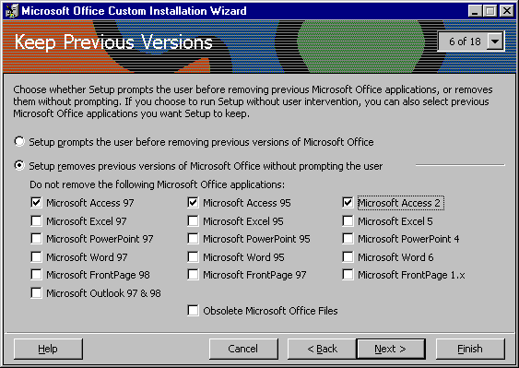
Kathy chooses not to remove any old versions of Microsoft Access. She’s not actually going to implement this choice at this point because this setting will be implemented on a department-by-department basis later on; however, she captures the screen shot to include in her implementation guide and then clears the check boxes.
In the next screen (number 7), Kathy determines which features to install and the source from which they will run. She chooses to have some of the features install on first use (or on demand):
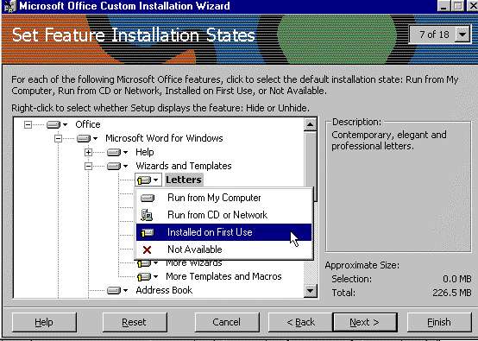
Then she chooses to hide Outlook by right-clicking Microsoft Outlook for Windows and selecting Hide so users won’t be able to see or install the Outlook program at any time.
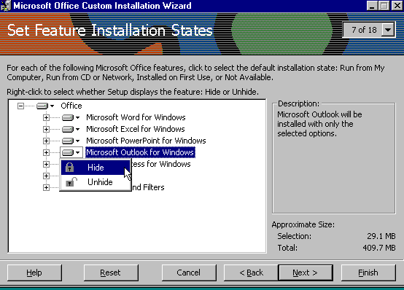
Next, Kathy adds the location of the .ops file that she created so that the settings can be added to the custom installation. The .ops file contains the custom user application settings that she created with the Office Profile Wizard.
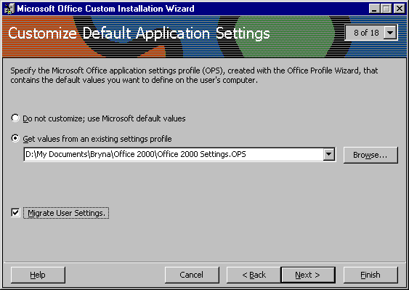
Since Kathy is relying on Install on Demand to allow users to add features that they might need later on, she uses screen number 12 to identify the multiple administrative installation server locations to ensure that the features will always be available.
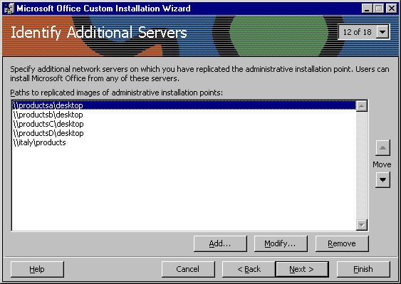
At the end of the process, the Custom Installation Wizard saves a transform, or .mst, file that contains all changes to the standard Office 2000 installation. Kathy answers some questions about how she’d like to deploy Microsoft Office at Adventure Works, and the Custom Installation Wizard provides the appropriate command line.

Deploying via Microsoft Systems Management Software
Microsoft Office has supported Microsoft system management software as a deployment tool starting with Office 4.x. Kathy uses system management software to create the Microsoft Office package. She opens the .pdf file that’s provided with Office and customizes it by creating an installation choice for each one of the configurations in her custom environment. With each choice, she enters the command line for setup that includes the appropriate .mst file and commands for running installation without user interaction.

Implementing Multinational User Support
Mario is the desktop administrator at the office in Trento, Italy. He is responsible for upgrading 1000 computers from the Italian version of Office 95 to Office 2000. Mario will build upon and modify the custom configurations that Kathy and her team have created.
Rather than supplying different versions of Office 2000 to accommodate various languages, Microsoft has created the Office 2000 Multi-Language Pack, which allows an administrator to modify the applications for individual languages. Mario installs Office 2000 and the Multi-Language Pack on a lab machine. Next he installs the .ops file that Kathy created to access the corporate settings, and then he changes the user interface and Help language from English to Italian using the Microsoft Office Language Settings applet. Mario then runs the Office Profile Wizard to capture all custom settings, including the change in language, and uses the Custom Installation Wizard to add the changes he made to the *.ops file. Finally, Mario uses the Custom Installation Wizard again, but this time to make the administrative installation of the multi-language pack. He sets Italian as the local installation language and leaves the remaining languages set to Install On First Use. He then creates two system management software packages—one for Office 2000 and one for the Office 2000 Multi-Language Pack.

Conclusion
Although previous versions of Office granted administrators some setup customization options, Office 2000 takes customization to a new level by providing administrators more flexibility and better deployment tools. These tools reduce costs and effort associated with deploying a standard configuration to a wide variety of user configurations, while allowing more control over the desktop, since administrators can easily create and support the multiple custom configurations of Microsoft Office that fit their company’s environment.

While this paper has shown some of the decisions administrators need to make regarding Office 2000 installation, it has not covered every possible situation. Use your knowledge of your environment combined with materials from Microsoft, such as white papers, case studies, and the Microsoft Office 2000 Resource Kit, to effectively deploy Office 2000 at your company.

For more information: http://www.microsoft.com/office/



This is a preliminary document and may be changed substantially prior to final commercial release. This document is provided for informational purposes only and Microsoft makes no warranties, either express or implied, in this document. Information in this document is subject to change without notice. The entire risk of the use or the results of the use of this document remains with the user. The example companies, organizations, products, people and events depicted herein are fictitious. No association with any real company, organization, product, person or event is intended or should be inferred. Complying with all applicable copyright laws is the responsibility of the user. Without limiting the rights under copyright, no part of this document may be reproduced, stored in or introduced into a retrieval system, or transmitted in any form or by any means (electronic, mechanical, photocopying, recording, or otherwise), or for any purpose, without the express written permission of Microsoft Corporation.
Microsoft may have patents, patent applications, trademarks, copyrights, or other intellectual property rights covering subject matter in this document. Except as expressly provided in any written license agreement from Microsoft, the furnishing of this document does not give you any license to these patents, trademarks, copyrights, or other intellectual property.
Unpublished work. © 1998 Microsoft Corporation. All rights reserved.
Microsoft, the Office logo, Outlook, PowerPoint, Windows and Windows NT are either registered trademarks or trademarks of Microsoft Corporation in the U.S.A. and/or other countries.
The names of actual companies and products mentioned herein may be the trademarks of their respective owners.

