

Office 2000 Guided Tour:
Increased Integration with the Web and the Enterprise


For IT Professionals

Published: February 1999

Table of Contents

Introduction to the Guided Tour 3
Hardware and Software Requirements 3
Installation/Setup Instructions 5
Pre-Tour Setup 6
Introduction to Microsoft Office 2000 6
Increased Integration with the Web and Enterprise 7
HTML Document Creation and Publishing 7
Connectivity to Enterprise Data 11
Office Server Extensions (OSE) 12
Web Components 14
Outlook Today 18
Presentation Broadcasting 20

Office 2000 Guided Tour:
Increased Integration with the Web and the Enterprise

For IT Professionals

Published: February 1999
For the latest information, please see http://www.microsoft.com/office/

Introduction to the Guided Tour
The purpose of a guided tour is to both inform and give a hands-on experience to the reader. This guided tour is designed for the IT Professional who will be responsible for evaluating, implementing, deploying, maintaining, and supporting Microsoft® Office 2000. It will also be of interest to those who need to be aware of how Microsoft Office 2000 is a platform for web development and custom solutions development. The Guided Tour is published in three parts: Reduced Total Cost of Ownership Guided Tour, Increased Integration with the Enterprise Guided Tour, and Simplified User Experience Guided Tour. For the complete Office 2000 experience, an organization should experience all three tours, although different personnel will most likely be responsible for each tour.
The next section of this document will cover the hardware and software requirements, installation instructions, and pre-tour setup instructions.
Then, the tour begins! Each section of the tour will start with a brief explanation of the user need, the Office 2000 solution, and the technology in use. Next, you get to try it! We include step-by-step instructions to follow the tour, and screen shots so you’ll know if your tour is proceeding as we planned it. The first time you take this tour, you may want to stick to the established itinerary to ensure that you will be able to run through the entire tour. Following that, feel free to explore the applications and sample files as much as you’d like. Since this is beta software, it is probable that some features won’t work as described in some of the other evaluation documents provided, such as the Product Enhancements Guides.

Hardware and Software Requirements

Hardware Requirements

One Server Computer with the following minimum requirements:
- 80486 or higher processor (A Pentium processor is recommended)
- 32 MB of memory
- 1.44 MB or 1.2 MB floppy drive, or active network connection
- CD-ROM drive
- VGA level video support
- Mouse
- Keyboard
- Sound Card and Microphone
- IDE, EIDE, SCSI or ESDI hard disk drive
- Minimum disk space requirements, depending upon the type of Server installation:
- Windows® NT Server 4.0 Standard installation: 124 MB free drive space.
NOTE: This includes installing from the Windows NT CD-ROM with the Setup disks, creating Setup disks from the CD-ROM during installation, and using the WINNT /B or WINNT32 /B option, where Setup disks are not created during setup.
- Windows NT Server 4.0 copying I386 files directory to the hard drive in addition to the Standard Installation : 223 MB free drive space.
NOTE 1: If the file system is FAT, for systems that do not require security, Microsoft recommends at least 300 MB of system partition.
NOTE 2: The above requirements are for a standard hard drive controller, not an enhanced IDE hard drive controller. If the hard drive is an EIDE, increase the sizes stated above by 80 MB.
- Disk space required for the Office Server Extensions: 120 Megs.

One Client Computer with the following Beta 2 minimum requirements:
- A Pentium with 32 MB or better
- Approximately 200 MB hard disk space for typical installation
- CD-ROM drive
- VGA or higher-resolution video adapter (Super VGA, 256-color recommended)
- Microsoft Mouse, Microsoft IntelliMouse®, or compatible pointing device
- Sound Card and Microphone
- 9600 or higher-baud modem (28,8000 baud or higher recommended)

Software Requirements

Server Software Requirements
- Windows NT Server or Workstation 4.0 with SP3 or higher for Beta 2 of Office 2000. SP4 for the Beta 2 Refresh, any Release Candidates, or the shipping version of Office 2000.
- Internet Information Server 4.0 or higher, or
Windows NT Workstation 4.0 with Personal Web Server for Windows NT Workstation 4.0.
- Internet Explorer 4.01 or higher
- Microsoft Exchange Server or other SMTP mail server somewhere on the network (optional, but required for Notification)
- Microsoft Index Server (optional, for using the Search functionality)
- Functioning Sound Drivers

Client Computer Software Requirements
- Windows NT Workstation 4.0 or higher with SP3, Windows® 95, Windows 98, or Windows 2000.
- Microsoft Office 2000 Professional, installed with all applications including Internet Explorer 5.
- Functioning Sound Drivers

Installation/Setup Instructions

Base Installation Instructions
- For all software listed in the above requirements sections, use the standard installation instructions to install the software.
- Install the demo files in \\GuidTour to a folder on your hard drive called \\GuidTour.

OSE Installation Instructions
Note: for Beta 2, if you are using one server for testing both deployment and OSE, then wait to install OSE until you are done testing deployment.
- You should already have your web server installed.
- Remove OSE beta 1, if necessary, through the control panel.
- Put CD #3 of Beta 2 in your CD-ROM drive.
- Click on Install Microsoft Office Server Extensions.
- Enter your user name and organization name and click Next.
- Choose “I accept the terms in the License Agreement” and click next.
- Click the Install Now button (try to avoid changing the installation location).
- Click Configure.
- Click Next.
- Enter the collaboration database information, including a database name, user name, and password if you are using a SQL Server database. Click Next.
- Make security choices on the Access Control dialog. You should probably go with the defaults. If you have only IE for clients, then turn off Basic Authentication. Click Next.
- Configure the mail settings. Click Next.
- Click Finish. Click OK when you get the successfully installed message. Click Yes to restart the server.

Adding Users as Collaborators for OSE Discussion
- On the Windows NT Server, choose Start, Programs, Administrative Tools (Common), User Manager for Domains.
- In the Groups pane in the bottom half, scroll down until you see WebServerName Collaborators, where WebServerName represents the name of your web server.
- Double-click on it.
- Click the Add button.
- Choose the Domain Users group.
- Click Add and Click OK.
Note: this is the easiest way to add any users you might want for your testing. If want to restrict use at this time, then add specific users with the same steps.
- Click OK.
- Close User Manager for Domains.

Pre-Tour Setup
If you will be using the same computers more than once to complete the guided tour, make sure you completely remove Office 2000 from the client computer.

Introduction to Microsoft Office 2000
Office 2000 advances the business productivity software category by providing new tools that allow IT professionals to better manage their Office environment. With its new Web-based capabilities, Office 2000 streamlines how people work together and share information.
In direct response to customer feedback gained through site visits, in-depth interviews and work with the Office Advisory Council, Office 2000 focuses on the following objectives:
- Significantly Reduce the Cost of Ownership. Reducing the total cost of ownership is the highest priority goal for Microsoft Office 2000. Based on feedback from customers, we determined that the best way to reduce the cost of owning Microsoft Office is to make it easier to install within a large organization and make it easier to maintain and support once it’s been installed. Using the new Windows Installer technology, the Office group has redesigned Microsoft Office installation from the ground up, providing unparalleled flexibility and capabilities that have never been offered in desktop applications software.
- Increase Office Integration with the Web and the Enterprise. Office 2000 extends communication to include Web publishing, real-time or ad-hoc document collaboration, and analysis using the Web. It also tightly integrates with the Microsoft BackOffice® family to facilitate better information sharing through the Office applications.
- Simplify the User Experience. Over 25 percent of the features requested through the Microsoft Office Wish Line were for features already in the product. This told us that product functionality needs to be more discoverable and easier to use. Office 2000 addresses this need with better natural language support and an adaptable user interface. This simplified user experience decreases support costs while increasing user productivity and enjoyment.
The rest of this tour will step you through the enhancements in each of these three areas.
We’ll be following our fictional company, Adventure Works throughout this guided tour. Adventure works is a multi-national company with more than 10,000 desktops, using Office in six different languages.

Increased Integration with the Web and Enterprise
As organizations increasingly adopt an intranet strategy to store information, typical users still find it too complex to place information on the Web. Office 2000 makes it easy for anyone to publish information on the Web, while extending its usefulness as a central work environment for collaboration and communication. With Microsoft office Web Components and Office Server Extensions, groups can have ad-hoc or real-time document reviews or threaded discussions. Groups can even perform analysis directly in a browser, creating a results-centered Web workspace.
Let’s see how Adventure Works is using Office 2000 to make it easier to publish to their intranet, provide analysis tools that are easy to create and use, and provide a collaboration environment that is rich and easy to implement and administer.

HTML Document Creation and Publishing
Office 2000 makes HTML a companion format to its own native file formats. This is a radical shift for Office that enables anyone with a browser on any platform to view Office-created content. In order to make HTML a viable Office file format that people will use, Office 2000 delivers on two critical goals. First, Office 2000 makes HTML document creation simple by building it into the standard document open and save practices everyone is familiar with. Second, Office 2000 creates HTML documents with high fidelity, enabling the viewing experience to be the same for the browser user as it is for the Office user who created the document.

HTML as a Native File Format
HTML has been elevated to the same level as Office’s own proprietary file formats. This means HTML documents can be used in much the same way that Office binary files (*.doc, *.xls, *.ppt, *.mdb) are used today. Office 2000 can easily create high-quality HTML documents that maintain the rich formatting of Office documents while enabling universal viewing to anyone with a Web browser, on any platform. In addition to viewing, HTML documents preserve the functionality users expect in Office documents such as styles, PivotTable® dynamic views, revision marks, OLE objects, command bar customizations, document properties and more. This enables the Office user to reopen the HTML document in the Office application that created it and receive the same functionality, formatting and edit state as when originally created (referred to as file “round-tripping”). Office 2000 accomplishes this by fully embracing existing Web technologies.

Save to the Web
Each of the Office 2000 applications allows users to easily save to a high-quality HTML format. Publishing HTML documents to a Web server is as simple as saving a file to a hard drive. Opening, browsing and saving files on Web servers is done within the same file Open/Save dialog box used for regular files. It is also now possible to preview published documents in the default Web browser right from Office. On the main command bar, the Print Preview button has been expanded to support Web Preview. The File menu also includes this command. Web Preview makes it easy to see the final result just the way others will view it.

Word Tables and Frames
There are a variety of features in each specific application designed to make it easier to create specific Web-based content. Word has made improvements to the table feature to specifically improve its ability to create Web content. These improvements include tables within tables, AutoFit and floating tables.
Other improvements to Word as an HTML creation tool include the ability to easily create an HTML document with frames, based on the headings in the document.
Microsoft Word is the content creation tool that users at Adventure Works are most familiar with. Now they can use this tool regardless of whether the content will be consumed in print or online.

You Try It!
- Start Microsoft Word 2000 if it isn’t running.
- Open \\GuidTour\PromPlan.doc.
- Click on the Tables and Borders tool on the standard toolbar to draw a table.
- Use the mouse pointer as if it was a pen and drag out the outside borders of a table above the “Promotion Details” heading.
- Draw two vertical lines, creating three somewhat equal columns.
- Make sure that you can use features not supported by Word 97 by choosing Tools, Options. Click on the Save tab and make sure that the “Disable features not supported by Word 97” check box is clear.
- Put your cursor inside one of the regular cells in the table.
- Nest another table inside that cell by choosing Table, Insert, Table…
- Type 3 for number of columns and leave number of rows at 2. Click OK.
- Choose Format, Frames, Table of Contents in a Frame, to create a Table of Contents that will appear in a scrollable frame on the left like a web page.
- Click on each heading to navigate the document.
- Choose File, Save as Web Page… and enter a file name. Click OK. If you get messages about features that convert differently to HTML, continue until it's done.
- Choose File, Web Page Preview to preview your web document in your browser. Use the framed table of contents.

PowerPoint Save as HTML
When users publish a PowerPoint 2000 presentation in HTML, they can do so in three different formats. The output can be optimized for Internet Explorer 4.0 or higher with the full fidelity of the original presentation, including graphics, animations, voice narration and other multimedia types. The second option is to publish in a format that works in older browsers, such as Navigator 3.0 or Internet Explorer 3.0. The third option is to publish in a dual format HTML file with scripts that check the browser type and load the appropriate information. Because editing data is downloaded only when the presentation is being edited, performance during viewing is improved.
This is a very easy way for anyone at Adventure Works to publish content created with PowerPoint to their intranet, reducing the work required to create and post content.

You Try It!
- Start PowerPoint if it isn’t running.
- Open \\GuidTour\PromPres.
- Save it in web format by choosing File, Save as Web Page…
- Click on the Publish button.
- Leave the defaults as is (should be publishing the entire presentation), and click on the Publish button. If it tells you the page already exists, say yes to replace it.
- You should now be in your browser. Use the outline in the left-hand frame to navigate the presentation, or the arrow buttons in the toolbar at the bottom of the screen.
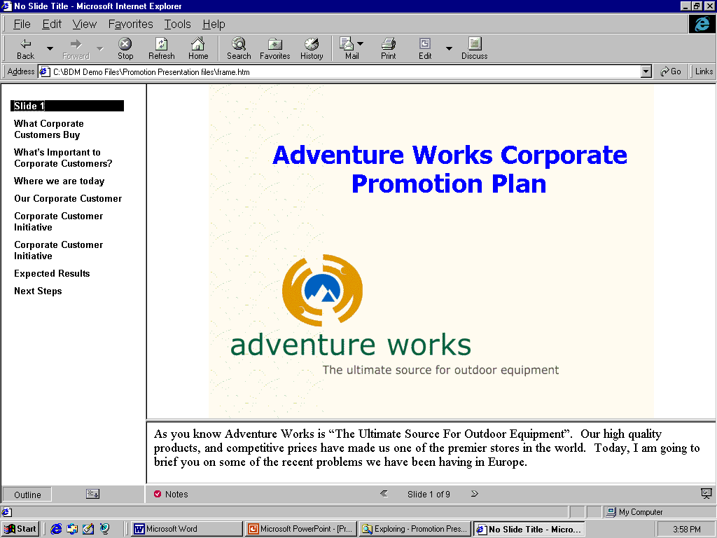
- Click on the Notes button on the toolbar at the bottom of the screen. If there’s a check mark in a red circle, there are notes for that slide.
- To see the presentation in Slide Show mode, click on the Full Screen Slide Show button at the far right end of the toolbar at the bottom of the screen.
- To advance a slide, click the mouse. To escape Full Screen Slide Show mode, press the ESC button, or click the mouse when you see the black screen slide.
- If you have a browser by a different manufacturer, view the presentation in the other browser as well.
Note: if this is not IE 4.0 or higher, you may need to publish the presentation again and choose the browser in the Publish dialog box.

Data Access Pages
With the increasing use of the Web, the Access team redesigned the concept behind Forms and Reports and built the ability to view and report on data from the ground up optimized for use on the Web. The result is a new feature known as Data Access Pages, which combines the ease of use of the popular Forms and Reports with a Web-based environment.
Although similar in function to the classic Forms and Reports, Data Access Pages are specifically designed to view, edit and report on data hosted within a browser. Users can design the pages easily in a manner similar to Forms and Reports but use new Web-enabled features and drag-and-drop capabilities. Data Access Pages are essentially HTML pages with the ability to maintain a live link to the data (in other words, the data is “bound”).
Unlike traditional Forms and Reports, Data Access Pages are stored as HTML files outside the Access database .mdb file. This allows users to easily send Data Access Pages through e-mail or post them on the Web as an HTML page.
Adventure Works is going to create a data access page to its HR address book. This way, users can easily look people up, and even have permission to change some elements of their own record. The development time and effort is very small. For the purposes of trying this feature, however, we will use the Northwind Sample Database to minimize the setup you would need to do.

You Try It!
- Start Access. The Northwind Sample Database should be listed in the File Open dialog box. Select it and click OK. If you are prompted to install it, click Yes. Make sure you are connected to the original source. Click OK at the Northwind start up screen.
On Windows NT Workstation, if you are using profiles, you may need to browse to C:\Program Files\Microsoft Office\Office\Samples, where C: represents the drive Microsoft Office is installed on.
- Click OK on the start up screen for Northwind database.
- Click on the Pages button in the Objects bar, and double-click on Create data access page by using wizard. Again, if prompted, install the feature.
- In the Tables/Queries dropdown, choose Query: Products by Category.
- Click on the button with two arrows to add all fields.
- Click the Next button three times.
- Select Open the Page.
- Click the Finish button.
- Click on the Forward button in the record bar to see that the form works.
- To preview it in your browser, choose File, Web Page Preview.
- Click Yes to the prompt about saving the file.
- Click on the Web Folders button in the Save in: bar.
- Double-click on the Guided Tour folder.
- Enter the text "Products" in the File name: box (don't type the quotes).
- Click the Save button. If you get a warning dialog box, click Yes.
- Use the buttons in the record bar to scroll through the data.
- Close the browser.
- Close Access.

Connectivity to Enterprise Data
Connectivity to business-critical data is very important for organizations, and information technology (IT) professionals want to provide easier, more timely access to information for their users. Microsoft has made significant advancements in Office 2000 to address this issue and expand the capability of using Office as a front end to corporate data, no matter where it resides.
Microsoft Excel 2000 uses a client/server approach to provide fast access to large server-based data stores. This includes support for Decision Support Services (DSS), a new Online Analytical Processing (OLAP) capability that is provided as a component of Microsoft SQL Server 7.0.

Office Server Extensions (OSE)
Office 2000 uses Office Server Extensions (OSE) to provide a bridge between current Web technologies and the functionality needed to make the Web a friendly place to work with people and information. Office Server Extensions is a collection of FrontPage extensions and other technologies that live on an HTTP server to provide additional publishing, collaboration and document management capabilities. When OSE is present on the server, it enhances the functionality of Office 2000, the Windows Explorer and the Web browser. OSE does not replace existing Web server technologies. Rather, the extensions in Office 2000 are designed to enhance the user experience with Office in a Web-based environment.

Web Folders
Office 2000 enables users to manage HTTP server file operations directly from the Windows Explorer. Users can create folders, view properties, and perform file drag-and-drop operations. Web folders are displayed as top-level folders within the Windows Explorer. In the Windows Explorer, users can drag and drop files on Web servers just as they would on normal file servers. In the browser, Office Server Extensions enables on-the-fly display of Web directory listings, files and HTML views of Web folders.

You Try It!
- Start the Windows Explorer.
- Scroll down the left pane until you see Web Foldersand click on it so select it.
- In the right pane you should see at least Add Web Folder. You may see some other folders as well.
- Double-click on Add Web Folder.
- In the text box, type "http://ServerName/msoffice". Do not type the quotes, and replace the text "ServerName" with the actual name of the server where you've installed the Office Server Extensions.
- Click the Next button.
- Enter the text "Guided Tour" for the name of the web folder.
- Click the Finish button.
- In Windows Explorer, double-click on the Guided Tour folder. You should now see all of the web files in the right hand pane, just as you would see regular files on a file server.
- Start Internet Explorer 5.0.
- In the Address box, type in "http://ServerName/msoffice". Again, don't type the quotes and replace "ServerName" with your actual server name.
- You should see the Office Server Extensions Start Page. There is a lot of functionality here, including a method for non-Internet Explorer 4.01 and higher users to participate in Web Discussions (covered in the next section).
- Click on the Browse Web Folders hyperlink.
- This is the default Web Folders view from the browser. It can be customized to match your intranet. You can filter on specific file types. The default is to filter on web pages and Office document types. On webs with more items, this can greatly simplify looking for an Office document by being able to filter out image files and other extraneous files.
Note: if you move or delete files on a web server with FrontPage Server Extensions or Office Server Extensions, the FrontPage Link Fix-up feature will automatically fix any links to that page without webmaster intervention.

Web Discussions
With the Office Server Extensions installed on a Web server, users can have discussions in both native Office 2000 documents and HTML files. Discussions can be added either through an Office application or through the browser using a special toolbar supplied by Office Server Extensions. The discussions can be made in-line in the document or as general discussions about the document, which are stored in the discussion pane at the bottom of the page. Using the Discussions toolbar, users can insert new comments; navigate through, edit and reply to existing comments; subscribe to a particular document; and view or hide the Discussions window.
At Adventure Works, the marketing group is using web discussions to review new products and marketing programs for them.

You Try It!
- Switch to Word 2000.
- Open \\GuidTour\Promotion Plan.
- Choose File, Save As…
- Click on the Web Folders button in the Save in: pane on the left.
- Double-click on Guided Tour.
- Click the Save button.
- Choose Tools, Online Collaboration, Web Discussions.
- The first time you do this, you will be prompted to tell Word which discussion server you are using. Enter the name of the server where you installed Office Server Extensions, and enter a name for yourself.
- Click OK.
- At the bottom of your screen, you'll see the Discussions toolbar.
- Select the text "Reduce Prices on Big Ticket Items" and click on the Insert Discussion in the Document button.
- Enter a title for the discussion such as "Reducing Prices", and a comment, such as "We'd better make sure we're still making a profit and that we know when prices will go back up."
- Go to another client computer.
- Start IE 5.0. For the web address, enter "http://ServerName/msoffice".
- Click on the Browse Web Folders hyperlink.
- Click on PromPlan.doc. If you get a message that the file is locked for editing, click on the Read-only button.
- Click on the Discuss button on the main IE toolbar at the right hand end.
Note: If the Discussion Toolbar doesn't turn on when click on this button, you are using Beta 2 or earlier. Instead, Start Word and open the file using the Web Folders button.
- Click on the Discussion button at the end of the comment.
- Choose Reply.
- Enter some text for your response.
- Go back to the first computer.
- Refresh the page. On the Discussions toolbar, choose Discussions, Refresh Discussions. You should see the comment you just added on the other computer.

Web Subscription and Web Notification
Collaboration on the Web is much simpler with Web Subscription and Web Notification features. Office 2000 gives users an opportunity to “subscribe” to particular documents on a Web server and to be automatically “notified” by e-mail when status of selected documents changes. Users can choose to be notified when a document changes, is created or deleted. They can be notified immediately, once per day, or even weekly to prevent undue amounts of e-mail in cases where a document is changed several times in a short period. In addition to e-mail notification, users can also add a given document to an Internet Explorer channel to receive updates through a browser.
A product manager at Adventure Works has created a new promotion plan for a new product and wants to get feedback from her team members.

You Try It!
- Continue from the previous exercise in the PromPlan.doc file (from either Word or Internet Explorer 5).
- Click the Subscribe… button on the Discussion toolbar.
- Leave most of the settings the way they are, but change the Time to when a change occurs. Click OK.
- Go to the other client computer you were using and add another comment anywhere in the PromPlan.doc document discussion.
- Go back to the first client computer. Start up Outlook and log into e-mail as the user who subscribed to the discussion. You should see a notification e-mail soon.

Web Components
Office 2000 includes a number of features designed to improve its place as a corporate reporting tool. Office 2000 includes three new Office Web Components — Spreadsheet component, PivotChart™ component and PivotTable component — that make corporate data available through a browser. The Spreadsheet component provides basic spreadsheet functionality in the browser, allowing users to enter text and numbers, create formulas, recalculate, sort, filter and perform basic formatting. It supports frozen panes for keeping header rows and columns visible while scrolling through data, as well in-cell editing and resizable rows and columns. The PivotChart component provides interactivity and automatic updates as the underlying data changes. The PivotTable component is very similar to PivotTable views in Excel and provides a dynamic way to view and analyze database information in the browser. The PivotTable component is created in either Microsoft Access or Excel and resides on a Data Access Page. This component lets users browse report data, dynamically sort and filter it, group it by rows or columns, create totals and focus on the details behind the totals. It helps users work efficiently with large or small amounts of data. Though the author of the Data Access Page decides what will be the initial view, the user can access the Field List Chooser to drag and drop the dynamically linked fields directly onto the page.
In this particular case, a product manager at Adventure Works is trying to understand how her competitor’s latest promotion has affected sales of her product. Once she has done the analysis, she can publish it to the web without concerns about platform compatibility, and can allow all of her colleagues to view the data.

You Try It!
Note: this exercise requires a SQL 7.0 OLAP data source.

- Get external data for a PivotChart and PivotTable.
  - Start Excel. Use the blank workbook that opens.
  - Choose Data, PivotTable and PivotChart Report…
  - Choose External Data Source.
  - Choose PivotChart (with PivotTable)
  - Click the Next button.
  - Click the Get Data… button.
  - Click on the OLAP Cubes tab.
  - Select <New Data Source> and click OK.
  - In step 1 of the dialog box, enter the text "SALES" (don't type the quotes).
  - In step 2, select Microsoft OLE DB Provider for OLAP Services.
  - In step 3, click the Connect… button.
  - Choose OLAP Server.
  - Type the server name. This is the server where you've installed SQL 7.0 and OLAP Services, including the sample databases.
  - Click the Next button.
  - Select Foodmart.
  - Click Finish.
  - In step 4, select the Sales table. The completed dialog box should look like the following:
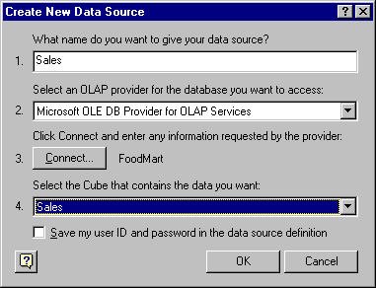
  - Click OK twice.
  - Click the Next button.
  - Select Existing worksheet.
  - Click Finish.
- Create the PivotChart
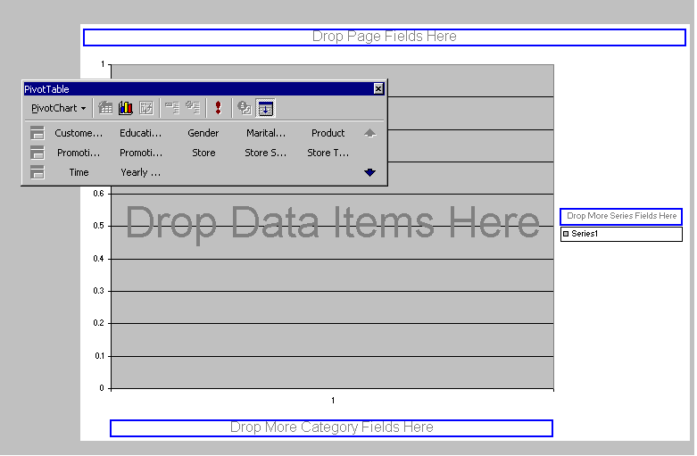
  - From the PivotTable Toolbar, drag the field "Store Type" to the box with the text "Drop More Series Fields Here".
  - From the PivotTable Toolbar, drag the field "Profit" to the box with the text "Drop Data Items Here". You may need to click the downward arrow in the toolbar to see this field.
  - From the PivotTable Toolbar, drag the field "Store Sales" to the box with the text "Drop Data Items Here".
  - From the PivotTable Toolbar, drag the field "Time" to the box with the text "Drop More Category Fields Here".
  - Click on the downward arrow to the right of the field "Year" at the Category axis.
  - Click the plus sign to the left of 1997 and click on the check box once so there are two checks in it. All quarters should have single check marks as well.
  - Do the same for 1998.
  - Click OK.
  - Your PivotChart should look similar to this:
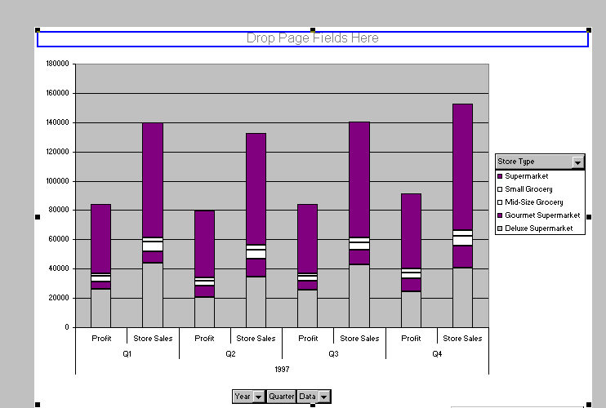
- Publish an interactive PivotChart to the web.
  - Choose File, Save as Web Page…
  - Click on the Web Folders button in the Save in: bar on the left.
  - Double-click on the Guided Tour folder.
  - Click on the Publish… button.
  - Click on the "Add interactivity with" check box.
  - Click on the "Open published web page in browser" check box.
  - Click on the Publish button. This is now a PivotChart Web Component published in a web page.
  - To check this interactivity, click on the Field List toolbar button between the PivotChart and the PivotTable.
  - In the PivotTable field list, scroll down to Time. Click to expand it.
  - Click on Quarter, and click the Add to button.
  - In the PivotTable, click the plus sign next to 1997 to expand it, and notice it expand in the PivotChart as well.
  - Close the browser.
  - Close Excel.

Outlook Today
The Outlook® 2000 messaging and collaboration client gives users the power to manage e-mail, calendar and task information in one place. The innovative new Outlook Today view gives users a customizable quick overview of upcoming meetings, tasks due and how many e-mail messages have arrived overnight — all without switching between windows.
Users can easily customize Outlook Today, including options for how many days of appointments to display, what folders to display, how many tasks to display and how to sort the tasks. And, because the Outlook Today view is defined using HTML, corporate IT departments can optionally deploy a customized Outlook Today view that includes dynamic information specifically tailored for their company or workgroup.
The IT Organization at Adventure Works is using Outlook Today to keep up links to the pages that answer the most frequently asked help desk questions, reducing their support costs on minor issues and freeing up the queue for tougher questions.

You Try It!
- Start up Outlook.
- Click on Outlook Today in the Outlook bar on the left to see what it looks like.
- Customize Outlook Today to add a link to the previously created Data Access Page.
  - Open the Outlook Today source file by starting Internet Explorer and going to the following URL:
res://C:\Program Files\Microsoft Office\Office\1033\Outlwvw.dll/outlook.htm
Note the forward slash after the .dll file name. If you installed outlook to a non-default directory, you must change the file path to the URL.
  - When you open the page in Internet Explorer, it may generate a script error because it is not being hosted within the outlook windows. Ignore this error. The Outlook Today HTML page will then display (without the graphics and data tables).
  - On the View menu, choose Source to open a copy of the Outlook.htm source file in Notepad.
  - In Notepad, go to the File menu and choose Save As. Make sure you name it and save it as an *.htm file and not as a .txt file.
Note: Because Outlook Today uses specialized layout properties and scripting, editing the page in graphical HTML editors may alter or damage it. Using a text editor is recommended.
  - The text "Display:none" appears three times in the file. Choose Search, Replace from the menu and replace "Display:none" with "Display:" all three times.
  - When you open the page in Internet Explorer, the images do not appear because their href properties assume they are in the same directory as the main Outlook Today page. Restore these images by adding a base href to the page in the head section:
<head>
<base href="res://C:\Program Files\Microsoft Office\Office\1033\Outlwvw.dll/outlook.htm
</head>
  - Create a simple customization by adding a hyperlink to the file. Below the <head>, </head> section, add the following line:
<a href=http://www.microsoft.com target="_new">Microsoft</a>
This adds a hyperlink near the top of the page to Microsoft.com that launches the link in a new browser window rather than in Outlook. Feel free to substitute your own link and format this link if you are familiar with HTML.
  - Close Notepad and save your changes.
- Add the correct setting to your Windows registry.
  - Run regedit by choosing Start, Run, type "regedit" and click OK.
  - Locate the following registry subkey:
HKEY_CURRENT_USER\Software\Microsoft\Office\9.0\Outlook
  - If the Today key does not exist, add it by selecting the Outlook key and choosing Edit, New, Key and entering "Today" for the name. Do not type the quotes.
  - Add a string value by selecting Today and choosing Edit, New, String Value.
  - When prompted, name the value Url (this value is case sensitive).
  - Double-click on the key to enter a value. The value should be the URL to the Outlook.htm file that you saved earlier. For example, it might be
file://C:\Guided Tour\Outlook.htm
  - Close Regedit.
- Start Outlook and click on the Outlook Today button in the Outlook bar on the left. You should see the hyperlink at the top of the page. Click on the hyperlink to see if it works.
- Close Outlook.
Note: For more details on customizing Outlook Today, including how to create a customized Outlook Today that would reside on a web server, see the Outlook 98 Deployment kit.

Presentation Broadcasting
PowerPoint® 2000 presentation graphics program uses Microsoft NetShow™ technology to enable broadcasting of presentations to a wide audience over an intranet.
NetShow uses streaming multicast technology to distribute a live or recorded audio and/or video broadcast over an intranet. PowerPoint 2000 adds ease of use to the technology of NetShow to allow broadcasting presentations directly from within PowerPoint. A camera is not required but video is supported if used. Since the presentation is sent in HTML, all the audience needs is a browser to view it on PCs, Macs or UNIX workstations. This could be used, for example, for company meetings, presentations to remote groups, or a team meeting at several different locations. No browser is needed for the presenter, but Internet Explorer 4.0 or higher is required for the audience. A NetShow server is required for audiences of 16 or more.
Presenters can schedule a presentation just like any other meeting using Outlook 2000. A Lobby Page is automatically generated and available when the audience is ready to tune in. When the presenter is ready to start the broadcast, the presentation is saved in HTML format and copied out to the specified server location. If a NetShow server is set up, the pages will be multicast automatically. As the audience tunes in to the Lobby page for the event, the HTML pages will be cached on members’ machines. When the presenter begins a separate multicast stream with audio, video (if present) and the slide navigation commands will be sent to the audience. Viewers are also free to join in after the meeting has started.
Adventure Works uses presentations broadcasting for training on new products without having everyone travel to the same location.

You Try it!
- On the computer that will be broadcasting the presentation, start up PowerPoint, and choose Slide Show, Online Broadcast, Setup and Schedule…
Note: you may be prompted to install this feature. Also, the computer doing the presenting must have a microphone and a working audio driver. You can set up the broadcast on a computer that doesn't, as the settings are stored with the presentation, but you must have a microphone on the computer that is broadcasting.
- Click OK when you get the Broadcast Schedule dialog box.
- Enter a title and description in the dialog box.
- Click on the Broadcast Settings tab and the Server Options… button. You'll need to specify a share location. Use the Browse button to enter a share location. If you need to enable video or reach more than 15 viewers, you'll need to specify a NetShow server as well. Click OK.
- Click Schedule Broadcast. If you chose to not use a NetShow server, you will get an alert dialog telling you that a maximum of 15 users will be able to watch the broadcast and asking you to confirm that that is what you want. Click Yes.
- PowerPoint will now launch your e-mail client and you will need to invite at least on attendee. Change anything about the message that you need to, including the start time. Click the Send message when you've completed it.
- If you are ready to go, choose Slide Show, Online Broadcast, Begin Broadcast…
- On another computer, log on as the user you sent the message to. Check your email. Open the message for the broadcast and accept the invitation. If you are within 15 minutes of the start time for the broadcast, you will not get a reminder, so just click on the event address URL contained in the body of the message.
- Or, you will get a reminder 15 minutes before the broadcast begins. Click the View Broadcast button, which will take you to the lobby page in your browser. You will see a countdown, and when the broadcast begins, it will be shown in your browser.
- On the presenter computer, click the mouse or press the page down key to advance the slide. In about 10 – 20 seconds, you will see the slide advance on the audience computer.

For more information: http://www.microsoft.com/office/



© 1999 Microsoft Corporation. All rights reserved.
The information contained in this document represents the current view of Microsoft Corporation on the issues discussed as of the date of publication. Because Microsoft must respond to changing market conditions, it should not be interpreted to be a commitment on the part of Microsoft, and Microsoft cannot guarantee the accuracy of any information presented after the date of publication.
This document is for informational purposes only. MICROSOFT MAKES NO WARRANTIES, EXPRESS OR IMPLIED, IN THIS DOCUMENT.
Microsoft, Intellimouse, NetShow, the Office logo, Outlook, PivotChart, PivotTable, PowerPoint, Windows, and Windows NT are either registered trademarks or trademarks of Microsoft in the United States and/or other countries.
Other company or product names herein may be the trademarks of their respective owners.
Part number here

The Office Advisory Council is a small group of corporate customers, representing a cross section of industries and organization sizes, who participate in design reviews during the product development process.

