Microsoft® Office 2000
Extending File Server Document Solutions with Intranet-based Web Solutions

By Cindy Leong and Carl Grzybowski, Unisys Corporation

Published: April 1999
For the latest information, please see http://www.microsoft.com/office/

Introduction
Office 2000 provides all the necessary tools for creating a dynamic and collaborative environment where users can be both surveyors and creators of knowledge and information.

In Focus

Enterprise
A growing Consulting Practice organization within a very large, global information technology and services company.

Network/Applications
The Windows® 95/98 and Windows NT® 4.0 Workstation and Server operating systems, Microsoft Exchange Server, Microsoft Internet Information Server (IIS) 4.0⎯the Web server built into Windows NT Server, and Office 2000.

Challenge
The Consulting Practice consists of highly mobile professionals accessing the company’s WAN via notebook computers from either their home offices, customer sites, or from one of the many worldwide office locations. The geographically dispersed nature of this organization, coupled with the ineffectiveness of their existing applications and systems, makes knowledge transfer and the ability to collaborate on projects extremely difficult. Also, other departments have limited awareness of the Consulting Practice organization. Finally, the highly structured consulting methodology and framework serves as the cornerstone for much of the group’s project success. To address these issues, Unisys needs to establish a workspace where all project deliverables can be developed and leveraged in a highly consistent and efficient manner.

Solution
Using the features and functionality of Office 2000 and the Office 2000 Server Extensions, Unisys set out to extend the capabilities of a traditional file server-based document solution to a more interactive intranet Web-based solution that encourages collaboration and that serves as a catalyst for supporting workgroup and business processes.

Overview
The widespread emergence of intranets has caused organizations to migrate away from the traditional file server-based document libraries to intranet Web-based solutions. Rather than simply storing content on file servers and hoping that they are located and updated, or relying on e-mail attachments to distribute documents to the masses, the intranet has provided an entryway into a new paradigm for employees working together and communicating.
Additionally, Web sites today are most frequently developed for an enterprise by a relatively small number of designated Webmasters who have a specific role to fulfill. However, as intranets are more and more becoming the standard for dissemination of information, all users will need to become both content producers and content consumers if they are going to be able to leverage and benefit from the information and knowledge of the enterprise. Given the ease of saving documents with Office 2000 Server Extensions, as well as the added benefits of indexing, searching, and embedding threaded discussions, it is anticipated that soon all documents will be stored on a Web server. Office 2000 provides the necessary tools for users to fully exploit and take advantage of what the Web and the intranet have to offer.
The following sections illustrate how one Office 2000 Rapid Deployment Program (RDP) customer, Unisys Corporation, took advantage of Office 2000’s enhanced capabilities to improve upon some of their existing business processes. This chapter provides insight into how Office 2000 served as the underlying toolset and common denominator for extending an existing file server-based document solution with an intranet-based Web solution.

About the Enterprise
Like many large companies, Unisys has several independent business units that are scattered throughout various offices, and that are complemented by a vast network of sales, marketing, and support sites worldwide. The Consulting Practice organization consists of highly mobile professionals who are dispersed geographically and who rely on their notebook computers for access to needed information and resources, as well for communicating with other employees.

Business Opportunity
For many years the common practice for sharing information and documents between users and groups was to store them on a shared volume on a file server, or to send attachments to multiple users via e-mail. The concept of workflow and workgroup collaboration quickly proliferated. As a result, several years ago Unisys decided to implement a document store using commercial groupware software. The groupware application allowed the company to create “virtual team rooms” (VTR) where different organizations could store and share documents, fill out forms, and post discussions and comments.
However, as Unisys grew, so did the number of servers and databases, as well as the amount of replication. Additionally, users had to be explicitly granted access to use a particular database. With the large number of organizations and VTRs, finding the right database often became quite a chore, and finding a document was even more tedious.
Furthermore, because of the dispersed nature of the company and the mobility of the Consulting Practice group, collaborating together and communicating information effectively among the various business units, and even within the same Consulting Practice, continued to be extremely challenging and almost non-existent. For example, marketing and sales have little insight into what the Consulting Practice group can deliver and the service offerings they provide. Additionally, to comply with the consulting methodology framework, project deliverables need to be consistent across the Consulting Practice group and quickly leveraged from project to project. Collaboration and feedback among consultants are difficult to obtain under the current process, and productivity is less than optimal as a result of the amount of effort involved in locating and disseminating information and feedback.
The following list highlights some of the drawbacks that result from current business processes and that could be improved upon:
- Dissemination of project information to other consultants relies heavily on the use of e-mail, with many broadcasts of large document attachments. For remote laptop users, this can be very time consuming and wearisome.
- Consistency and standardization of project deliverables are hard to maintain, as multiple copies of documents and templates exist on various systems.
- Access to project information is difficult to achieve under the current system unless the respective database or location of information are known and permissions are explicitly granted to allow the appropriate access.
- Visibility to other departments of the Consulting Practice group’s methodology, service offerings, and success stories is limited or, in some cases, non-existent.
- Workgroup collaboration, where discussions and feedback can be obtained or freely published, is not promoted.
- There is no convenient way to access individual work files from any location.

User Roles
The following are users at Unisys and the parts they play in the intranet project.
- Consulting Practice Manager - Maintains methodology templates and project deliverables (Consultants’ Toolbox).
- Consulting Practice Team Members- Creates and modifies project deliverables, and manages the technical forum.
- Sales and Marketing - Needs access to project deliverables, as well as the ability to incorporate Sales and Marketing Collateral.
- Corporate User (from other organizations of the company) - Needs visibility into the Consulting Practice organization, such as project success stories, Service Offerings, as well as the methodology behind the success of the Consulting Practice organization.

Project Vision
Unisys views Office 2000 as the catalyst to improving its existing business processes. The vision is that all employees will be able to conveniently publish information and access it from any workstation on the intranet. The single location will be seen as a one-stop personal workspace that is secure and reliable. Easy to use search tools will allow employees to locate documents by many file properties such as author, file type, date modified, and subject categories, as well as to hierarchically browse directories. The documents can be viewed, edited and saved from within a Web browser. The intranet-based Web document solution will provide a common user interface and render an intuitive navigation model. It would replace the inconsistent and confusing array of documents stored on individual workstations, multiple file servers, and database repositories.
When employees want to share information contained within a personal directory, only the URL will need to be sent. Large attachment downloads are avoided. More employees will be able to publish content that is dynamic and that can be viewed incrementally. In addition, users will be able to subscribe to the documents to automatically be informed about any change. Documents contained in shared project and team resources will host discussion and support version control. The consistent content placement and work patterns will mean greater convenience for our employees, partners, and customers to communicate and learn.

Project Goals
In moving from static, file server-based document storage and database systems to a dynamic intranet Web-based solution, Unisys has set the following goals:
- Support geographically independent collaboration among members of workgroups.
- Reduce e-mail broadcasts containing large attachments.
- Reduce dependency on individual workstations, as well as duplicate storage of information.
- Enhance ability to publish and deliver content.
- Institute services and information placement that will guide individuals’ patterns of working and thinking.
- Improve employees’ and teams’ ability to learn, share information, and make better decisions.
- Provide enterprise search and knowledge management and retrieval capabilities making it easier to navigate and find information relevant to specific business objectives.

Project Scope
This project involves the following elements:
- Engage in the discovery and needs assessment phase for Unisys.
- Identify functional business and technical requirements.
- Assemble project team and develop the design and deployment strategy.
- Establish the functional design of the intranet Web-based solution.
- Establish the infrastructure to support the intranet Web based solution and install the Office 2000 Web components and support pages.
- Populate directories with existing content.
- Add search, browse, and authorization services.
- Evaluate functionality and prepare strategies for extended deployment.

Assessing the Environment
The user environment for Unisys basically consists of two classifications: the highly mobile Consulting Practice organization that connect to the corporate WAN via their laptop computers, and the corporate desktop users that are typically based in one location. The Office 2000 intranet Web-based solution Unisys developed satisfied specific business requirements that were relevant to each of the user environment groups.

Assessing End-User Requirements and Constraints
The following subsections describe the intranet requirements and constraints of the two basic groups at Unisys.

Consulting Practice Requirements
Consulting practice requirements for Unisys are that:
- Users need the ability to easily publish, modify, and give feedback on project deliverables and templates.
- Users need the ability to easily locate and download needed information.
- Users need to be up-to-date on project status, announcements, and events.

Consulting Practice Constraints
Consulting practice constraints for Unisys are that:
- Users are predominantly mobile, utilizing their laptops to connect to the WAN from a remote location.
- Users are geographically dispersed, spanning various regions of the country.
- Multiple projects may be in progress or under development concurrently, and may be initiated out of any one of the worldwide corporate offices.
- Not all users are on Microsoft Exchange.

Corporate User Requirements
Corporate user requirements for Unisys are that:
- Users need access to the Consulting Practice group’s marketing collateral and service offerings.
- Users need visibility into the Consulting Practice group’s project information and project success stories.

Corporate User Constraints
Corporate user constraints for Unisys are that:
- Some users may be running earlier versions of Microsoft Internet Explorer.
- Not all users are on Microsoft Exchange.
- Compatibility with existing application and templates must be maintained.

Assessing Data Access Requirements
The majority of data content that needs to be accessed will come in the form of HTML or Word documents and templates, Microsoft Excel spreadsheets, and PowerPoint® slides.

Assessing the Network Environment
Major site LANs are interconnected with a high-speed network utilizing the leading technologies and services that are appropriate for a given geography (i.e., private line, Frame Relay, and ATM). In addition, the WAN provides Virtual Private Network access gateways to support mobile and telecommuting employees connecting in from the Internet.
Microsoft Windows NT Server version 4.0 is currently the standard network operating system for Unisys. Based on the large user population and need for centralized administration capability, the network environment is based on a multiple master domain model, with a total of seven master account domains servicing the domestic and international offices. Domestically, there are three distinct master account domains that support the East, Central and West Coast regions of this continent. A large number of resource domains exist throughout the various office locations and provide network users with file, print, and application level services.
Equipment for Unisys’ Web infrastructure is distributed among the three worldwide data centers. This ensures an added degree of reliability and fault tolerance. Web servers range in task from hosting the official company Web site, to accepting customer orders (electronic commerce), to serving as departmental servers for small workgroups.

Planning and Design
Bringing up a new intranet Web site is very easy to do, but integrating it into an existing corporate IT infrastructure and incorporating the proper security measures require thorough planning and coordination. Some of the factors that Unisys considered were as follows:
- Corporate LAN/WAN architecture.
- Placement of the production intranet Web site after development and lab testing.
- Network security and user access permissions.
- Administration and backup of the Web site.
- Network traffic and performance.
- Server sizing and hardware requirements.

Corporate Web Standards and Policies
Identification of any corporate Web standards and policies was also a very critical step associated with the introduction of a new intranet Web site into the existing corporate IT infrastructure. For the most part, this involved compliance with corporate standards on the interface, and ensuring that navigational links, graphics, and page headers and footers were consistent throughout other corporate Web sites. It also involved the acquisition of standard font types and pitch sizes, as well as approved company and vendor logos and graphics. Compliance with corporate Web standards and policies also served to help minimize any effort associated with transitioning the support and administration of the new Web site to the corporate IT support organization.

Web Design and Deployment Plan
Another critical step to the design and planning process was in clearly defining a set of goals for what this intranet Web site would accomplish. Without a clear statement of purpose and objectives, it is easy for an intranet Web site project to lose focus and fail to meet a company’s business requirements. Careful planning and clear objectives are key to successfully building a Web site, particularly if it needs to obtain approval from Corporate IT and involves the work of a project team.
As a result, in order to provide insight into the requirements of this Office 2000 intranet Web-based solution and to help identify any key deployment issues that would prevent the rapid deployment of this new solution, Unisys created a Web design and deployment plan.
The intent of a Web design and deployment plan is to bring some awareness of the project to other organizations and to IT groups within the company. The Web design and deployment plan should contain:
- Identification of the target audience.
- Statement of purpose for the Web site.
- Description of the main objectives for the Web site.
- Contact information on the Webmasters and project team members.
- Network and server requirements for the Web site.
- Milestones for creation of the Web site.
- Content description and requirements.

Documents and Templates
Another important step to the planning and preparation process was in acquiring all of the required documents, templates, and presentation files that would need to be available from this Web site for downloading or browsing. Additionally, any informational material that assisted in populating the content/descriptions for each Web page was also gathered.

Functional Design
The functional design phase involved thinking through the process of how the intranet Web site would be structured and organized, keeping in mind the purpose and main objectives of the Web site, who the audience would be, and how they would use and benefit from this site.

Employee Workspace
A major result of extending file server functionality to intranet-based Web folders was the elimination of the need for a traditional file server or database repository to store most documents. With this in mind, one aspect of the intranet Web site design was to establish an area where each employee within the Consulting Practice could store and maintain personal documents while letting those with appropriate permissions access and engage in discussions on particular documents.
Similar to having a private, “home” directory on a file server for each user, each user was provided with a set of individual folders with varying degrees of access permissions. For example, each user had their own “inbox” folder to which other users had only write-access permissions so they could submit documents. Each user also had a “private” folder to which only that user would have access. Lastly, a “shared” folder was created that allowed read and write access to other distinct users or members of the Consulting Practice group. The shared folder provided a vehicle for members of the Consulting Practice to share documents and obtain feedback from others. By utilizing the Web subscription features of Office 2000, users had the ability to receive notification via e-mail of when someone modified the contents of their shared folder.
The new Office 2000 browse folder functionality was utilized to provide a link from the staff page to the individual directories for that specific user. Figure 1 depicts the concept of extending file server functionality by creating an “active” workspace for each employee through the use of Web folders.
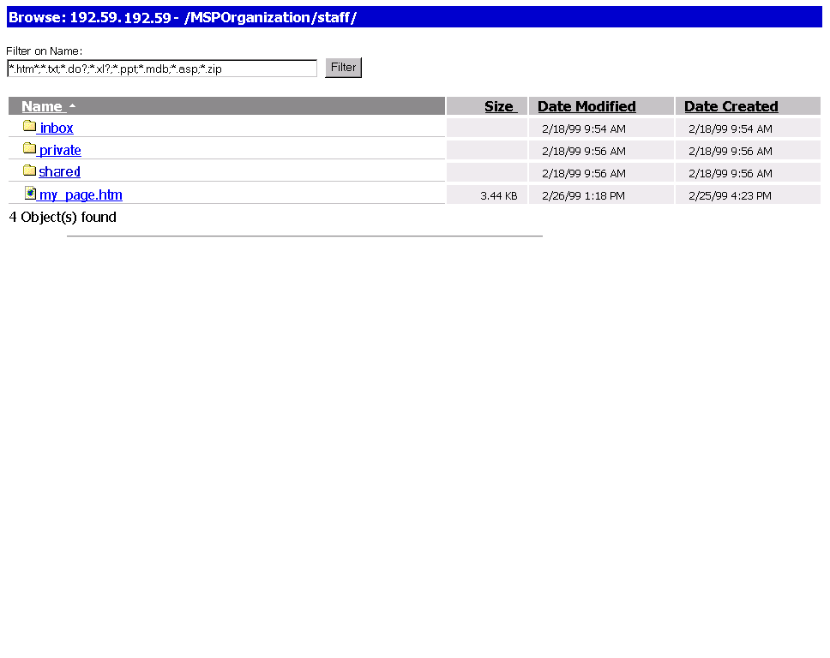
Figure 1: Employee Workspace via Web Folders.

Workgroup Collaboration
Another major design goal was to develop a workspace where members of the Consulting Practice group could interact with one another on projects and work as a team. This resulted in the creation of a “Scopes In Motion” area that served as a working ground for collaboration and development of new project documents up until project completion. Unlike the traditional file server environment, this aspect of the intranet Web-based solution focused on delivering a more dynamic and free-form environment were users could participate in on-going discussions on projects that are in progress, or interact and collaborate on project deliverables. Users can link to other documents within folders, and can also take advantage of the Web subscription feature of Office 2000 to receive notification by e-mail of any changes made to a file or folder.

Library
The intent of this area was to provide the Consulting Practice team members with a repository of information on clients, technology, and service offerings, as well as access to templates, white papers, presentations and support documents that could be easily leveraged and help expedite the development of project deliverables. Read and write access to this area was limited to specific members of the Consulting Practice Organization. Others were, for the most part, assigned read-only access.
Unisys used the extensive browse and search functionality built into the Office 2000 Server Extensions to provide users with the ability to browse the library folder and filter by any document type. For example, users may conduct a search by text, by date modified, or by author, on all text contained in the library (except zip documents). Additionally, users can filter by document type. Using the new categories feature in the FrontPage® 2000 Web site creation and management tool, it is also possible to present a complete list of all library documents sorted by document function (e.g., Sales and Marketing), or by document type (e.g. Word templates, Word documents, Excel spreadsheets, PowerPoint presentations and Zip files). Figure 2 shows an example of a filtered file search.
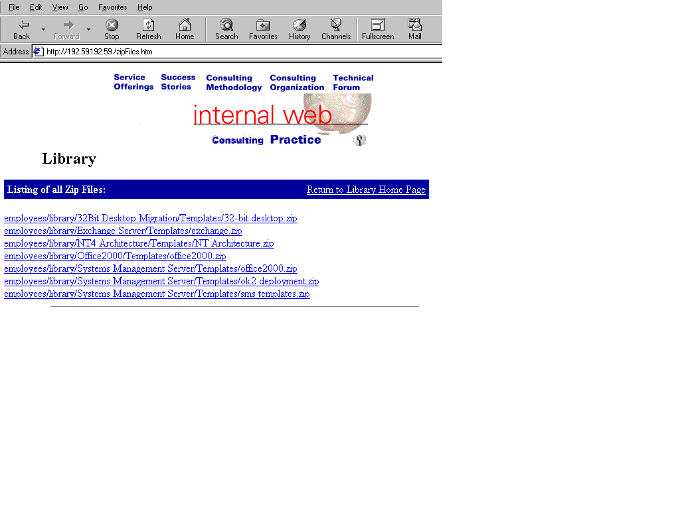 Figure 2: Example of a Filtered Search.

Enterprise Perspective
On an enterprise-wide level, some key design considerations of the Web site were to provide visibility and linkage into the Consulting Practice Web site from the company’s main intranet Web site and to provide navigation consistency according to corporate standards. Employees from other departments and organizations, such as sales and marketing, should experience the same look and feel as they move from one Web site to another, and they should have view and print access to the service offerings and success stories specific to the Consulting Practice. Search and browse features were also built into the design to allow customers to easily locate any reference material or documents and presentations that could be leveraged as sales or marketing collateral. Additionally, it became evident that clear access controls had to be implemented to manage permissions.

Implementation
The following sub-sections describe the process Unisys followed to implement the intranet Web-based solution and functionality outlined in the previous section.

Building the Framework
Before actual deployment of the intranet Web site, Unisys needed to build the framework. The following sections describe the steps Unisys took to prepare the intranet Web site.

Layout
The initial step in implementing the Consulting Practice’s intranet Web-based solution was to establish the initial framework for which the Web site would be designed. This involved using FrontPage 2000 to lay out the root page for the Web site, setting up the headers and footers, as well as placement of logos. Frames were not allowed since it is not a corporate Web standard at Unisys.

Directory Structure
The next step involved creating and organizing the overall directory structure for the entire Web site via FrontPage 2000. As much as possible, Unisys’ intent was to create a consistent and organized space for all content, where applicable. The objective was to create a set of normalized directories in advance. For example, for the individual employee workspaces, the same set of empty folders was consistently created for all employees. Although it is expected that employees will later create additional sub-folders/sub-directories within their own workspace, the idea was to establish a common ground for users to work from.
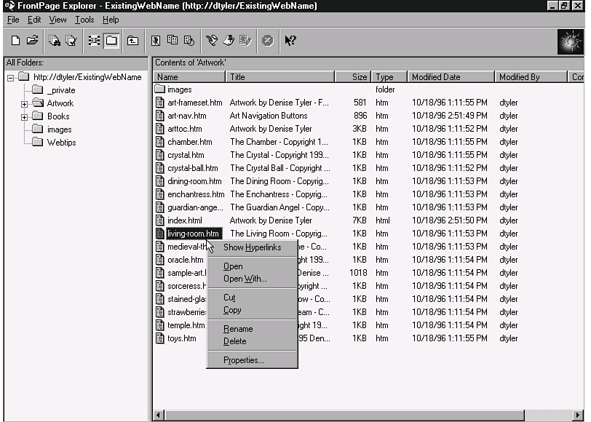
Another added benefit to establishing the directory structure first was to help organize the Web site and make it easier to maintain afterwards. For example, if a document or a Web page needed to be moved, changes were made as easily as dragging and dropping a document or a link to the new directory (as shown in Figure 3). Establishing an organized directory structure also enhanced the search capabilities of the built-in Office 2000 browse function and provided the ability to apply explicit permissions to individual folders based on specific needs.
Figure 3: The Directory.

Documentation
Another important step in implementing this project was the accumulation of all existing documents, templates, presentation slides and spreadsheets that would be maintained by this intranet Web-based solution. Part of the process also involved reviewing document naming standards and identifying how the document names would appear and what the document names would signify when users browsed or searched on documents. For example, while keeping file names as short as possible, it was still important to provide names that users could identify with while browsing. Furthermore, while conducting a search, a key benefit was taking advantage of a document’s property features and entering in a more useful and descriptive title under which the criteria for a search could be conducted. Figure 4 illustrates the benefit of using a document’s property summary sheet to input a descriptive and meaningful title.
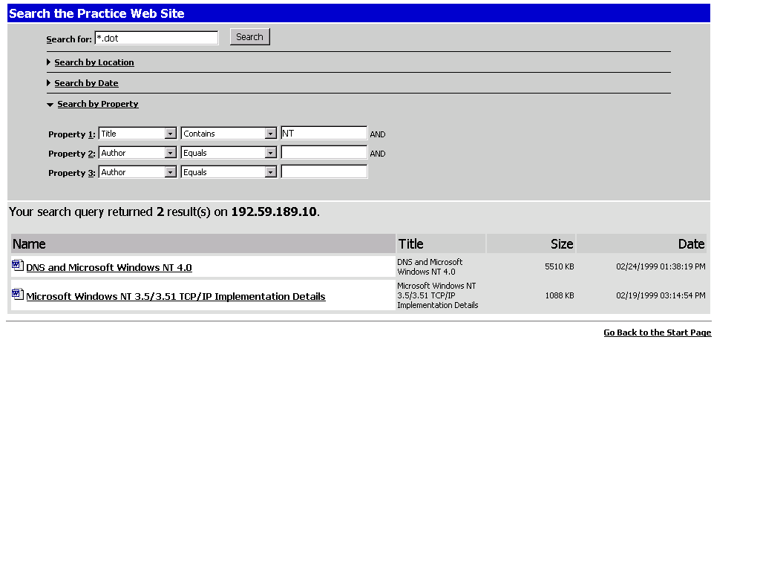
Figure 4: Benefit of using document titles and descriptions.
Another aspect involved the determining, according to usage requirements, the formats in which documents would be represented. For example, some documents would be opened mainly for viewing and printing purposes, while others would need to be downloaded and saved in their native format.
The Consulting Practice group operates by a structured consulting methodology and relied upon existing document templates to help them quickly and consistently develop project proposals and other deliverables. This determined the requirement for incorporating read-only and downloadable document template files. As a result, part of the functionality provided by the Library section of the intranet Web-based solution was the ability for members of the Consulting Practice group to quickly develop specific project documents. This was accommodated by providing the ability for a consultant to simply conduct a browse or search on a specific document template, based on the project type and project phase. Once the needed template file was located, the consultant could simply click on the filename to launch the document template in Word 2000 and begin typing. Since the file was a Word 2000 template file, the consultant would be required to give the document a new name associated with the new project engagement. The document could then be stored either locally on the consultant’s workstation, or saved on the Web server under the Scopes In Motion area, where the user could receive feedback and comments on the new document.
Lastly, file permissions were also specified on a file-level basis according to the file’s content and who or what group needed access to specific files. For example, limited read-and-write access to financials, management reports, and project deliverable templates were granted only to the executive management team of the Consulting Practice group, whereas all project deliverable template files had read-access permissions granted to members of the Consulting Practice group.

Authorization
With a consistent authorization approach, Unisys incorporated the usage of groups for providing permissions. Native Windows NT groups and underlying security were applied as well. The table below shows the groups that were established to manage access the intranet Web site.

Groups | Description
Team | All members of the Consulting Practice group.
Managers | Consulting Practice Managers.
Everyone | Any authorized user of the Domain (all other corporate users)
Sales and Marketing | Corporate Sales and Marketing Team

The following table shows the level of access that was assigned for the employee workspace area of the Consulting Practice intranet Web-based solution.
Folders | User/Groups | Permissions
Inbox | Everyone  Owner  Administrator | Write  Change (read/write/delete)  Full Control
Private | Owner  Administrator | Change (read/write/delete)  Full Control
Public | Everyone  Owner  Administrator | Read  Change (read/write/delete)  Full Control

The following table shows the level of access that was assigned for the workgroup collaboration area of the Consulting Practice intranet Web-based solution.
Folders | User/Groups | Permissions
Inbox | Everyone  Team  Administrator | Write  Change (read/write/delete)  Full Control
Public | Everyone  Team  Administrator | Read  Change (read/write/delete)  Full Control
Project x1,x2,x3 | Team  Administrator | Change (read/write/delete)  Full Control

The following table shows the level of access that was assigned for the library area of the Consulting Practice intranet Web-based solution.
Folders | User/Groups | Permissions
Service Offerings | Everyone  Sales and Marketing  Team  Administrator | Read  Read and Write  Change (read/write/delete)  Full Control
Success Stories | Everyone  Sales and Marketing  Team  Administrator | Read  Write  Change (read/write/delete)  Full Control
Private | Team  Administrator | Change (read/write/delete)  Full Control
Consulting  Methodology | Everyone  Team  Administrator | Read  Change (read/write/delete)  Full Control

Customization
To better satisfy project objects and adhere to corporate standards, Unisys made customizations to the Office 2000 intranet. The following sections describe those customizations.

Customizing the FrontPage Web
Unisys used FrontPage shared borders to create standard headers and footers that comply with corporate policies. Left side navigation was also created for all major element navigation pages. On pages where the search or browse functions needed to be focused, a directory scope was added to the URL. In FrontPage security, permissions for administer, author and browse were set.

Office 2000 Start Page
The Office 2000 Start Page is created automatically when the Office 2000 Server Extensions are installed. It resides in an MSOffice virtual file that is physically located in the program directory.
Based on some of the requirements for the Consulting Practice group, Unisys decided that the default Office 2000 Start Page did not need to be part of the Consulting Practice group’s home FrontPage-based Web site. Although the Office 2000 Start Page provides many beneficial features, it was determined that much of the functionality could be launched from other, more appropriate areas of the Web site. For example, the browse and search folders feature would already be available on every single Web page because those features were built into the standard headers and footers required by the Consulting Practice group. Furthermore, in the Consulting Practice’s Library section, the search and browse function included the directory location, which resulted in localized searching and browsing capabilities. Since the “add discussion” feature is only required for users without Office 2000, it would only add unnecessary confusion. As a result, it was placed into a separate location within “Help.” Additionally, the Subscription Management utility was placed into its own page.
Although this Web site did not heavily rely on the default Office 2000 Start Page, part of the design did include providing a link to it from within the Consulting Practice group’s own Help page. Additionally, the Office 2000 Start Page was customized by replacing the default black top header and associated default links with the Unisys standard header. Additionally, the default browse page utilized large unwieldy fonts for the path name and file details, so this was modified so that the sizes of the file details fit within the company standard width of 800 pixels. The current path name format was difficult to read so it was also shortened and placed within the title bar. Additionally, the existing default page came with three navigation buttons built in for Home, Up, and Search. As none of the other pages included this type of navigation within the content frame, it was simply removed. All of the functionality of those buttons could be achieved by using the header or the browser back button. Figure 5 below illustrates how the “Search Web Folders” Web page was customized both to comply with corporate standards and to simplify the appearance and functionality of the page.
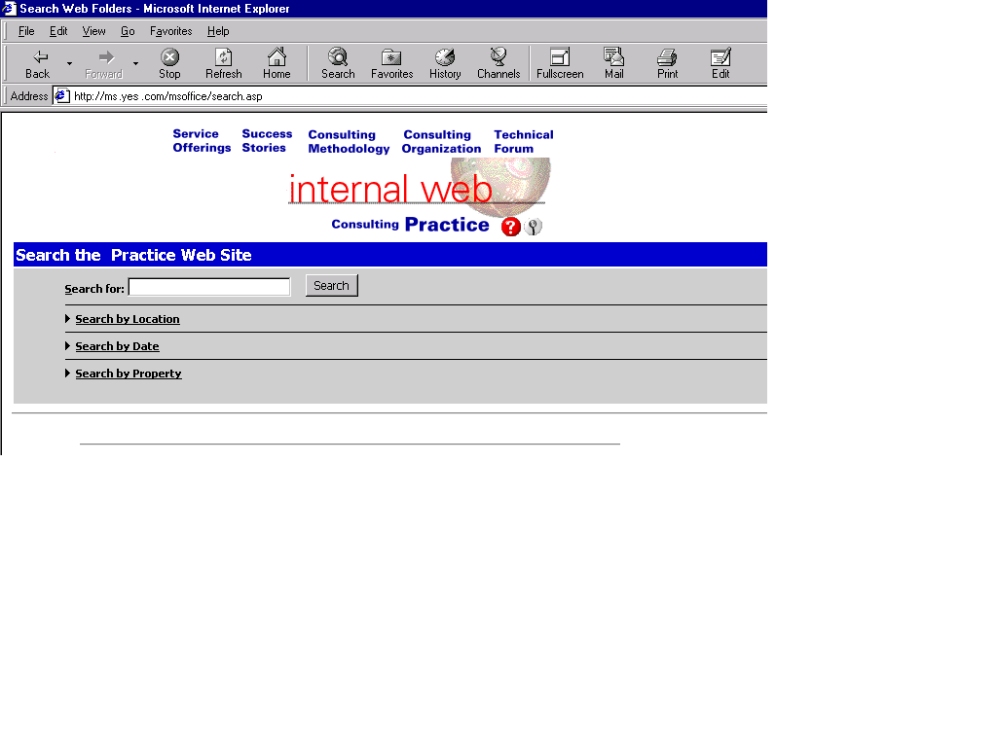
Figure 5: Customized “Search Web Folders” Web page.

Web Subscriptions and Discussions
The Office 2000 Web subscription feature was installed with the Office 2000 Server Extensions and will be utilized to subscribe to specific documents and folders. The Consulting Practice will utilize the subscribe buttons on the Internet Explorer 5.0 Web discussions toolbar whenever they want to subscribe to a document or folder. In addition, a link from the Consulting Practice home page to the default Office 2000 Server Extensions Manage Web Subscriptions page (delsub.asp) was added to allow the members of the Consulting Practice to view and delete their Web subscriptions. The appropriate access permissions were then applied to prevent unauthorized users from accessing these functions.
The Web discussion feature was also installed with the Office 2000 Server Extensions and will be utilized by the Consulting Practice to collaborate on on-going and pending project documents. Several areas on the Web site (Scopes in Motion, Staff, Public and Staffing and Recruiting) were targeted as the popular discussion areas. Team members will be able to add threaded discussion on inline points of the documents and use filters such as date and author. Since discussions can be added to Web pages located anywhere on the Internet, this feature was tested on some external sites as well. It is anticipated that additional discussion servers will be added to host discussions for peer groups such as Engineering and Marketing. To add discussion servers, new virtual Webs would be created to host additional server instances. The link to the default Office 2000 Server Extensions page was not necessary since all members of the Consulting Practice group were upgraded to Internet Explorer 5.

MMC Browse and Indexing
Browsing and indexing were enabled using the MMC, indexing from the IIS Help files, sample Web sites and directories (such as images, borders, etc.). Directory browsing was also enabled where appropriate. Other considerations in MMC were to limit access via specific IP addresses, remove anonymous authentication, and enable logging.

Tools
Various third-party Web publishing and graphical software products are also available that can assist in the development of Web sites. PhotoImpact, built by Ulead, was utilized to create and edit images. The default header was simply an image of text and graphics that was setup to conform to the Consulting Practice group’s corporate Web policies. Initially, the images were created in the proprietary object oriented format (UFO) for PhotoImpact, and then later saved in GIF format. The UFO file was used to make changes in text. All tier two navigational pages had a unique left side menu that conformed to the Consulting Practice group’s corporate Web policies. Overall, PhotoImpact made it easier to create buttons and revise text.

Test Strategies

Test Plan/Methodology
Unisys performed testing to benchmark and validate several integral Office 2000 Web server-centric and client-based application components that were targeted for deployment. Testing also focused on the functionality of the intranet Web-based solution and Web collaboration features.
The lab test plan defined a series of test scenarios along with acceptance criteria that specified the level of compliance required for acceptance. The plan included a schema for recording the results of each major test scenario and a summary for noting any test component deficiencies. It was also necessary to validate that permissions were properly set by occasionally logging on and off of the test workstations.

Overview of Test Lab Environment
The test lab environment consisted of an Office 2000 Web server running on a Compaq ProLiant 800 with 128MB RAM and 2x10GB SCSI hard disks. Test clients consisted of several Dell laptops running Windows NT Workstation 4.0, Windows 95 and Windows 98, as well as a Compaq desktop computer running Windows 98. The following table details the various components of the test lab environment.

Function | Software | Hardware
Internet Server with Office Server Extensions installed | Windows NT Server 4.0  Service Pack 4.0  Office 2000  Office 2000 Server Extensions  Internet Explorer 5.0 | Compaq ProLiant 800  128MB RAM  2 x 10GB SCSI  SVGA monitor  Mouse
Test Workstation | Windows NT Workstation 4.0  Service Pack | Compaq ProLiant 800  64MB RAM  10GB SCSI  SVGA monitor  Mouse
Test Laptop | Windows NT Workstation 4.0  Service Pack | Dell Latitude CPi  64MB RAM  2GB IDE
Test Laptop | Windows 95 | Dell Latitude CPi  64MB RAM  2GB IDE
Test Laptop | Window 98 | Dell Latitude CPi  64MB RAM  2GB IDE

General Test Guidelines for Working with Web Documents
The following pointers serve as guidelines on areas and functions that may need to be tested when documents are migrated from a file server-based repository to an intranet-based Web solution. In general, you should:
- Verify if files created in previous Office versions open, look right on the screen, and print correctly.
- Verify whether HTML documents generated by Office 2000 applications round-trip saved and displayed correctly with the specified browser.
- Test all macros and documents created in previous Office versions to see if they work correctly.
- Compare how the new version of Office compares to the old version in terms of features and functionality.
- Review for broken hyperlinks in FrontPage
- Perform tests to verify that the search and browse functionality work with different user permissions.

Web Documents and Preservation of Formatting
You can save content in Office Binary format on your Web server, but for universal access via the browser, Unisys chose to convert documents to HTML. To do so, open any existing document, choose the File | Save as Web Page command, specify any location (including Web servers) and click Save. The document is now in HTML format and stored on a Web server. Saving a document as a Web page is just like saving a document in binary format. Next, reopen the file, and:
- Check for visual and layout fidelity.
- Verify that all formatting is preserved and that everything functions as expected.
Open existing Web pages with any HTML Loading Office 2000 program, and verify that all formatting is preserved and that everything functions as expected.

Web Discussions
To add discussions within Internet Explorer 4.0 (or 5.0), choose the menu item View | Explorer bar | Discussions. The first time that the Web Discussions feature is used, it will prompt for the name of the discussion server. After choosing your discussion server, the discussions toolbar should appear. To insert a discussion into a document, click on the first toolbar button or choose Discussions | Insert in the document. Then:
- Verify that a yellow discussion marker appears in the document. Click a marker to choose the location of the discussion
- After clicking a marker, the Insert Discussion dialog box should appear and a discussion comment can be entered.
- Verify that the remark appears in the discussion pane at the bottom of the Web page.
- Also verify that it is possible to edit, delete, and filter on discussions.

Web Subscriptions
To subscribe to content directly from within Internet Explorer 5.0, do one of the following under Subscribe to:
- To subscribe to the current file, click File.
- To subscribe to all files in a Web folder, click Folder, type the path for the folder, and then select the options you want.
In the When box, select the conditions under which to be notified of changes. In the Address box, type the necessary e-mail address. In the Time box, specify how often notification of changes will be sent. Finally, modify the file for which subscriptions were activated and verify that an e-mail notification was received.

Overview of Lab Testing
The lab test scenarios listed below are not all encompassing, but served as the baseline testing exercises that were conducted specifically for this project. Unisys:
- Opened, viewed, edited and saved Office documents on the Web server in both their native file format and HTML.
- Opened Office 2000 documents in their native format and saved them in HTML format to see if the formatting of the documents was preserved. Identified issues with conversion.
- Tested the Office 2000 discussion capabilities by using the discussion feature in the lab environment.
- Tested general Office 2000 file compatibility. Opened documents from previous versions of Office in Office 2000 applications to ensure functionality and preservation of formatting.
- Saved Office documents as Web pages in HTML format on the Office 2000 workgroup Web server to identify if files view and display properly.
- Tested macros created in previous Office versions.
- Edited on-line Web-based Office 2000 documents and saved back to the Web server.
- Opened non-Office generated HTML files in an Office 2000 program to test compatibility and look and feel.
- Published an Excel spreadsheet as a Web page. Sorted, filtered and entered values within the published spreadsheet to test functionality.

Best Practice and Lessons Learned
The following sections describe approaches and processes that Unisys found to be indispensable in its intranet project.

Compliance and Design Standards
Placing more attention to details of style and corporate policies helped prevent delays in obtaining corporate acceptance associated with publishing a new intranet Web site. Replacing the functionality of a traditional file server with a Web-based solution provides considerable flexibility and opens the door to many new publishers. As a result, it is important to proactively address the corporate concerns of publishing inaccurate or inappropriate information.

Web Plan
As suggested in the Planning and Design section of this document, it is critical to clearly define a set of goals and objectives for what an intranet Web site will accomplish. It is easy to design a Web site that looks great but fails to meet the functional needs of the organization. It is also easy to incorporate new functions simply because they are new. Beware of these traps. If an intranet is unstructured and filled with insignificant information, the result will be lost productivity. At some point after the initial layout of the Web site is created, and while the Web site is still being developed, a best practice would be to engage in a “check point” discussion amongst all team members to gather feedback. This would serve a good breaking point for determining whether the Web site is meeting its objectives, or whether modifications need to be made.
Although Unisys’ intention was to keep the Web site navigation structure as simple as possible, it still required coordinating with and training a few FrontPage authors. The check in /check out and task list features in FrontPage were useful in managing updates. We also encouraged short folder names to make it easier to browse folders.

FAQ and Help
A key item in encouraging appropriate use of the Web site was the creation of simple Frequently Asked Questions (FAQ) and Help sections for end users. Items on this Help page could include:
- How to set up a personal directory as a Web folder and assign permissions to each directory.
- Verification on the author properties that were set in the applications so that a search invoked by the author would work with their content.
- How to leverage the search facility, keeping in mind that the search feature only includes secure folders that the user has privileges to.
- How to use the browse Web folder features and how, using the data binding component, a user can view folders within the browser.
- An explanation of the new Open and Save dialog boxes in Office 2000 applications, including the fact that the Web folders are not available to non-Office 2000 applications.
Provide tips on saving a file as a Web page and information on all supporting files (such as bullets, background textures, and graphics) and folders. For example, if a Web page is moved or copied to another location, the supporting folder must also get moved so that all the links to the Web page are maintained.

More Information
For more information on Office 2000 Server Extensions features and functionality, as well as to obtain configuration information, please refer to the Microsoft Office 2000 Resource Kit.
For information on the new features and functionality of Internet Explorer 5.0, please visit the Microsoft Internet Explorer Web site at: http://www.microsoft.com/windows/ie/default.htm.
To uncover the additional benefits of running Office 2000, such as reduced cost of ownership, or from increased integration with the Web, please refer to the Extending Microsoft Office 2000 white paper located on the Microsoft Office 2000 Web site at: http://www.microsoft.com/office/enterprise/evaluation/ExtenOfc.htm
For more information: http://www.microsoft.com/office/



The information contained in this document represents the current view of Microsoft Corporation on the issues discussed as of the date of publication. Because Microsoft must respond to changing market conditions, it should not be interpreted to be a commitment on the part of Microsoft, and Microsoft cannot guarantee the accuracy of any information presented after the date of publication.
This document is provided for informational purposes only. MICROSOFT MAKES NO WARRANTIES, EXPRESS OR IMPLIED, IN THIS SUMMARY.
© 1999 Microsoft Corporation. All rights reserved.
Companies, names, and/or other data used in screens and sample output are fictitious, unless otherwise noted.
Microsoft, FrontPage, PowerPoint, the Microsoft Office logo, Windows, and Windows NT are either registered trademarks or trademarks of Microsoft Corporation in the United States and/or other countries.
Other product or company names mentioned herein may be the trademarks of their respective owners.

