Example1: sendvartoasp.asp
Create a Flash form, enter your name and send it to an ASP file. Receive the variable in to the ASP page process it (i.e. add Hello with the name and ask for e-mail address) and send it to the client’s browser.
Solution:
1. Create a Flash document with an input box and a button as shown below.

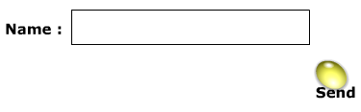
2. Open the Property Inspector and assign a variable “name” to the input box as shown below.
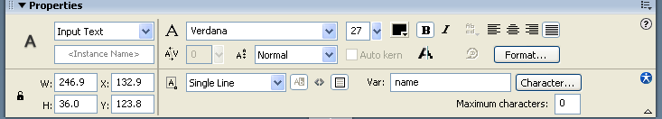
3. You need the only one line of action script given below to send the data (variables and values) from Flash to the ASP page
getURL("http://localhost/kktasp/sendvartoasp.asp",0,"post");
Attach this code to the on (press) event of a button as shown below.
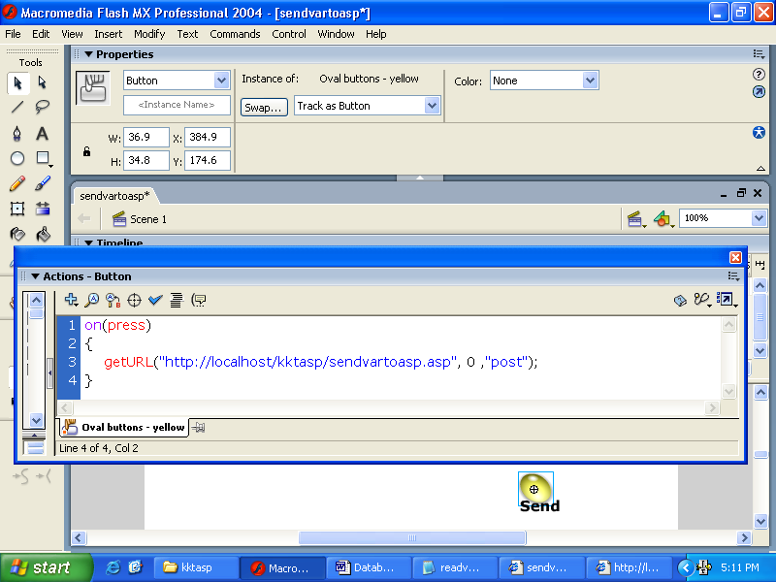
The first parameter of this method is the url of the ASP file. It has three parts: the protocol (http), computer name in which the IIS Server has been installed and the path of the asp file. In this example, the sendvartoasp.asp file is stored in Inetpub>wwwroot>kktasp folder.
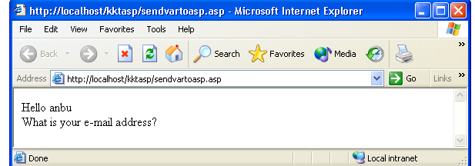
The third parameter specifies which method should be adopted for sending the variables. The value “post” sends the variables in a separate HTTP header and is used for long strings of variables. The value “get” appends the variables to the end of the URL and is used for a small numbers of variables.
When the method getURL () is executed, the client requests the server for the sendvartoasp.asp file. The .asp extension indicates that the server must run something (server-side scripting) within that page. The ASP can run Vbscript (similar to Visual Basic), Jscript (similar to Java script), Perlscript and Python. The content of the sendvartoasp.asp is given below.
<%@ Language = "VBSCRIPT" %>
<%
strFirst=Request("name")
Response.Write("Hello " & strFirst) & "<br>"
Response.Write( "What is your e-mail address?") & "<br>"
%>
You note that the first line of the ASP program indicates the scripting language used to receive and display the variables is VB script. You also note that all server side scripting must fall between an opening server-script tag <% and a closing server-script tag %>.
When the asp file is requested from the client, it establishes a connection between the client and the server. When the server executes the asp file the request method request the variables (here name) from the client side. The Write () method of the Response object sends the values of the variables from the server to the client in HTML form.
Note: If you are using a local server you can write “localhost” instead of the computer name. But if you store the asp file in a remote server then the actual server name must be provided in the place of local server. Before executing this application, you ensure that sendvartoasp.asp, sendvartoasp.swf and sendvartoasp.html files are kept in the Inetpub>wwwroot>kktasp folder of the server. To execute this application open the browser and type http://localhost/kktasp/sendvartoasp.html. This will open the SWF file within the browser. Type your name in the input box and press the key.

Example2: readdatabase
Create a Flash document that contacts an ASP program, which in turn reads the data from an ACCESS database file and supplies the data to the client.
Solution:
Open a new Flash document and name it readdatabase.fla. Create a button and attach the following script to it. Publish the FLA file and create HTML and SWF files. Store these two files in Inetpub>wwwroot>kktasp folder of the server
on(press)
{
getURL("http://kkt/kktasp/readdatabase.asp",0,"post");
}
Create an Access database and save it as “example.mdb”. Create a table with four fields as shown below. Store this data base file in Inetpub>wwwroot>kktasp>access folder of the server
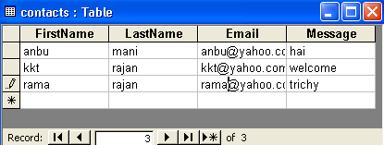
Type the following ASP code and store it as readdatabase.asp under the folder Inetpub>wwwroot>kktasp
- <%@ Language = "VBSCRIPT" %>
- <% Option Explicit %>
- <!--#include virtual="/kktasp/adovbs.inc"-->
- <%
- Dim conn
- Set conn = Server.CreateObject("ADODB.Connection")
- conn.Open "DRIVER={Microsoft Access Driver (*.mdb)};" & "DBQ=E:\Inetpub\wwwroot\kktasp\access\example.mdb"
- Dim objRS
- Set objRS = Server.CreateObject("ADODB.Recordset")
- objRS.Open "contacts", conn, adOpenForwardOnly, adLOckReadOnly, adCmdTable
- Do While Not objRS.EOF
- Response.Write objRS("FirstName") & "<BR>"
- Response.Write objRS("LastName") & "<BR>"
- Response.Write objRS("Email") & "<BR>"
- Response.Write objRS("Message") & "<P><HR><P>"
- objRS.MoveNext
- Loop
- objRS.Close
- Set objRS = Nothing
- conn.Close
- Set conn = Nothing
- %>
The second line of the program checks whether the variables are declared before they are used in the program.
The third line of the program includes the values of the constants used in line 10 as given below.
Const adOpenForwardOnly = 0
Const adLOckReadOnly = 1
Const adCmdTable = 2
Const adLockOptimistic = 3
Const adLockPessimistic = 2
These constant names and values have been stored in the adovbs.inc file. By default this file is installed in c:\Program Files\Common Files \ System \ado when IIS is installed. But in this ASP program the first slash in the file path indicates the publishing directory of the IIS Web server. Therefore you have to store the adovbs.inc file under Inetpub>wwwroot>kktasp folder.
Instead of using symbols for constants the values can be directly used in the 10th line as shown below. In that case 3rd line may be omitted.
10. objRS.Open "contacts", conn, 0,1,2
The constant 1 (adLOckReadOnly) indicates that the recordset is opened only for reading.
The fifth line creates a variable to hold the server connection object using the Dim keyword. The next line creates a new Server Connection object and assigns it to the variable “conn”.
The seventh line sets the driver for the type of the database we are using and opens the database file. The full path of the database file is provided here.
The ninth line creates a record set object and in the tenth line it is opened. If the record set is opened, then the ASP file can read the filed values in the record using the format,
Recordsetobject (“fieldname”)
The MoveNext method of the recordset object moves current position of the record pointer to the next accessible record. All the records in the database are read one by one using Do While … Loop and are sent to the client’s browser.
Lines 12 to 15 read the values in a record and send them to the client. Lines 18 to 21 close the recordset object and then close the connection
To execute this program run the HTML file from the browser and then click the button.
NB: localhost is not working.

Example 3: storedata
Create a Flash document that accepts User ID and Password and store them in a database file.
Open a new Flash document and name it storedata.fla. Create a button and attach the following script to it.
on(release)
{
getURL("http://kkt/kktasp/storedata.asp",0,"post");
}
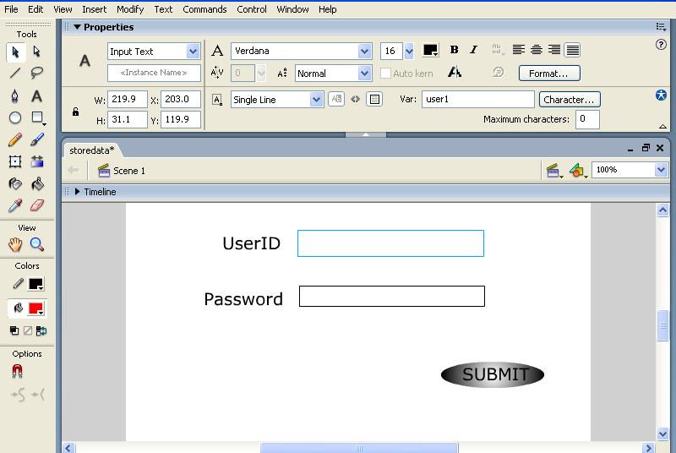
Draw two input boxes as shown above. Set the variable to the User ID input box as user1 and set the variable for password input box as pass1.
Publish the FLA file and create HTML and SWF files. Store these two files in Inetpub>wwwroot>kktasp folder of the web server.
- <%@ Language="VBScript" %>
- <% Option Explicit %>
- <!-- #include virtual="/kktasp/adovbs.inc"-->
- <%
- Dim conn
- Set conn = Server.CreateObject("ADODB.Connection")
- conn.Open "DRIVER={Microsoft Access Driver (*.mdb)};" & "DBQ=E:\Inetpub\wwwroot\kktasp\access\login1.mdb"
- Dim objRS
- Set objRS = Server.CreateObject ("ADODB.Recordset")
- objRS.open "data1",conn, ,3,2
- objRS.AddNew
- objRS("UserID") = Request.Form("user1")
- objRS("Password") = Request.Form("Pass1")
- objRS.Update
- objRS.MoveNext
- objRS.MoveFirst
- objRS.Close
- Set objRS = Nothing
- conn.Close
- Set conn = Nothing
- %>
In the 10th line of the program, data1 is the table name provided in the database login1 and the constant 3 indicates adLockOptimistic locking. Optimistic locking means that records are locked by the provider when update is called. The constant, 2 indicates adCmdTable. When you make a database accessible over the web, you may have hundreds of people accessing it at once. This is fine as long as they are just reading. When two people try to change the same record then problem arises. To prevent this the first person who tries to change the record puts a lock on it. While the lock is on nobody else can change the record. As soon as the user is finished, the lock is removed.
The AddNew method creates a new record in the recordset. The new record is not added (saved)to the database until the Update method is called. After AddNew is called, the new record becomes the current record, and it remains the current record even after Update is called.
Line 16 resets the cursor to the beginning of the recordset using MoveFirst method.
Create an Access database and save it as “login1.mdb”. Create a table with two fields as shown below. Store this data base file in Inetpub>wwwroot>kktasp>access folder of the server
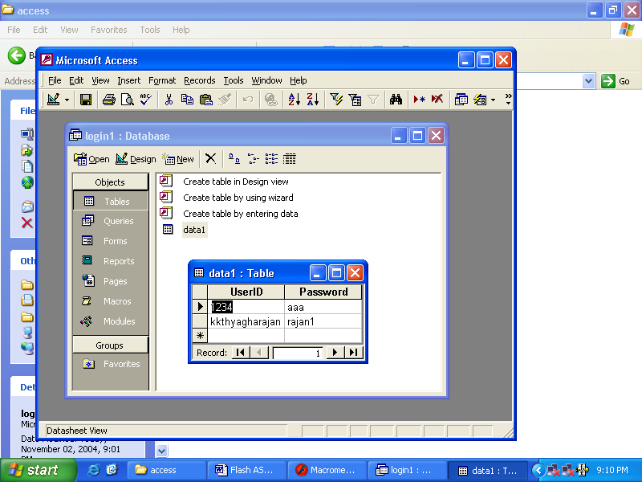

To run this program, open the browser and type http://localhost/kktasp/storedata.html. Enter a UserID and a password. Open the data base login1.mdb and check whether the new ID and password get stored.

