MISource Documentation
Table of Contents
Taking Lessons 1
The Main Menu 1
The Lesson Menu 2
Overview of Lessons 3
Scoring 4
Navigation 5
Navigation for MISource with Office XP Lessons 5
Navigation for MISource with Office 2003 Lessons 5
Teach Me 6
Show Me 8
Let Me Try 9
Working with the Question Box (Access, PowerPoint and Excel only) 10
Comprehensive Exercises 11
Progress Review 11
Using the Video Case Studies 12
Playing the Videos 12
Answering Review Questions 12
Tips and Tricks 13
Using the Simulated Interface 13
Showing and Hiding the Question Box 14
Troubleshooting 14
Audio and Video Problems 14
Technical Support 15
Virus Protection 15
Credits 16
Triad Interactive, Inc. 16
Triad Interactive, Inc. 16
The McGraw-Hill Companies 16
McGraw-Hill Higher Education 16
License Agreement 16

Taking Lessons

The Main Menu
The MISource Main Menu includes two sections from which you can select a lesson to open. The image below shows the Main Menu for MISource with Microsoft Office 2003 lessons. If you installed the version with Office XP lessons, your Main Menu will look slightly different.
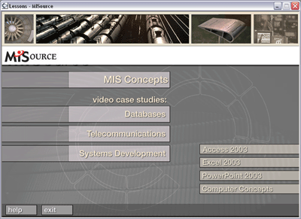
- At the top of the screen is the MIS Concepts lesson. Click the lesson to open it. Lessons can take a minute or two to load - be patient if nothing happens at first. You should see a Loading Lessons... screen within 30 seconds or so.
- There are three video case studies. To start of one of the case studies, click the title.
- At the bottom right corner there are four review lessons: Access, Excel, PowerPoint, and Computer Concepts.
- You can return to this Help file at any time by clicking the Help button near the bottom of the Main Menu screen.
- Click the Exit button to close the MISource program.

The Lesson Menu
If you are using the Office XP version of MISource: Each lesson opens with the Lesson Progress Report on the right, and the lesson menu on the left.
- The lesson menu on the left displays a list of folders, or chapters, in the lesson. Click a folder or chapter title to open the list of tasks in that folder. Note: Some folders may have only one task, and some folders on the Excel, PowerPoint, and Access menus may have more than one folder, so it may be necessary to click a subfolder to open the list of tasks.
- Skills appear as underlined titles. Click a title to open that skill.
- Click Progress Review at the bottom of the list of folders to view your Progress Report.
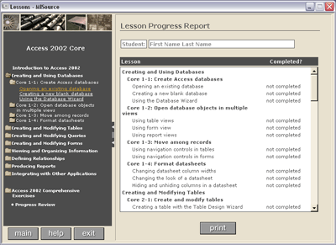
If you are using the Office 2003 version of MISource, your lesson menu will appear somewhat different:
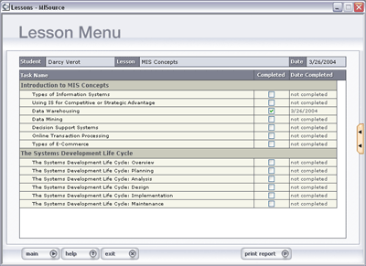
In this version, the Progress Review and the lesson menu have been combined. Each item in the menu is a "hot link" to that skill. Click any title to open the skill.
The following information applies to both versions of MISource:
- When you start a new lesson, all entries in the Progress Report show "not completed." As you complete each task in the lesson, this message will be replaced with the date you completed the task. (Skills are recorded as "completed" when you click the Finish button at the end of the Let Me Try exercise.)
- Click the Print or Print Report button at the bottom of the Progress Report to print a copy of how far you have progressed in the lesson.
- Use the buttons at the bottom of the lesson menu to return to the Main Menu and select another Lesson, to display this Help file, or to Exit the program.

Overview of Lessons
- Each skill has three parts: Teach Me, Show Me, and Let Me Try. The Teach Me Section opens automatically. Click the Show Me or Let Me Try button to display those parts of the skill.
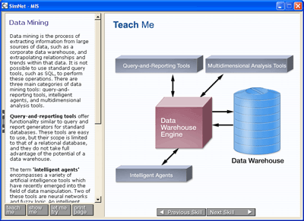
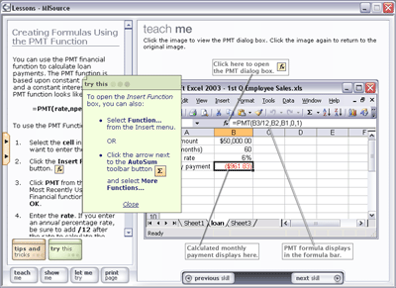
- To print the Teach Me text, click the Print button at the bottom of the left pane.

Scoring
Skills are recorded as "completed" when you click the Finish button at the end of the Let Me Try exercise.

Navigation

Navigation for MISource with Office XP Lessons
- Use the navigation menu at the left of the Lesson Menu to navigate the skills in the lesson. Click a folder in the lesson navigation menu. If the lesson is for Excel, PowerPoint, or Access, there may be multiple folders. If necessary, click a subfolder to expand it to see the list of tasks.
- Tasks appear as underlined titles in the navigation menu. Click a title to open it.
- To go to another skill without returning to the Lesson Menu, click the Next Skill or Previous Skill button at the bottom of the Teach Me or Show Me window.
- To return to the lesson and navigation menu, click the arrows to the left of the window, and then select another skill.
- Use the buttons at the bottom of the navigation menu to return to the Main Menu and select another Lesson, to display this Help file, or to Exit the program.

Navigation for MISource with Office 2003 Lessons
- The lesson menu lists all of the skills in the lesson. Click any skill title to open that page.
- To go to another skill without returning to the Lesson Menu, click the Next Skill or Previous Skill button at the bottom of the Teach Me or Show Me window.
- To return to the lesson and navigation menu, click the arrows to the left of the window, and then select another skill.
- Use the buttons at the bottom of the lesson menu to return to the Main Menu and select another Lesson, to display this Help file, or to Exit the program.

Teach Me
- Each Teach Me section includes a brief explanation of the skill or task and step-by-step instructions in the left pane.
- The right pane displays a graphic illustrating the specific skill.
Note: Some Teach Me illustrations include interactive instructions. Be sure to follow the instructions to view all of the Teach Me's contents.
- Some Teach Me's include further information at the end of the text. Click each of the buttons to see the information in a pop-up window.
  - Click the Tips and Tricks button for related information about the skill. The pop-up window will close when you click anywhere else on the screen, or click the Close button.
  - Click the Tell Me More button for further information and advanced techniques.
  - Click the Try This button for alternate methods such as menu commands and keyboard shortcuts.

Show Me
The Show Me section includes step-by-step instructions on the left and an animation with audio narration showing how to complete the skill on the right.
- Click the Start button to play the animation.
- Click the Caption button to display text of the narration.
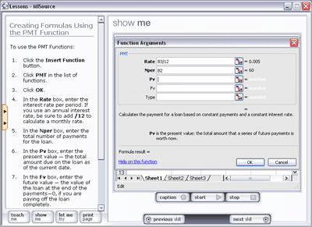
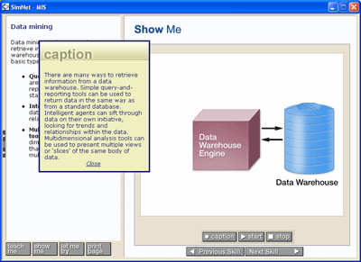

Let Me Try
- The Let Me Try exercise poses a question to test your knowledge of the skill. Answer the question by completing the appropriate action.
- The program will tell you if your response was correct or incorrect.
- In the MIS Concepts lesson and the Computer Concepts review lesson, each Let Me Try exercise has a single question. When you have answered the question correctly, click the Finish button.
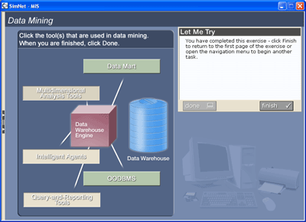
- In the Excel, PowerPoint, and Access lessons, the Let Me Try exercises use a simulated application interface. The questions may require multiple action to complete the skill. If you answer a step incorrectly, you can try again. You must complete each step correctly before moving on to the next step.
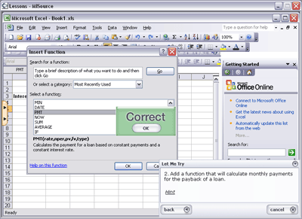
- If you have trouble completing a step, click the Hint at the bottom of the question box.

Working with the Question Box (Access, PowerPoint and Excel only)
- You can hide the question box if it is in your way by clicking the Hide Question button or clicking the minimize arrow at the top right corner of the question box.
- Click the Show Question button to display the question again. If you "lose" the question box, just click the Show Question button to show the question box again.
- You can also move the question box to another part of the window by clicking the title bar, then dragging the box to its new location.
- You can click the Cancel button in the question box to return to the Teach Me and review it before trying again. But remember: you must finish all the steps in the Let Me Try to receive credit for completing the skill.
- MISource displays a message in the question box when you have completed the last step. Click Finish to complete the exercise.

Comprehensive Exercises
This information applies to the Office XP version of MISource only.
The Excel 2002 and Access 2002 Lessons contain Comprehensive Exercises. You will find them near the bottom of the Navigation menu. Comprehensive exercises are Let Me Try exercises that encompass multiple skills. They don't have a Teach Me or Show Me section.
- Click the Start Exercise button to begin the Comprehensive Exercise.
- Click the Print Page button to print the steps of the exercise.
- Complete the Comprehensive Exercise by completing each step. You must complete each step successfully to advance to the next step. If you have trouble completing a step, click the Hint link near the bottom of the question box.
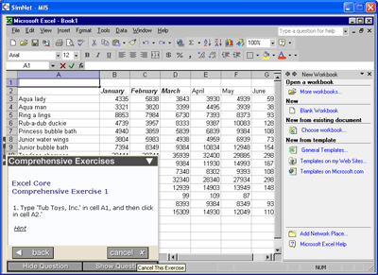

Progress Review
This information applies to the Office XP version of MISource only.
To check your progress, click Progress Review at the bottom of the Navigation menu. Skills are recorded as "completed" when you click the Finish button at the end of the Let Me Try exercises. You can print your Progress Report at any time.

Using the Video Case Studies

Playing the Videos
MISource includes three video case studies. Each case study begins with a video, followed by a series of questions.
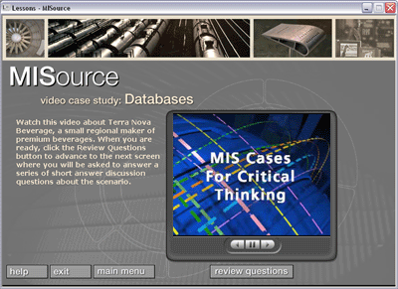
The video will begin playing automatically. Beneath the video window are three video controls: Rewind, Pause, and Play.
When you have watched the video and are ready to answer the questions, click the review questions button.

Answering Review Questions
Each video case study includes a series of review questions.
Type your answer in the space provided, then click the next question button. After answering all the questions, you'll have the opportunity to print or save your responses to a text file.
When you are on the last question, the next question button changes to review answers. Click the review answers button to go to the last page of the case study. From this page you can print your answers, save them as a text file, or go back to previous screens to change your answers.
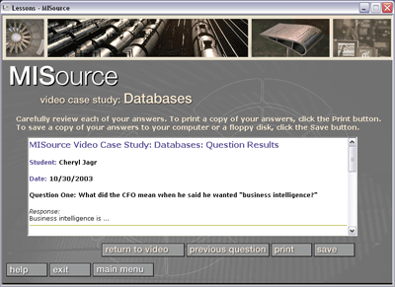

Tips and Tricks

Using the Simulated Interface
MISource uses a simulated application interface for the Let Me Try and Comprehensive exercises in the Access, PowerPoint, and Excel lessons. In the simulated interface, you can open menus without being judged immediately.
Sometimes, depending on how the question is worded, you can open a dialog box, and then click Cancel, without being judged incorrect. If the question asks you to open a specific dialog box, opening the wrong dialog box will result in "incorrect".
Remember, Let Me Try and Comprehensive exercises are scored as "complete" or "incomplete" only. So you can try each step as many times as necessary to get it right.

Showing and Hiding the Question Box
- You can hide the Let Me Try question box by:
  - clicking the Hide Question button
  - or clicking the minimize arrow at the top right corner of the question box.
- Click the Show Question button to display the question again. If you "lose" the question box, just click the Show Question button to show the question box again.
- You can also move the question box to another part of the window by clicking the title bar, then dragging the box to its new location.

Troubleshooting

Audio and Video Problems
The Show Me sections in the lessons and the case study videos require that you have sound capabilities with your computer, including:
- A properly installed sound card
- Speakers or headphones
- Windows Media Player 7.0 or higher installed
If you receive errors when displaying the Show Me exercises or playing the animations or videos, there is probably a problem with the file associations for your .wma audio files or your .mpg video files.
To fix the problem:
- Open the Windows Media Player
  - Click the Windows Start button.
  - Point to Programs. Point to Accessories. Point to Entertainment. Click Windows Media Player.
- Click the Tools menu, and select Options...
- Click the Formats or File Types tab.
- Ensure that Windows Media Audio file (wma) is checked.
- Ensure that Movie file (mpeg) is checked.
- Click OK. Close the Windows Media Player.
If the problem persists, re-install the Windows Media Player from the Windows Media Player 7.0 folder on the MISource CD-ROM or download and install the latest version of Windows Media Player from Microsoft's Web site.

Technical Support
For up-to-date technical support, check our Web site at http://www.simnethelp.com The Web site includes answers to the most frequently asked questions.
You can call Triad Interactive toll free for technical assistance at 1-866-TRIADHELP or contact us via e-mail at support@triadinteractive.com.

Virus Protection
Because MISource writes progress files to your hard drive, some virus protection programs may view this action as "malicious". If you see a warning from your virus protection program, allow MISource to run the scripts.
In the example below (Norton Anti-Virus 2002), you would select Authorize this script, to allow the TILA (Triad Interactive Learning Architecture) program to delete the temporary progress file. TILA is the program that runs MISource.
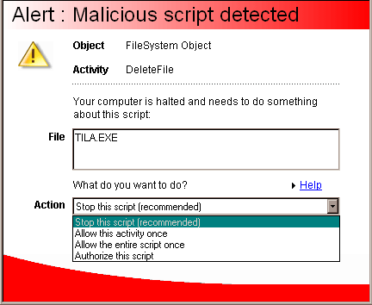

Credits

Triad Interactive, Inc.
MISource was designed and developed by Triad Interactive, Inc. All lesson content was written by Triad Interactive.
The characters and companies portrayed and the names used in MISource are fictitious, and any resemblance to the names, character, or history of any person, living or dead, or company is coincidental and unintentional.

Triad Interactive, Inc.
http://www.triadinteractive.com
- Cheryl Manning, Producer
- Catherine Manning, Producer
- William Kohudic, Lead Programmer
- Michelle Martello, Interface and Graphic Design
- Dianne F. Manning, Animations and Graphics
- Robert Shortley, HTML Programming and MIS Content
- Adam Stasio, HTML Programming
- Jeffrey Barscz, HTML Programming and MIS Content
- Frank Stasio, Narration
- Charlotte Akin, Narration

The McGraw-Hill Companies
Published by McGraw-Hill Higher Education, an operating unit of The McGraw-Hill Companies, Inc., 1333 Burr Ridge Parkway, Burr Ridge, IL 60521. Copyright © 2005 by The McGraw-Hill Companies, Inc. All rights reserved. No part of this publication may be reproduced or distributed in any form or by any means, or stored in a database or retrieval system, without the prior written consent of The McGraw-Hill Companies, Inc., including, but not limited to, network or other electronic storage or transmission, or broadcast for distance learning.

McGraw-Hill Higher Education
http://www.mhhe.com/catalogs/irwin

License Agreement
FOR MCGRAW-HILL SOFTWARE
This agreement gives you, the customer, certain benefits, rights and obligations. By using the software, you indicate that you have read, understood, and will comply with the terms.
Terms of Agreement:
1. McGraw-Hill licenses and authorizes you to use the software specified below only on a microcomputer located within your own facilities.
2. You will abide by the Copyright Law of the United States. The law provides you with the right to make only one back-up copy. It prohibits you from making any additional copies, except as expressly provided by McGraw-Hill. In the event that the software is protected against copying in such a way that it cannot be duplicated, McGraw-Hill will provide you with one back-up copy at minimal cost or no charge.
3. You will not prepare derivative works based on the software because that also is not permitted under the Copyright Law. For example, you cannot prepare an alternative hardware version or format based on the existing software.
4. If you have a problem with the operation of our software or believe it is defective, contact your nearest McGraw-Hill Book Company office about securing a replacement. We cannot, however, offer free replacement of software damaged through normal wear and tear, or lost while in your possession. Nor does McGraw-Hill warrant that the software will satisfy your requirements, that the operation of the software will be uninterrupted or error-free, or that the program defects in the software can be corrected. Except as described in this agreement, software is distributed "as is" without any warranties of any kind, either express or implied, including, but not limited to, implied warranties of merchantability and fitness for a particular purpose or use.
5. Additional right and benefits may come with the specific software package you have purchased. Consult the support materials that come with this program, or contact the nearest McGraw-Hill Book Company office in your area.

