Going beyond the capability of Outlook & Word using ProWrite.

Microsoft Outlook and ProWrite can be used to quickly and easily standardize the way information is distributed and collected electronically. The first important step in doing so is to understand how to use Outlook to record information that is unique to your organization. The contact forms you are accustom to using can be customized to add fields unique to your business needs, such as, client and contract numbers, contract start and end dates, etc. Once you have entered the information into Outlook using a custom form, ProWrite allows the merging of these custom fields into e-mails, letters, faxes, envelopes and labels or the creation of custom forms such as invoices, contracts, etc.

In the next few pages, we will take a tour of just how to take full advantage of your Outlook contacts using ProWrite. This document is made up of four sections. Section 1 – Using your information, Section 2 – Creating a custom form in Outlook, and Section 3 – Creating Custom forms in ProWrite and Section 4 – Customizing your E-mail message and Attachment

Section 1 – Using Your Contact Information
Step 1:
- Create a contact record. (Here’s a sample record for ease of entry.)
John Doe, Acme Bar & Grill, 123 Any Street, Anytown, XX 90210,
T - 303-555-8254, F-303-555-8255, E-mail, jdoe@acme.com,
(Note: See Section 2 – Creating a custom form in Outlook)
Sales Contract #;123456, Start Date 02-21-2000, End Date 02-21-2003.
Save the record.
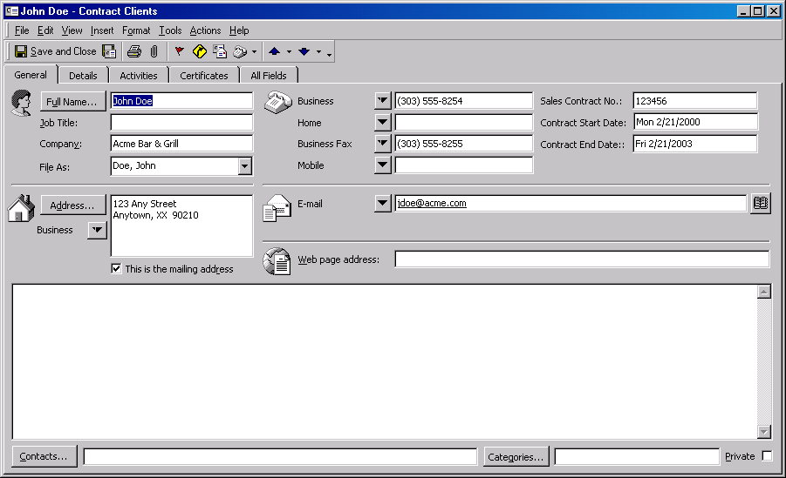

Now we’re ready to create a ProWrite template using our custom fields. Let’s first begin with a letter template.

Step 2:
- From Contacts with Acme Bar & Grill hi-lighted, choose ProWrite-Letter.

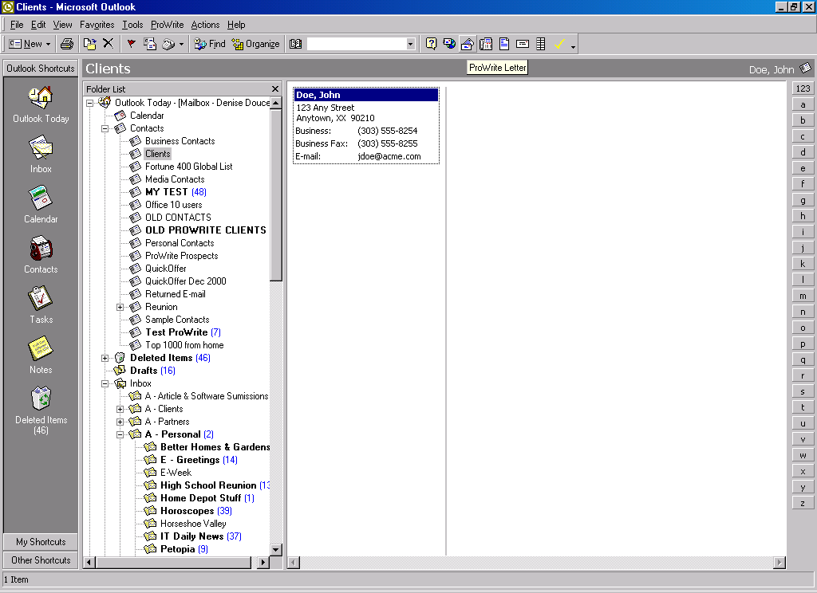

- Now with the Letter dialogue box displayed, choose the “…” icon to the right of the “Templates” field.

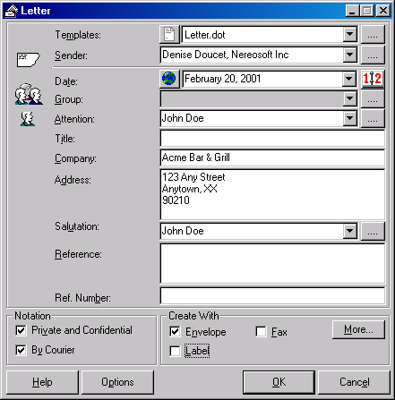

- Select a template to be used. By clicking on the “+” sign to the left of “User Templates”.

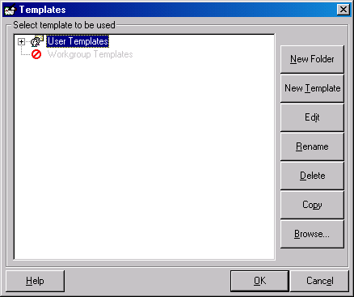

- Choose “Letter.dot” as our sample letter. (Note: Do not skip this step.) Click “Ok”

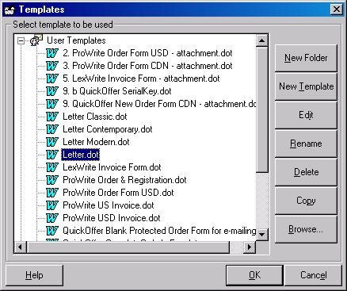

- Select the notation “Private and Confidential and By Courier by clicking on the box. Choose to print an envelope.

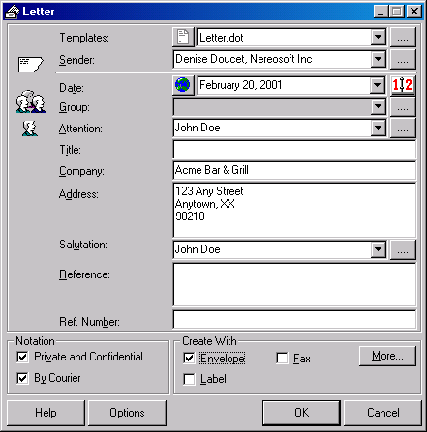

- Click “Ok”, two documents will be created. The letter will be it’s own document and the envelope will be it’s own document. If there were many contacts, the second and subsequent contacts would be on the next page within the same document.

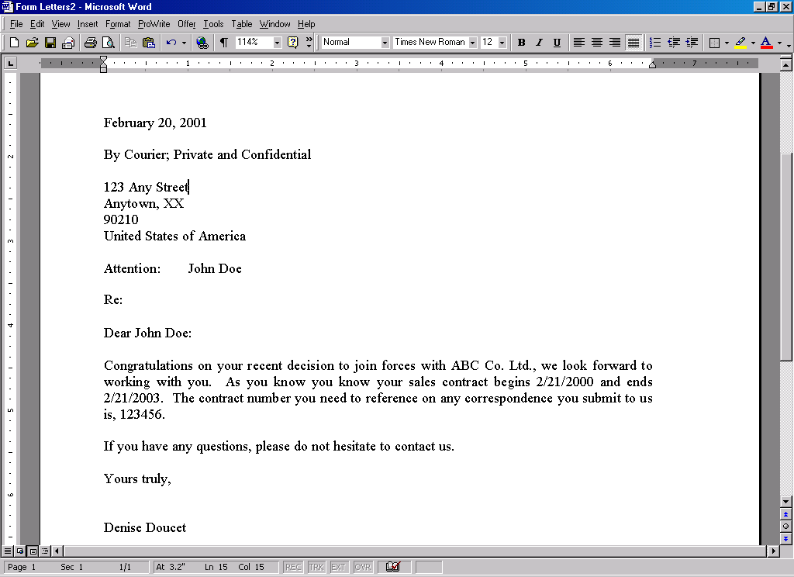

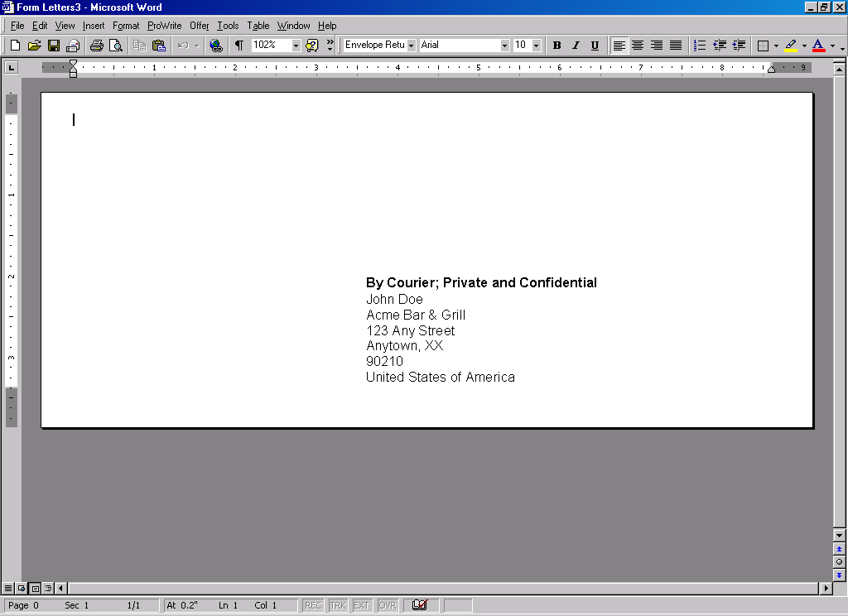
Section 2 - Creating a Custom Form in Outlook

In this section we will be touring through the creation of a Custom Form in Outlook. The tour will show how to use the newly created custom fields in a template document generated using ProWrite.

Step 1: Using Outlook’s Contact Form Design:

- Create a new contact folder name it “Clients”

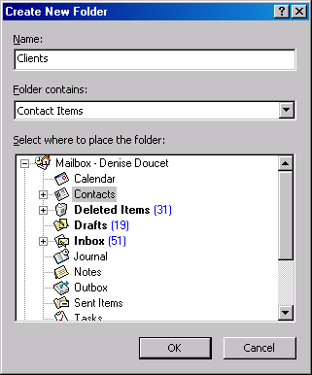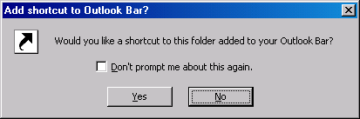
Note: Deciding to have a shortcut to this folder doesn’t make a difference to ProWrite or this exercise.

- With the contact folder created, choose Tools, Forms, Design a Form.
- Select the place where to store the newly designed forms.
Note: For the example: The forms are placed in the Standard Forms Library under the Contact.

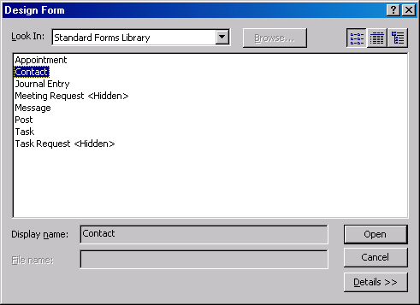

- The Contact form layout including the “Fields Chooser” utility appear. Make all necessary changes to the form that is required.

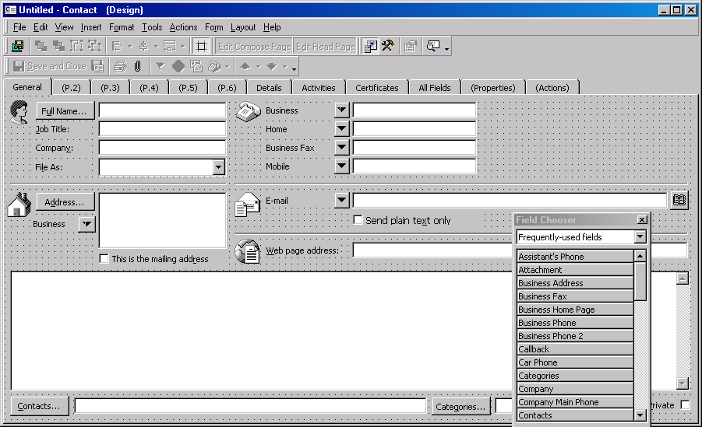

- Add a “Sales Contract No.” field beside the existing telephone # field.

- Choose “New” from the “Fields Chooser” utility,

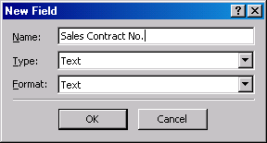

- Now, in the “Field Chooser” the “Sales Contract No.” will appear.

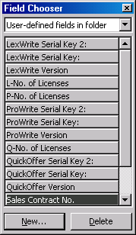
h) Now create a Sales Contract Start Date field. (Note: Remember to select the “Date/Type” and
Format.

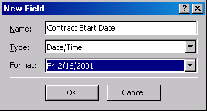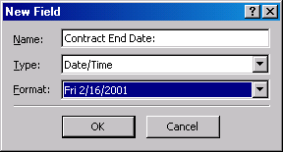

- Create a Sales Contract End Date field. (Note: Remember to select the “Date/Type” and Format.

- Hi-light the newly created fields “Sales Contract No.” “Contract Start Date”, “Contract End Date” and drag them to the place on the form you wish the fields to appear. (For this example: place it to the right of the Bus. Phone Number field.

- Your custom form should appear like the example below:

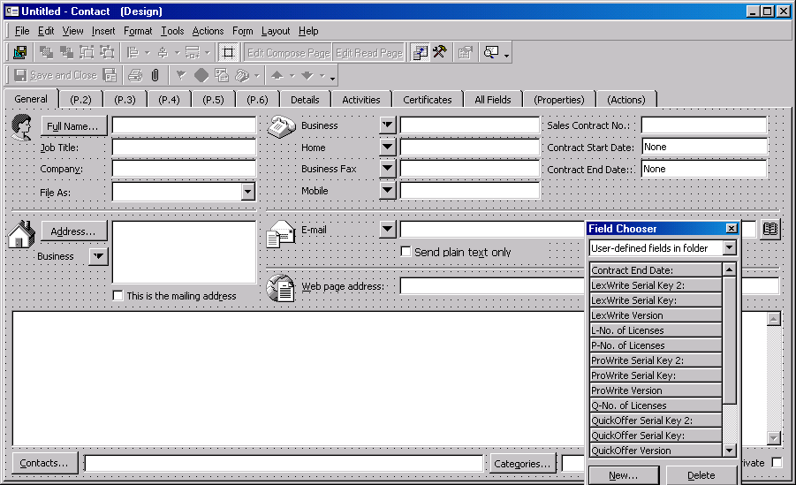

- We’re ready to save the form. Choose File “Save As”, Contract Clients.

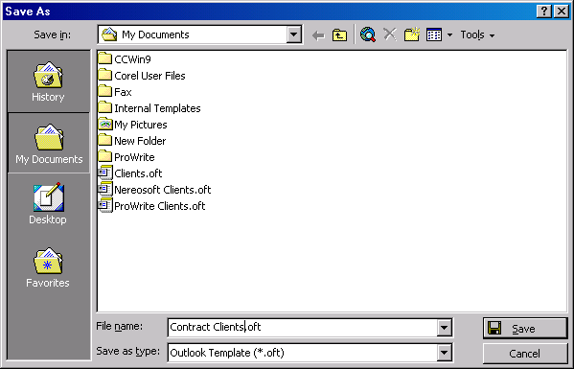

- Now we want to “publish” the form. Choose the icon at the top left of the screen.

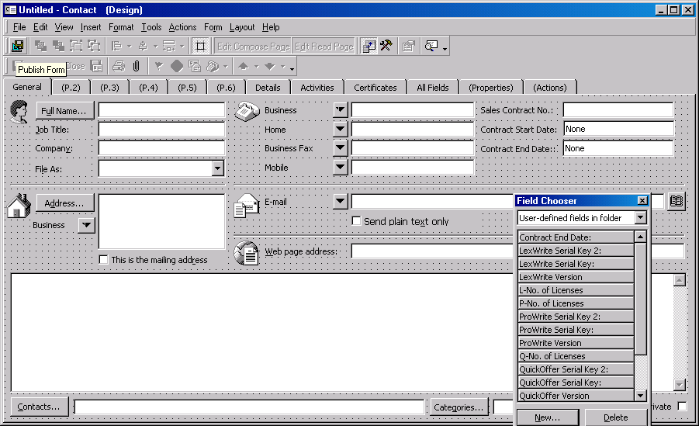

- Publish the form in the Personal Forms Library and publish it as “Contract Clients”.

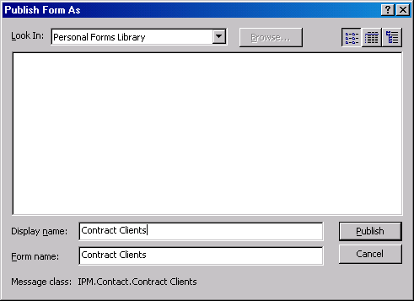

- Close the “Field Chooser” utility

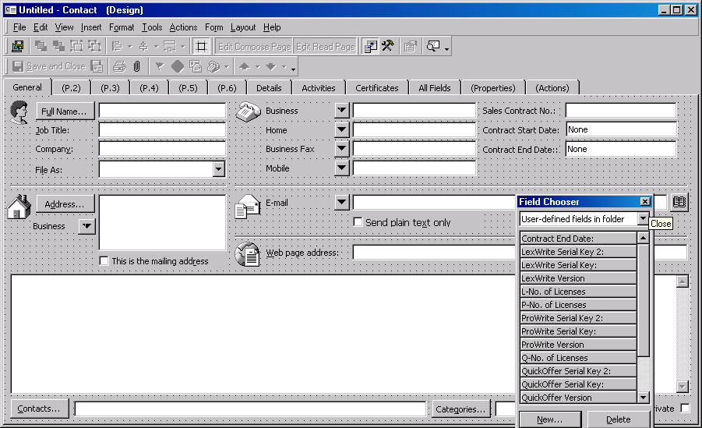

- Close the Form, save changes, No. (Note: this will actually save a record in the contact folder.)

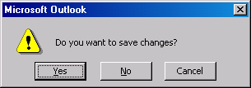

With the form created, we need to apply it to the contact folder. Here’s how to do it.

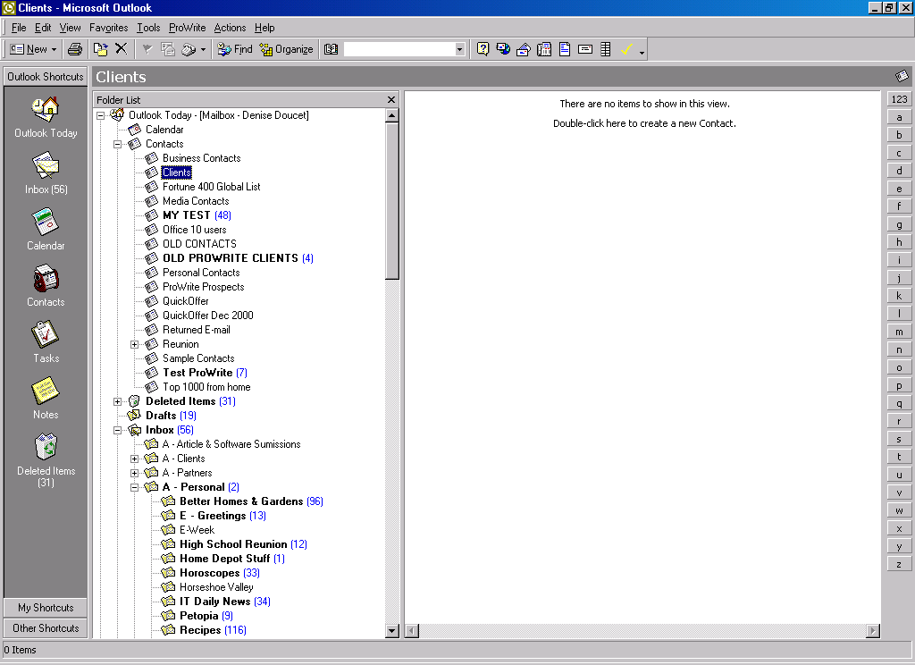

- Hi-light the “Clients” folder and right mouse click. Choose “Properties”

- With the “Properties” dialogue box open, choose the Forms tab. Choose the “Manage” button.

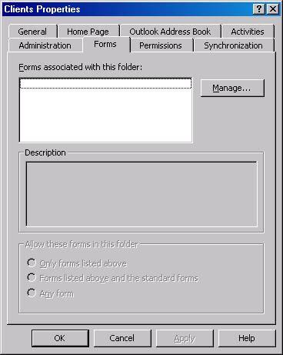

- Select from the “Forms Library & Personal Forms”.

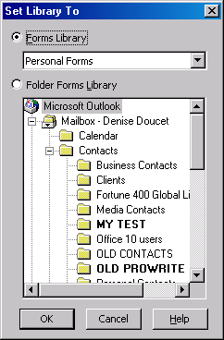

- From the Forms Manager dialogue box, choose “Copy”

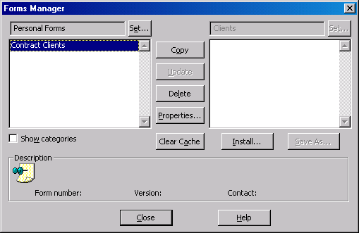

- Choose “Close”

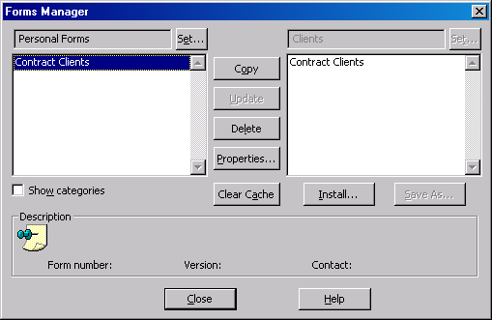

- From the Clients Properties dialogue, choose “Apply”

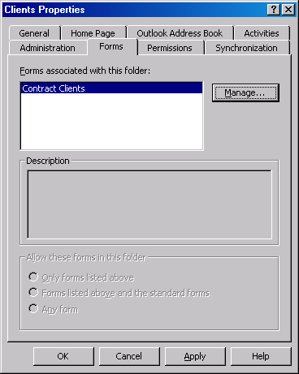

- Switch to the “General” tab.

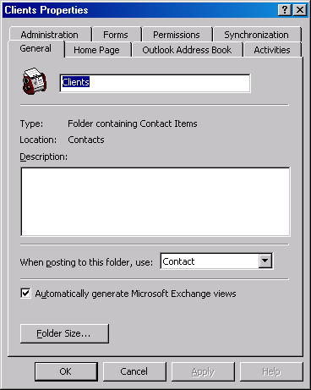

- Change the option “When posting to this folder, user…” by clicking on the down-arrow and selecting “Forms…” and “Personal Forms Library”. Choose “Open”, and choose “Contract Clients”.

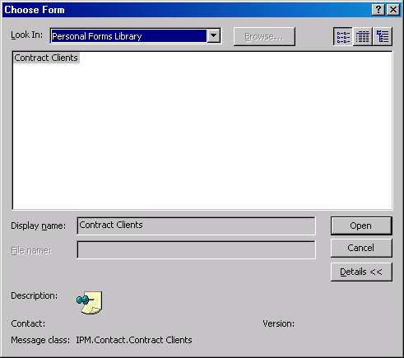

- Choose “Apply”

Now the contacts folder “Clients” is ready to have contact information entered into it.

Section 3 – Creating Custom forms in ProWrite

- From Contacts with Acme Bar & Grill hi-lighted, choose ProWrite-Letter.

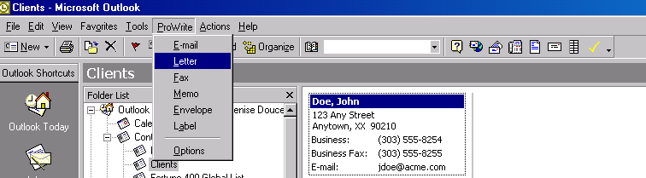
or
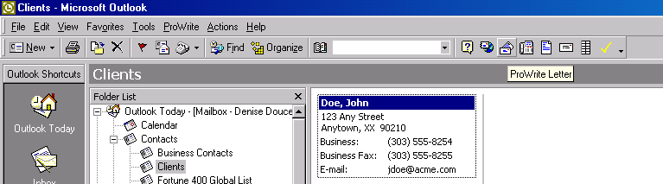

- Now with the Letter dialogue box displayed, choose the “…” icon to the right of the “Templates” field.

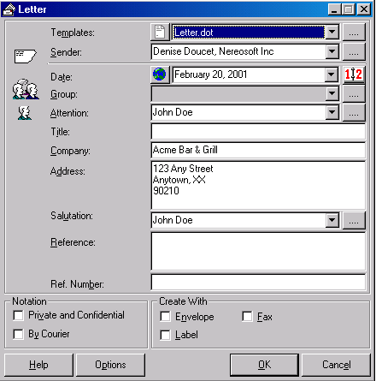

Important Note: In order for ProWrite to recognize the custom fields you have added to this contact folder you must generate at least one letter before editing your templates to add the custom fields. If you have selected a group of recipients then this is not necessary.

- Select a template to be used. By clicking on the “+” sign to the left of “User Templates”.

- Choose “Letter.dot” as our sample letter. (Note: Do not skip this step.) Click “Ok”

- Choose Edit (on the right side)

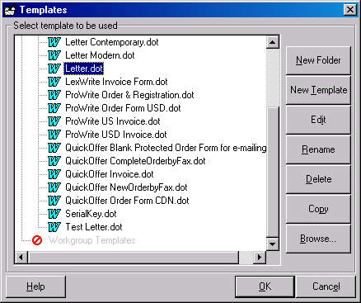

- The letter.dot file has pre-existing fields that can be modified, removed or added to. We’re going to add to the body of the letter using the custom fields (Sales Contract #, Start & End dates)

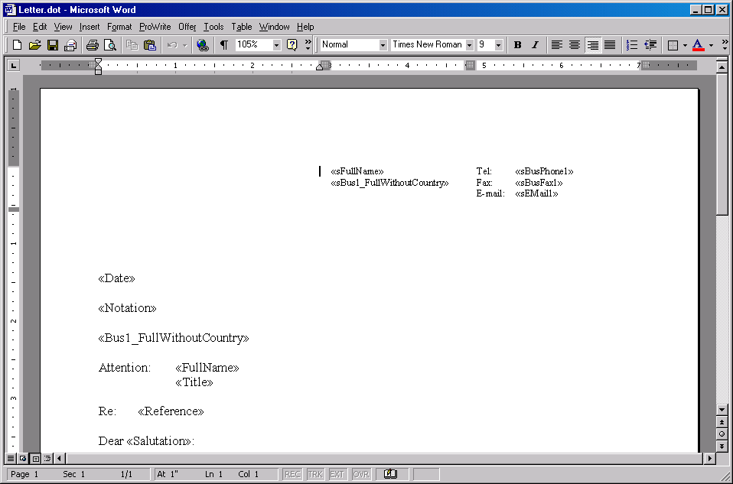

- Using the “fields utility”, locate the “custom fields” option located at the top of the utility.

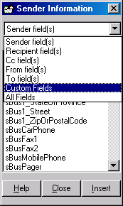

- Modify the letter by adding the following paragraph. Make sure to include the custom field where necessary.

Congratulations on your recent decision to join forces with ABC Co. Ltd., we look forward to working with you. As you know you know your sales contract begins «Contract_Start_Date» and ends «Contract_End_Date». The contract number you need to reference on any correspondence you submit to us is, «Sales_Contract_No.».

Please if you have any questions, do not hesitate to contact us.

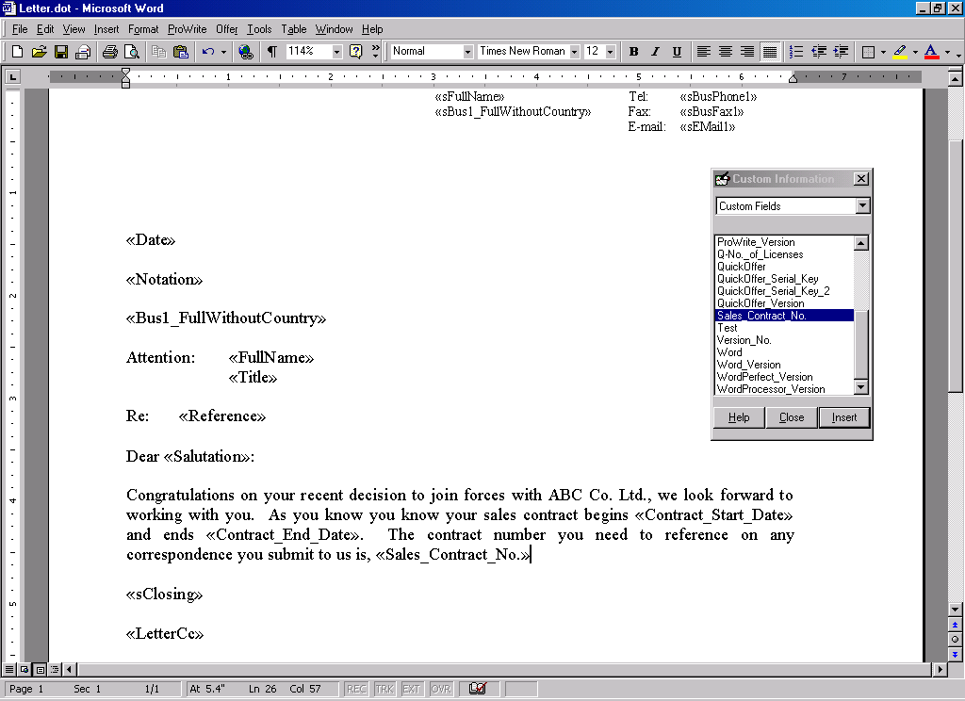

- Choose “Close” on the bottom of the “fields utility” and answer “yes” to the prompt.

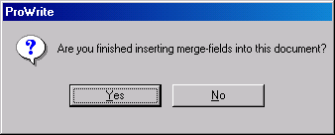

- Save and close the Letter.dot template.

Now we’re ready to create the document.

- Hi-light the contact John Doe, select the ProWrite menu & letter option or choose the ProWrite letter icon.

- The Letter dialogue box will appear (as below). Choose, if you wish the Notation area – Private and Confidential and/or By Courier. Choose Envelope. (as shown in the diagram below). Now choose “Ok”

- The results will be two separate documents, the first with the letter and the second with the envelope.

Section 4 – Customizing your E-mail message and Attachment

Creating a custom e-mail is as simple as creating a custom letter with a few extra options to consider. On our tour, the custom e-mail will consist of a personalized e-mail body with a personalized attachment to that same e-mail.

- From Contacts with Acme Bar & Grill hi-lighted, choose ProWrite-E-mail.

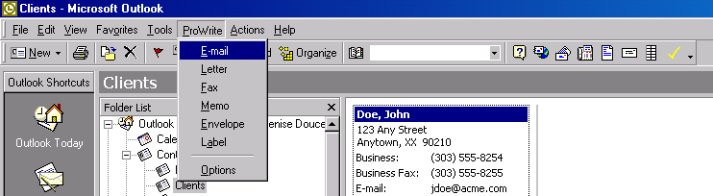
or
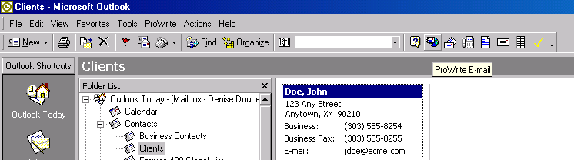

- Now with the E-mail dialogue box displayed, choose the “…” icon to the right of the “E-mail Templates” field.

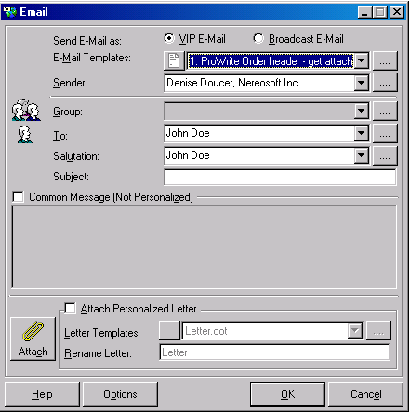

- Select a template to be used. By clicking on the “+” sign to the left of “User Templates”.

- Choose “E-mail.dot” as our sample e-mail. (Note: Do not skip this step.) Click “Ok”

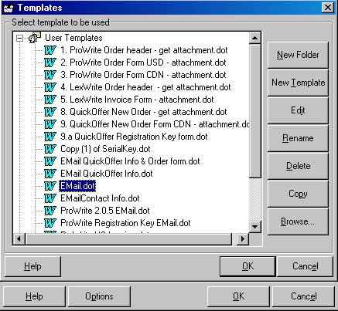

- Create the custom e-mail message. (Note: Do not skip this step, this is to test that the message will function. Once the test is complete, simple exit & not save.

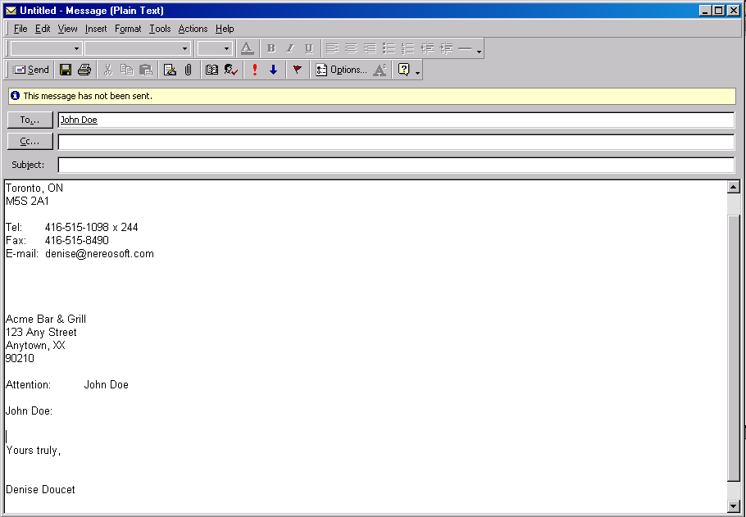

Once the custom e-mail message is complete, now it’s time to customize the attachment to the e-mail message. On our tour we will be attaching a customized invoice.

- From Contacts with Acme Bar & Grill hi-lighted, choose ProWrite-E-mail.

or

- Now with the E-mail dialogue box displayed, choose the “…” icon to the right of the “E-mail Templates” field.

- Select a template to be used. By clicking on the “+” sign to the left of “User Templates”.

- Choose Sales Order Form USD – get attachment.dot and choose Edit (on the right side)

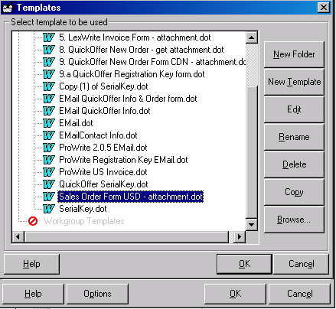

- The Sales Order Form USD – get attachment.dot file has pre-existing fields that can be modified, removed or added to. The tour will show that the header of the invoice has the custom fields (Sales Contract #, Start & End dates)

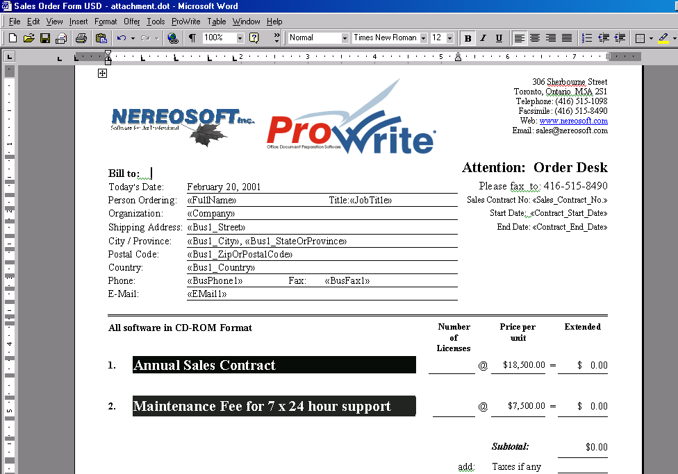

- Using the “fields utility”, locate the “custom fields” option located at the top of the utility.

- Choose “Close” on the bottom of the “fields utility” and answer “yes” to the prompt.

- Save and close the Sales Order Form USD – get attachment.dot template.

Now we’re ready to create the custom e-mail with custom attachment document.

- Hi-light the contact John Doe, select the ProWrite menu & e-mail option or choose the ProWrite e-mail icon.

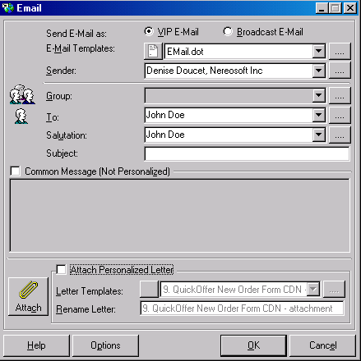

- With the E-mail.dot template selected, it’s now time to select the “Attach Personalized
Letter” option and select Sales Order Form USD – get attachment.dot (see screen
shot below)
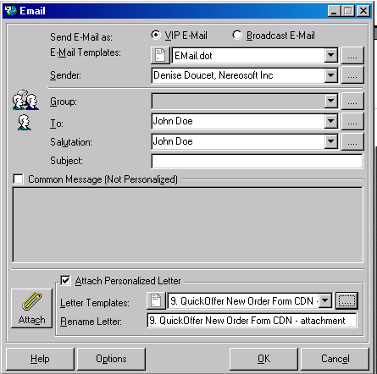

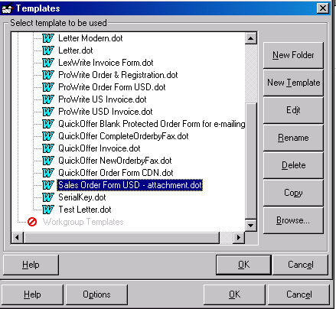

- With the custom template selected and the personalized letter attachment also selected, press OK, to continue.

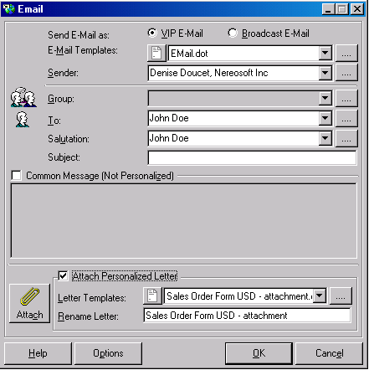

- The results will be two separate documents, the first with the letter and the second with the envelope.

