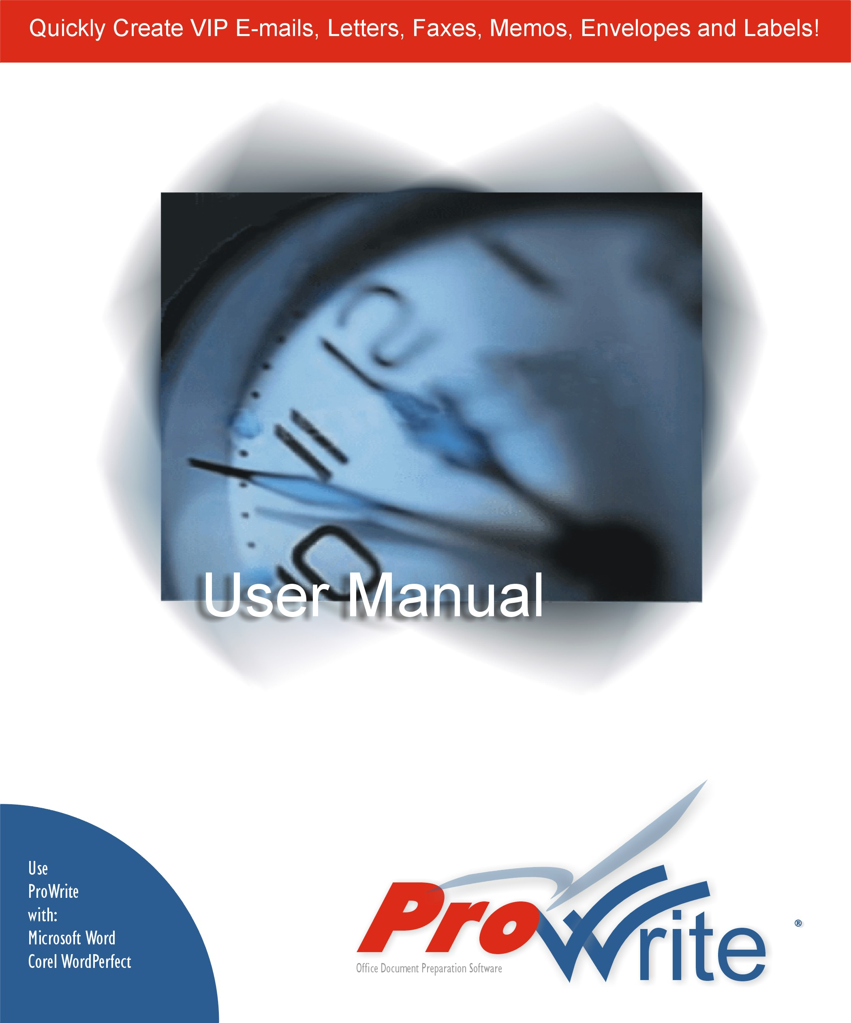
COPYRIGHT

Copyright © 2000 Nereosoft, Inc. All rights reserved.

Portions of the software described in this document are copyright © Microsoft Corporation and Corel Corporation. All rights reserved.

Information in this document is subject to change without notice. The software described in this document is furnished under a license agreement or nondisclosure agreement. The software may be used or copied only in accordance with the terms of those agreements. No part of this publication may be reproduced, stored in a retrieval system, or transmitted in any form or any means electronic or mechanical, including photocopying and recording for any purpose other than the purchaser’s personal use without the written permission of Nereosoft, Inc.

Nereosoft, Inc.
306 Sherbourne Street
Toronto, ON M5A 2S1
CANADA
www.nereosoft.com

(416) 515-1098 Tel
(416) 515-8490 fax

TRADEMARKS

ProWrite, Nereosoft are trademarks or registered trademarks of Nereosoft, Inc. Microsoft and Windows are registered trademarks of Microsoft Corporation. Other brands and their products are trademarks or registered trademarks of their respective holders and should be noted as such.

Rev. 11/00
License Agreement

NEREOSOFT PROWRITE
LICENSE AGREEMENT

IMPORTANT-READ CAREFULLY: This Nereosoft License Agreement ("LA") is a legal agreement between you (either an individual or a single entity) and Nereosoft Inc. for the Nereosoft software product identified above, which includes computer software and "online" or electronic documentation and may include associated media and printed materials ("SOFTWARE PRODUCT" or "SOFTWARE"). Carefully read all the terms and conditions of this agreement before installing this software package. By installing, copying, or otherwise using the SOFTWARE PRODUCT, you agree to be bound by the terms and conditions of this LA.

If you do not agree to the terms of the agreement, do not install or use the SOFTWARE PRODUCT.

SOFTWARE PRODUCT LICENSE

This SOFTWARE PRODUCT is protected by copyright laws and international copyright treaties, as well as other intellectual property laws and treaties. This SOFTWARE PRODUCT is licensed, not sold.

1. GRANT OF LICENSE
This LA grants you limited, non-exclusive, non-transferable license to install and use one copy of this software on a single computer owned or controlled by you. The information in these files is provided "as is" without warranty of any kind. All warranties, either expressed or implied are specifically disclaimed.

2. COPYRIGHT. All rights, title, and copyrights in and to the SOFTWARE PRODUCT (including, but not limited to, any images, photographs, animations, video, audio, music, text, and "applets" incorporated into the SOFTWARE PRODUCT) and any copies of the SOFTWARE PRODUCT are owned by Nereosoft Inc. or its suppliers. The SOFTWARE PRODUCT is protected by copyright, and trademark laws and international treaty provisions. Therefore, you must treat the SOFTWARE PRODUCT like any other copyrighted material, except that you may either (a) make one copy of the SOFTWARE PRODUCT solely for backup or archival purposes, or (b) install the SOFTWARE PRODUCT on a single computer, provided you keep the original solely for backup or archival purposes. You may not copy the printed materials accompanying the SOFTWARE PRODUCT.

By accepting this license you acknowledge that the program is proprietary in nature, and that the program contains valuable confidential information, including data processing algorithms, innovations and concepts. You will not disclose to others or utilize such trade secrets or proprietary information. This obligation shall survive the termination of this Agreement.

4. LIMITATION OF LIABILITY
This software is provided as is. In no event will Nereosoft, Inc. be liable to you for damages, including any lost profit, lost savings, or other incidental or consequential damages arising out of your use of or resulting from any inability to use the software. Nereosoft's entire liability and your exclusive remedy under this license agreement shall not exceed one Canadian dollar (CD $1).

5. DESCRIPTION OF OTHER RIGHTS AND LIMITATIONS
*Limitations on Reverse-Engineering, Decompilation and Disassembly: You may not reverse-engineer, decompile, or disassemble the software product.

*Rental: You may not rent or lease the software product.
*Termination: Without prejudice to any other rights, Nereosoft may terminate this license if you fail to comply with the terms and conditions of this license agreement. In such event, you must destroy all copies of the software product and all of its component parts.

*Software Transfer: You may not transfer the license, the SOFTWARE PRODUCT (including, but not limited to, any images, photographs, animations, video, audio, music, text, and "applets" incorporated into the SOFTWARE PRODUCT) or any copy of the SOFTWARE PRODUCT.

*Separation of Components: This SOFTWARE PRODUCT is licensed as a single product. You agree that you will not separate the component parts (including, but not limited to the macros, templates, database, help files, DLL and OCX files) for distribution, use on more than one computer, or any other use.

*Limitations on software usage: This software is designed for office professionals to generate their correspondence documents. You agree that you will not use this software product, its intellectual property or the forms created by the software for any other purpose. You will not utilize the software product or its components for the creation of any other software product (in, including, but not limited to XML, HTML or other media formats) for any other use.

*WARRANTY: No implied warranty (or condition) as to the quality or performance of the software, including any warranty (or condition) of merchantability or fitness for a particular purpose is given for the software and all such warranties are expressly disclaimed. No other warranty or guarantee given by any person, firm or corporation with respect to the software or delivery of the software shall bind the licensee or anyone else who has been involved in the creation, production or delivery of the software.

NEITHER THE LICENSOR NOR ANY OTHER PERSON, FIRM OR CORPORATION IS RESPONSIBLE FOR LOSS OF REVENUE OR PROFITS, EXPENSE OR INCONVENIENCE, OR FOR ANY OTHER SPECIAL, INCIDENTAL OR CONSEQUENTIAL DAMAGES CAUSED BY THE USE, MISUSE OR INABILITY TO USE THE SOFTWARE, WHETHER ON ACCOUNT OF NEGLIGENCE OR OTHERWISE, OR BY FAILURE TO CONFORM TO ANY EXPRESS OR IMPLIED WARRANTIES OR CONDITIONS

6. NO SUPPORT/UPGRADES: The Licensor is not responsible for maintaining or helping you to use the Software. Because the Software is provided "AS IS", no updates, customization services or support services will be made available for the Software, unless you enter into a separate support and maintenance services agreement.

7. ACKNOWLEDGMENT: YOU ACKNOWLEDGE THAT YOU HAVE READ THIS AGREEMENT, UNDERSTAND IT, AND AGREE TO BE BOUND BY ITS TERMS AND CONDITIONS. YOU ALSO AGREE THAT THIS AGREEMENT IS THE COMPLETE AND EXCLUSIVE STATEMENT OF AGREEMENT BETWEEN THE PARTIES AND SUPERSEDES ALL PROPOSALS OR PRIOR AGREEMENTS, VERBAL OR WRITTEN, AND ANY OTHER COMMUNICATIONS BETWEEN THE PARTIES RELATING TO THE SUBJECT MATTER OF THIS AGREEMENT. NO AMENDMENT TO THIS AGREEMENT SHALL BE EFFECTIVE UNLESS SIGNED BY AN OFFICER OF THE LICENSOR.

8. BINDING AGREEMENT: This agreement is binding on you and your successors and assigns.
Table of Contents

System Requirements 6
Installation 7
Overview 8
Getting Started 9
The ProWrite Menu 9
Setting your Personal Information 10
Creating your Customized Templates 11
Using Help 18
Six Basic Documents – E-Mail, Letter, Memo, Fax, Envelope & Label. 19
Creating a VIP Person-to-Person E-Mail and Fax 20
Creating a VIP Person-to-Person E-Mail and Fax 20
Creating a VIP Person-to-Person E-Mail and Fax - continued 21
Creating a VIP Person-to-Person E-Mail and Fax - continued 22
Creating a Letter 23
Creating a Fax Cover Sheet 31
Creating a Memo 39
Creating an Envelope 47
Creating a Label 53
Creating Boilerplate Templates 59
Options 60
General 60
Changing between English, French, German, Spanish and Italian 60
Setting “Cc” & “To” Formats and Template History 60
Using Different E-mail Address Books 61
Customizing the ProWrite Menu 61
Compacting and Repairing the Database 62
Editing and Creating Customized Templates 63
Creating New Templates 64
Creating File Folders 64
Renaming Templates and Folders 64
Copying Templates 64
Deleting Templates and Folders 64
Browsing for an existing Template 64
Editing Templates 65
Distributing Templates to other users 67
Advanced Options 68
Uninstalling or Removing 70
Contact Us: 71
Index 72

System Requirements

ProWrite© is designed for 32-bit operating systems running Windows 95, 98, ME, NT 4.0 (or later) and Windows 2000 Windows 3.1 systems are not supported.

- 486 processor or faster (Pentium recommended)

- 32 MB RAM or more (recommended)

- 32-bit operating system such as Windows 95, Windows 98, Windows 2000 and NT 4.0 (or later)

- 20 MB free disk space

- Word Processor (at least one of the following)

- Microsoft Word 97 or 2000

- Corel WordPerfect 8.0 or 2000 (9.0)

Installation

To install ProWrite:

- Insert the CD labeled ProWrite into you computer.

- If Autorun is enabled on your system, the installation will start automatically and you can skip steps 3 and 4.

- If Autorun is disabled on your system, from the Start menu, select Run.

- Type D:\SETUP or E:\SETUP (substitute the appropriate letter of your CD-ROM drive for D or E).

- Follow the instructions on the screen.
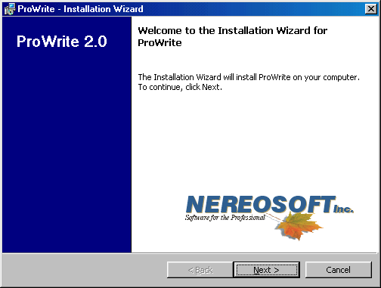

Click on the INSTALL button, then on the next screen click the ProWrite button. The installation of ProWrite will then begin.

Overview

ProWrite is an office document preparation software add-on to MicroSoft Word 97 & 2000 & WordPerfect 8.0, 2000 (9.0) and, which creates VIP E-mails, letters, memos, fax cover sheets, labels and envelopes faster, smarter and easier then you ever thought possible.

Whether you are trying to create one or one hundred letters, ProWrite will assist you in creating these emails, letters, the envelopes and labels to accompany them. All in a fraction of the time it would normally take to manually create one of these documents. ProWrite also has the ability to create boilerplate letters so that you can automate repetitive or routine correspondences.

In addition, ProWrite is designed to take advantage of the fact that most people today are using e-mail and have address books. ProWrite, with the click of a mouse, can access all the popular address books (i.e. GroupWise, Outlook, Lotus Notes, Act, Maximizer, etc.)

Highlights and Features:

- Easy to create VIP Person-to-Person e-mail and faxing

- Adds drop-down menu to main Menu Bar of WordPerfect & Word.
- this menu can be positioned anywhere on the menu bar
- the menu name can be changed to your company/person's name

- Links to GroupWise, Outlook, Lotus Notes, Act, Maximizer and other address books.

- Allows creation of English, French, German, Spanish and Italian documents and the menus and dialogs can switch dynamically between English, French, German, Spanish and Italian.

- Allows users to edit and customize the letter, fax, memo, envelope and label templates. Or, the users can substitute existing templates for the templates that ship with ProWrite.

ProWrite was inspired by the repeated request by organizations and companies to produce a simple, fast mechanism to create uniformly standardized office documents. Ideal for large corporations or small business alike, ProWrite will open new possibilities for your organization.

Getting Started
Once installed ProWrite is ready to create individualized e-mails, letters, faxes, memos, envelopes and labels, however, you should take a few minutes to customize the menu, templates and input your personal information. This will allow ProWrite to more effectively serve your particular needs and requirements.

The ProWrite Menu

Once ProWrite has been installed, when you launch Microsoft Word, Corel WordPerfect, Microsoft OutLook and Groupwise , a new menu item will be visible. Note: The menu item ProWrite can be changed to either your own name or your company name. (See Options: Customizing the ProWrite Menu Page 61)

Corel WordPerfect

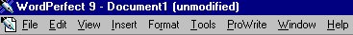
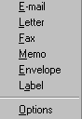
Microsoft Word

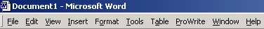
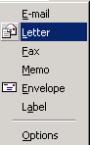

To create an e-mail, letter, fax cover sheet, memo, label or envelope, simply click on the desired option in the menu.

Setting your Personal Information

Before you create an e-mail, letter, fax cover sheet, memo, label or envelope you should save your personal information. This information is used to insert your name, address, phone, fax and e-mail address into your documents. If you have a number of people for whom you prepare these documents then you should save each person’s information. Likewise, if you act on behalf of several different companies, then saving the information for each company will allow you to switch between them when creating e-mail messages, letters, fax cover sheets, memos, labels or envelopes.
On the E-mail, Letter, Fax, Memo, Envelope or Label dialog, click on the more options button at the right of Sender. The Sender Information dialog will appear.

Choose the Add new Sender icon. If you are going to be creating documents for others or for different companies, create additional Sender profiles by clicking on Add New Sender. If you already have this information in the company address book of your e-mail system, you can import it directly by clicking on Address Books, choosing the address book of choice. (See Options: Using Different E-mail Address Books Page 61) for more information on how to set up ProWrite to use your address book.) Click on OK to return to the E-mail, Letter, Fax, Memo, Envelope or Label dialog screen.

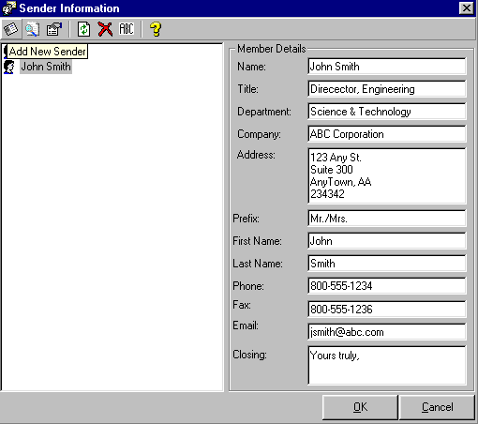

Once you have set up your personal information and anyone else’s that you will be using, the different Sender profiles are available when creating any of the ProWrite documents. Simply select the desired information by clicking on the down arrow of the From or Sender information depending on the dialog screen.

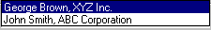

Creating your Customized Templates

You can start creating e-mails, letters, faxes, memos, envelopes and labels with the generic and basic templates that are installed along with ProWrite. This is usually a good starting point, especially for the fax cover sheet, which is very feature rich. However, most companies or organizations, unless they are using pre-printed stock, have logos which should be inserted into the templates. Adding logos to the templates that are used to create the e-mails, letters, faxes, memos, envelopes or labels allows the logos to be printed along with the sender and recipient information. As well, to conform with existing company and organization standards you may wish to re-arrange the content and appearance of the templates.

Remember that the templates themselves are Word and WordPerfect documents. You have available all the power of your word processor to customize your new templates. You can even cut and paste information from existing documents into the ProWrite templates or convert your existing templates into ProWrite templates. (Note: Once you have customized templates for your company or organization you can distribute them to other users in your organization. See Distributing Templates to other users Page 67)

Editing Templates

One of the most powerful feature of ProWrite is the ability to use any number of templates for creating the e-mails, letters, faxes, memos, envelopes and labels. At the top of each dialog you can select the template you would like to use to create each of the various documents.

Clicking on the down arrow to the right of the templates option to display a history of templates that have been used. So if you are working for different companies or switching between pre-printed and non-pre-printed letterhead you can with ease. Likewise, if you are using Boilerplate template (i.e. letters with standard wording already inserted) you can select these just as quickly. (See Creating Boilerplate Templates Page 59)

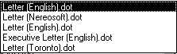

To select, edit, copy, rename, delete, customize or use your existing templates, simply click on the more button on the right of the Templates. This will cause the template explorer to appear. (See Template Explorer Page 12)

Template Explorer

The template explorer is used to organize templates and give you the maximum flexibility in using different templates to create e-mails, letters, faxes, memos, envelopes or labels.

The template explorer will display both the local and network templates. The path for these templates is determined by the setting of your word processor (i.e. Word or WordPerfect). (See Editing and Creating Customized Templates Page 14.)

To use any of the templates listed in the template explorer simply select or highlight the template and click on OK.

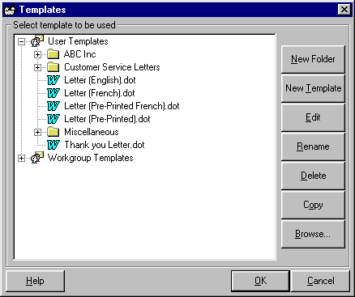

To edit one of the existing ProWrite templates simply highlight the template and click on the Edit button.

Using the ProWrite Templates

To edit one of the existing ProWrite templates simply highlight the template in the template explorer and click on the Edit button. The template explorer will close and the template you highlighted will be opened in either Word or WordPerfect. In addition, the Edit Toolbar will appear on your screen.

The Edit Toolbar allows you to insert the merge codes into the template. Each piece of information you provide in the dialogs for the e-mail, letter, fax, memo, envelope, label or sender information has a corresponding merge code. If you look at the template on the screen you will see the merge codes. (See Inserting Merge Codes Page 15).

Once you have finished editing the template save the templates by selecting File, Save in either Word or WordPerfect. Close the template and also close the edit toolbar by clicking on Close. (See Inserting Merge Fields Page 66)

Using Existing Templates

If you already have an existing document or template you would like to use with ProWrite, in the template explorer click on the Browse button. Locate your existing template, highlight it and click on the Open button to import it into the ProWrite directory structure. (See Browsing for an Existing Templates Page 64)

Since most individuals or organizations already have existing templates. The browse feature allows you to locate and import existing templates into the ProWrite directory structure.

Click on Browse will cause the following screen to appear.

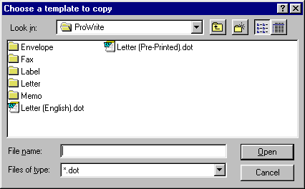

Locate the existing template or document you wish to convert and click on Open. The template you have selected will be imported into the ProWrite directories.

Editing Imported Templates

Once you have imported the template, highlight the template and click on the Edit button. Your existing template will appear on the screen. Although you have imported the template, it will not function until you insert the merge codes for the sender, recipient and other information.

The Edit Toolbar which has appeared allows you to insert the merge codes into the template. Each piece of information you provide in the dialogs for the letter, fax, memo, envelope, label or sender information has a corresponding merge code. Insert the appropriate merge codes and change the font and attributes according to your company standards (See Inserting Merge Codes Page 66 Error: Reference source not found).

Once you have finish editing the template, save the templates by selecting File, Save in either Word or WordPerfect. Close the template and also close the edit toolbar by clicking on Close. (See Editing Templates Page 66)

(Note: You can also copy and paste these codes into your existing template or you can use the edit toolbar to insert the merge codes into the template.)

Creating New Templates

To create a new template for use with ProWrite, highlight the folder or a file within the folder where you wish to create the new template. Once in the template explorer click on the New Template button. Follow the same procedure as with editing ProWrite templates or existing templates above.

Creating File Folders

To create a new file folder for use with ProWrite, highlight the folder or a file within the folder where you wish to create the new folder and click on the New Folder button.

Renaming Templates and Folders

To rename a template or folder, highlight the template or folder to be renamed and click on the Rename button.

Copying Templates

To copy a template, highlight the template to be copied and click on the Copy button.

Deleting Templates and Folders

To delete a template or folder, highlight the template or folder to be deleted and click on the Delete button.

Inserting Merge Codes

Merge code are markers that allow information to be inserted into a document and also to create multiple copies of the same document. For example, create multiple letters addressed to a number of different people. The procedure in both Word and WordPerfect is identical, however, the appearance of the merge codes is slightly different. See the examples below.

Word WordPerfect

Step #1 Position your cursor on the template

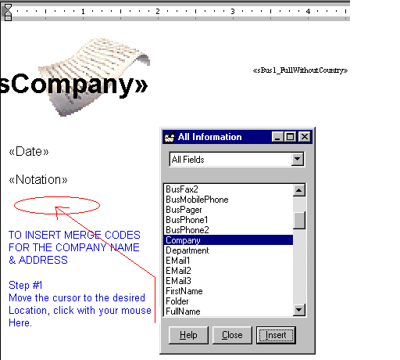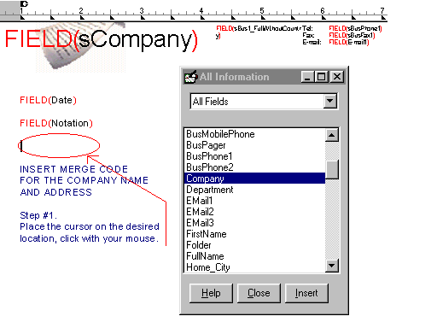

Each merge code is inserted individually into the document. You can have multiple occurrences of a merge field and you can omit codes you do not wish to have in the template.

Step #2. Click on the Edit Toolbar button corresponding to the merge code you would like to insert into the document.

Word WordPerfect

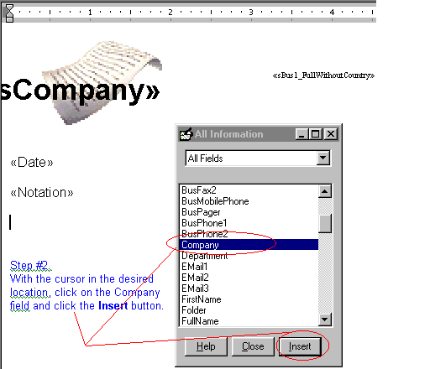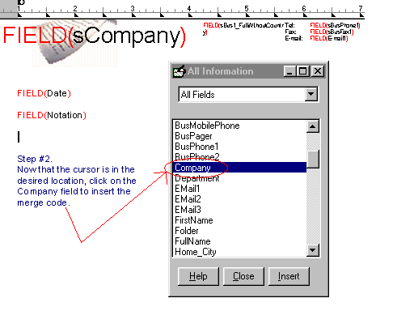

The appropriate merge code is inserted into the document. Repeat this procedure until you have inserted all of the desired merge codes.

Word WordPerfect

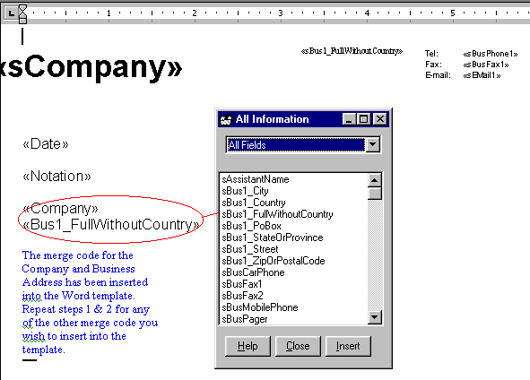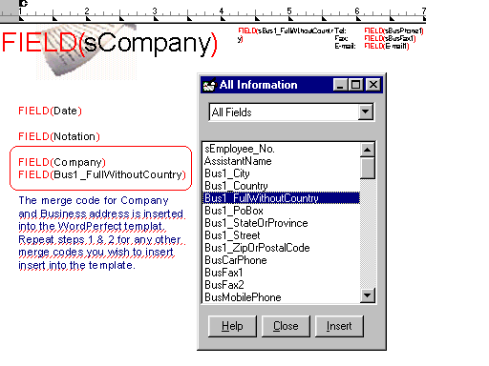

Using Help

If you would like help on any of the features in ProWrite you have two types of help available Contact Sensitive Help and Help button.

Contact Sensitive Help

Contact Sensitive help simply means that you can get assistance with any control on the ProWrite dialogs by clicking on it with your mouse or tabbing to the control button, and pressing the F1 key on your keyboard. The appropriate help file will be displayed to assist you with this feature or control.

Help Button

Each of the dialog screens for ProWrite has a Help button at the bottom of the screen. Clicking on the help button will open a help file which will display a graphic of the dialog. Clicking on any of the controls or features in this graphic will display additional help on the selected item.

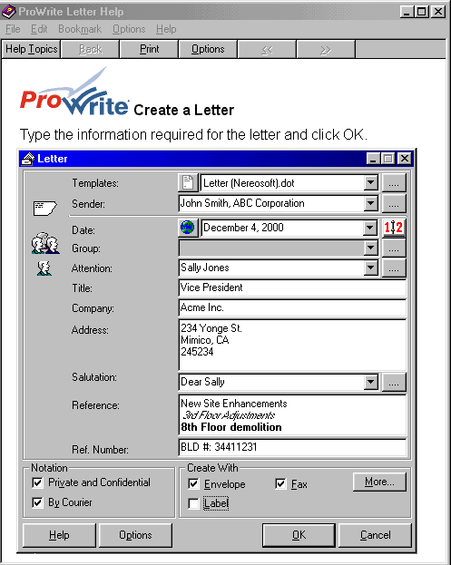

Press Crtl-Tab to highlight all the available hotspots. Dragging the mouse cursor over any valid hotspot will turn the mouse cursor to a little hand. When the hand appears, simply click with your mouse and the appropriate help will be displayed.

Six Basic Documents – E-Mail, Letter, Memo, Fax, Envelope & Label.

These next few pages are designed to show you in more detail the functions and features available in the six basic documents that can be generated by us ProWrite.

The ProWrite Menu in MicroSoft Word.

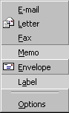

The ProWrite Menu in Corel WordPerfect.

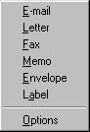

Creating a VIP Person-to-Person E-Mail and Fax
To create an e-mail or multiple VIP Person-to-Person e-mail messages click on the option from the ProWrite menu. The following screen will appear and will allow you to create one or more e-mail messages.

(Note: If this is the first time that you are using ProWrite you have to enter the Sender information. If you are required to send information on behalf of others, you will need to setup a Sender Profile for each person. (See Sender Information page 24.)

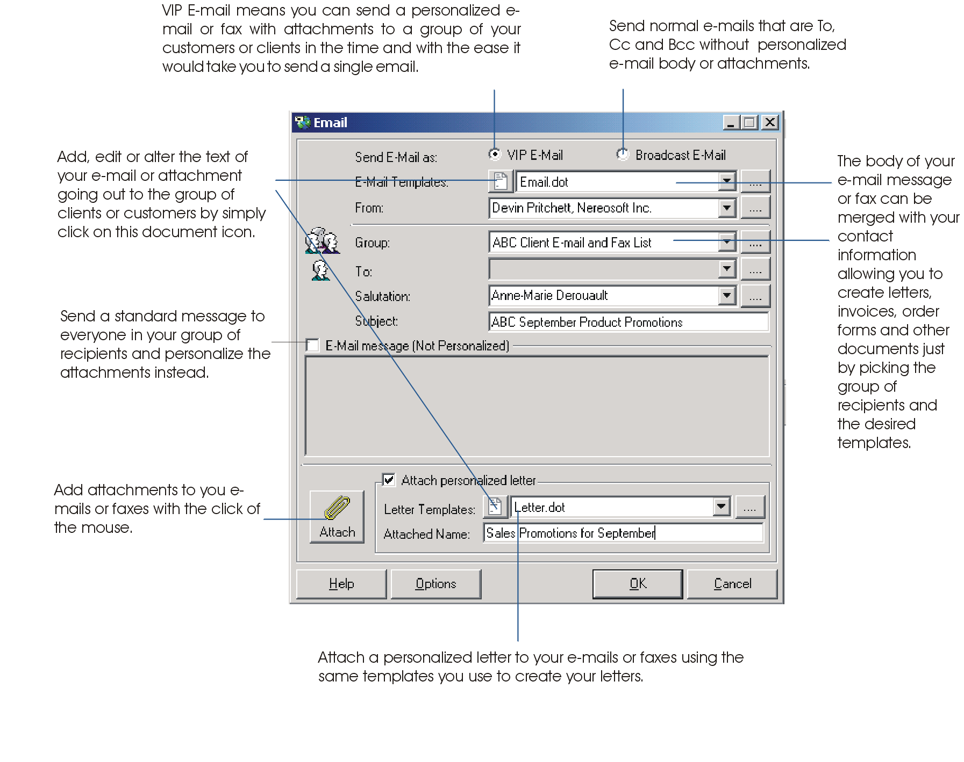
The E-mail screen is explained above.
E-MAIL OPTIONS:
- VIP E-mail or Broadcast E-mail – allows for personalized e-mails or when creating an e-mail message and if you wish to have all recipients knowing who received the e-mail message with the exception of BCC (Blind Carbon Copy) recipients, select the option Broadcast E-mail .
- E-mail Templates - Insert Text button – allows the editing “on-the-fly” to the generated document
- The More button indicates that there are more templates, groups, sender records, recipient records and salutation records to be accessed.
- Selecting the checkbox will make the message a generic and non-personalized message to all recipients.

Creating a VIP Person-to-Person E-Mail and Fax - continued

While working in OutLook, the ProWrite menu and icons are made available for quick and easy access. The OutLook
screen shown below shows the ProWrite menu. Simply select the individual or individuals you wish to send correspondence to. With the individuals selected, click on the ProWrite menu choose the type of document to be created ProWrite will automatically fill-in the information for each individual previously selected. The final step of completing the specifics for the e-mail message and clicking on the ok button will cause the generation of the e-mail messages.

Step 1: Select the records in OutLook

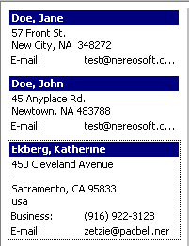

Step 2: Select the ProWrite menu from within Outlook and choose the document you wish to generate.

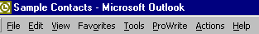
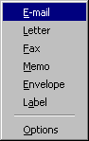

Step 3: A temporary group automatically set. The temporary group can become permanent if a group name is assigned.

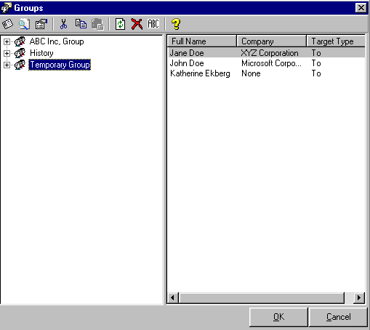

Creating a VIP Person-to-Person E-Mail and Fax - continued

ProWrite installs icons directly onto the OutLook menu.

For easy access on the OutLook menu bar, icons are available to access ProWrite are: ProWrite E-mail,
ProWrite Letter, ProWrite Fax, ProWrite Memo, ProWrite Envelope & ProWrite Label.

Admin Options:
The Options menu item from the ProWrite menu is where to configure ProWrite. For example, under the Advanced Tab & the E-mail Options, is where to set the “preview e-mail message” prior to sending. The other options are: the various address books, the language to display in, renaming the menu item in OutLook, creating a distribution disk and more.

(Note: You also have options for inserting a letter and/or an attachment of other files.)

Note: If you want to configure your system for faxing, Start, Programs, ProWrite and select . This document will step you through setting up Outlook faxing.

Note: If you are using vCards or if people are sending you e-mail are using vCards, this is a wonderful way to transfer contact information into the Microsoft Outlook Contacts for use with ProWrite when creating letters, faxes, etc. (See Microsoft Outlook Help and search vCards)

Creating a Letter

To create a letter or multiple letters click on from the ProWrite menu. The following screen will appear which will allow you to create one or more letters.

(Note: If this is the first time that you are using the software you will have to enter the Sender information for yourself or anyone you will be creating documents for using ProWrite. See Sender Information below.)

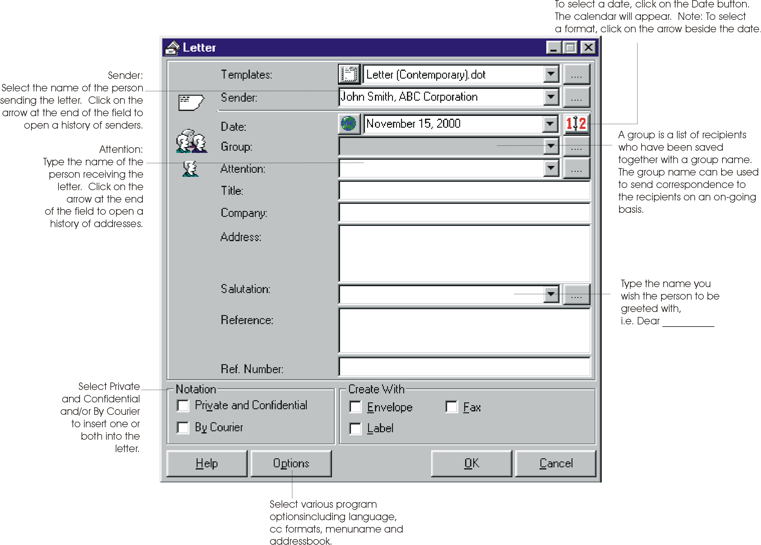

If you want to create a simple letter, just fill in the appropriate information for your letter i.e. Attention, Title, Company and Address, Salutation, Reference and Reference Number. Click on OK to create the letter.

(Note: You also have options for inserting the text Private and Confidential and/or By Courier into the letter. Also, if you would like to create an envelope and/or label and/or fax at the same time, put a check mark beside envelope and/or label.)

Sender Information

On the Letter dialog, click on the more options button at the right of Sender. The Sender Information dialog will appear. Enter your information and click on OK. This will now automatically be inserted for you into your e-mails, letters, faxes, memos, envelopes and labels. If you are going to be creating for others or for different companies, create additional Sender profiles by clicking on New Sender. If you already have this information in the company address book of your e-mail system, you can import directly by clicking on Address Books and selecting from which address book you wish to pull the information from. (See Options: Using Different E-mail Address Books Page 61 for more information on how to set up ProWrite to use your address book.) Click on OK to return to the Letter dialog screen.

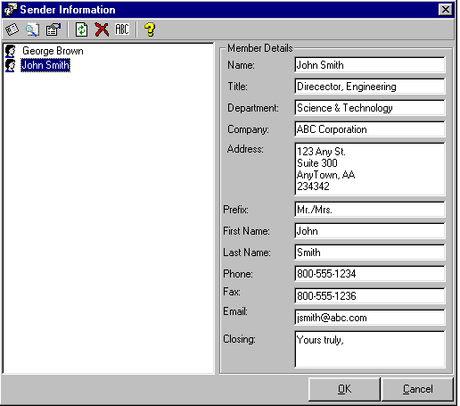

Once you have set up your personal information and anyone else’s that you will be using, the different Sender profiles are available when creating any of the ProWrite documents. Simply select the desired information by clicking on the down arrow of the Sender information on the Letter dialog.

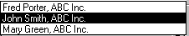

Date

The dialog also has the ability to allow you to pick a date other than the current date or select a different format for the date. You can also insert the date in English, French, German, Italian or Spanish by selecting the region .

To select a different date simply click on the icon to the right of the current date. The calendar dialog will appear. Here simply select the desired day, month or year and either click on OK or double click.

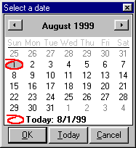

If you wish to have the date appear in a different format click on the down arrow of the date picker. You can scroll through the different formats and simply click on the desired format.

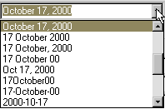

Address Book

ProWrite has the built-in address book to allow you to save frequently used addresses. However, if you have Microsoft Outlook, Novell GroupWise, Corel Address Book, Lotus Notes, Act or Maximizer ability on your system, you can use these address books. You can access your contact and address books directly to pull address information directly into your letters. (See Options: Using Different E-mail Address Books Page 61)

Note: If you are using vCards or if people are sending you e-mail are using vCards, this is a wonderful way to transfer contact information into the Microsoft Outlook Contacts for use with ProWrite when creating letters, faxes, etc. (See Microsoft Outlook Help and search vCards)

To access the address book simply click on the more button at the right of Attention. Depending on which address book you have selected to use under the advanced options, the appropriate address book will appear. (See Options: Using Different E-mail Address Books Page 61)

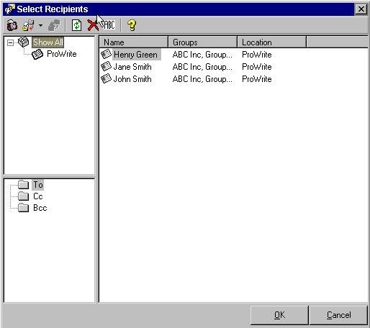

To select a recipient for the list hi-light the recipient’s name(s) and choose the Send to icon. A drop down list displaying To, CC, or BCC will be available for choosing how the recipient will receive the correspondence. Alternatively, you can hi-light the recipient’s name (s) drag and drop onto the To file folder (middle left hand side of screen). Do the same for CC and Bcc (See Options: Setting Cc and To Formats Page 60) for more information on the formatting of Cc in letters.) You can delete recipients by hi-lighting and choosing the button. Click on OK to return the Letter dialog.

If you select only one recipient for the letter, the address information is imported directly into the Letter dialog. However, if you select more then one recipient because you want to generate multiple letters, you will see a new prompt.
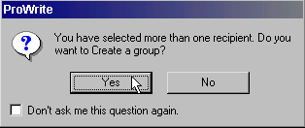

If you will be using this group of recipients again you can click on Yes or, if this is a one-time group of recipients, simply click No. If you click No, then you will be returned to the Letter dialog. If you click No the multiple letters will be created. If you click on Yes you will be asked to give a name to the group.

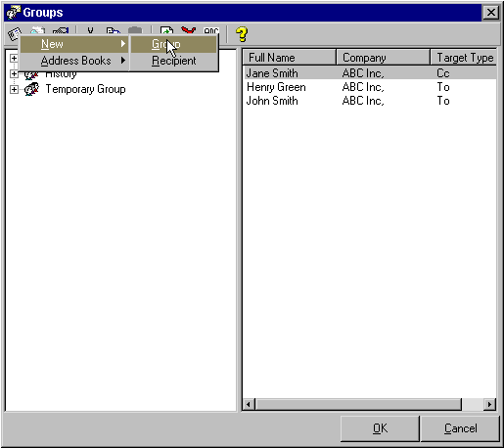

Type a meaningful name for the group of recipients where it says and click on OK.

Using Groups

If, for example, we had call this group of recipients ABC Inc., when we clicked on OK and the Letter dialog re-appeared. The group would show ABC Inc.

Any time in the future that we want to send this group of recipients a letter, fax, memo, envelope or label simply click on the down arrow to the right of the group and a list of all available groups will appear.

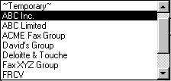

You can scroll through the list of groups and simply click on the group you would like to use. If you wish to edit, add, remove or otherwise work with groups, click on the more button to the right of the group and the group dialog will appear and allow you to work with the groups.

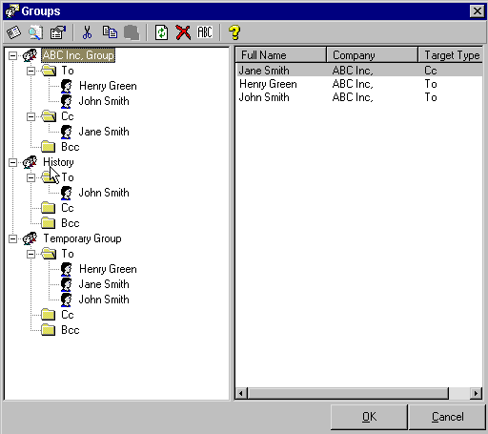

If you would like to take full advantage of the ability to create multiple letters you should also see how you can create standard letters with boiler plate text. (See Using Templates below Page 29)

Salutation

The salutation, if you are simply typing in the address information, is not very significant other then you can specify the salutation in the letter. However, if you are using the address book to use one or more recipients you can use the salutation drop down feature to pick the desired format.

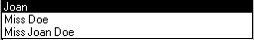

Notation

Click on the Notation features to put a check mark beside the desired option. This will insert the text Private and Confidential and/or By Courier into the letter.

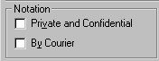

Creating Letter with Envelope and/or Label

If you would like to create an envelope and/or label at the same time you are creating the letter or letters you can by putting a check mark beside envelope and/or label.

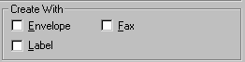

If you click on the More button, you will be able to select the type of envelope or label you would like to create.

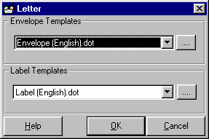

Clicking on the more button, to the right of either envelope or label, will bring up the template explorer. (See Using Templates below or Options: Editing and Customizing Templates Page 63)

Using Templates

The most powerful feature of ProWrite is the ability to use any number of templates for creating the letter. At the top of the Letter dialog you can select the template you would like to use to create the letter.

Clicking on the down arrow to the right of the templates displays a history of templates that you have used.

To select, edit, copy, rename, delete, customize or use your existing templates, simply click on the more button on the right of the templates. The template explorer will appear. For more information about customizing templates or working with the features in this template dialog, (See Options: Editing and Creating Customized Templates Page 63).

To use any of the templates listed in the template explorer simply select the template and click on OK.

Help

Clicking on the Help button at the bottom left corner of the Letter dialog allows the user to access help on using the features of the Letter dialog. Contact sensitive help is also available by pressing F1 while your cursor or focus is on a feature or control.

Options

Clicking on the Options button at the bottom left corner of the Letter dialog allows the user to set the advanced options and edit the templates. (See Options Page 60)

Creating a Fax Cover Sheet

To create a fax cover sheet click on from the ProWrite menu. The following screen will appear which will allow you to create a fax cover sheet.

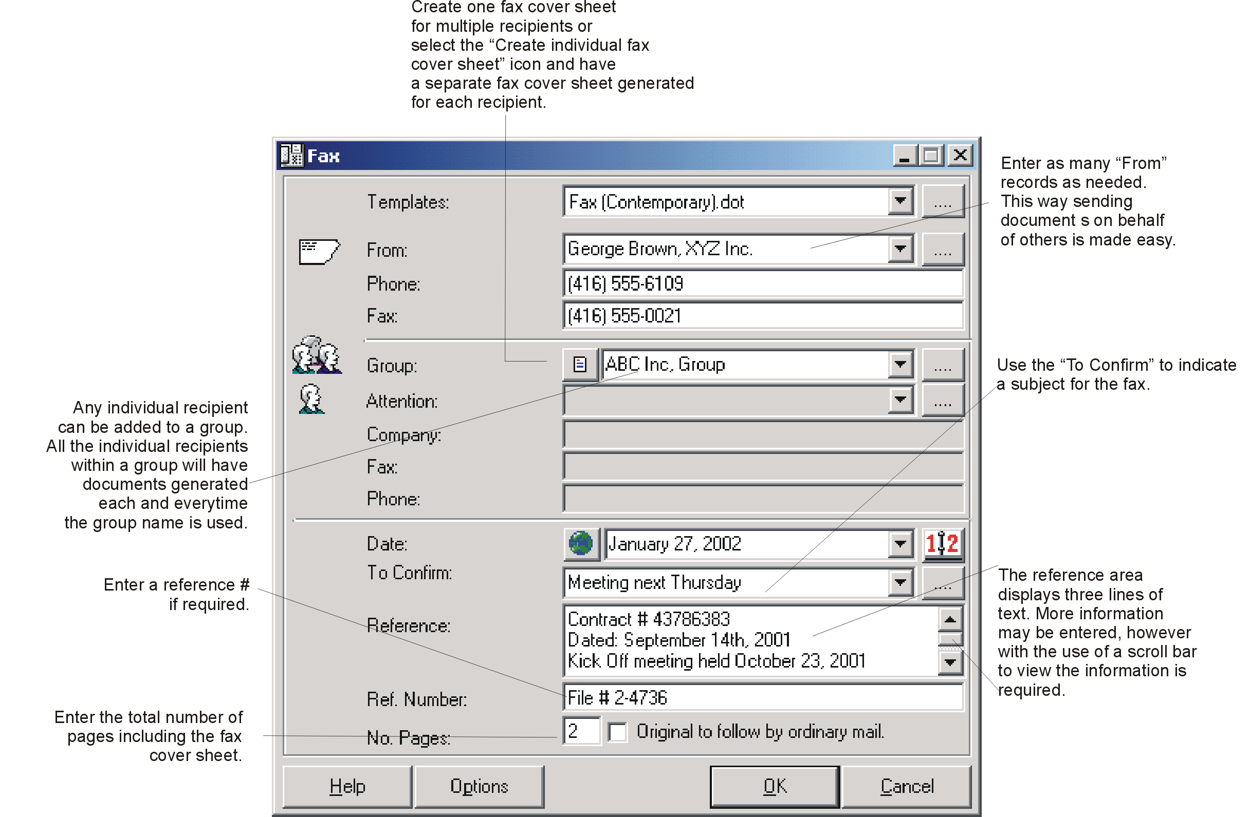

(Note: If this is the first time that you are using the software you will have to enter the Sender information for yourself or anyone you will be creating documents for using ProWrite. See Sender Information below.)

If you want to create a simple fax cover sheet just fill in the appropriate information for your fax i.e. Attention, Company, Fax, Phone, Reference, Reference Number, and Number of Pages. Click OK to create a fax coversheet.

Sender Information

On the Fax dialog, click on the more options button at the right of Sender. The Sender Information dialog will appear. Enter your information and click on OK. This will now automatically be inserted for you into your e-mails, letters, faxes, memos, envelopes and labels. If you are going to be creating for others or for different companies, create additional Sender profiles by clicking on New Sender. If you already have this information in the company address book of your e-mail system, you can import directly by clicking on Address Books and selecting from which address book you wish to pull the information from. (See Options: Using Different E-mail Address Books Page 61 for more information on how to set up ProWrite to use your address book.) Click on OK to return to the Fax dialog screen.

Once you have set up your personal information and anyone else’s that you will be using, the different Sender profiles are available when creating any of the ProWrite documents. Simply select the desired information by clicking on the down arrow of the Sender information on the Letter dialog.

Date

The dialog also has the ability to allow you to pick a date other than the current date or select a different format for the date. You can also insert the date in English, French, German, Italian or Spanish by selecting the region .

To select a different date simply click on the icon to the right of the current date. The calendar dialog will appear. Here simply select the desired day, month or year and either click on OK or double click.

If you wish to have the date appear in a different format click on the down arrow of the date picker. You can scroll through the different formats and simply click on the desired format.

Confirm

Confirmation upon receipt of the fax has a history feature, so that, if you are sending fax for others and need to vary the confirmation person, you can simply click and select that person.

Number of Pages

To indicate the number of pages attached to your fax cover sheet, type the number in the No. Pages field of the Fax Dialog

Original to follow by ordinary mail

Putting a check mark beside the original to follow by mail option will insert this phrase into the fax cover sheet.

Address Book

ProWrite has the built-in address book to allow you to save frequently used addresses. However, if you have Microsoft Outlook, Novell GroupWise, or Corel Address Book (Note: Lotus Notes and Netscape to be supported soon) ability on your system, you can use these address books. You can access your contact and address books directly to pull address information directly into your fax cover sheet. (See Options: Using Different E-mail Address Books Page 61)

Note: If you are using vCards or if people who are sending you e-mail are using vCards this is a wonderful way to transfer contact information into the Microsoft Outlook Contacts for use with ProWrite when creating Letters, faxes, etc. (See Microsoft Outlook Help and search vCards)

To access the address book simply click on the more button at the right of Attention. Depending on which address book you have selected to use under the advanced options, the appropriate address book will apear. (See Options: Using Different E-mail Address Books Page 61)

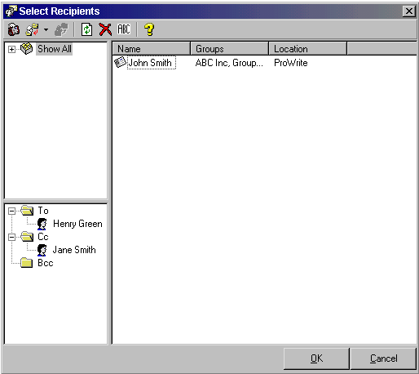

To select a recipient for the list click on To-> or double click on the name in the list on the left of the screen. If you want to Cc someone click on Cc->. You can add or delete additional recipients by using the Delete and Save buttons and entering the information in the field below. Click on OK to return the Fax dialog.
If you select only one recipient for the fax cover sheet the address information is imported directly into the fax dialog. However, if you select more then one recipient because you want to generate a multiple recipient fax cover sheet you will see a new prompt.

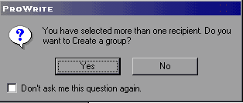

If you will be using this group of recipients again you can click on Yes or if this is a one-time group of recipients, simply click No. If you click No, you will be returned to the Fax dialog. Then if you click on OK, a multiple recipient fax will be created. If you click on Yes, you will be asked to give a name to the group.

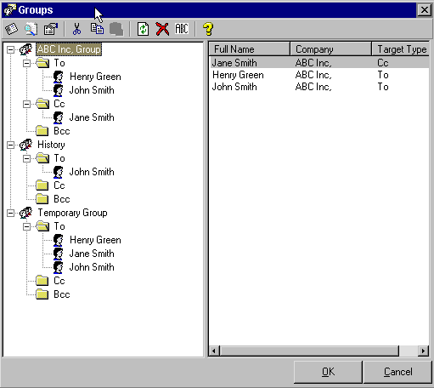

Type a meaningful name for the group of recipients where it says and click on OK.

Using Groups

If, for example, we had call this group of recipients ABC Inc., when we clicked on OK and the Fax dialog re-appeared. The group would show ABC Inc.

Any time in the future that we want to send this group of recipients a letter, fax, memo, envelope or label simply click on the down arrow to the right of the group and a list of all available groups will appear.

You can scroll through the list of groups and simply click on the group you would like to use. If you wish to edit, add, remove or otherwise work with groups, click on the more button to the right of the group and the group dialog will appear and allow you to work with the groups.

If you would like to take full advantage of the ability to create multiple or single recipient fax cover sheets you should also see how you can use different fax cover sheet templates. See Using Templates below.

Using Templates

The most powerful feature of ProWrite is the ability to use any number of templates for creating the fax cover sheet. At the top of the Fax dialog you can select the template you would like to use to create the fax cover sheet.

Clicking on the down arrow to the right of the templates displays a history of templates that you have used.

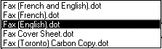

To select, edit, copy, rename, delete, customize or use your existing templates, simply click on the more button at the right of the templates. The template explorer will appear. For more information about customizing templates or working with the features in this template dialog (See Options: Editing and Creating Customized Templates Page 63).

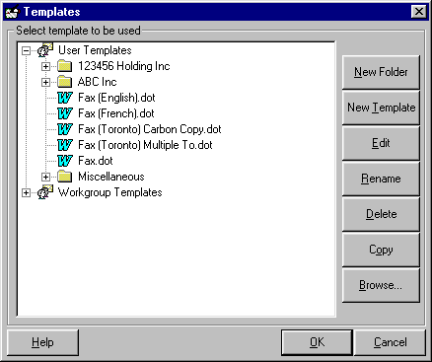

To use any of the templates listed in the template explorer simply select the template and click on OK.

Help

Clicking on the Help button at the bottom left corner of the Fax dialog allows the user to access help on using the features of the Fax dialog. Contact sensitive help is also available by pressing F1 while your cursor or focus is on a feature or control.

Options

Clicking on the Options button at the bottom left corner of the Fax dialog allows the user to set the advanced options and edit the templates. (See Options Page 60)

Creating a Memo

To create a memo, click on Memo in the ProWrite menu. The following screen will appear which will allow you to create a memo.

(Note: If this is the first time that you are using the software you will have to enter the Sender information for yourself or anyone you will be creating documents for using ProWrite. See Sender Information below.)

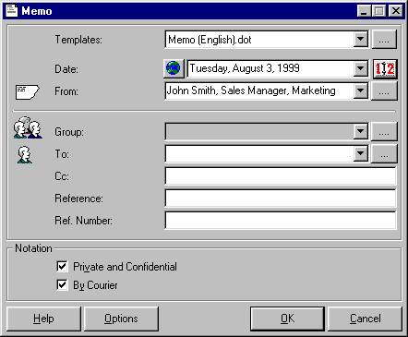

If you want to create a simple memo just fill in the appropriate information for your memo i.e. To, Cc, Reference and Reference Number. Click on OK to create the Memo.

(Note: You also have options for inserting the text Private and Confidential and/or By Courier into the memo.)

Sender Information

On the Memo dialog, click on the more options button at the right of Sender. The Sender Information dialog will appear. Enter your information and click on OK. This will now automatically be inserted for you into your e-mails, letters, faxes, memos, envelopes and labels. If you are going to be creating for others or for different companies, create additional Sender profiles by clicking on New Sender. If you already have this information in the company address book of your e-mail system, you can import directly by clicking on Address Books and selecting from which address book you wish to pull the information from. (See Options: Using Different E-mail Address Books Page 61 for more information on how to set up ProWrite to use your address book.) Click on OK to return to the Memo dialog screen.

Once you have set up your personal information and anyone else’s that you will be using, the different Sender profiles are available when creating any of the ProWrite documents. Simply select the desired information by clicking on the down arrow of the Sender information on the Letter dialog.

Date

The dialog also has the ability to allow you to pick a date other than the current date or select a different format for the date. You can also insert the date in English, French, German, Italian or Spanish by selecting the region .

To select a different date simply click on the icon to the right of the current date. The calendar dialog will appear. Here simply select the desired day, month or year and either click on OK or double click.

If you wish to have the date appear in a different format click on the down arrow of the date picker. You can scroll through the different formats and simply click on the desired format.

Address Book

ProWrite has the built-in address book to allow you to save frequently used addresses. However, if you have Microsoft Outlook, Novell GroupWise, Corel Address Book or soon-to-be-supported Lotus Notes or Netscape ability on your system, you can use these address books. You can access your contact and address books directly to pull address information directly into your letters. (See Options: Using Different E-mail Address Books Page 57)

Note: If you are using vCards or if people are sending you e-mail are using vCards, this is a wonderful way to transfer contact information into the Microsoft Outlook Contacts for use with ProWrite when creating letters, faxes, etc. (See Microsoft Outlook Help and search vCards)

To access the address book simply click on the more button at the right of Attention. Depending on which address book you have selected to use under the advanced options, the appropriate address book will appear. (See Options: Using Different E-mail Address Books Page 61)

To select a recipient for the list hi-light the recipient’s name(s) and choose the Send to icon. A drop down list displaying To, CC, or BCC will be available for choosing how the recipient will receive the correspondence. Alternatively, you can hi-light the recipient’s name (s) drag and drop onto the To file folder (middle left hand side of screen). Do the same for CC and Bcc (See Options: Setting Cc and To Formats Page 60) for more information on the formatting of Cc in letters.) You can delete recipients by hi-lighting and choosing the button. Click on OK to return the Letter dialog.

If you select only one recipient for the letter, the address information is imported directly into the Letter dialog. However, if you select more then one recipient because you want to generate multiple letters, you will see a new prompt.

If you will be using this group of recipients again you can click on Yes or, if this is a one-time group of recipients, simply click No. If you click No, then you will be returned to the Letter dialog. If you click No the multiple letters will be created. If you click on Yes you will be asked to give a name to the group.

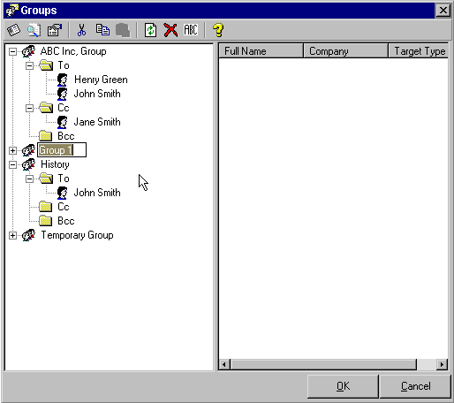

Type a meaningful name for the group of recipients where it says and click on OK.

Using Groups

If, for example, we had call this group of recipients ABC Inc., when we clicked on OK and the Memo dialog re-appeared. The group would show ABC Inc.

Any time in the future that we want to send this group of recipients a letter, fax, memo, envelope or label simply click on the down arrow to the right of the group and a list of all available groups will appear.

You can scroll through the list of groups and simply click on the group you would like to use. If you wish to edit, add, remove or otherwise work with the groups, click on the more button to the right of the group and the group dialog will appear and allow you to work with the groups.

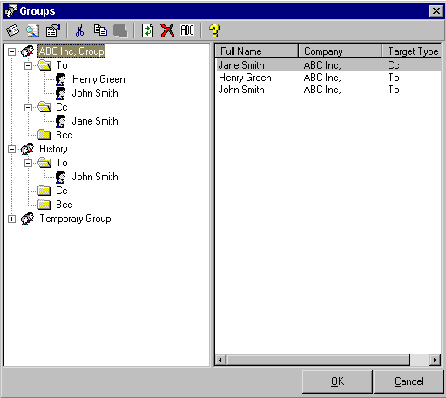

Notation

Click on the Notation features to put a check mark beside the desired option. This will insert the text Private and Confidential and/or By Courier into the memo.

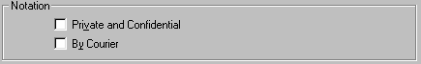

Using Templates

The most powerful feature of ProWrite is the ability to use any number of templates for creating the memo. At the top of the Memo dialog you can select the template you would like to use to create the memo.

Clicking on the down arrow to the right of the templates displays a history of templates that you have used.

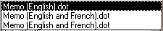

To select, edit, copy, rename, delete, customize or use your existing templates simply click on the more button on the right of the templates. The template explorer will appear. For more information about customizing templates or working with the features in this template dialog, (See Options: Editing and Creating Customized Templates Page 63).

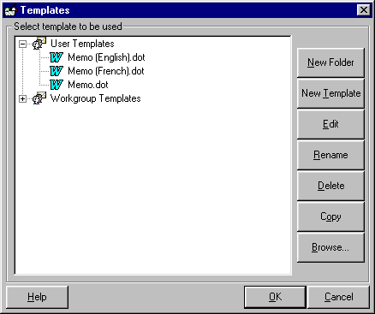

To use any of the templates listed in the template explorer simply select the template and click on OK.

Help

Clicking on the Help button at the bottom left corner of the Memo dialog allows the user to access help on using the features of the Memo dialog. Contact sensitive help is also available by pressing F1 while your cursor or focus is on a feature or control.

Options

Clicking on the Options button at the bottom left corner of the Memo dialog allows the user to set the advanced options and edit the templates. (See Options Page 60)

Creating an Envelope

To create an envelope or multiple envelopes, click on Envelope in the ProWrite menu. The following screen will appear which will allow you to create one or more envelopes.

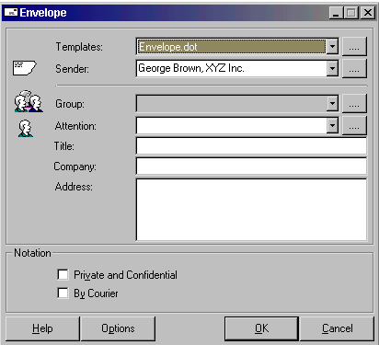

(Note: If this is the first time that you are using the software you will have to enter the Sender information for yourself or anyone you will be creating documents for using ProWrite. See Sender Information below.)

If you want to create a simple envelope just fill in the appropriate information for your envelope i.e. Attention, and Company and Address. Click on OK to create the envelope.

(Note: You also have options for inserting the text Private and Confidential and/or By Courier into the envelope.)

Sender Information

On the Envelope dialog click on the more options button at the right of Sender . The Sender Information dialog will appear. Enter your information and click on Save. This will now automatically be inserted for you into your letters, faxes, memos, envelopes and labels. If you are going to be creating documents for others or for different companies, create additional Sender profiles by clicking on Add New. If you already have this information in the company address book of your e-mail system you can import directly by clicking on Address Book. (See Options: Using Different E-mail Address Books Page 57) for more information on how to set up ProWrite to use your address book.) Click on OK to return to the Envelope dialog screen.

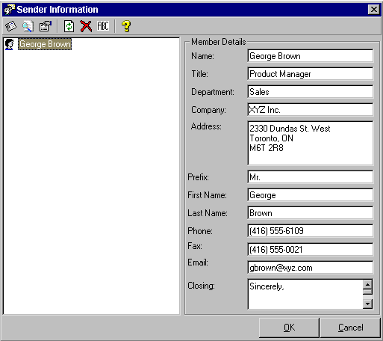

Once you have set up your personal information and anyone else’s that you will be using, the different Sender profiles are available when creating any of the ProWrite documents. Simply select the desired information by clicking on the down arrow of the Sender information on the Envelope dialog.

Address Book

ProWrite has the built-in address book to allow you to save frequently used addresses. However, if you have Microsoft Outlook, Novell GroupWise, Corel Address Book or soon-to-be-supported Lotus Notes or Netscape ability on your system, you can use these address books. You can access your contact and address books directly to pull address information directly into your envelopes. (See Options: Using Different E-mail Address Books Page 57)

Note: If you are using vCards or if people who are sending you e-mail are using vCards this is a wonderful way to transfer contact information into the Microsoft Outlook Contacts for use with ProWrite when creating Letters, faxes, etc. (See Microsoft Outlook Help and search vCards)
To access the address book simply click on the more button at the right of Attention. Depending on which address book you have selected to use under the advanced options the appropriate address book will apear. (See Options: Using Different E-mail Address Books)

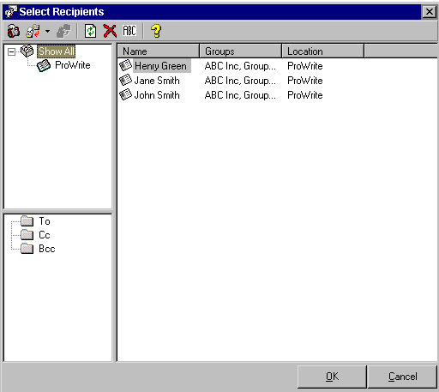

To select a recipient for the list click on To-> or double click on the name in the list on the left of the screen. If you want to Cc someone click on Cc->. (See Options: Setting Cc and To Formats Page 60) for more information on the formatting of Cc in letters.) You can add or delete additional recipients by using the Delete, Save buttons and entering the information in the field below. Click on OK to return the Envelope dialog.

If you select only one recipient for the envelope the address information is imported directly into the Envelope dialog. However, if you select more then one recipient because you want to generate multiple envelopes you will see a new prompt.

If you will be using this group of recipients again you can click on Yes or, if this is a one-time group of recipients, simply click No. If you click No, then you will be returned to the Letter dialog. If you click No the multiple letters will be created. If you click on Yes you will be asked to give a name to the group..

If you will be using this group of recipients again you can click on Yes or, if this is a one-time group of recipients, simply click No. If you click No, then you will be returned to the Letter dialog. If you click No the multiple letters will be created. If you click on Yes you will be asked to give a name to the group.

Type a meaningful name for the group of recipients where it says and click on OK.

Using Groups

If, for example, we had call this group of recipients ABC Inc., when we clicked on OK and the Letter dialog re-appeared. The group would show ABC Inc.

Any time in the future that we want to send this group of recipients a letter, fax, memo, envelope or label simply click on the down arrow to the right of the group and a list of all available groups will appear.

You can scroll through the list of groups and simply click on the group you would like to use. If you wish to edit, add, remove or otherwise work with groups, click on the more button to the right of the group and the group dialog will appear and allow you to work with the groups.

If you would like to take full advantage of the ability to create multiple letters you should also see how you can create standard letters with boiler plate text. (See Using Templates below Page 29)

Notation

Click on the Notation features to put a check mark beside the desired option. This will insert the text Private and Confidential and/or By Courier into the letter.

Blocking Address in Document

If you have a letter on the screen and wish to create either an envelope or a label for it, all you need to do is highlight the address and click on either Envelope or Label, in the ProWrite menu. The address will automatically be pulled into the envelope or label dialog.

Using Templates

The most powerful feature of ProWrite is the ability to use any number of templates for creating the envelope. At the top of the Envelope dialog you can select the template you would like to use to create the envelope.

Clicking on the down arrow to the right of the templates displays a history templates you have used.

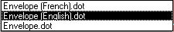
To select, edit, copy, rename, delete, customize or use your existing templates simply click on the more button on the right of the temples. The template explorer will appear. For more information about customizing templates or working with the features in this template dialog, (See Options: Editing and Creating Customized Templates Page 63).

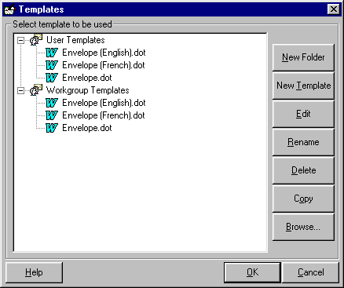

To use any of the templates listed in the template explorer simply select the template and click on OK.

Help
Clicking on the Help button at the bottom left corner of the Envelope dialog allows the user to access help on using the features of the Envelope dialog. Contact sensitive help is also available by pressing F1 while your cursor or focus is on a feature or control.

Options
Clicking on the Options button at the bottom left corner of the Envelope dialog allows the user to set the advanced options and edit the templates. (See Options Page 60)

Creating a Label

To create a Label or multiple Labels, click on Label in the ProWrite menu. The following screen will appear which will allow you to create one or more Labels.

(Note: If this is the first time that you are using the software you will have to enter the Sender information for yourself or anyone you will be creating documents for using ProWrite. See Sender Information below.)

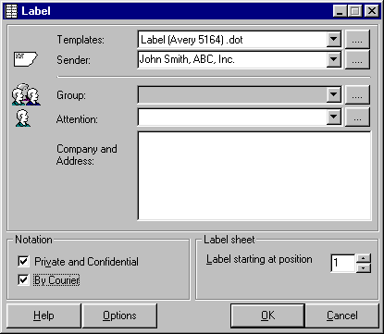

If you want to create a simple Label just fill in the appropriate information for your Label i.e. Attention, and Company and Address. Click on OK to create the Label.

(Note: You also have options for inserting the text Private and Confidential and/or By Courier into the Label.)

Sender Information

On the Label dialog, click on the more options button at the right of Sender. The Sender Information dialog will appear. Enter your information and click on OK. This will now automatically be inserted for you into your e-mails, letters, faxes, memos, envelopes and labels. If you are going to be creating for others or for different companies, create additional Sender profiles by clicking on New Sender. If you already have this information in the company address book of your e-mail system, you can import directly by clicking on Address Books and selecting from which address book you wish to pull the information from. (See Options: Using Different E-mail Address Books Page 61 for more information on how to set up ProWrite to use your address book.) Click on OK to return to the Label dialog screen.

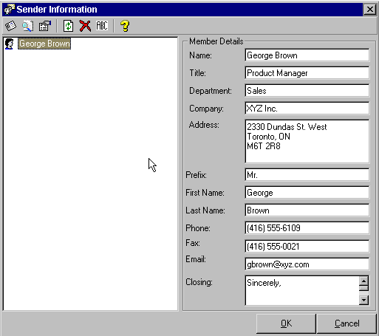

Once you have set up your personal information and anyone else’s that you will be using, the different Sender profiles are available when creating any of the ProWrite documents. Simply select the desired information by clicking on the down arrow of the Sender information on the Letter dialog.

Date

The dialog also has the ability to allow you to pick a date other than the current date or select a different format for the date. You can also insert the date in English, French, German, Italian or Spanish by selecting the region
To select a different date simply click on the icon to the right of the current date. The calendar dialog will appear. Here simply select the desired day, month or year and either click on OK or double click.

If you wish to have the date appear in a different format click on the down arrow of the date picker. You can scroll through the different formats and simply click on the desired format.

Address Book

ProWrite has the built-in address book to allow you to save frequently used addresses. However, if you have Microsoft Outlook, Novell GroupWise, Corel Address Book, Lotus Notes or Netscape ability on your system, you can use these address books. You can access your contact and address books directly to pull address information directly into your letters. (See Options: Using Different E-mail Address Books Page 61)

Note: If you are using vCards or if people are sending you e-mail are using vCards, this is a wonderful way to transfer contact information into the Microsoft Outlook Contacts for use with ProWrite when creating letters, faxes, etc. (See Microsoft Outlook Help and search vCards)

To access the address book simply click on the more button at the right of Attention. Depending on which address book you have selected to use under the advanced options, the appropriate address book will appear. (See Options: Using Different E-mail Address Books Page 61)

To access the address book simply click on the more button at the right of Attention. Depending on which address book you have selected to use under the advanced options, the appropriate address book will appear. (See Options: Using Different E-mail Address Books Page 61)

To select a recipient for the list hi-light the recipient’s name(s) and choose the Send to icon. A drop down list displaying To, CC, or BCC will be available for choosing how the recipient will receive the correspondence. Alternatively, you can hi-light the recipient’s name (s) drag and drop onto the To file folder (middle left hand side of screen). Do the same for CC and Bcc (See Options: Setting Cc and To Formats Page 60 for more information on the formatting of Cc in letters.) You can delete recipients by hi-lighting and choosing the button. Click on OK to return the Letter dialog.

If you select only one recipient for the letter, the address information is imported directly into the Letter dialog. However, if you select more then one recipient because you want to generate multiple letters, you will see a new prompt.

If you will be using this group of recipients again you can click on Yes or, if this is a one-time group of recipients, simply click No. If you click No, then you will be returned to the Letter dialog. If you click No the multiple letters will be created. If you click on Yes you will be asked to give a name to the group.
If you will be using this group of recipients again you can click on Yes or, if this is a one-time group of recipients, simply click No. If you click No, then you will be returned to the Letter dialog. If you click No the multiple letters will be created. If you click on Yes you will be asked to give a name to the group.

If you would like to take full advantage of the ability to create multiple letters you should also see how you can create standard letters with boiler plate text. (See Using Templates below Page 29)

Salutation

The salutation, if you are simply typing in the address information, is not very significant other then you can specify the salutation in the letter. However, if you are using the address book to use one or more recipients you can use the salutation drop down feature to pick the desired format.

Notation

Click on the Notation features to put a check mark beside the desired option. This will insert the text Private and Confidential and/or By Courier into the letter.

Using Templates

The most powerful feature of ProWrite is the ability to use any number of templates for creating the Label. At the top of the Label dialog you can select the template you would like to use to create the Label.

Clicking on the down arrow to the right of the templates displays a history templates that you have used.

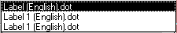

To select, edit, copy, rename, delete, customize or use your existing templates simply click on the more button on the right of the temples. The template explorer will appear. For more information about customizing templates or working with the features in this template dialog, see Options: Editing and Creating Customized Templates Page 63).

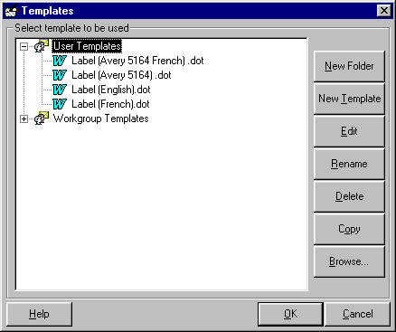

To use any of the templates listed in the template explorer simply select the template and click on OK.

Help

Clicking on the Help button at the bottom left corner of the Label dialog allows the user to access help on using the features of the Label dialog.

Options

Clicking on the Options button at the bottom left corner of the Label dialog allows the user to set the advanced options and edit the templates. (See Options Page 60)

Creating Boilerplate Templates

Once you have created all of your desired templates, you can use a very powerful feature in ProWrite called boilerplate templates. A boilerplate template is simply a letter that contains a number of pre-written sentences or paragraphs. This allows you to save letters that you create on a regular basis, so that the next time you need to create such a letter it is simply a matter of highlighting the existing letter in the template explorer. For example, you have interviewed someone for a job and want to thank him or her for coming for the interview. (Note: The real power of course comes when you want to send the same letter to 35 people that you interview. ProWrite will create all 35 letters with envelopes in less time then it would have taken you to create one letter.)

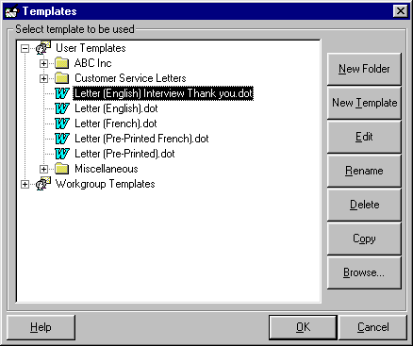

To create a boilerplate template, first highlight your standard letter. (1.) Click on Copy so that you have two templates. (2.) Give the new template a more meaningful name by clicking on Rename. (3.) Highlight the renamed template and click on Edit. The copied template appears on the screen where you can now either type or copy and paste the desired content into the template. Once you have made the appropriate adjustment to the template and inserted the desired text, save the template. Then close the template. (4.) To select the template you have created,
click on the more button beside the template box in the Letter dialog. (See Using Templates above) You can now use this letter to create one or more letters in the same time it would take to do one letter. You have automated a reoccurring task, so that the next time you have to thank someone for coming for an interview it will be painless.

Options

Clicking on Options from the menu or from any of the main dialogs for Letter, Fax, Memo, Envelope or Label will cause the Options screen to be displayed.

General
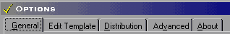

The general tab allows you to change the language being used by the dialogs, the format of Cc & To in the letter and memo templates, the type of address book being used and the name and position of the ProWrite menu.

Changing between English, French, German, Spanish and Italian

To change the language being used by the dialogs simply select the language you would like to use and click on Apply or OK.

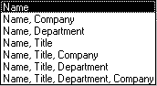
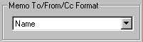
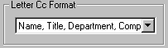
The following combinations are available:
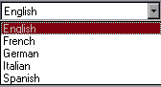

Setting “Cc” & “To” Formats and Template History

To change the format of the Cc and To fields being inserted into letters and memos select the desired format you would like to use and click on Apply or OK.

The number of templates shown in the template history drop down (i.e. list of previously used templates) is defaulted to 5 but you can increase this to a maximum of 20.

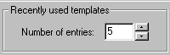

Using Different E-mail Address Books

To select a different address book to use, click on the checkbox for the address book(s) you wish to use.

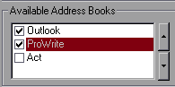

The default set during installation is ProWrite. Note: Links to the address books of Lotus Notes and Netscape are currently not available but are expected to be available soon.
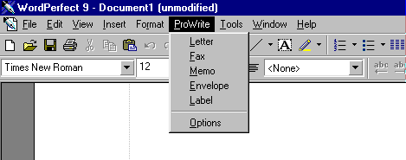
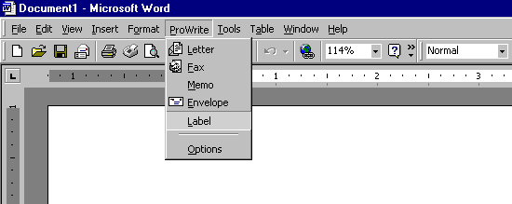

Customizing the ProWrite Menu

When ProWrite is installed the menu that appears in Corel WordPerfect or Microsoft Word is ProWrite. You can change this menu to your own name, your company name or anything else you would like to use instead. You can also position the menu anywhere on the menu bar.

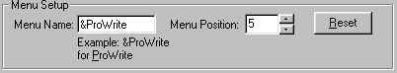

Change the menu name from ProWrite to your company name i.e. ABC. The “&” indicates the keyboard command ALT-P in the case of “&ProWrite” to activate the menu. The Menu position is the horizontal position of the menu on the Word or WordPerfect menu bar.

Compacting and Repairing the Database

Compacting and repairing the ProWrite database on your computer is something that should be done on a regular bases especially if you have been making extensive use of groups, templates and different senders.

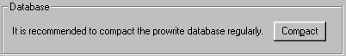

This will normally only take a few seconds. To begin click on the Compact button. The button will change to Wait…

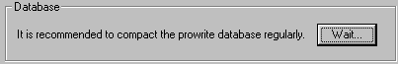

Once the database has been compacted the following message will appear. Click on OK.

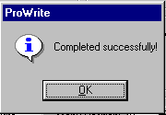

Editing and Creating Customized Templates

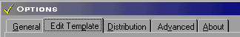

Clicking on the Edit Template tab in the Options dialog will cause the template explorer to be displayed.

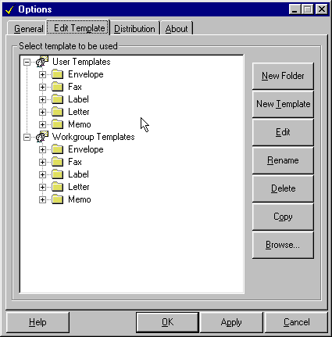

The template explorer will display both the local and network templates. The path for these templates is determined by the setting of your word processor (i.e. Word or WordPerfect)

In WordPerfect, click on Tools, Settings, Files and click on the Templates tab. In Word, click on Tools, Options, and File Locations. ProWrite looks here for the location of the templates used by Word or WordPerfect. This allows organizations with networks to maintain their templates on the local user's machine, on the network or both.

In both instances ProWrite will create a directory structure as follows:

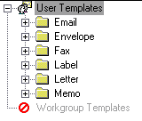

This directory structure is required for ProWrite to function properly. You are, however, able to create any number of sub-directories under each of the primary directories for letter, fax, memo, envelope and label.

Note: Each of the main dialogs for E-mail, Letter, Fax, Memo, Envelope and Label allow the use to access the template explorer by clicking on the more button to the right of the template selection box.

Creating New Templates

To create a new template for use with ProWrite, highlight the folder or a file in the folder where you wish to create the new template and click on the New Template button.

Creating File Folders

To create a new file folder for use with ProWrite, highlight the folder or a file in the folder where you wish to create the new folder and click on the New Folder button.

Renaming Templates and Folders

To rename a template or folder, highlight the template or folder to be renamed and click on the Rename button.

Copying Templates

To copy a template, highlight the template to be copied and click on the Copy button.

Deleting Templates and Folders

To delete a template or folder, highlight the template or folder to be deleted and click on the Delete button.

Browsing for an existing Template

The browse feature is very important because most individuals or organizations already have existing templates. The browse feature allows you to locate and import existing templates into the ProWrite directory structure.

Click on Browse will cause the following screen to appear.

Locate the existing template or document you wish to convert and click on Open. The template you have selected will be imported into the ProWrite directories.

Editing Templates

Since every individual or organization has unique logos and layouts for their letters, fax cover sheets, memos, envelopes and labels, the first thing that you will have to do upon installing ProWrite is to CUSTOMIZE your five basic templates.

Using the ProWrite Templates

You can start with the generic and basic templates that are installed along with ProWrite. This is usually a good starting point, especially for the fax cover sheet, which is very feature rich.

Remember that the templates themselves are Word and WordPerfect documents. You have all of the available, powerful word processor features and functions to customize your new templates. You can insert you organizations logos and even cut and paste information from existing documents into the ProWrite templates.

To edit one of the existing ProWrite templates simply highlight the template and click on the Edit button. Once you have finish editing the template save the templates by selecting File, Save in either Word or WordPerfect. Close the template and also close edit toolbar. See Insert Merge Fields below.

Using Existing Templates

If you already have and existing document or template you would like to use. Browse for the template to import it into the ProWrite directory structure. (See Browse above)

Once you have imported the template, highlight the template and click on the Edit button. Your existing template will appear on the screen. Although you have imported the template, it will not function until you insert the merge codes for the sender, recipient and other information to be passed to the template by ProWrite, when it creates the document.

You can copy and paste these codes into your existing template or you can use the edit toolbar to insert the merge codes into the template. When you click on the Edit button, the appropriate edit toolbar is displayed. (See all five toolbars below)

Inserting Merge Fields

To insert the desired merge code, first position your cursor in the template where you want the information to be inserted. Click on the corresponding button in the edit toolbar. The merge code corresponding to that button will appear in your templates. Repeat this procedure until you have inserted all of the desired merge codes. Use your normal functions and features in Word and WordPerfect to change the font, font size, alignment or any other attribute. Omitting any of the merge fields will not have an impact on the creation of the template. Missing merge codes are ignored, so that information is not inserted into the template when generated by ProWrite. (See sample below.)

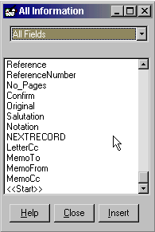

Note: Once you have saved and closed your revised templates, click on Close or to close the Edit toolbar.

To use the template to create a document using ProWrite go back to the Letter, Fax, Memo, Envelope or Label dialog and select the template you have create by clicking on the more button beside the template box. (See Using Templates above)

Distributing Templates to other users

To distribute any or all of the templates you have created for ProWrite to other ProWrite users, click on Options in the menu.

In the Options dialog select the Distribution tab.

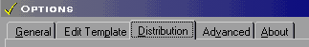

Note: The ProWrite Standard version does not have a distribution option. ProWrite Professional and Enterprise versions are the only versions with a built in template distribution option. If you have a need to distribute templates to colleges, clients or across several offices you should upgrade to either the ProWrite Professional or Enterprise versions.

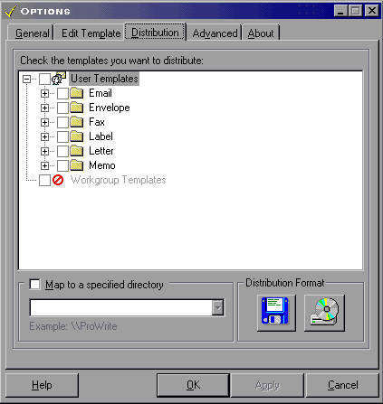

The distribution tab allows you to select the template or templates you would like to distribute to other users. Simply click on the templates or folders you would like to copy to your users or colleges.

Note: If you are distributing different temples to different departments you can also specify the folder or sub folders to copy the templates into that you are distributing.

To change the menu name or position, click on the Options menu. Select the General tab and you will be able to alter the name of the menu or the location of the menu.

Advanced Options

To set some of the advanced features for ProWrite, click on Options in the menu.

In the Options dialog select the Advanced tab.

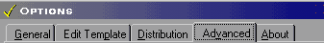

Advanced Features
To set some of the advanced features within ProWrite, simply choose one of the three areas; Security Patch option, Preferred Address format, and E-mail options.

Microsoft Outlook Security Patch
There are two settings which work differently depending on having the security patch installed or not. In either case the e-mail addresses will be returned, it’s a matter of a wanting to view warning message or not.

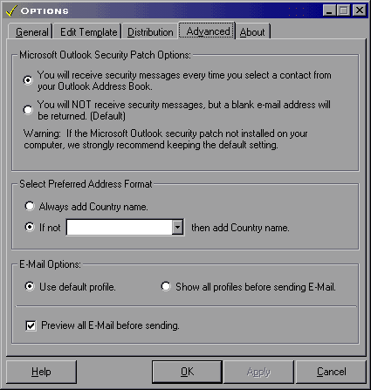

Preferred Address Format
When retrieving contact from outside your home country, the prompt will allow for the country to be automatically returned with that address so you don’t have to worry about it.

E-mail Options
ProWrite will prompt you with the default profile be it your own or someone of whom you are working on behalf of. The Show Profiles will display the profile of the sendor prior to sending the e-mail in case the message it to be sent on behalf of another person. The Preview all Email prior to sending will allow for any changes or deletions of e-mails prior to sending the message. This is a handy feature for anyone having to create correspondence on behalf of others.

Select the templates you wish to copy to others in your organization (who are also using ProWrite). Click on the floppy disk icon or the CD ROM icon to have ProWrite create a setup routine that you can use to distribute your new templates.

To install your templates on a user’s machine, make sure ProWrite is already installed and then simply click Start, Run and A:\SETUP if you are using a floppy disk or type the path on the network where the setup files are located i.e. F:\PROWRITE\SETUP.

The following prompt will appear to determine if you wish to proceed with the installation of the templates.

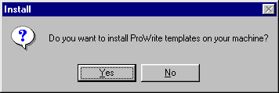

If you click on Yes the installation routine will begin to copy the templates to your system.

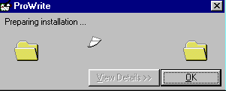

Once the templates have been copied to the user’s system the final screen will appear.
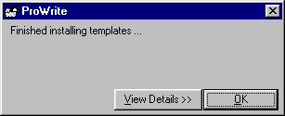

Uninstalling or Removing

To uninstall or remove ProWrite from your computer click on the Start in Windows 95, 98 or NT. Select Settings and Control Panel.

The control panel will appear. Select Add/Remove Programs.

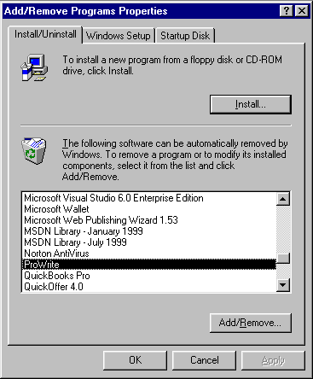

Find ProWrite in the list of installed programs and select Add/Remove. Follow the instructions that will guide you through the uninstall.

Contact Us:

Nereosoft, Inc., established in 1995, is a privately held corporation, with headquarters in Toronto, Canada.

Nereosoft, Inc.
306 Sherbourne Street
Toronto, ON M5A 2S1
CANADA
www.nereosoft.com Web Site

(416) 515-1098 Tel
(416) 515-8490 fax

sales@nereosoft.com Sales

tech@nereosoft.com Technical Support

Office Hours: Monday – Friday
8:30 A.M. - 5:00 P.M. Eastern Standard Time

Note: Technical support is only provided for registered users. Be sure to include your product serial number when you contact us by e-mail, fax or phone. All telephone technical support is on a fee basis.

Index
A
address book, 10, 24, 25, 28, 32, 34, 40, 41, 42, 48, 49, 54, 55, 56, 57, 60, 61
Address Book, 10, 24, 25, 32, 34, 40, 41, 48, 54, 55
B
Blocking Address in Document, 51
boiler plate templates, 59
C
Cc, 34, 39, 49, 60
change the menu name, 67
Compacting, 62
Confirm, 33
Contact Sensitive help, 18
Contact Us, 71
copy, 14
Corel Central, 8
create, 14
Creating Boiler Plate Templates, 59
Creating with Envelope and/or Label, 29
D
database, 4, 62
Date, 24, 32, 40, 54
delete, 14
distribute, 67, 68
Distribution, 67, 68
E
E-Mail, 19, 20
English, 8, 60
envelopes, 8, 24, 32, 40, 47, 48, 49, 54
existing document, 13, 65
F
Fax, 21, 22
fax cover sheets, 8, 36
French, 8, 60
G
German, 8, 60
group of recipients, 26, 27, 35, 36, 43, 49, 50, 56, 57
groups, 27, 36, 43, 44, 50, 51, 62
GroupWise, 8, 25, 34, 41, 48, 55
H
Help, 18, 22, 25, 30, 34, 38, 41, 45, 48, 52, 55, 58
I
INSTALL, 7
Italian, 8, 60
L
labels, 8, 24, 32, 40, 48, 54
language, 60
letters, 8, 24, 25, 26, 28, 29, 32, 40, 41, 42, 43, 48, 49, 50, 51, 54, 55, 56, 57
LICENSE, 3
M
memos, 8, 24, 32, 40, 48, 54
menu, 61
merge code, 12, 13, 15, 16, 17, 66
multiple letters, 15, 26, 42, 56
N
Notation, 28, 44, 51, 57
Number of Pages, 31, 33
O
Options, 9, 10, 24, 25, 26, 29, 30, 32, 34, 37, 38, 40, 41, 42, 45, 46, 48, 49, 52, 54, 55, 56, 58, 60
Original to follow by ordinary mail, 33
Outlook, 8, 22, 25, 34, 41, 48, 55
P
personal information, 10
position the menu, 61
ProWrite templates, 11, 12, 14, 65
R
rename, 14
repairing, 62
S
Salutation, 28, 57
Sender information, 10, 23, 24, 31, 32, 39, 40, 47, 48, 53, 54
Sender Information, 10, 23, 24, 31, 32, 39, 40, 47, 48, 53, 54
Sender profiles, 10, 24, 32, 40, 48, 54
Spanish, 8, 60
T
Technical Support, 71
template explorer, 11, 12, 13, 14, 29, 30, 37, 45, 52, 58, 59, 63, 64
To, 60
U
uninstall, 70
Using Groups, 27, 35, 43, 50
Using Templates, 11, 28, 29, 36, 37, 45, 51, 52, 57, 58
V
VIP, 20
VIP Person-to-Person, 21, 22
VIP Person-to-Person E-Mail, 21, 22
W
Word, 6, 8, 9, 11, 12, 13, 15, 16, 17, 61, 63, 65, 66
WordPerfect, 6, 8, 9, 11, 12, 13, 15, 16, 17, 61, 63, 65, 66

