DocOrganizer V1.0

Shareware Document Organizer utility
for Word 97 & 2000

Features:
- User configurable to organize several categories of documents
- Displays lists of existing documents with Title and Subject information
- From the list, documents can be Opened, Copied, Printed, Deleted, Renamed and Previewed
- Create new documents with automatic naming and directory locating
- For use with Microsoft Word for Windows 97 & 2000 under Windows 95, 98 & NT

Installation

- Copy this Docorganizer.dot to your Word Startup directory from where it will become a global addin template next time Word is started. (To determine what the startup directory is, in Word do Tools Options FileLocations)

- Copy DocOrganizer.ini to your Word startup directory (as above)

- Copy CDEVSum.dll to your Word program directory, something like: C:\Program Files\Microsoft Office\Office - this is the location where Word.exe resides.

Setup & Operation

See the Setup & User guide below

Registration

If you find DocOrganizer useful then please register it – send a check for 49 US Dollars (29 UK pounds) to the address below and you will be issued with a registration code. Unregistered, DocOrganizer will eventually time-out.
Contact

For information on this and other Word productivity addons see CDEV Computing’s web site www.cdev.demon.co.uk.

Chris Devrell, CDEV Computing
Tele/Fax: ++44 1703 740990
chris@cdev.demon.co.uk
11 Homefield Drive, Nursling
Southampton, SO16 0TH
United Kingdom

Improvements to DocOrganizer

We are keen to improve on DocOrganizer in any way we can. Send us your wish list and we will do our best to deliver the improvements.

DISCLAIMER OF WARRANTY
THE SOFTWARE (INCLUDING INSTRUCTIONS FOR ITS USE) IS PROVIDED 'AS IS' WITHOUT WARRANTY OF ANY KIND. CDEV COMPUTING FURTHER DISCLAIMS ALL IMPLIED WARRANTIES INCLUDING WITHOUT LIMITATION ANY IMPLIED WARRANTIES OF MERCHANTABILITY OR OF FITNESS FOR A PARTICULAR PURPOSE. THE ENTIRE RISK ARISING OUT OF THE USE OR PERFORMANCE OF THE SOFTWARE AND DOCUMENTATION REMAINS WITH YOU.

IN NO EVENT SHALL CDEV COMPUTING OR ANYONE ELSE INVOLVED IN THE CREATION, PRODUCTION OR DELIVERY OF THE SOFTWARE BE LIABLE FOR ANY DAMAGES WHATSOEVER (INCLUDING, WITHOUT LIMITATION DAMAGES FOR LOSS OF BUSINESS PROFITS, BUSINESS INTERRUPTION, LOSS OF BUSINESS INFORMATION, OR OTHER PECUNIARY LOSS) ARISING FROM THE USE OF OR INABILITY TO USE THE SOFTWARE OR DOCUMENTATION, EVEN IF CDEV COMPUTING HAS BEEN ADVISED OF THE POSSIBILITY OF SUCH DAMAGES. BECAUSE SOME STATES/COUNTRIES DO NOT ALLOW THE EXCLUSION OR LIMITATION OF LIABILITY FOR CONSEQUENTIAL OR INCIDENTAL DAMAGES THE ABOVE LIMITATION MAY NOT APPLY TO YOU.
DocOrganizer Setup and User Guide

DocOrganizer Installation

- Copy this DocOrganizer.dot template to your Word Startup directory from where it will become a global addin template next time Word is started. (To determine what the startup directory is, in Word do Tools Options FileLocations)

- Copy DocOrganizer.ini to your Word startup directory (as above)

- Copy CDEVSum.dll to your Word program directory, something like: C:\Program Files\Microsoft Office\Office - this is the location where Word.exe resides.

DocOrganizer Setup
Start by simply running DocOrganizer, press the toolbar button :

The main form appears.
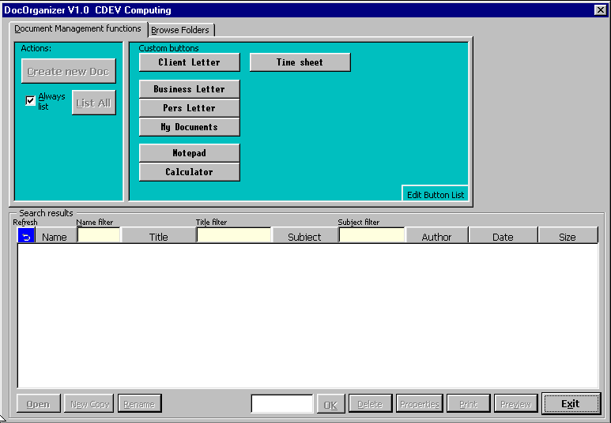
Custom buttons area
List functions
File functions
File listing area
Edit Button list

Your setup task is principally that of specifying your own Custom Buttons. The system comes with a few example buttons, some of which may work on your system even as they are.

In essence the custom buttons represent 'favorite' document sets.

For example the My Documents button operates on the directory c:\My Documents. If you have that directory on your system try pressing the My Documents button.

If you do not have that directory then no matter, look at the screen dump below to see what the output would be.

Form after having pressed a Type-1(filelist) button:

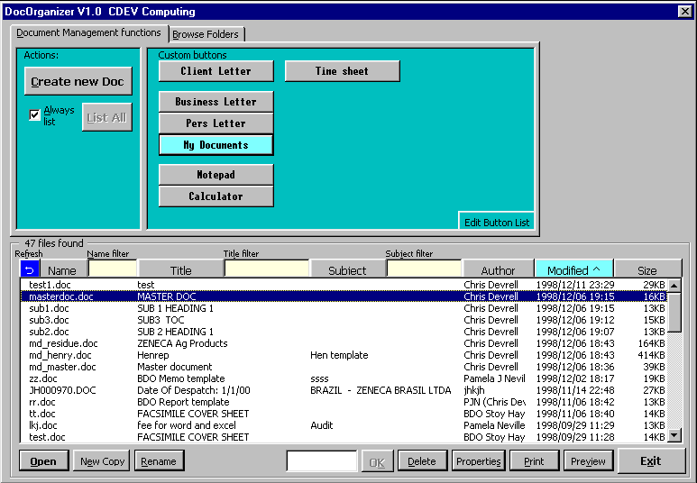
Document Title and Subject details
My Documents is a Type-1 button
Always List means that a list is displayed as soon as a button is pressed
OR
List All button means list on demand only

Custom Button Setup

You setup a custom button for each category of documents that you wish to work with.

A custom button can do one of several things depending on it’s type:

Type 1 – performs a file list of all the files in the directory specified for that button.
Type 2 – displays a further sub-list of, for example client companies with whom you frequently correspond.
Type 3 – immediately opens a specified document, for example a timesheet that you regularly update
Type 4 – runs a program, for example Calculator or Notepad.

Form after having pressed a Type-2 (client list) button:
Custom list of ‘clients’

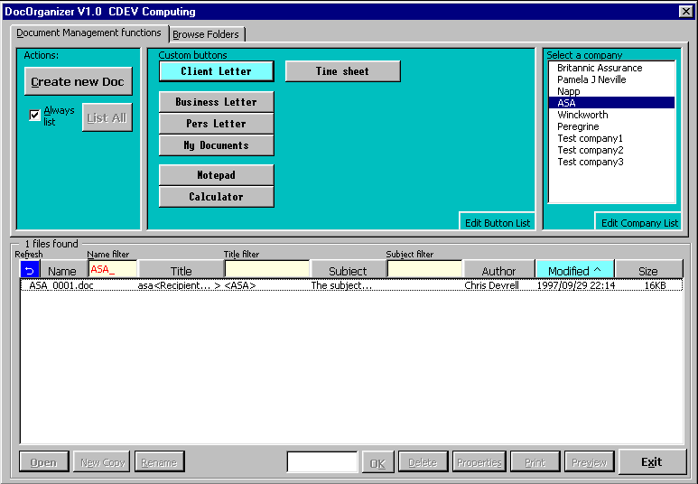
All files displayed for the selected ‘client’

To add and edit custom buttons use the Edit Button List button. The following form is displayed which is used to modify DocOrganizer.ini - where the custom buttons specification is stored:

Custom button editor form

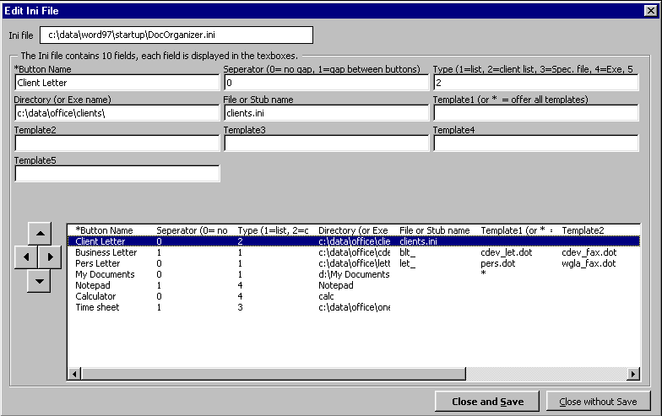
Use right-arrow button to add the entry to the list, then Close and Save to save the changes.
Before setting up your buttons it is a good idea to give some thought to how you wish to organize your documents on disk. Although you could have all your documents in one folder and DocOrganizer will work with this, it is better to put different categories of documents into distinct directories.

For example lets keep general purpose business letters in a directory called C:\data\docs\business.

And personal letters in c:\data\docs\personal.

Lets keep all our stationary documents like business cards, With Compliment Slips etc in c:\data\docs\stationary

And so on…

All the above will be Type 1 buttons. That is we click the button and get the list of all documents in the directory. From this list we can do any of the file functions. We can also create a new document.

Lets say that we have a set of clients with whom we correspond frequently. We wish to see each client's correspondence separately but there are too many clients to justify a custom button for each. This where the Type-2 button comes in. A Type-2 button, when pressed, will display a further custom list of clients each of which can be selected.

There are a few documents that we may wish to frequently update such as a timesheet. A type-3 Button is used to immediately open a specified document. There are no other functions with this type of button it is simply a fast document opener.

Type-4 buttons are used to run other programs such as calculator, notepad etc.

Now that we have a plan for how we want to establish our document directories its back to the custom button editor.

A custom button definition has up to 10 fields - not all are compulsory. The fields are:

Field | Description of data required for the field
Button Name | The name that appears on the button. Mandatory and must be unique
Separator | This specifies the gap between this button and the one above. 0 for no gap, 1,2,3 etc for an increasing gap. 1 should suffice for a gap.  This separator field enables you to group the buttons.
Type | 1 – performs a file list of all the files in the directory specified for that button.  2 – displays a further breakdown list of, for example client companies with whom you frequently correspond.  3 – immediately opens a specified document, for example a timesheet which you regularly update  4 – runs a program, for example Calculator or Notepad.
Directory  (depends on button type) | if Type 1 - the directory where the documents reside  if Type 2 - the directory where the client list file resides  if Type 3 - the path and name of the specific document  if Type 4 - the path and name of the program to run
File or Stub name  (depends on button type) | if Type 1 - this is the prefix that will be used to name new documents for this button. EG for Business letter could use BLT_. Then a new document would be created with the name BLT_0002, and subsequently BLT_003. This name is also used as a filter for listing documents. Ie only documents that begin BLT_ will be listed for Business Letters button.  if Type 2 - the name of the client ini file that will contain the list of clients  if Type 3 - nothing  if Type 4 - nothing
Template1 (-5)  only for Type-1 buttons | These 5 fields allow you to specify which templates are offered in this category if a new document is being created. For example for the Business Letters button a Fax template and Letter template are specified.  Alternatively set the Template1 field to * and DocOrganizer will display all available templates.

Create New document

Here is an example of how to create a new document:

- Press the Business Letter button
- the list of all business letters is displayed.
- Press the Create new Doc button
- the list of nominated templates is displayed in blue
- Select a template
- a new unique file name is calculated from the stub name (BLT_). Notice that the preview button is available to give a preview of the selected template.
- Press OK
- the new document is created and opened and DocOrganizer is closed

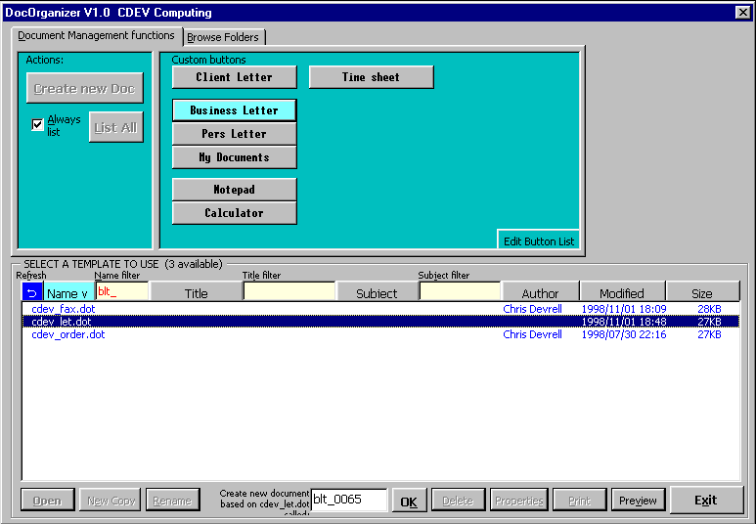
Client list setup

As described above, a Type-2 button has a list of clients. The name and path of the list are given in the button definition. Having setup a new Type-2 button then run DocOrganizer, press the button, allow DocOrganizer to create a new file and then press Edit Company List button. You will get the Client list editor form:

Client list editor form
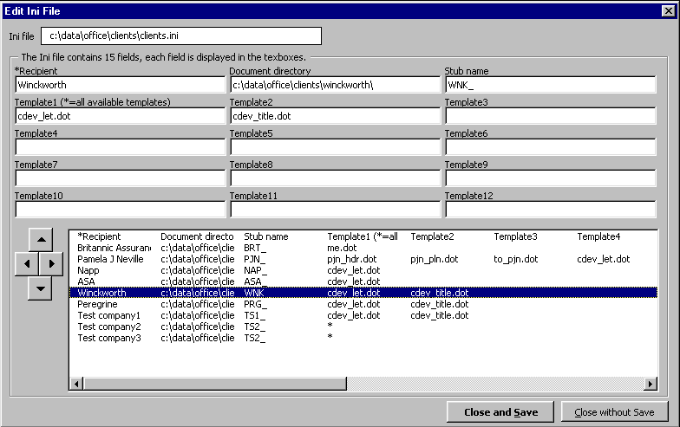

Use right-arrow button to add the entry to the list, then Close and Save to save the changes. Left arrow deletes an entry and up/down arrows move the entry up/down the list.

Each client entry has up to 15 fields - not all are compulsory. The fields are:

Field | Description of data required for the field
List item name  (ie company/Client name) | The name that appears on the client list. Mandatory and must be unique
Directory | The directory where this clients document are to be kept.
File or Stub name | This is the prefix that will be used to name new documents for this Client. EG for Winckworth could use WNK_. Then a new document would be created with the name WNK_0002, and subsequently WNK_003. This name is also used as a filter for listing documents. Ie only documents that begin WNK_ will be listed for Winckworth.
Template1 (-12) | These 12 fields allow you to specify which templates are offered for this client when a new document is being created.  Alternatively set the Template1 field to * and DocOrganizer will display all available templates.

Document List functions

Having displayed the required list of documents you can act on them using the File list functions and the File action functions.
Refresh button

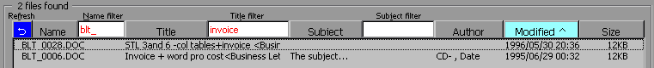
For each document listed there are 6 columns of information: Name, Title, Subject, Author, Last Saved date and Size. Each column has a button at its head which has a sort ascending/descending action. In the example above the list is sorted by Modified.

Three of the columns have a filter function. Typing text into the filter box and pressing refresh button causes the list to be searched for files whose details match the filter. In the above example all files which have blt_ in their name and invoice in their title are displayed.

Note that it is necessary to press the refresh button to apply the filter and rebuild the filtered list.

Document Action buttons
File renaming box

When a file from the filelist is selected then the action buttons become enabled. The actions are:

Open | Opens the selected file(s) and hides DocOrganizer
New Copy | Invites user to provide a name for the new copy (in the file renaming box) then creates and opens a new copy of the document. The new document is stored in the same directory as the original and is given the name as supplied
Rename | This renames the document to the name that the user provides in the file renaming box.
Delete | This deletes the selected file(s)
Properties | This displays the selected file’s exiting properties and enables the user to update them.
Print | This displays Word’s normal print form and enables printing of the selected file(s)
Preview | Displays a preview of the file. The preview pops up into a separate form and requires pressing enter to close it.

Note that a subset of the actions are available if multiple files are selected, as follows:
Document Properties

Document Properties, or File Summary Information, is crucial to DocOrganizer. It is essential that when a new document is created that the Summary information form below is filled in with Title and Subject. Only then will DocOrganizer's filelist be meaningful.

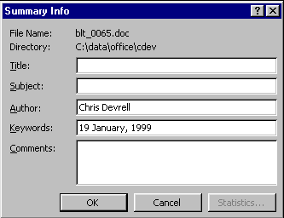

Browse folders

DocOrganizer has a browse folders view. Press the Browse Folders tab and you can navigate around your file system looking at documents and interacting with them.

