Clearance Sale!
Desks
File Cabinets
Executive Chairs
Computer Desks
Office Lighting of All Kinds
And More!
Storewide Savings on Name Brands!
For deals that make the superstores go nuts,
come to the once-a-year clearance event at...
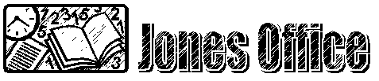
27 Main Street
Brownson, NE 51662
555-555-2800

Just north of the Gulf station!

