Analysis and Design of Railway Minor Bridge (Box Type)

Prashant K. Mutnure, Kaushik Pande, Swati Bhagele

Department of Civil Engineering

K.D.K. College of Engineering

**ABSTRACT:**

Bridges are the structures that are constructed and utilised for an efficient movement of the traffic and provides a link between two different points. They are constructed to overcome all the obstacles that come in the way of a vehicular movement and to maintain the required elevation throughout its route and to maintain the desired speed. In case of Indian Railway, as per the Railway Circular it is required to construct bridges without obstructing movements of a locomotive along its length where ever is possible. Bridge can be of various types; it may be big structure or may be a small one as per the requirements and it may be of arch type, Box Girder Bridge or a simple Box type.

As per the Indian Railway is concerned it is vital to construct and design a Railway bridge by considering all the relevant IRS codes and RDSO drawings and follow all the norms of Indian Railway, because the loading conditions and requirements of a Railway Bridges are very much different from an ordinary Civil Structures and bridges.

In this paper, all the design steps, analysis process by STAAD and MDM process has been shown, and the various clauses and rules which are given by relevant IRC codes has been shown in detail. And also the structural behaviourof various bridge components as they are analysed by the STAAD software are shown. And the involvement of various load factors and loading combinations along with their justification and various governing factors involved in the design and load applications are given in Detail.

Key words- IRC Codes, Box Bridge, STAAD analysis and MDM Calculations

**INTRODUCTION**

Box Bridge which has got its name from its appearance. It can also be called as R.C.C. box frame. It is a monolithic R.C.C box which is capable of taking heavier loads irrespective of its size and can transfer loads to a wider area without producing any cracks and damages. It can be very rapidly constructed and so its construction is very productive with respect to economic point of view of railways. The bridge cover upto waterways of 6 m (IRC: 5-19981) and can mainly be of two types, namely, box or slab. The box is one which has its top and bottom slabs monolithically connected to the vertical walls. In case of a slab bridge the top slab is supported over the vertical walls (abutments/piers) but has no monolithic connection between them.

The main emphasis is on the methodology of design which naturally covers the type of loading as per relevant IRS Codes and their combination to produce the worst effect for a safe structure. Although box of maximum three cells has been discussed but in practice a box bridge can have more cells depending on the requirements at site. Sometimes the rail alignment may cross a stream at an angle other than right angle; in such situation a skew bridge may be provided. For a box bridge, the top slab is required to withstand dead loads, live loads from moving traffic, earth pressure on sidewalls, water pressure from inside, and pressure on the bottom slab besides self-weight of the slab. The structure is designed like a rigid frame considering one meter element and adopting moment distribution method for obtaining final distributed moments on the basis of the relative stiffness of the slab and vertical walls. The moments at centre and supports for slabs and walls are obtained for various combinations of loads and the member is designed for the maximum moment it may be subjected to. Also the shear force at a distance of effective depth from the face of wall and shear stresses it produces in the section is considered in the design.

A few things like coefficient of earth pressure for lateral pressure on walls, effective width (run of bridge) for live loads and applicability of braking force on box without cushion (or little cushion) for structural deformation are important items where opinion of the designers vary and need to be dealt in much detail. These affect the design significantly and therefore, required to be assessed correctly for designing a safe structure. It is customary to consider box a rigid frame and unit length of box is taken for design by considering the effect of all forces acting on this unit length (generally 1.0 m of box). While calculating weight of cushion on top slab, some designer take average height of earth fill coming over full length of box including sloping side fill. This is not correct and full height of cushion should be taken at the worst section of the box (central portion) will be subjected to this load and the section needs to be designed accordingly.

If the discharge in a drain or channel crossing a road is small, and if the bearing capacity of soil is low, than a box bridge is an ideal structure. A box bridge consists of a R.C.C box of square or rectangular opening with span generally over 6.7m. The top of the box may be at road level or it may be at a depth below the road level if the road is in embankment. If the design discharge is considerable, a single box bridge becomes uneconomical because of the higher thicknesses if the slab and walls. In such cases, more than one box is cast side by side monolithically.

**LITERATURE REVIEW**

The first bridges were made by nature itself as simple as a log fallen across a [stream](http://en.wikipedia.org/wiki/Stream) or stones in the [river](http://en.wikipedia.org/wiki/River). The first bridges made by humans were probably spans of cut wooden logs or planks and eventually stones, using a simple support and crossbeam arrangement. The greatest bridge builders of antiquity were the [ancient Romans](http://en.wikipedia.org/wiki/Roman_Engineering). The Romans built [arch bridges](http://en.wikipedia.org/wiki/Arch_bridges) and [aqueducts](http://en.wikipedia.org/wiki/Aqueduct) that could stand in conditions that would damage or destroy earlier designs. The *[Arthashastra](http://en.wikipedia.org/wiki/Arthashastra" \o "Arthashastra)* of [Kautilya](http://en.wikipedia.org/wiki/Kautilya" \o "Kautilya) mentions the construction of dams and bridges. A [Mauryan](http://en.wikipedia.org/wiki/Mauryan" \o "Mauryan) bridge near [Girnar](http://en.wikipedia.org/wiki/Girnar" \o "Girnar)was surveyed by [James Princep](http://en.wikipedia.org/wiki/James_Prinsep). The bridge was swept away during a flood, and later repaired by Puspagupta, the chief architect of emperor [Chandragupta I](http://en.wikipedia.org/wiki/Chandragupta_I). The bridge also fell under the care of the [Yavana](http://en.wikipedia.org/wiki/Yavana" \o "Yavana)Tushaspa, and the [Satrap](http://en.wikipedia.org/wiki/Satrap) Rudra Daman. The use of stronger bridges using plaited bamboo and iron chain was visible in India by about the 4th century. A number of bridges, both for military and commercial purposes, were constructed by the [Mughal](http://en.wikipedia.org/wiki/Mughal_Empire) administration in India.

As per the Indian Railway is concerned, according to the survey done by the India Railway it was seen that from past 1900 to 2002 there are total 127154 bridges including all minor and major bridges were constructed all over India for linking up the various roots and to maintain the efficient traffic flow on rail line throughout its length.

**METHODOLOGY**

* Analysis and design by STAAD pro.
* Analysis method adopted for RCC box is MDM (Moment Distribution Method).
* Designing Box Bridge considering LSM.
* Various cases those are to be generally adopted for designing:

Case 1: Dead load and live load acting from outside as well as earth pressure, while no water pressure from inside (i.e. Design of Box Bridge by considering the box as in empty conditions, no water will flow from it)

Case 2: Dead load and live load acting from outside as well as earth pressure, while water pressure acting from inside (i.e. designing the by considering that it is half full)

Case 3: Dead load and live load acting from outside as well as earth pressure, while water pressure acting from inside (i.e. designing the box by considering that it is full)

* We are considering case one, as it is the worst possible case for designing bridge.

**CODAL PROVISION**

Combinations 1 – The permanent loads i.e. dead load, superimposed loads etc. together with

the appropriate live loads.

Other loads that are supposed to be come on it are Surcharge loads.

The above combinations of load are provided by the IRS Code of Plain, Reinforced and prestressed concrete.

All the dead loads (i.e. dead loads of bridge components like side walls, deck etc.) will be calculated in accordance with IRS code.

All the dead loads and UDL due to train movement will be converted into EUDL as per IRS.

1. Dead Load

* Self-Weight of the complete R.C.C. frame
* Ballast Cushion of 400mm depth for B.G.
* Sleeper
* Track Load
* Soil Fill pressure

[From IRS Bridge Manual clause 2.2]

1. Live Load

* Maximum Axle load of 25t (i.e. 245.2 KN)
* Train Load 9.33 t/m (i.e. 91.53 KN/M)

[From Bridge Manual appendix-12 (a), clause 2.3.1 (a)

1. Dynamic Loads

* For Broad Gauge the augmentation in the load due to dynamic effect should be considered by adding a load equivalent to a coefficient of dynamic augment (CDA) multiplied by live load giving the maximum stress in members under consideration. The CDA should be obtained as follows and shall be applicable upto 160 kmph on BG and 100 kmph on MG

For Single Track

CDA=0.15+ (8/6+L)

[From Clause 2.4 (a) of bridge manual]

1. Force due to curvature and eccentricity of track

* It should not be considered as it is not included in the combination 1 of the IRC code.

[As per Concrete bridge code Clause 11.2]

1. Temperature effect

* It is not required to be considered as for the bridge design only combination 1 is used, and also as per the concrete bridge code it is stated that “For design of concrete bridges of span 30m and larger, an appropriate temperature gradient shall be considered” clause 11.1.1, as per GAD the span length is 14.7m.
* It is required to be included only if the combination 3 is considered for the designing.

[As per Concrete Bridge code Clause 11.1.1 and 11.2]

1. Frictional resistance of Expansion bearing

* It is not to be used as the bridge we are designing is an RCC box frame and no bearing is included in it.

[As per concrete bridge code clause 11.2]

1. Racking force

* It is not required to be included as it is not included in the combination 1

[As per concrete bridge code clause 11.2]

1. Forces on Parapets

* It is not required to be considered as it is not included in the design part.

[As per concrete bridge code clause 11.2]

1. Wind pressure

* This load is to be used in design calculation only if combination 2 is used.
* As per Code of practice for the design of sub-structures and foundations of bridges “Wind pressure shall be taken into account for bridges of span 18m and over” and for design purpose the span is considered to be 14.7m.
* But still in case if we have to find the wind pressure the following equation should be used:

Pz=0.6Vz2

Where: Pz = design wind pressure in N/m2 at height z, and

Vz = design wind velocity in m/s at height z.

[As per Sub-structure code clause 5.11, Concrete bridge Code 11.2, I.S. 875 (part 3) Clause 5.4 of Design Wind Pressure]

1. Earthquake Pressure

* It is to be used only if the combination 2 is used.
* As per bridge rule in Zone 1 to 3 Seismic forces is considered in case of bridge of over-all length more than 60m or span more than 15m.

[As per concrete bridge code Clause 11.2, Sub-structure code, Clause 5.12.1.1 and bridge rule clause 2.12.5.2]

1. Water Pressure

* Water pressure is not been considered during the designing process as it is required to be designed in an empty condition.
* But still if in case during its life span rain occurs, the water pressure on the bridge will be very less or negligible as the drains are being provided for that purpose.
* And in case if the bridge get filled up by the water the bridge will get safer because the internal water pressure is counter balanced by the external soil pressure and the water is free to flow and hence there is no problem of arising of water pressure within the and its accumulation at there.

**LOADS FOR STAAD ANALYSIS**

1. Dead Load

It will be obtained by STAAD output

1. Super Imposed Dead load (SIDL)

|  |  |  |  |  |
| --- | --- | --- | --- | --- |
| Load of Rails , ballast etc = | | | 60 | kN/m |
| SIDL / m |  | = | 20 | kN/m2 |
| UDL |  | = | **20** | **kN/m** |
|  |  |  |  |  |

1. Live Load

|  |  |  |
| --- | --- | --- |
| As per IRS, BR ,Appendix XII(a)  CDA factor= | 0.15 + 8 / ( 6+L ) Clause 2.4.1.1(a)] | |
| = | 0.7702 |

[From Bridge Rule Clause 2.4.1.1 (a)]

**EUDL for Bending Moment**

Cushion= 400mm

|  |  |  |
| --- | --- | --- |
| L | EUDL | |
| 6 | 839 | |
| 6.9 | **920.09** | |
| 7 | 929.1 | |
| EUDL ( B M ) | | | | = | | | **920.09** | | | **kN** | | |
| Load/m2 | |  | | | = | | | **44.449** | | | **kN/m2** | | |
| Consider 1 m width load = | | | | | | 44.449 | | | kN/m | | |
| UDL with CDA factor | | | | = | | | **78.681** | | | **kN/m** | | |

**EUDL for Shear Force**

Cushion=400mm

|  |  |  |
| --- | --- | --- |
| L | EUDL | |
| 6 | 937.6 | |
| 6.9 | **1006.27** | |
| 7 | 1013.9 | |
| EUDL ( S F ) | | | | = | | | **1006.27** | | | **kN** | | |
| Load/m2 | |  | | | = | | | **48.612** | | | **kN/m2** | | |
| Consider 1 m width load = | | | | | | 48.612 | | | kN/m | | |
| UDL with CDA factor | | | | = | | | **86.051** | | | **kN/m** | | |

1. Earth Pressure (as per IRS code)

Density of soil= 18 KN/m3

Design height =7m

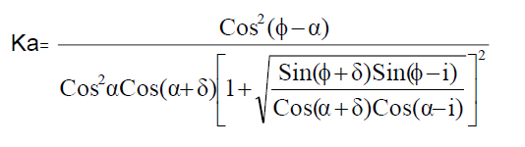

|  |  |  |  |  |  |
| --- | --- | --- | --- | --- | --- |
| φ | = | 30 | deg | 0.524 | rad |
| δ | = | 10 | deg | 0.175 | rad |
| α | = | 0 | deg | 0.000 | rad |
| i | = | 0 | deg | 0.000 | rad |
| Ka | **=** | 0.472 |  |  |  |

Triangular Earth pressure on side wall @ Base= 59.524 KN/m

[From Sub-Structure code Clause 5.7.1]

1. Surcharge load due to Live load + SIDL (As per IRS)

|  |  |  |  |  |  |  |  |  |
| --- | --- | --- | --- | --- | --- | --- | --- | --- |
| Surcharge S | = | | | | 137 | | kN/m | |
| Load of Rails , ballast etc V = | | | | 60 | | kN/m | |
| Height h | |  | = | 7 | | m | |
| length | | L | = | 5 | | m | |

1. Surcharge load due to earth filling (Formation)

|  |  |  |  |  |  |  |  |  |  |
| --- | --- | --- | --- | --- | --- | --- | --- | --- | --- |
| Height of Surcharge load = | | | | 1m | | |  | | |
| Load on Deck slab | | **=** | | | 18 | | | kN/m2 | | |
| Load/m |  | | = | | | **18** | | | **kN/m** | | |
| ( 1 m width ) | | |  | | |  | | |  | | |

1. Load Combinations

Load Combination 1 (ULS)

1.4DL+2SIDL+1.7EP+1.7SURCH+2LL

Load Combination 2 (SLS)

1DL+1.2SIDL+1EP+1SURCH+1.1LL

**GEOMETRY AS PER GENERAL ARRANGEMENT DRAWING (GAD)**

All the dimensions that have been decided for the designing of a bridge are as follows:

1. R.C.C. twin box of 2x6m

Where

* No. of Boxes= 2
* Barrel length= 6m for both boxes

1. Internal height is of 6m.
2. Ballast Retainer height is 1.2m.
3. Ballast cushion height will be 0.4m for Broad gauge as per Bridge Manual.
4. Soil fill will be of 1m.
5. Bottom and Top slab thickness= 1m
6. Side wall thickness= 0.9m
7. Concrete grade= M35
8. Steel grade= Fe415

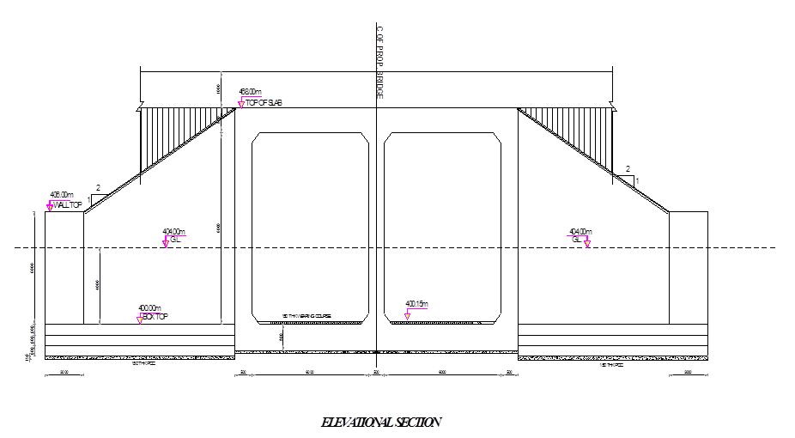

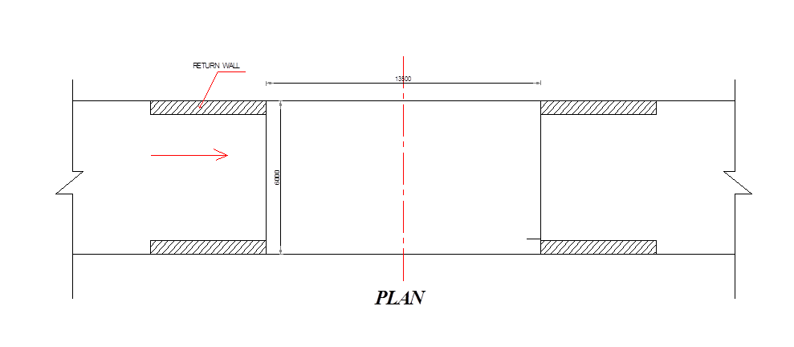

**STAAD MODAL AND LOAD APPLICATIONS**

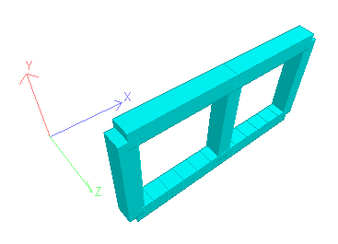

Fig. 1

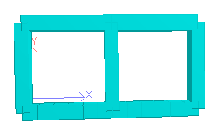

Fig. 2

3D Modal of STAAD

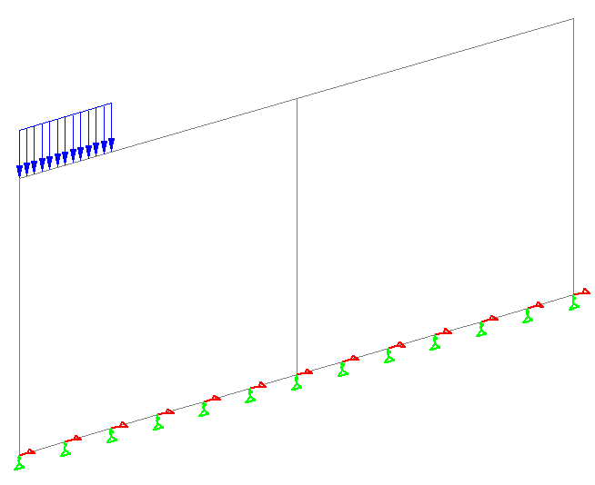

Fig. 3

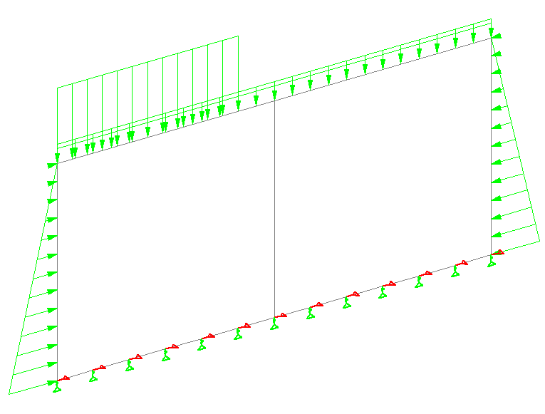

Fig. 4

Figure showing load application at a distance of 2m, load combinations and supports.

**STRUCTURAL BEHAVIOUR OF A STRUCTURE AT VARIOUS LOADS**

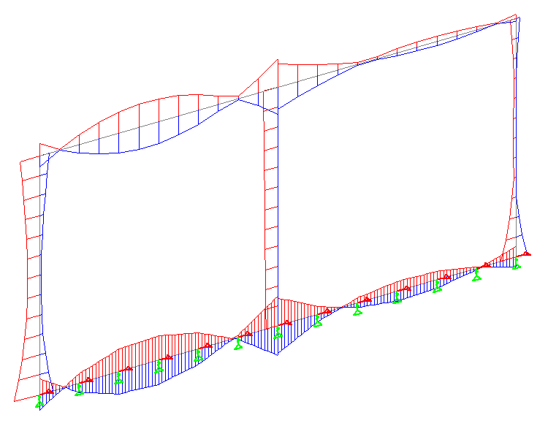

Fig. 5

Behaviour of a structure at Loading Combination 1.7 (ULS)

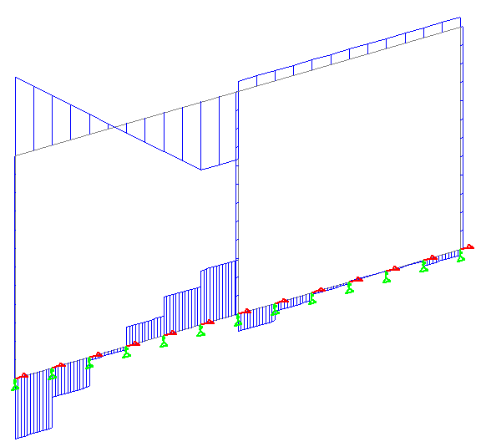

Fig. 6

Shear force diagram at a distance of 5m form left.

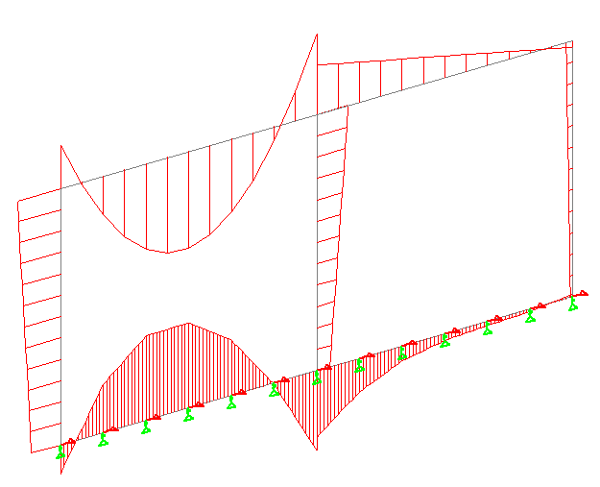Fig. 7

Bending Moment Diagram due to live load of 78.681KN/m on full span.

**CONCLUSION**

* After the evaluation of IRC codes and various bridge rules, it has been noted out that the dimension and site condition of the structure plays a major role for the consideration of various loads and there combinations.
* More the dimensions and size of box we consider as per the site condition, more amount of loads will come into existence.
* The amount of loads and their combination depends on the selected dimensions.
* STAAD analysis gives avery quick results as compared to any other method and shows an immediate behavior of the structure after applying loads.

**REFERENCES**

1. Indian Railway Bridge Manual, edition 1998
2. Indian Railway Standard Code of practice for plain, reinforced and prestressed concrete for general bridge construction
3. Design of Bridge Structure by T.R. Jagadeesh and M.A. Jayaram
4. Bridge Rules, Rules specifying the loads for design of super-structure and sub-structure of bridges
5. IRS Code for design of Sub structure and foundation of bridge, by RDSO, adopted 1936.
6. RCC Box Bridge, Methodology and design by B. N. Sinha and R. P. Sharma.