**Simulation of simple cylindrical flume in rectangular channel by using HEC-RAS software**

**Rahul Kumar1, Ravi Prakash Patel2, Samyak Parekar3, Sarang Pokale4**

**Department of civil Engineering, K.D.K college,Nagpur University, Nagpur, India.**

**Email: rahulisc@gmail.com**

***Abstract-* We are blessed with very precious and essential thing by nature i.e. water. There is strong necessity of water conservation since water resources are limited. Measuring water is an important first step towards conservation of water. Because of unavailability of suitable measuring devices, there are possibilities of either under or over irrigating the cropscausing uneconomic returns of crop. To measure the flow efficiently various types of flumes can be used as a flow measuring devices. A flume is a flow measuring device which can be developeby reducing the cross section of theflow.A simple cylindrical flume is a type of flume which is obtained by keeping cylinder axially in the channel. Present study mainly concentrates on development of soft model of simple cylindrical flume by using HEC-RAS software. After development of the model it is tested by passing the different discharges and the output obtained are water surface profile, Velocity, Froude’s number, Flow area, Energy grade line, Flow depth etc.From this study we have found out various parameters without performing the laboriouslaboratory experiment by developing the soft model of simple cylindrical flume and by running the model.**

***Index terms:* simulation, flume, rectangular channel, HEC-RAS.**

**INTRODUCTION**

**Though there is 79% of water available on the earth but the quantity of useful water is only 2 to 3%. This limited water resources is become one of the most critical situation of the 21th century as world’s thirst for water is increasing day by day as population, industrialization , agriculture increasing day by day. For distribution of water we must know the availability of water and how much water is required for irrigating the field. Current methods of irrigation will have to be urgently revisited and more efficient means reinvented.**

**At the present scenario, HEC-RAS software is used for finding out various parameters which are obtained by passingdischarge through the soft model of simple cylindrical flume. HEC-RAS stands for the Hydrologic Engineering Centre River Analysis System. HEC-RAS is a**[**computer program**](http://en.wikipedia.org/wiki/Computer_program)**that models the hydraulics of water flow through natural**[**rivers**](http://en.wikipedia.org/wiki/Rivers)**and other channels.**

**A)Flume**

**The study of flow measurement methods used in open channels was carried out by various researches by using various flumes. Various critical depth flumes has developed and implemented in the measurement of open channel flow. Measuring discharge of topic and lot of studies has been made on the flumes is historical topic and lot of studies through experiments has been made on the flumes.Samani et al (1993) developed the necessary equations for calibration of a simple flume that consisted of a cylinder installed in a particular position in the channel.**

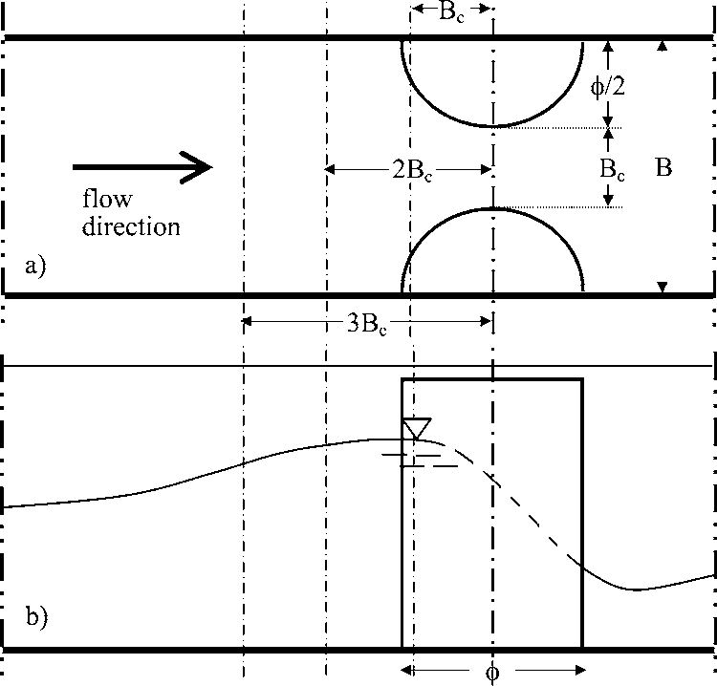

$$Q=a^{\frac{3}{2}}g^{\frac{1}{2}}B_{c}^{\frac{(5-3n)}{2}}h^{\frac{3n}{2}}$$

**B)Working**

**The basic computational procedure of HEC-RAS for steady flow is based on the solution of the one-dimensional energy equation.**

**http://www.ce.utexas.edu/prof/maidment/grad/tate/research/RASExercise/webfiles/energyeq.gif , which states that the total energy (H) at any given location along the stream is the sum of potential energy (Z + Y) and kinetic energy (αV2/2g). The change in energy between two cross-sections is called head loss (hL). The energy equation parameters are illustrated in the following graphic:**

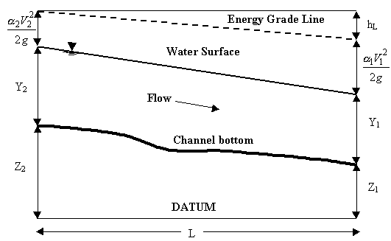

**C)Result**

**By running discharge through model of flume the following parameters are obtained .**

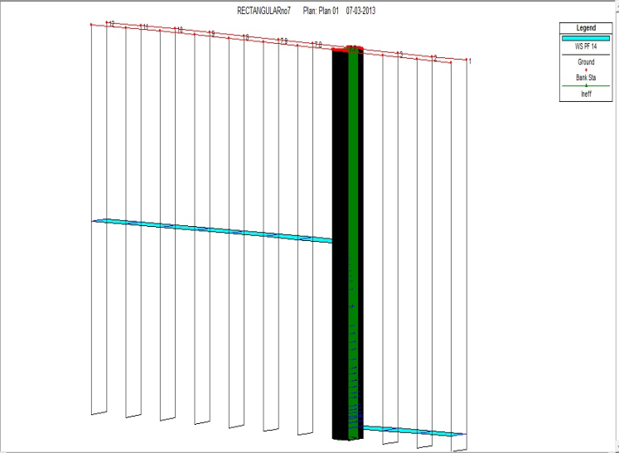

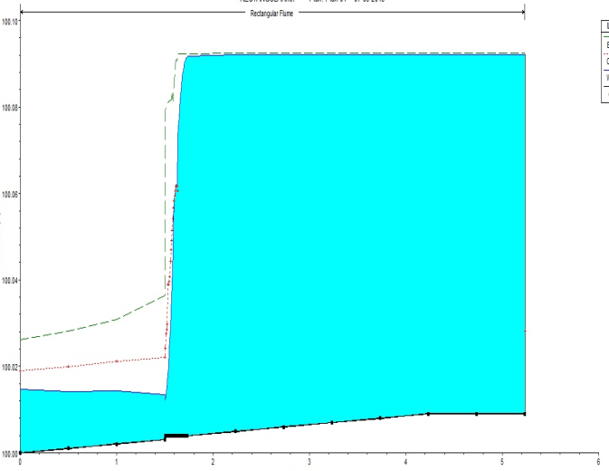

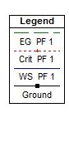

**Table: Output data**

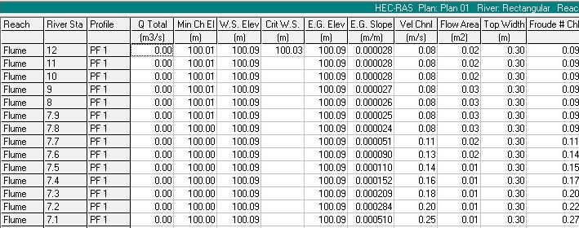

**REFERENCES**

**a) US army corps**

**b) ASCE library**

**c)Bos,M.G.,ed.,”Discharge Measurement Structures,”Laboratory of Hydraulics and Catchment Hydrology,Wageningen,Netherlands,1976.**

**d)Harvey, W.B.,”Harvey’s Irrigation Outlet,”Punjab Irrigation Branch Paper,**

**Fig: Main channel distance(m) on x-axis and elevation(m) on y-axis**