Evaluation of the Infiltration Capacity of Soils in Lakhandur river basin

Anagha Phusate¹, Ashwini Khoke², Ankita Warkade³, Laxmichand Pawar⁴, N. R. Dhamage⁵
Department of Civil Engineering,K. D. K. C. E. Nagpur

Abstract

The study evaluates the infiltration capacity of soils in Lakhandur river basin. The double ring infiltrometer with inner ring of 31cm and outer ring of 50cm diameter with a height of 34cm above the ground was used to measure infiltration rates on bare and sparsely vegetated land. Two runs were done at each location. Soil samples were collected from sampling point using a soil core cutter at a depth ranging from 0-15cm. Samples on soil types were collected because it was believed that soil type greatly influences the rate of infiltration in soil. The results revealed that the mean of sand, silt and clay was 93.3, 5.5 and 1 per cent respectively. This shows that the soil in the study area was dominated by sandy soil. Also the research revealed that the infiltration rate for sparsely vegetal and bare surfaces have values of 204 and 36mm/hr respectively. Three infiltration models namely Philip, Horton and Green Ampt models were used to predict infiltration rates at the sites.

Keywords: Infiltration, Soils, Runoff and vegetal cover

Infiltration is an important component of the hydrological cycle and is defined as the process of entry of water through the soil surface. Earlier the term infiltration was used to denote the difference between rainfall and runoff in small areas. Several factors affect infiltration rate of a given soil type, these include the nature of the soil layer, the moisture content of the soil, rainfall intensity, temperature, vegetation cover, hydraulic characteristics, permeability and moisture content. Water in excess of infiltration capacity of the soil will flow overland as surface run-off once the minor undulations in the surface have been filled. Runoff occurs most frequently on degraded soils depending on topography and rainfall intensity. Generally, infiltration has a high initial rate that diminishes during continued rainfall to a nearly constant lower rate. The rate at which water enters into the soil at a given moment is known as the ‘Infiltration rate’. Infiltration rate is of greatest interest to the hydrologists and water resources engineers, as it influences many of the hydrological parameters, such as, surface runoff, soil moisture,evapouration and evapotranspiration,groundwater recharge and spring flow rates.

Study area:

The study area is in Lakhandur river basin near Bhandara in state of Maharashtra.The study was conducted at a location named Kardha.(fig.1)

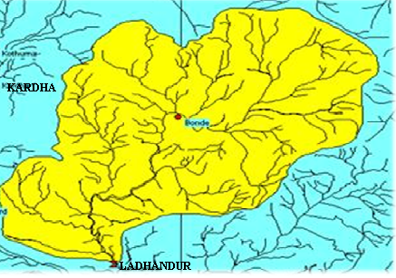
Fig.1. Location map

Factors affecting infiltration rate:

Once the importance of study of infiltration rate has been established, it is useful to understand the effect of various soil and climate factors on the infiltration rate. Some of the most common factors affecting infiltration rate are:

- Soil properties(including structure, texture and distribution, porosity and compactness of soil grain)
- Soil moisture
- Land use characteristics
- Rainfall(duration and intensity)
- Surface slope
- Climate

Method of study:

1. Pre-field preparation:

A base map, indicating road network of the area, was prepared. The site was chosen in the area which is easily approachable.

2. Field investigation:

The study made use of the double ring infiltrometer with inner ring of 30cm and outer ring 51cm diameter each had a height of 34cm above the ground. Although it has some disadvantages such as the disturbance of soil structure, lateral flow of water into drier surrounding and the sampling of small area of land at a time. Infiltration test was carried out at selected site such as bare crusted and sparsely vegetated surfaces. Two runs were done at each location depending on the type of surface. The infiltrometer was driven into the soil at a depth of 5cm with the aid of a hammer and care was taken to ensure that it creates minimum disturbance to the soil. The outer ring acts as a buffer ensuring a vertically downward movement of water. The infiltrometer was flooded at a constant 10cm depth throughout the duration of each test run. The process continued until a steady state was reached. Soil samples were collected from one (1) sampling locations using core cutter at a depth of 0-15cm.Sample on soil types were collected because it was believed that soil type greatly influences the rate of infiltration in soil.

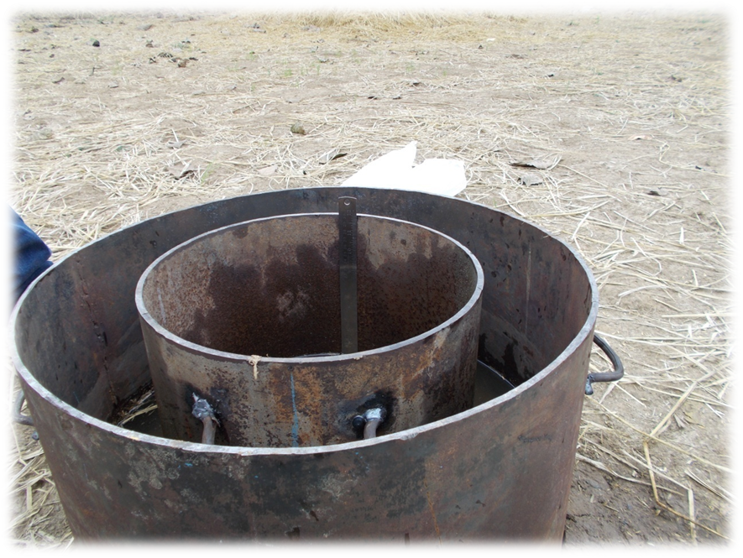
Fig.2. Double ring infiltrometer

3. Post field analysis:

After the field work was over, the sample were brought to the Geotechnical lab, KDKCE,Nagpur using the core cutter for laboratory analysis, i.e. particle size analysis, moisture content and specific gravity.

Textural analysis:

The samples collected from the field were tested in the Geotechnical Laboratory of KDKCE, Nagpur for the particle size distribution. Particle size distribution of the soils was done by sieve analysis. Soil samples after oven drying were sieved through a set of sieves mechanically and the percentage of sol retained on each sieve was calculated and thus the soil was classified into three groups of clay, silt and sand. The values obtained were as follows:

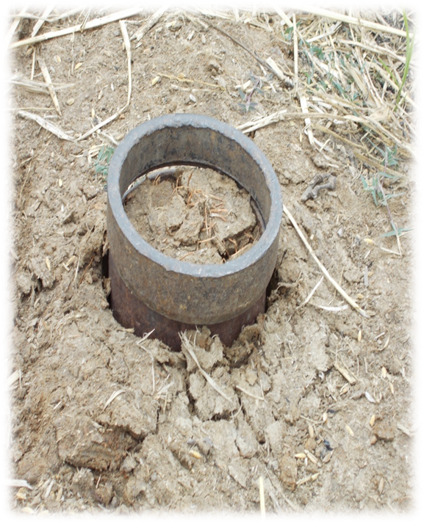
Fig.2.Core cutter

Moisture content:

The soil sample was weighed giving a value of w1 and then it was oven dried for a span of 24hrs.It was removed from oven and again weighed giving value w2.Now using formula the moisture content was calculated.

Moisture content = (w1-w2/w1)*100

Specific gravity:

The specific gravity of soil sample was determined using a pignometer.

Determination of infiltration capacity theoretically:

The infiltration capacity of soil was theoretically calculated using three methods as follows;

HORTON’S EQUATION: Horton presented three parameters infiltration equation in 1939 (Chow et al., 1988) which relates infiltration rate to time. Philip (1983) introduced the first two terms of infinite series solution for infiltration to be used as infiltration equation.

Whereas fc is the final constant infiltration rate, fo is the infiltration capacity at 0, and β is
A soil parameter which controls the rate of decrease of infiltration rate. The parameters fo
And β must depend on the initial water content as well as the application rate, and for Homogeneous profiles, fc will be somewhat smaller than the saturated hydraulic conductivity.

PHILIP EQUATION: Philip (1954) proposed that the first two terms of his series solution for infiltration from a ponded surface into a deep homogeneous soil be used as a concise infiltration equation. The equation may be written for infiltration rate as,

t a f = S t −1 / 2 +C

Readings observed at Kardha:

Time t(min) | Depth of water before filling | After filling | Depth of infiltration d in (mm) | Infiltration rate (mm/hr) | Cumulative infiltration | f-fc
0 | 100 |  | 0 | 0 | 0
5 | 76 | 100 | 24 | 288 | 24 | 84
10 | 78 | 100 | 22 | 264 | 46 | 60
15 | 80 | 100 | 20 | 240 | 66 | 36
20 | 80 | 100 | 20 | 240 | 86 | 36
25 | 81 | 100 | 19 | 228 | 105 | 24
30 | 83 | 100 | 17 | 204 | 122 | 0
35 | 83 | 100 | 17 | 204 | 139 | 0
40 | 83 | 100 | 17 | 204 | 156 | 0
45 | 83 |  | 17 | 204 | 173 | 0

Fp(cm) | Incremental depth of water in (cm) | t (hr) | fp(cm/hr) | t^(-.5) | 1/Fp | Ln(Fp) | Ln(t)
2.4 | 2.4 | 0.083 | 28.916 | 3.464 | 0.417 | 0.875 | -2.485
4.6 | 2.2 | 0.167 | 26.506 | 2.449 | 0.217 | 1.526 | -1.792
6.6 | 2 | 0.25 | 24.096 | 2 | 0.152 | 1.887 | -1.386
8.6 | 2 | 0.333 | 22.892 | 1.732 | 0.116 | 2.152 | -1.099
10.5 | 1.9 | 0.417 | 20.482 | 1.549 | 0.095 | 2.351 | -0.875
12.2 | 1.7 | 0.5 | 20.482 | 1.414 | 0.082 | 2.501 | -0.693
13.9 | 1.7 | 0.583 | 20.482 | 1.309 | 0.072 | 2.632 | -0.539
15.6 | 1.7 | 0.667 | 20.482 | 1.225 | 0.064 | 2.747 | -0.405
17.3 | 1.7 | 0.75 | 20.482 | 1.155 | 0.058 | 2.851 | -0.288

Graphs obtained:

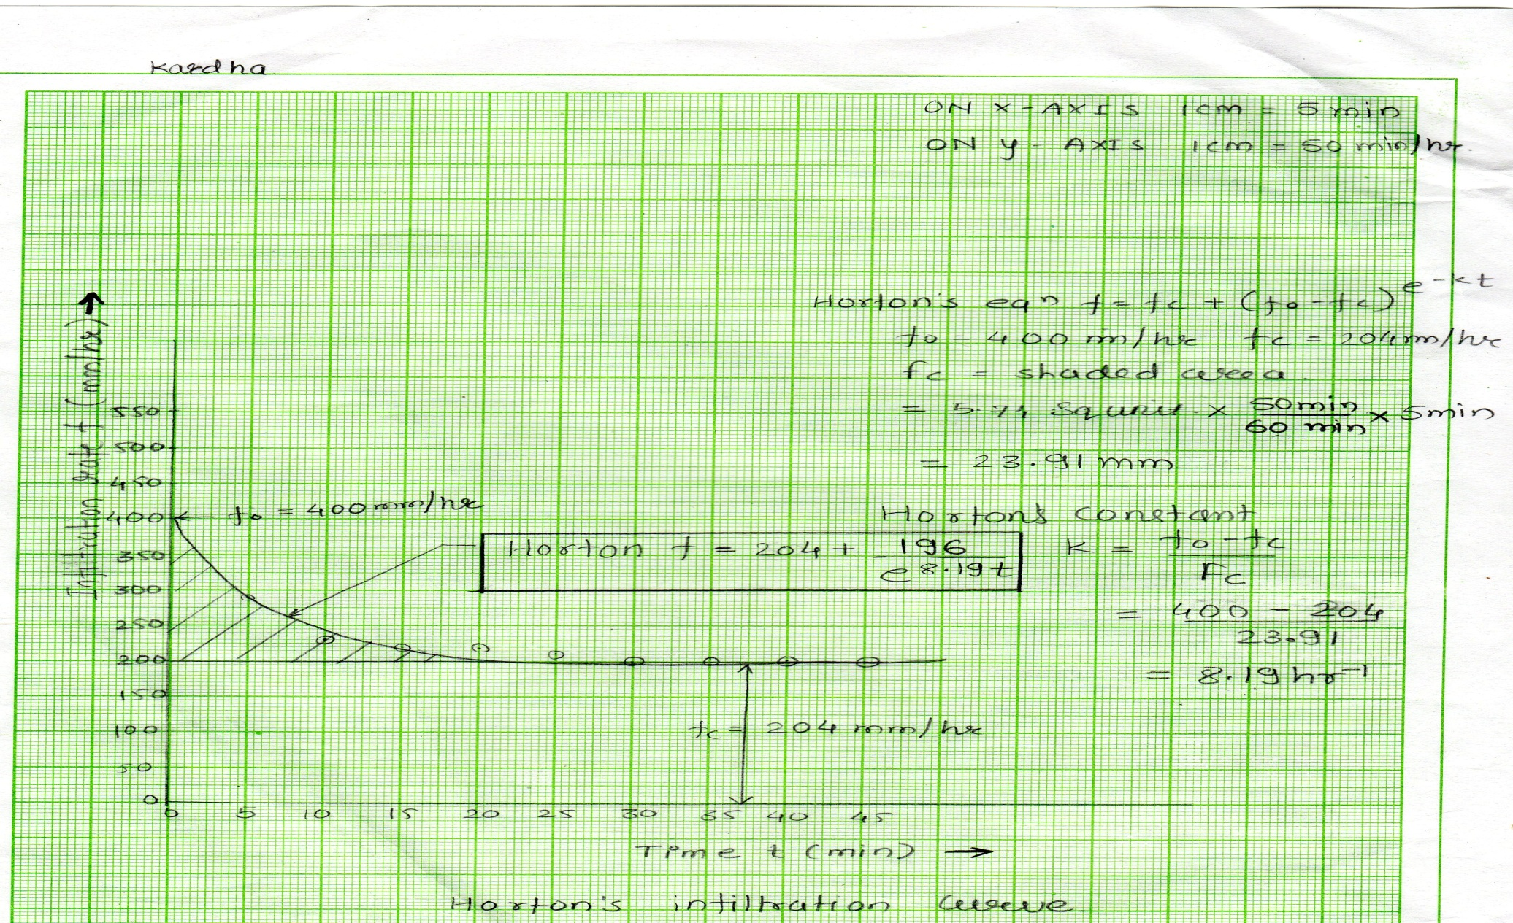
PHILIP’S GRAPH

GREEN AMPT GRAPH
Result:

In the initial period of water application the infiltration rate is very high which reduces very rapidly with time. Initial high infiltration rate may be because of the presence of cracks in the soils. As the time of water application increases, the infiltration rate reduces very quickly.

Conclusion:

Studies on infiltration rates of soils are required in solving many hydrological problems such as runoff estimation, soil moisture budgeting irrigation planning, land use planning and management. This research shows that vegetation cover is one of the most important factors that accelerates infiltration rate and thus reduces overland flow which and ultimately in turns conserves the soil. The mean for vegetal cover was as high as 204mm/hr. The sand, silt and clay contents of the soils had mean values of 93.3, 5.5 and 1 per cent which shows that the area is dominated by sandy soil. The area is unsuitable for surface irrigation due to its high infiltration capacity. It is recommended that human activities in the form of deforestation, bush burning and grazing by livestock should be discouraged, while in this area; planting of trees on bare lands should be encouraged to reduce erosion. The soil present there had moisture content 9.09%.

References:

- Evaluation of the Infiltration Capacity of Soils in Akpabuyo Local Government Area of Cross River, Nigeria, Journal of Geography and Geology.
- Infiltration studies in Sher Umar river Doab in Narmada basin, National Institute of Hydrology,Rorkee 1996-97
- Hydrology,K.Subramanyam

SUBMITTED BY:
- Anagha D. Phusate
- Ashwini Khoke
- Ankita Warkade
- Laxmichand Pawar

K.D.K. College of Engg.

