**K.D.K. COLLEGE OF ENGINEERING NAGPUR**

**DEPARTMENT OF CIVIL ENGINERRING**

**2012-2013**

**STRUCTURAL ANALYSIS AND DESIGN OF FOOT-OVER BRIDGE**



**SUBMITTED BY:**

VARSHA MENDHE JAYSHREE LOKHANDE

ANKIT ATKAR TRIRATNA RANGARI

UNDER THE GUIDANCE OF: **PROF. V.D. VAIDYA**

**INTRODUCTION**

A bridge is structure providing passage over an obstacle without closing the way beneath. The passage may be for a road, a railway, pedestrians or a canal. Bridges are classified in several ways; they may be term railway, highway or pedestrian bridges. If they are classified by materials they are called steel, concrete, Timber, stone or Aluminium Bridge.

In this project we had objective of designing of railway FOB considering only static load for pedestrian traffic. The design bridge is a steel plate girder type of a bridge.

**Types of foot over bridge:**

1. Steel beam bridge
2. Truss girder bridge
3. Steel box girder bridge
4. Suspension bridge
5. Composite beam bridge
6. Plate girder bridge

**Plate Girder Bridge:**

A plate girder bridge is a bridge supported by two or more plate girders. The plate girders are the main loads carrying members in the plate girders bridge

The plate girder bridge are also known as solid web girder bridge. The plate girder are typically I beam made up of separate structural steel plate (rather than role as single cross section) which are welded or in older bridge bolted or riveted together to form the vertical web and horizontal flange of the beam. In some case the plate girder may be formed in a z shape rather than I shape.

Plate Girder Bridge are suitable for short to medium span and may support rail road, high way or other traffic. Plate girder are usually prefabricated and the length limit is frequently set by the mode transportation used to move the girder from the bridge shop to the bridge site. The plate girders are used so long as the plate girder may be transported in one piece. measured from gravity axis of top flange up to the gravity axis of the bottom flange. Generally, the depth of the girder is no less than 1115 the span, and for a given load bearing capacity, a depth of around 1/12 the span minimizes the weight of the girder. Stresses on the flanges near the center of the span are greater than near the end of the span, so the top and bottom flange plates are frequently reinforced in the middle portion of the span. The plate girders are comparatively free from secondary stresses. Vertical stiffeners prevent the web plate from buckling under shear stresses. These are typically uniformly spaced along the girder with additional stiffeners over the supports and wherever the bridge supports concentrated loads.

**Components of Plate Girder Bridges**

a) Plate Girder.

b) Tie Beam.

c) Foundation.

d) Steel Column

e) Bracing.

f) Gusset Plate.

g) Precast Panel.

b) Pedestal.

j) Base Plate.

k) Bolts.

**LITERATURE REVIEW**

1.IS: 875 (Part 2) - 1987 Indian Standard CODE OF PRACTICE FOR DESIGN LOADS (OTHER THAN EARTHQUAKE) FOR BUILDINGS AND STRUCTURES PART 2 IMPOSED LOADS

This standard (Part 2) covers imposed loads (live loads) to be assumed in the design of structures. The imposed loads, specified herein, are minimum loads which should be taken into consideration for the purpose of structural safety of structures. This Code does not cover detailed provisions for loads incidental to construction and special cases of vibration, such as moving machinery, heavy acceleration from cranes, hoists and the like. Such loads shall be dealt with individually in each case.

2.IS: 800-1984 Indian Standard CODE OF PRACTICE FOR GENERAL CONSTRUCTION IN STEEL (Second Revision)

This code applies to general construction in steel. Specific provisions for bridges, chimneys, cranes, tanks, transmission line towers, storage structures, tubular structures and structures using cold formed light gauge sections etc, are covered in separate code. The provision of this code generally applied to riveted, bolted and welded construction using hot rolled steel secnons. This code gives only general guidance as regards the various loads to be considered in design.

**Codal Provision**

Combinations 1 – The permanent loads i.e. dead load, superimposed loads etc. together with the appropriate live loads.

Other loads that are supposed to be come on it are Surcharge loads.

The above combinations of load are provided by the IRS Code of Plain, Reinforced and prestressed concrete.

All the dead loads (i.e. dead loads of bridge components like side walls, deck etc.) will be calculated in accordance with IRS code.

All the dead loads and UDL due to train movement will be converted into EUDL as per IRS.

1. **Dead Load**

* Self-Weight of the complete R.C.C. frame
* Ballast Cushion of 400mm depth for B.G.
* Sleeper
* Track Load
* Soil Fill pressure

1. **Live Load**

* Maximum Axle load of 25t (i.e. 245.2 KN)
* Train Load 9.33 t/m (i.e. 91.53 KN/M)

1. **Dynamic Loads**

* For Broad Gauge the augmentation in the load due to dynamic effect should be considered by adding a load equivalent to a coefficient of dynamic augment (CDA) multiplied by live load giving the maximum stress in members under consideration. The CDA should be obtained as follows and shall be applicable upto 160 kmph on BG and 100 kmph on MG

For Single Track

CDA=0.15+ (8/6+L)

1. **Force due to curvature and eccentricity of track**

* It should not be considered as it is not included in the combination 1 of the IRC code.

1. **Temperature effect**

* It is not required to be considered as for the bridge design only combination 1 is used, and also as per the concrete bridge code it is stated that “For design of concrete bridges of span 30m and larger, an appropriate temperature gradient shall be considered” clause 11.1.1, as per GAD the span length is 14.7m.
* It is required to be included only if the combination 3 is considered for the designing.

1. **Frictional resistance of Expansion bearing**

* It is not to be used as the bridge we are designing is an RCC box frame and no bearing is included in it.

1. **Racking force**

* It is not required to be included as it is not included in the combination 1

1. **Forces on Parapets**

* It is not required to be considered as it is not included in the design part.

1. **Wind pressure**

* This load is to be used in design calculation only if combination 2 is used.
* As per Code of practice for the design of sub-structures and foundations of bridges “Wind pressure shall be taken into account for bridges of span 18m and over” and for design purpose the span is considered to be 14.7m.
* But still in case if we have to find the wind pressure the following equation should be used:

Pz=0.6Vz2

Where: Pz = design wind pressure in N/m2 at height z, and

Vz = design wind velocity in m/s at height z.

1. **Earthquake Pressure**

* It is to be used only if the combination 2 is used.
* As per bridge rule in Zone 1 to 3 Seismic forces is considered in case of bridge of over-all length more than 60m or span more than 15m.

1. **Water Pressure**

* Water pressure is not been considered during the designing process as it is required to be designed in an empty condition.
* But still if in case during its life span rain occurs, the water pressure on the bridge will be very less or negligible as the drains are being provided for that purpose.
* And in case if the bridge get filled up by the water the bridge will get safer because the internal water pressure is counter balanced by the external soil pressure and the water is free to flow and hence there is no problem of arising of water pressure within the and its accumulation at there.

**Precast slab**

The concept of precast (also known as “prefabricated”) construction includes those structures where the majority of structural components are standardized and produced in plants in a location away from the building, and then transported to the site for assembly.

Precast slab saves time and money by eliminating unnecessary man hours in the preparation of forms, cutting rebar, concrete pouring. No need to fabricated steel angles to span openings and rust proofing is not required.

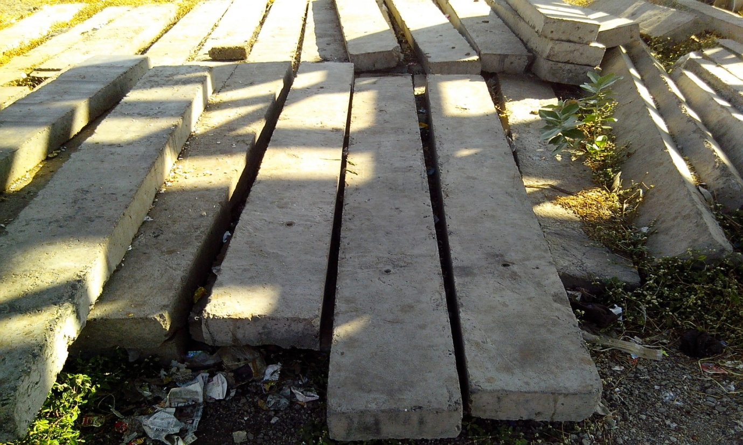

**Advantages of Pre-cast Concrete**

- Pre-cast concrete slabs are usually the correct size as it is manufactured off site.  
- Pre-cast concrete saves a lot of time on site as it is manufactured off site.  
- Pre-cast concrete also saves a lot of space on site as pre-cast concrete is usually on site when required.

- Pre-cast concrete saves money in terms of labour on site as pre-cast concrete can usually be assembled by semi skilled operatives.

**Disadvantages of Pre-cast Concrete**

- Pre-cast concrete lacks design and dimension flexibility as the manufactures may only have fixed shapes and sizes.  
- Pre-cast concrete may affect the construction programme as the delivery on site may not always be on time.  
- Pre-cast concrete may incur addition financial costs as delivery on site may not always be on time.  
- Pre-cast concrete allows for a very small margin for error as the incorrect dimensions of pre-cast concrete may result in changing the entire design.

**COMPARISON of STEEL AND CONCRETE STRUCTURES**

**or**

**Your Next Bridge: Steel or Concrete?**

One-third of INDIA's bridges need to be repaired or replaced, according to the Highway Administra­tion. Most of these bridges are short-spans owned by county and municipal agencies. For agencies that need to replace bridges, there are essentially two choices: concrete or steel.

The use of prestressed concrete bridges has grown drastically since they were first introduced in the INDIA in 1979. They represent over half of all bridges built today. But don’t rule out steel yet. Steel is practical and economical in many situations.

1. **Ability of Owner to Construct**
2. **Availability of Materials.**
3. **Repairs.**
4. **Upgrades.**
5. **Seismic.**
6. **Navigation.**
7. **Aesthetics.**
8. **Initial and Life-cycle Costs.**

**ADVANTAGES OF STEEL BRIDGES**

1. dead load to live load is lower

2. longer spans, lesser pier and foundation cost

3. lesser construction depth

4. lesser cost of embankment

5. rapid construction

6. lower cost of money, lesser disruption of traffic

7. less disruption of traffic in urban environment

8. lesser ecconomic loss to community

9. better performance

10. under fatigue, seismic load, impact load, blast load

11. longer life

12. lower life cycle cost

**FURTHER INNOVATION**

1. sides of the fob’s can be used as a display area for advertisements.

2. escelators can be very easily installed for the convenience of public, mostly the physically challenged.

3. solar panels can be installed easily and effectivly over the top of the fob’s.