**USE OF INDUSTRIAL AND AGRICULTURAL WASTES AS A SUSTAINABLE CONSTRUCTION MATERIAL.**

**NAME :- KSHITIJA NARKHEDE**

**DEPARTMENT OF CIVIL ENGG, K.D.K.C.E, NAGPUR**

**Abstract:**

The waste generated from industries is the huge concern for the environment, health, and land filling problems. Recycling of such wastes and using them as sustainable construction materials will be advantageous to overcome the above problems. Many research works have been done on wastes like fly ash, rice husk ash, crumb rubber, quarry dust, etc.

Out of several wastes being produced at present, the use of lime sludge, fly ash, rise husk ash, saw dust, various types of fibers and hypo sludge is of paramount significance to protect the environment. For producing 4million tons of cement, 1 million tone greenhouse gases are emitted. It causes serious environmental problems. Henceto reduce disposal and pollution problems emanating from these industrial wastes, it is most essential to develop profitable building materials from them.

This approach for development of new construction material using industrial waste is useful to provide a potential sustainable source.

**2. Introduction:**

We can say that the today’s age is concrete age, as we see the growth of the infrastructure sector. The Indian construction industry consumes approximately 400 million tons of concrete every year and the relative amount of mortar too. Hence the huge amount of raw material i.e. coarse aggregates, fine aggregates, and cement. Demand of these materials is very high so the costs of them are steadily increasing, and few times shortage is also occurred. To avoid these two crises to development we the Civil Engineers have to do something.

Energy plays a crucial role in growth of developing countries like India. In the context of low availability of non-renewable energy resources coupled with the requirements of large quantities of energy for Building materials like cement, the importance of using industrial waste cannot be under estimated. Cement-based materials (cement paste, mortar, concrete etc.) are widely used in many structures of the construction industry. Knowledge of physical properties of such materials is important for determination of their quality.

Human activities on earth produce wastes in considerable quantities of more than 2,500 million tons per year, including industrial and agricultural wastes from rural and urban societies. Recent technological developments have shown that these materials can be used as valuable inorganic and organic resources to produce various useful value added products. Some value added products generated from waste are listed below.

1. Rice Husk Ash (RHA)

2. Fly Ash

3. Quarry Dust

4. Crumb Rubber

5. Sewage Sludge Ash

6. Paper Pulp

7. Recycled Aggregates

8. Plastic Waste

**3. Details of the Wastes Used in Construction Industries:**

**3.1 Rice Husk Ash:**

In average 1000 kg rice produces 200 kg husk which after combustion produces 20 kg rice husk ash. After controlled combustion it is seen that RHA contains large amount of silicon dioxide along with some alkaline compounds. RHA has pozzolanic properties, which is useful for pozzolona mixes and for replacement of cements. From past two decades RHA is used in concrete and mortar as partial replacement of cement.

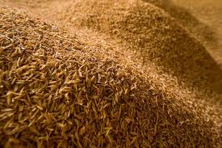

Fig.1. Rice husk

**3.2 Fly Ash:**

Fly ash is usually generated from combustion of coal. Fly ash also possesses pozzolanic properties. Fly ash can be used for replacement of cement as well as fine aggregate i.e. sand. Sand is widely used fine aggregate in mortar and concrete, but where it is not locally available requires its transportation which increases its cost. In such cases Fly ash can be used.

Combustion of coal produces two forms of fly ash namely fly ash and bottom ash. Bottom ash can be replaced partially or fully as replacement for fine aggregate.

In fly ash geo-polymer technology is the new technology which reduces emission of carbon dioxide; this protects the environment up to some extent.

**3.3 Quarry Dust:**

It is the production of concrete aggregates by crushing of rocks. A potential benefit to use quarry dust (QD) is the cost saving, because the material cost varies depending on the source. Incorporation of QD requires high dosage of super plasticizer as its addition increases water content due to its fineness and to get the desired strength super plasticizers are required. Due to this reason the use of QD is limited.

**3.4 Crumb Rubber:**

Waste rubber tire cause environmental problems all over the world. One of the potential means of the use of the waste material is the protection of the environment and society. The concrete containing waste rubber is differentiated in two types, rubberized concrete and rubber filler concrete. We can replace coarse as well as fine aggregate by crushed rubber. Gradual increase in the use of crumb rubber increases slump value and can decrease the value of modulus of elasticity.In mortars we can partially replace fine aggregate i.e. sand by crumb rubber up to limited amount. But before use of it, it should be grinded to get the desired nominal size. Limited percentage of addition of crumb rubber can give the desired strength.



Fig.2. Crumb rubber

**3.5 Sewage Sludge Ash: (SSA)**

During the process of sewage treatment, some byproducts are generated and among them sludge stands out, sludge is produced in huge amount and it contains heavy metals in its composition Researchers are already accomplished investigating the use of sewage sludge ash to form bricks, aggregates, fillers and pavements.

Before disposal the sludge is dehydrated, sludge also contains some toxic metals. Therefore before use of SSA it should be check that there should not be any toxic waste.SSA also requires X-ray diffraction analysis to make it safe for use.Due to various important checks and tests the use of SSA may be costly, or the tests will not readily carry out at any place.

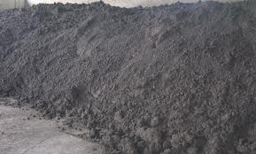

Fig.3. Sewage sludge ash

**3.6 Paper Pulp:**

The paper pulp sludge is produced in huge amount allover across the world, which causes environmental problems and also the vital problem of land filling. In an average about 6 kg of sludge is obtained for per ton of paper. In Italy 600,000 tons paper mill sludge is produced per year, this causes serious problem of land filling.

This paper mill sludge when dried can be used in incinerators for heat recovery and to reduce volume. Paper pulp can be used as auxiliary fuel. After the controlled combustion of paper pulp it gives the paper pulp ash, it contains Al2O3, CaO, MgO, and SiO2. These compounds are extensively used in concrete industries. As it contains these materials it can be utilized as the partial replacement of cement in concrete and in mortar.

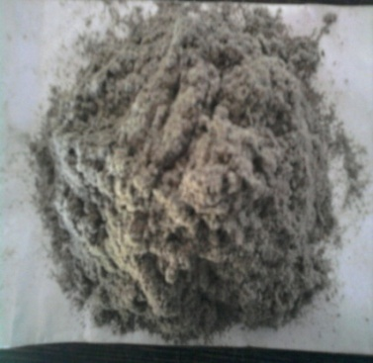

Fig.4. Paper pulp

**3.7 Recycled Aggregates**-

Recycled aggregates are aggregates derived from the processing of materials previously used in a product and/or in construction. Examples include recycled concrete from construction and demolition waste material (C&D), reclaimed aggregate from asphalt pavement and scrap tires. Recycled Concrete Aggregate (RCA) Description Coarse recycled concrete aggregate (RCA) is produced by crushing sound, clean demolition waste of at least 95% by weight of concrete, and having a total contaminant level typically lower than 1% of the bulk mass. Other materials that may be present in RCA are gravel, crushed stone, hydraulic-cement concrete or a combination thereof deemed suitable for premix concrete production.

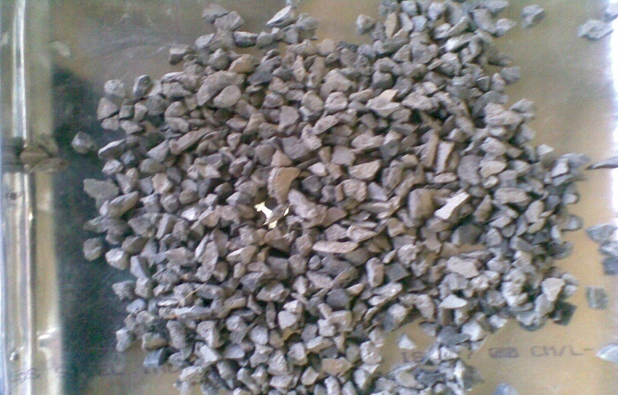

Fig.5. Recycled aggregate

**3.8 Micro-Silica (commonly known as Silica fume)**

Silica fume is a byproduct in the reduction of high-purity quartz with coke in electric arc furnaces in the production of silicon and ferrosilicon alloys. Silica fume consists of fine particles with a surface area on the order of 215,280 ft²/lb (20,000 m²/kg) when measured by nitrogen adsorption techniques, with particles approximately one hundredth the size of the average cement Because of its extreme fineness and high silica content, silica fume is a very effective pozzolanic material particle.

Silica fume is added to Portland cement concrete to improve its properties, in particular its compressive strength, bond strength, and abrasion resistance. These improvements stems from both the mechanical improvements resulting from addition of a very fine powder to the cement paste mix as well as from the pozzolanic reactions between the silica fume and free calcium hydroxide in the paste.

Addition of silica fume also reduces the permeability of concrete to chloride ions, which protects the reinforcing steel of concrete from corrosion, especially in chloride-rich environments such as coastal regions.During the last decade, considerable attention has been given to the use of silica fume as a partial replacement of cement to produce high-strength concrete.

It is a product resulting from reduction ofhigh purity quartz with coal in an electric arc furnace in the manufacture of silicon orferrosilicon alloy. When quartz are subjected to 2000ºC, reduction takes place and SiOvapors get into fuels. In the course of exit, oxidation takes place and the product iscondensed in low temperature zones. In the course of exit, Silica fume rises as an oxidized vapor, oxidation takes place and the product is condensed in low temperature zones.

**3.9 Plastic Wastes:**

Significant research efforts has been put-in to check the feasibility of using plastic wastes as a partial replacement of concrete constituents with an additional advantage of safe and environment friendly way of their disposal. There is no significant side effect on physical properties of concrete by using plastic waste as concrete ingredient and many a times, improvement in its basic properties has been observed. There are many possibilities which are required to be explored for the better use of plastic waste as concrete constituents.

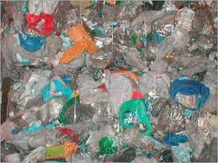

Fig.7. Plastic wastes

**4. Performance of Wastes as Partial Replacements in Construction Industry:**

**4.1. M. Rame Gowda; M.C. Narsimhan; and Karisiddappa**experimentally proved the **“Development and study of Strength of Self-Compacting Mortar (SCM) Mixes Using Local Materials”** Their study investigated the possibility of manufacturing he self-compacting mortar by partial replacement of cement and sand using locally available waste materials like rice husk ash and quarry dust respectively. They determined the compressive strengths of SCM with and without addition of RHA and QD, and concluded that we can get the desired strength of mortar by replacing cement and sand by RHA and QD. The replacement is limited to 10% for cement and 40%for sand.

The QD is used as partial replacement for fine aggregates in mortar. Authors concluded that the use of granite fines i.e. QD requires high dosage of super-plasticizer due to its fineness. As QD is fine its addition to concrete increases water demand and cement content. The study suggested that 40% replacement of sand by QD gives desired strength

**4.2. Muhammad Harunur Rashid, Md. Keramat Ali Molla and TarifUddin Ahmed**

Developed the thesis on **“Mortar Incorporating Rice Husk Ash: strength and porosity”.** They concluded that the use of RHA in mortar by partially replacing cement is beneficial and eco-friendly. They pointed on the porosity after addition of RHA. As the percentage of RHA increases to replace the cement porosity of the mix increases.

The use of RHA significantly improves the mortar strength at the 20% replacement level and at later stage 30% replacement level of OPC by RHA the porosity of mortar is increased at 28 and 90 days as compared to OPC mortar.

**4.3. WesamAmerAules**

Practically proved by publishing “**Utilization of Crumb Rubber as partial replacement of sand in cement mortar”.** The crumb rubber which is to be used as the partial replacement should be converted into desired nominal sizes. Author stated that mortars containing crumb rubber have a gradation close to that of typical sand. The decrease in compressive and flexural strength when increase in the crumb rubber in mortar, and modulus of elasticity decreases as crumb rubber increases. It happens that the addition of crumb rubber could be beneficial for reducing shrinkage in mortar.

**4.4. C.M.A. Fontes, M.C. Barbosa, R.D.ToledoFilho and J.P.Gonacalves**presented the **“Potentiality of Sewage Sludge Ash as mineral additive in cement mortar and high performance concrete”.** Authors stated that sewage sludge ash (SSA) which is to be use should be free from toxic metals.

From the results presented in this paper it is evident that SSA is a prospective material to be used as cement replacement in cement based material. Mortar mixtures containing 10-30% of SSA as cement replacement presented compressive strength at 7 days higher than that of the reference mixture and about the same strength at the age of 28 days. The high performance concrete produced replacing 5-10% of OPC by SSA also presented axial compressive strength equivalent to that of the reference mixture at the age of 28 days. The partial replacement of Portland cement by SSA promoted an increase in the total porosity and a reduction in the absortivity values of the OPC reference mixtures. The smaller values of absortivity presented by the SSA mixtures provide information concerning the quality of the material and indicate that these mixtures are likely to have longer service life than the reference ones. Regarding to the efficiency of the cementicious matrix in immobilizing the contaminants detected in the SSA, the results of the solubilization tests indicate that the pollutants identified in the ash were successfully encapsulated within the concrete plates and fragments, what can bring benefits to the environment by reducing the amount of non-inert material to be disposed in landfill.

**4.5. Gabriele Fava, Maria Letizia Ruello and Corinaldesi**

Presented **“Paper Mill Sludge Ash as supplementary Cementitious Material”** The use of paper mill sludge ash is very essential as it solves problem of land filling. Based on the experimental results of this study, the following observations can be drawn at 28 days, the mortars containing 5% PA exhibited a compressive strength higher than or as high as that of mortar made from cement only the results presented encouraged the researchers to undertake further study on the use of PA in concrete, which could lead to a reduction in the cost of mortars, and concrete, as well as a method for minimizing cost for disposal of PA.

On the basis of the data collected within this experimental Project, it can be concluded that the PA, particularly if it replaces Up to 10% of cement, shows a positive effect on the development of The mechanical performance of mortars. Judicious use of PA and Proper mixture proportioning can give a contribution to the cement Paste hardening, leading to an increase in the cement activity index.

On the other hand, because of its high fineness and, consequently, high water absorption, the dosage of PA should not be too high (the upper limit currently appears to be 10% of the weight of cement).

**4.6.Corinaldesi, Maria Letizia Ruello and Gabriele Fava**

Presented**“Paper Mill Sludge Ash as supplementary Cementitious Material.”** In which they concluded that Paper mill sludge is often incinerated for heat recovering and also for an important volume reduction. In Italy about 6x105tons of paper sludge is yearly produced giving 60kg of paper ash per ton. In this project, the ash coming from burning of paper mill sludge from primary mechanical separation process, fired as single fuel, was studied in order to evaluate its use as supplementary cementitious material in concrete manufacturing. On the basis of the data collected it can be concluded that the paper mill sludge ash, if replaced by 5 to 10% of Portland cement, show a positive effect on the mechanical performance of the concrete. On the other hand, due to its high fineness and consequently high water absorption, it requires a higher dosage of water, so that the use of paper ash should not be higher than 10% by weight of cement.

**4.7. C. Freeda Christy and D Tensing**

Presented **“Effect of class F- fly ash as partial replacement with cement and fine aggregate in mortar”** And suggested that fly ash is investigated for its use as partial replacement of cement and fine aggregate. They presented the results for cement mortar of various mix proportion with varying

Percentage of fly ash used as partial replacement of cement. Results showed that richer the mix higher the compressive strength has been obtained even with the partial replacement of cement. Test

Results indicated that when fine aggregates are partially replaced by the fly ash there is improvement in the strength.

**4.8. AlirezaNajiGivi, Suraya Abdul Rashid, Farah Nora A. Aziz, Mohammad AmranMohdSalleh**

Published **“Contribution of Rice Husk Ash to the Properties of Mortar and Concrete. A Review”** In this research they told thatin the last decade, the use of supplementary cementing materials has become an integral part of high strength and high performance concrete mix design. These can be natural materials, by-products or industrial wastes, or the ones requiring less energy and time to produce. Some of the commonly used supplementary cementing materials are fly ash, Silica Fume

(SF), Ground Granulated Blast Furnace Slag (GGBFS) and Rice Husk Ash (RHA) etc. RHA is a by-product material obtained from the combustion of rice husk which consists of non-crystalline silicon dioxide with high specific surface area and high pozzolanic reactivity. It is used as pozzolanic material in mortar and concrete, and has demonstrated significant influence in improving the mechanical and durability properties of mortar and concrete. This paper presents an overview ofthe work carried out on the use of RHA as partial replacement of cement in mortar and concrete. Reported properties in this study are the mechanical, durability and fresh properties of mortar/concrete.

**4.9. Djwantoro HARDJITO and Shaw Shen Fung**

Presented **“Fly ash based GAopolymer Mortar Incorporating Bottom Ash”** And they concluded that the results of study on effect of various parameters on mechanical properties of fly ash-based geopolymer mortar with bottom ash as partial or full replacement for sand. Compressive strength of samples with 10% bottom ash (BA) was comparable to those with only sand. Further increase in bottom ash content decreased the compressive strength. However, the reverse tendency occurred after exposing the samples to 1000oC for 24 hours.

**5. Conclusion:**

Several tons of industrial wastes are being produced per annum by chemical and agricultural

processesin India. These materials possess problems of disposal and health hazards. Numbers of researches were done by many researchers by using these wastes and very effective results were obtained. Many researchers are working on the incorporation of wastes that are created from industries and several researches have been carried out by incorporating various waste materials and by-products in construction materials.

**6. References:**

1. M. Rame Gowda; M.C. Narsimhan; and Karisiddappa “Development and study of Strength of Self-Compacting Mortar (SCM) Mixes Using Local Materials” (DOI: 10.1061/(ASCE)MT.1943-5533.0000202. © 2011 American Society of Civil Engineers.)
2. Muhammad Harunur Rashid, Md. Keramat Ali Molla and TarifUddin Ahmed Mortar Incorporating Rice Husk Ash: strength and porosity. (European Journal of Scientific Research ISSN 1450-216X Vol.40 No.3 (2010), pp.471-477 © EuroJournals Publishing, Inc. 2010
3. WesamAmerAules practically proved by publishing “Utilization of Crumb Rubber as partial replacement of sand in cement mortar”.( European Journal of Scientific Research ISSN 1450-216X Vol.51 No.2 (2011), pp.203-210 © EuroJournals Publishing, Inc. 2011 <http://www.eurojournals.com/ejsr.htm>
4. C.M.A. Fontes, M.C. Barbosa, R.D.ToledoFilho and J.P.Gonacalves presented the “Potentiality of Sewage Sludge Ash as mineral additive in cement mortar and high performance concrete”(Department of Civil Engineering, COPPE, Federal University of Rio de Janeiro, Rio de Janeiro, Brazil)
5. Gabriele Fava, Maria Letizia Ruello and Corinaldesi “Paper Mill Sludge Ash as supplementary Cementitious Material”(ASCE /June 2011)
6. Corinaldesi, Maria Letizia Ruello and Gabriele Fava “Paper Mill Sludge Ash as supplementary Cementitious Material.”
7. C. Freeda Christy and D Tensing “Effect of class F- fly ash as partial replacement with cement and fine aggregate in mortar”(Indian Journal of Engineering and Materials Sciences vol.17 2010 PP 140-144
8. AlirezaNajiGivi 1, Suraya Abdul Rashid 2, Farah Nora A. Aziz 3, MohamadAmranMohdSalleh 2 “Contribution of Rice Husk Ash to the Properties of Mortar and Concrete: A Review” (Journal of American Science 2010;6(3), NajiGivi, et al, Rice Husk Ash in Concrete)
9. Djwantoro HARDJITO (Corresponding author), Shaw Shen, FUNG “Fly Ash-Based Geopolymer Mortar Incorporating Bottom Ash”(Modern applied science [www.ccsenet.org/mas volume 4 no.1](http://www.ccsenet.org/mas%20volume%204%20no.1) January 2010)