**Roof –Top Rainwater Harvesting System for Institutional Campus**

By : Sandeep R. Pradhan, Aadhar Kuttarmare

Department of Civil Engineering, K. D. K. College of Engineering, Nagpur

8149983083, 9503202464

***Abstract :***

*Need for water conservation is deeply felt worldwide. Rooftop rainwater harvesting system is looked upon as one of the most feasible and economical ways of water conservation. With increasing problem of water scarcity, planning and designing rooftop rainwater harvesting is gaining wider importance to meet ever-increasing water demand and ground water depletion. It helps in recharging ground water and supplements the water demand, encouraging use of water on more sustainable basis. The paper highlights the case study wherein a rooftop rainwater harvesting system is planned and designed for an institutional campus to cater additional water demand for gardening and landscaping purpose and recharging the ground water with the excess amount of rainwater harvested.*

**1. Introduction**

Water is our most precious natural resource and the most essential element for human being’s prosperity and wealth. Indeed water is life itself. It is also the soul of all economic activity and development around the world. Earlier water was present in plenty and a demand was less, thus it was many times taken for granted that it is abundant. However with rapid increase in industrialization and development, an acute scarcity of water is felt. Despite of the fact that water is scarce, it is still being used recklessly further aggravating the water scarcity problem. A large amount of water is being used in agriculture, industries and urban areas[3,4].

In most of the developing countries the fresh water supply comes in the form of seasonal rains. Such rains do not provide enough of time for efficient use during the monsoon. India, for instance, gets 90 percent of its rainfall during the summer monsoon season, which lasts from June to September. For the rest of the months there is hardly any rain. As a result of the seasonal nature of rain, India can make use of more than 20 percent of its potentially available fresh water resources. It is reported that the per capita availability of renewable fresh water in the country has fallen over last 50 years. The water table is rapidly falling with unregulated, over-exploitation of groundwater. India’s ground water resources are almost ten times its annual rainfall. Like surface water, nearly 85 percent of the ground water is used mainly for

irrigation. But most of the governments do not have adequate laws or regulations to protect their water systems.

It is, therefore, necessary that the country must have a clear-cut water management policy for the next 50 years[2]. Rainwater harvesting which is being practiced for several years should again be reinvented to solve the problem of water scarcity. A holistic, conjunctive and integrated approach should be adopted towards water management policies. In urban areas the roof top rainwater harvesting should be encouraged to meet the ever- increasing water demand and recharging groundwater[1].

KDK campus is found to be having sufficient number of potential rooftop catchments where harvesting can be suitably done. Moreover, in the recent years, additional water demand for lawns and gardening has also increased which is currently met through pumping from bore wells causing loss of energy, money and valuable resource. Against this backdrop it is felt to plan and design a roof top rainwater harvesting system, mainly to satisfy the additional water demand for watering lawns and gardens. It is also envisaged to use the excess rainwater harvested to recharge ground water, supplement the existing water supply whenever required and meticulously use water on more sustainable basis.

**2. Objective Of Rain-water Harvesting At KDK Campus**

The campus of this institute is situated at centre of Nagpur City, over an area of 16.32 acres of land. There are seven departments. Hence, total strength of campus including students and staffs people will be more than 7,000.

Thus, with this present strength and also with the expansion programmers, campus should also increase its facilities and maintenance requirements. Thus water is the most natural resource which is being always in high demands by human being and is indispensable part of the life. If this demand is not met, then it will lead to water scarcity. Now on days, water scarcity has become the most common problem in every parts of India. And, this problem is also being profoundly seen in the inside the campus. And, if it has not been dealt earlier with proper care then this problem will become a major hurdle in the development phase of campus and the standard of living of will declining.

Hence, keeping in view all the above problems and status of campus, KDK Collage administrative body should focus more on the water scarcity problem. Therefore, in this situation, Rainwater harvesting system can be considered as a best solution for fighting against scarcity of water inside campus. Moreover, owing to its simple technique, ease of construction & installation and low cost of investment, this technique again suites for implementation inside KDK Collage campus. Rainwater harvesting can meet potable and non-potable water demands and also control flooding. Again, this non-potable harvested rainwater can be best utilized for purpose of constructing new infrastructure building, gardening, etc. which reduces the investment to be made for filtration purpose. And in this way, campus can easily meet the potable water demand and also able to save money which is being spends for procuring potable-water. In this way potable water can be conserve and harvested rainwater plays major part in conserving it. Rainwater harvesting also helps in increasing the soil moisture condition and fertility factor of soil for plantation. Hence, this simple technique tends to increase the greenery surrounding the campus, increasing aesthetic factor for a proper residential institute to live in. Thus in that similar way, rainwater harvesting systems has endless advantages without any harmful disadvantages or if there are any, then it must be negligible.

Hence for water scarcity, Rainwater harvesting is seems to be a perfect replacement for surface & ground water as later is concerned with the rising cost as well as with ecological problems. Therefore, Rainwater harvesting is highly recommended for campus of KDK COLLAGE.

**3. Study Areas and Data Collection**

**3.1 Study Area**

As discussed earlier in the section of introduction – importance of rainwater harvesting at Karmavir Dadasaheb Kannmawar College Campus, we clearly came to know the all the advantages which we can draw out by implementing this small but highly efficient technique in the campus. Thus to increase the potential, benefits of this system and draw maximum advantages from it, we need to have large rooftop areas which will be going to act as catchment areas. More the catchment areas more will be the surface runoff and thus more will be the amount of harvested water.

Therefore as much as possible, we have included and considered all the major buildings having large rooftop areas. Hence, study areas includes all the seven buildings (KDKCE, NPN, BMAC, SRMCEW, SANSKAR SCHOOL, D.PHARM & HOSTEL). Given below (figure 1) a satellite picture, showing majority of the buildings considered for rainwater harvesting system at Karmavir Dadasaheb Kannmawar College Campus.

**3.2 Data Collection**

**3.2.1 Rainfall Data Collection**

Nagpur is located at  [79.09°E](http://toolserver.org/%7Egeohack/geohack.php?pagename=Nagpur&params=21.15_N_79.09_E_type:city%284405421%29_region:IN-MH) longitude and 21.15°N latitude in Nagpur district of [Maharashtra](http://en.wikipedia.org/wiki/Maharashtra) at an elevation of about 310 meters above mean sea level. Nagpur has a tropical climate and receives high rainfall during Southwest monsoon (June-September) and retreating Northeast monsoon (December-January). Average annual rainfall ranges 1200 mm.

The average monthly rainfall data are being taken from the Metrological Department Nagpur. According to the past 20 years data the annual rainfall ranges from 814.6 mm (min) to 1753.6 mm (max). Thus monthly rainfall data of the Nagpur city is given below in the table no.1 which is assumed to be same for the station of KDK Collage campus.

**4. Planning and Designing of Rooftop**

**Rainwater Harvesting System**

A rooftop rainwater harvesting system was planned and designed considering a design period of 30 years. This system was designed only from academic point of view. The amount of rainwater to be harvested from the rooftop catchments area identified is calculated by multiplying the measured rooftop area by runoff coefficient and the average intensity of rainfall. The runoff coefficient of the slab roof was taken as 0.9 where as for sloping roof with asbestos sheets as 0.75. The average intensity of rainfall for estimation was taken as the mean value of the intensity of the rainfall in the last 20 years data, which works out to be 1122.96 mm. The estimated rooftop rainwater yield from all potential rooftop identified on the campus is 38285.52 m3. The amount of potential rooftop rainwater harvested is found to be quite high. However in the present study, only partial rainwater quantity was considered during planning and designing of rooftop rainwater harvesting system.

The rainwater quality was determined by analyzing the water quality parameters using the procedures recommended for analysis of water in Standard Methods of Examination of Water and Waste Water. The range of values of different parameter of water quality. The rain water quality was found to be slightly acidic with values ranging from 5.77 to 6.83 whereas little amount of alkalinity was also present. The hardness of the rainwater was very less in the range of 28.45 mg/l to 30.64 mg/l indicating that the water is soft. MPN value was observed in samples from two sampling station indicate bacterial contamination perhaps, the rooftop runoff got contaminated with the bird dropping, decaying leaves etc. at roof top.

Based on the above, in the present study only few potential rooftops from each zone was selected based on their location, for design of rainwater harvesting system, for satisfying the water demand for lawns and gardening purpose for all the seasons. The water demand for gardening and lawns were estimated by multiplying the area of lawns and garden with normal water requirement of 1.5 inches per week. A 33% increased water requirement is considered in the summer months of April and May and half of the normal water requirement is considered in the month of June and September.

Four major zones ere identified and a storage tank for each zone was designed to supply water for gardening of specified lawns in their respective zones. The capacity of the storage tank was calculated considering maximum deficit condition which mainly prevails in summer season. It is decided to use the excess water than designed volume for recharging ground water through the existing abandoned wells. The amount of harvested rainwater contributing to each storage tank and its water demand for gardening and lawns estimated along with the dimensions of the designed storage tanks are given in Table 2.

**5. Conclusions**

The campus has huge potential of roof top rain water harvesting. The present designed roof top harvesting system, would meet fully the additional water demand for lawns and gardens. An integrated system using full potential of the rooftop rainwater can also supplement the existing water supply and help in recharging the ground water. Institutions should be encouraged to practice rooftop rainwater harvesting on their campus which would promote self- sufficiency and helping to foster an appreciation for this essential and precious resource.

**References**

1. A. G. Bhole (2002), ‘ Rainwater Harvesting in Urban Areas”, Workshop on “ Rainwater Harvesting in Urban Areas” at Institution of Engineers (India) Nagpur local centre 0n 26th Oct. 2002, Pg. 9

2. Central Ground Water Board, Ministry of Water Resourcees (2000), “ RainWater Harvesting and Ground Water Recharge” ‘The Hitvada’ 23rd May 2000

3. C. D. Thatte(1994), “ Matching Water Supply with Growing Demands” IWWA , Vol XXVI (02), 67- 72

4. K. Balachandra Kurip (1994), “ Community Managed Traditional Water supply System in Rural South India” IWWA Vol XXXI (03), 1-12

5. S. K. Jain, S.S.Hastak, R.D.Jadhav (2002), “Rainwater Gardening in Public Gardens in Nagpur City” Workshop on “ Rainwater Harvesting in Urban Areas” at Institution of Engineers (India) Nagpur local centre 0n 26th Oct.

2002, Pg. 3

6. [www.rainwaterharvesting.org](http://www.rainwaterharvesting.org)

7. [www.sustainable.com](http://www.sustainable.com)

8. [www.unep.org](http://www.unep.org)

9. [www.geocities.com](http://www.geocities.com)

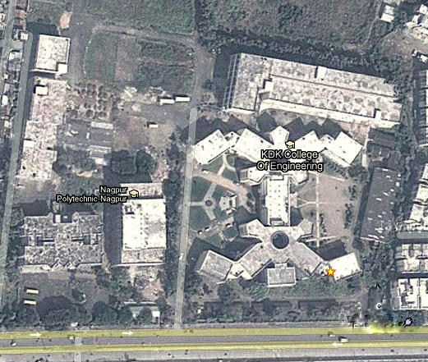

**Figure 1: KDK COLLAGE CAMPUS [Google Earth, Date: 9th MARCH, 2013}**

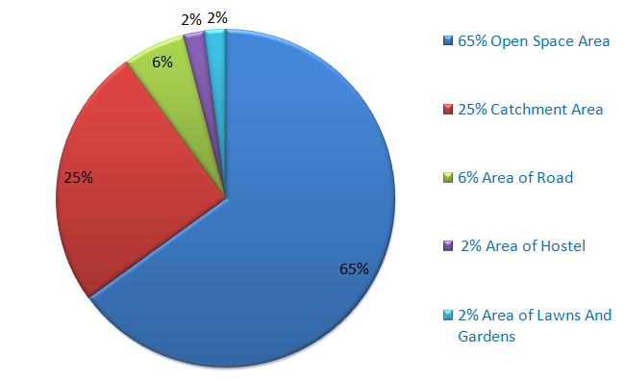

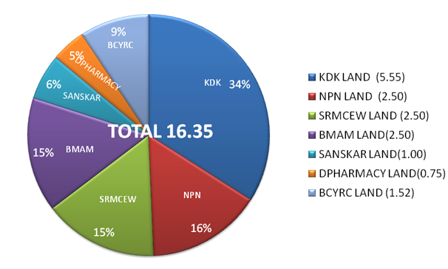

**Figure 2**

**Landuse pattern in the Campus**

**Figure 2**

**Area Of KDK Campus**

**TABLE NO.1: MONTHLY RAINFALL DATA OF NAGPUR STATION**

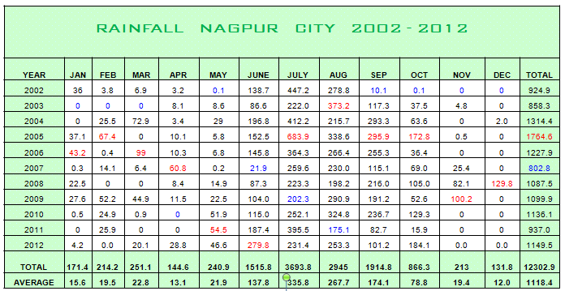

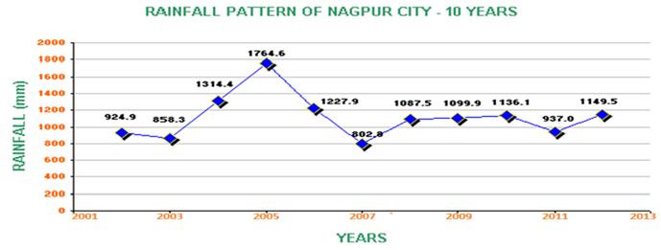

**Design Details of Components of Roof top Rainwater Harvesting System :-**

**Table No. -2**

|  |  |  |  |  |  |  |
| --- | --- | --- | --- | --- | --- | --- |
| **Sr No** | **Name of**  **Building** | **Building No.** | **Roof Area**  **( Sq. m )** | **Runoff (m3)**  **(rooftop area x1.2x0.85m)** | **Reservoir**  **Capacity July and August** | **Dimension of storage tank (m)** |
| 1 | KDK | A | 4198.303 | 4282.269 | 2153.624 | 23.0x23.0x4.2 |
|  |  | E | 2298.541 | 2344.512 | 1663.55 | 21.0x21.0x4.2 |
| 2 | NPN | E | 944.42 | 963.308 |
|  |  | G | 1442.226 | 2344.512 | 739.825 | 14.0x14.0x4.2 |
| 3 | BMAC | F | 1548.681 | 1579.654 | 794.434 | 14.0x14.0x4.2 |
| 4 | SCHOOL | I | 972.528 | 991.978 | 508.859 | 11.5x11.5x4.2 |
| 5 | D.PHARM | H | 466.773 | 476.108 | 239.44 | 8.0x8.0x4.2 |
| 6 | SRMCEW | J | 1285.576 | 1311.287 | 659.468 | 13.0x13.0x4.2 |
|  |  | K | 1369.699 | 1397.092 | 702.62 | 13.5x13.5x4.2 |
| 7 | HOSTEL | L | 477.77 | 487.325 | 245.08 | 8.0x8.0x4.2 |