**Cloud Computing**

**Ajit S. Deshpande,**

**Department of Computer Science & Engineering,   
Smt. Bhagwati Chaturvedi College of Engineering, RTM Nagpur University, Nagpur, India**

[ajitdeshpande26@gmail.com](mailto:ajitdeshpande26@gmail.com)

Mob.: 8149850962

Abstract—

**Cloud computing comes into focus only when you think about what we always need: - a way to increase capacity or add capabilities on the fly without investing in new infrastructure, training new personnel, or licensing new software. Cloud computing encompasses any subscription-based or pay-per- use service that, in real time over the Internet. This paper mainly focuses on introduction of cloud computing.**

**Cloud computing is Internet ("cloud") based development and use of computer technology ("computing"). It is a style of computing in which dynamically scalable and often virtualized resources are provided as a service over the Internet.**

**Users need not have knowledge of, expertise in, or control over the technology infrastructure "in the cloud" that supports them. The concept incorporates infrastructure as a service (IaaS), platform as a service (PaaS) and software as a service (SaaS) as well as Web 2.0 and other recent technology trends which have the common theme of reliance on the Internet for satisfying the computing needs of the users.**

**Examples of SaaS vendors include Salesforce.com and Google Apps which provide common business applications online that are accessed from a web browser, while the software and data are stored on the servers. The term cloud is used as a metaphor for the Internet, based on how the Internet is depicted in computer network diagrams, and is an abstraction for the complex infrastructure it conceals.**

*Keyword*– Cloud, Infrastructure as a service (IasS), Software as a Service (SaaS), Platform as a Service (PaaS).

1. **INTRODUCTION**

Imagine yourself in the world where the users of the computer of today’s internet world don’t have to run, install or store their application or data on their own computers, imagine the world where every piece of your information or data would reside on the Cloud (Internet).

As a metaphor for the Internet, "the cloud" is a familiar cliché, but when combined with "computing", the meaning gets bigger and fuzzier.

Some analysts and vendors define cloud computing narrowly as an updated version of utility computing as : basically virtual servers available over the Internet. Others go very broad, arguing anything you consume outside the firewall is "in the cloud", including conventional outsourcing.

Cloud computing is at an early stage, with a motley crew of providers large and small delivering a slew of cloud-based services, from full-blown applications to storage services to spam filtering. Yes, utility-style infrastructure providers are part of the mix, but so are SaaS (software as a service) providers such as Salesforce.com. Today, for the most part, IT must plug into cloud-based services individually, but cloud computing aggregators and integrators are already emerging.

Cloud Computing has become a scalable services consumption and delivery platform in the field of Services Computing. The technical foundations of Cloud Computing include Service-Oriented Architecture (SOA) and Virtualizations of hardware and software. The goal of Cloud Computing is to share resources among the cloud service consumers, cloud partners, and cloud vendors in the cloud value chain. The resource sharing at various levels results in various cloud offerings such as infrastructure cloud (e.g. hardware, IT infrastructure management), software cloud (e.g. SaaS focusing on middleware as a service, or traditional CRM as a service), application cloud (e.g. Application as a Service, UML modeling tools as a service, social network as a service), and business cloud (e.g. business process as a service).

**Cloud Computing :**

In simple words it is the application on the remote server and to access it you will need the internet access and browser.  
Examples : Gmail,Yahoo Mail – Email on remote server not on your local system.

It may be possible that you have virtual server (Server at remote place) or development environment at remote place. This is also included under term “**Cloud Computing**”.

1. **ARCHITECTURE**

Cloud architecture, the systems architecture of the software systems involved in the delivery of cloud computing, comprises hardware and software designed by a cloud architect who typically works for a cloud integrator. It typically involves multiple cloud components communicating with each other over application programming interfaces, usually web services.

This closely resembles the UNIX philosophy of having multiple programs doing one thing well and working together over universal interfaces.

Complexity is controlled and the resulting systems are more manageable than their monolithic counterparts.

Cloud architecture extends to the client, where web browsers and/or software applications access cloud applications. Cloud storage architecture is loosely coupled, where metadata operations are centralized enabling the data nodes to scale into the hundreds, each independently delivering data to applications or user

[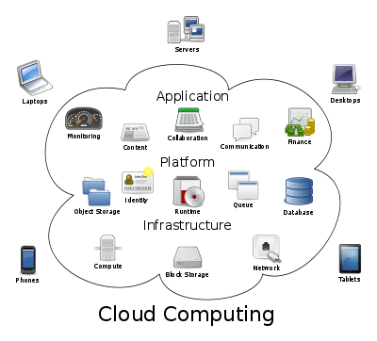](http://shivasoft.in/blog/wp-content/uploads/2012/01/What-is-Cloud-computing.png)

Fig. 1 Cloud computing sample architecture

1. *IaaS stands for Infrastructure as a service*

In this type of service, you will get the Virtual System which can be connected using internet. Where you can install any Software even in some service providers you can install the operating system. You can get the root level of access to the server. System admins are mainly benefited because of no hardware maintenance and overhead.

Example – Amazon ECS and Rackspace Cloud

1. *PaaS stands for Platform as a service*

In this type of service, you get development platform bundled with all the types of software preinstalled. You will then have to write and execute all your codes in remote server by some mechanism. Normally you will get the sandbox to program and test your applications. In this type of mechanism you cannot get the root level of access to the remote server. Servers will normally follow the multitenant architect where same server used by multiple organizations. It’s preferred by the developers who want to quickly start the development on particular technology without worrying about the hardware and underlying technology framework installations.

Example – Heroku and force.com both belongs to Salesforce

*C. SaaS stands for Software as a service*

This is the highest level of service in which everything is provided from hardware to software to already build applications.

Example – Salesforce.com used for the CRM already have bunch of applications build.

**III.TYPES OF CLOUD COMPUTING**

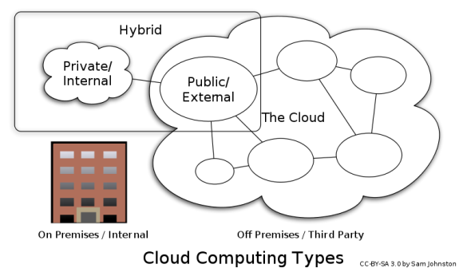

Fig. 2 Cloud computing types

1. *Public cloud*

Public cloud or external cloud describes cloud computing in the traditional mainstream sense, whereby resources are dynamically provisioned on a fine-grained, self-service basis over the Internet, via web applications/web services, from an off-site third-party provider who shares resources and bills on a fine-grained utility computing basis.

1. *Private cloud*

Private cloud and internal cloud are neologisms that some vendors have recently used to describe offerings that emulate cloud computing on private networks. These products claim to "deliver some benefits of cloud computing without the pitfalls", capitalizing on data security, corporate governance, and reliability concerns. While an analyst predicted in 2008 that private cloud networks would be the future of corporate IT, there is some uncertainty whether they are a reality even within the same firm. Analysts also claim that within five years a "huge percentage" of small and medium enterprises will get most of their computing resources from external cloud computing providers as they "will not have economies of scale to make it worth staying in the IT business" or be able to afford private clouds.

1. *Hybrid cloud*

A hybrid cloud environment consisting of multiple internal and/or external providers "will be typical for most enterprises".

**IV. COMPONENTS**

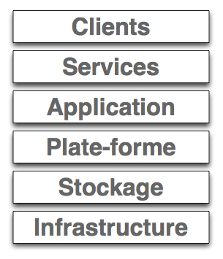

Fig.3 Cloud computing Components

1. *Application*

A cloud application leverages the Cloud in software architecture, often eliminating the need to install and run the application on the customer's own computer, thus alleviating the burden of software maintenance, ongoing operation, and support.

For example:

* Web application (Facebook)
* Software as a service (Google Apps, SAP and Salesforce)

1. *Client*

A cloud client consists of computer hardware and/or computer software which relies on cloud computing for application delivery, or which is specifically designed for delivery of cloud services and which, in either case, is essentially useless without it.

For example:

* Mobile (Android, iPhone, Windows Mobile)
* Thick client / Web browser (Google Chrome, Mozilla Firefox)

1. *Infrastructure*

Cloud infrastructure, such as Infrastructure as a service, is the delivery of computer infrastructure, typically a platform virtualization environment, as a service.

For example:

* Full virtualization (GoGrid, Skytap)
* Management (RightScale)
* Compute (Amazon Elastic Compute Cloud)
* latform (Force.com)

1. *Platform*

A cloud platform, such as Platform as a service, the delivery of a computing platform, and/or solution stack as a service, facilitates deployment of applications without the cost and complexity of buying and managing the underlying hardware and software layers.

For example:

* Web hosting (Mosso)
* Proprietary (Force.com)

1. *Service*

A cloud service includes "products, services and solutions that are delivered and consumed in real-time over the Internet".

For example:

Web services may be accessed by other cloud computing components, software, e.g., Software plus service, or end users directly. Specific examples include:

* Identity (OAuth, OpenID)
* Integration (Amazon Simple Queue Service)
* Payments (Amazon Flexible Payments Service, Google Checkout, PayPal)
* Mapping (Google Maps, Yahoo! Maps)
* Search (Alexa, Google Custom Search, Yahoo! BOSS)
* Others (Amazon Mechanical Turk) 8.6 Storage

Cloud storage involves the delivery of data storage as a service, including database-like services, oftenbilled on a utility computing basis, e.g., per gigabyte per month.

* Database (Amazon SimpleDB, Google App

Engine's BigTable datastore)

* Network attached storage (MobileMe iDisk,

Nirvanix CloudNAS)

* Synchronization (Live Mesh Live Desktop

component, MobileMe push functions)

* Web service (Amazon Simple Storage Service,

Nirvanix SDN)

1. **KEY CHARACTERISTICS**

Cost is greatly reduced and capital expenditure is converted to operational expenditure. This lowers barriers to entry, as infrastructure is typically provided by a third-party and does not need to be purchased for one-time or infrequent intensive computing tasks. Pricing on a utility computing basis is fine-grained with usage-based options and minimal or no IT skills are required for implementation.

• Device and location independence enable users to access systems using a web browser regardless of their location or what device they are using, e.g., PC, mobile. As infrastructure is off-site (typically provided by a third-party) and accessed via the Internet the users can connect from anywhere.

• Multi-tenancy enables sharing of resources and costs among a large pool of users, allowing for: o Centralization of infrastructure in areas with lower costs (such as real estate, electricity, etc.) o Peak-load capacity increases (users need not engineer for highest possible load-levels) o Utilization and efficiency improvements for systems that are often only 10-20% utilized.

• Reliability improves through the use of multiple redundant sites, which makes it suitable for business continuity and disaster recovery. Nonetheless, most major cloud computing services have suffered outages and IT and business managers are able to do little when they are affected.

. • Scalability via dynamic ("on-demand") provisioning of resources on a fine- grained, self-service basis near real-time, without users having to engineer for peak loads. Performance is monitored and consistent and loosely-coupled architectures are constructed using web services as the system interface.

• Security typically improves due to centralization of data, increased security- focused resources, etc., but raises concerns about loss of control over certain sensitive data. Security is often as good as or better than traditional systems, in part because providers are able to devote resources to solving security issues that many customers cannot afford. Providers typically log accesses, but accessing the audit logs themselves can be difficult or impossible.

• Sustainability comes about through improved resource utilization, more efficient systems, and carbon neutrality. Nonetheless, computers and associated infrastructure are major consumers of energy.

1. **CONCLUSIONS**

Cloud Computing is a vast topic and the above report does not give a high level introduction to it. It is certainly not possible in the limited space of a report to do justice to these technologies. What is in store for this technology in the near future? Well, Cloud Computing is leading the industry’s endeavor to bank on this revolutionary technology. Cloud Computing Brings Possibilities……..

* Increases business responsiveness.
* Reduces acquisition complexity via service oriented approach.
* Uses IT resources efficiently via sharing and higher system utilization.
* Reduces energy consumption.
* Handles new and emerging workloads.
* Scales to extreme workloads quickly and easily.
* Simplifies IT management.

**ACKNOWLEDGEMENT**

I would like to thank my friends for their support. I thank all teachers from Smt. Bhagwati Chaturvedi College of Engineering and Mr. Jitendra Zaa from Cognizant Technology for their valuable guidance in developing this paper.

**REFERENCES**

[1] [www.infoworld.com/article/08/04/07/15FE-cloud-](http://www.infoworld.com/article/08/04/07/15FE-cloud-)

computing- reality_1.html

[2] [www.wiki](http://www.wiki).cloudcommunity.org/wiki/

CloudComputing: Bill_of_Rights

[3] www.davidchappell.com/ CloudPlatforms—

Chappell. PDF

[4] [www.thinkgos.com/cloud/index.html](http://www.thinkgos.com/cloud/index.html)

[5] http://www.tcs.com/resources/white_papers/

[Pages/TCS_Cloud](http://www.tcs.com/resources/white_papers/%20Pages/TCS_Cloud)_Computing.aspx

[6]

[http://www.tcs.com/SiteCollectionDocuments/](http://www.tcs.com/SiteCollectionDocuments/         White)

[White](http://www.tcs.com/SiteCollectionDocuments/         White) 20Papers/Innovation_Whitepaper_Cloud_

Computing _09_2009.pdf

[7] <http://shivasoft.in/blog/salesforce/what-is-iaas-paas->

and-saas-in-cloud-computing/