**GRAPHICAL PASSWORD AUTHENTICATION**

**USING PERSUASIVE CUED CLICK POINTS**

*Department of Computer Science*

Bhausaheb mulik college of engineering and technlogy

PRESENTED BY:

* DEEPALI KADAV
* ANJALI WANJARI
* SWATI KOLHE

**Abstract**

An important usability goal for authentication systems is to support users in selecting better passwords. Users often create memorable passwords that are easy for attackers to guess, but strong system-assigned passwords are difficult for users to remember. So researchers of modern days have gone for alternative methods wherein graphical pictures are used as passwords. Graphical passwords essentially use images or representation of images as passwords. Human brain is good in remembering picture than textual character. There are various graphical password schemes or graphical password software in the market. However, very little research has been done to analyze graphical passwords that are still immature. There for, this project work merges persuasive cued click points and password guessing resistant protocol. The major goal of this work is to reduce the guessing attacks as well as encouraging users to select more random, and difficult passwords to guess. Well known security threats like brute force attacks and dictionary attacks can be successfully abolished using this method.

**Index Terms: -** Authentication, graphical passwords, guessing attacks, computer security.

**1. Introduction**

There has been a great deal of hype for graphical passwords since two decade due to the fact that primitive’s methods suffered from an innumerable number of attacks which could be imposed easily. Here we will progress down the taxonomy of authentication methods.

To start with we focus on the most common computer authentication method that makes use of text passwords. Despite the vulnerabilities, it’s the user natural tendency of the users that they will always prefer to go for short passwords for ease of remembrance [10] and also lack of awareness about how attackers tend to attacks. Unfortunately, these passwords are broken mercilessly by intruders by several simple means such as masquerading, Eaves dropping and other rude means say dictionary attacks, shoulder surfing attacks, social engineering attacks [10][1]..

To mitigate the problems with traditional methods, advanced methods have been proposed using graphical as passwords. The idea of graphical passwords first described by Greg Blonder (1996). For Blonder, graphical passwords have a predetermined image that the sequence and the tap regions selected are interpreted as the graphical password. Since then, many other graphical password schemes have been proposed. The desirable quality associated with graphical passwords is that psychologically humans can remember graphical far better than text and hence is the best alternative being proposed. There is a rapid and growing interest in graphical passwords for they are more or infinite in numbers thus providing more resistance.

The major goal of this work is to reduce the guessing attacks as well as encouraging users to select more random, and difficult passwords to guess.

**2. Taxonomy of Authentication**

The following Figure 1: is the depiction of current authentication methods

Biometric based authentication systems techniques are proved to be expensive, slow and unreliable and hence not preferred by many. Token based authentication system is high security and usability and Accessibility compare then others. But this system employ knowledge based techniques to enhance security. But the current knowledge based techniques are still immature. For instance, ATM cards always go hand in hand with PIN number.

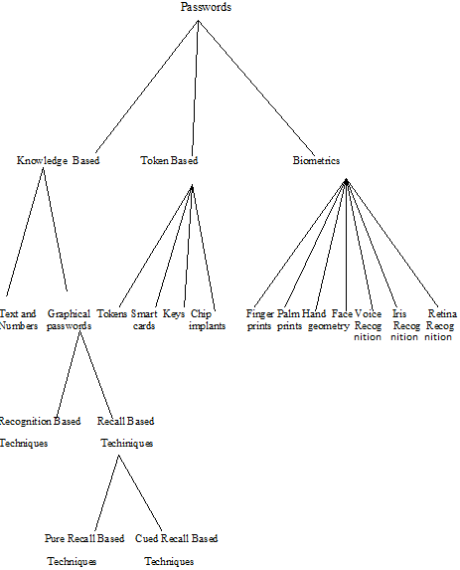

**Figure 1: Taxonomy of Password Authentication Techniques**

So the knowledge based techniques are the most wanted techniques to improve real high security. Recognition based & recalls based

are the two names by which graphical techniques could be classified.

**3. Background on graphical Password Systems**

Graphical passwords were first described by Blonder. Since then, many other graphical password schemes have been proposed. Graphical password systems can be classified as either recognition-based (image based scheme, cued recall-based (image based scheme) or pure recall-based (grid based scheme.

**3.1 Recognition Based Techniques:** **3.1.1 Dhamija and Perrig**

Dhamija and Perrig [4] proposed a graphical authentication scheme based on the Hash Visualization technique. In their system Figure 2: the user is asked to select a certain number of images from a set of random pictures generated by a program later the user will be required to identify the pre selected images in order to be authenticated. A weakness of this system is that the server needs to store the seeds of the portfolio images of each user in plain text. Also, the process of selecting a set of pictures from the picture database can be tedious and time consuming for the user.

Akula and Devisetty’s algorithm [5] is similar to the technique proposed by Dhamija and Perrig .the images will be converted into hashing code using SHA-1 techniques to give more secure and less memory. In this Technique produces a 20 byte output. Both the above algorithms are prone to shoulder surfing attacks.

**3.2.2 Hong’s Methods**

Hong, et al. [7] proposed another shoulder-surfing resistant algorithm. In this approach to allow the user to assign their own codes to pass-object variants. Figure 3: shows the log-in screen of this graphical password scheme. However, this method still forces the user to memorize many text strings and



therefore suffer from the many drawbacks of text-based passwords.

**3.3 Recall based techniques:**

In this section we discuss recent there types of click based graphical password techniques:

1. Pass Points (PP)

2. Cued Click Points (CCP)

3. Persuasive Cued Click- Points (PCCP)

**3.3.1 Pass point (PP)**

Based on Blonder’s original idea [7], Pass Points (PP) [7] is a click-based graphical password system where a password consists of an ordered sequence of five click-points on a pixel-based image as shown inFigure.4 To log in, a user must click within some system-defined tolerance region for each click-point. The image acts as a cue to help users remember their password click-points.

**Figur: 4 Pass Points**

**3.3.2 Cued Click Points (CCP)**

CCP [1] was developed as an alternative click based graphical password scheme where users select one point per image for five images Figure.5: The interface displays only one image at a time; the image is replaced by the next image as soon as a user selects a click point. The system determines the next image to display based on the user’s click-point on the current image. The next image displayed to users is based on a deterministic function of the point which is currently selected. It now presents a one to-one cued recall scenario where each image triggers the user’s memory of the one click-point on that image. Secondly, if a user enters an incorrect click-point during login, the next image displayed will also be incorrect. Legitimate users who see an unrecognized image know that they made an error with their previous click-point. Conversely, this implicit feedback is not helpful to an attacker who does not know the expected sequence of images.



**Figure 5:** -**Cued Click point**.

**3.3.3 Persuasive Cued Click- Points (PCCP)**

To address the issue of hotspots, PCCP was proposed [7]. As with CCP, a password consists of five click points, one on each of five images. During password creation, most of the image is dimmed except for a small view port area that is randomly positioned on the image as shown in Figure. 6. Users must select a click-point within the view port. If they are unable or unwilling to select a point in the current view port, they may press the Shuffle button to randomly reposition the view port. The view port guides users to select more random passwords that are less likely to include hotspots. A user who is determined to reach a certain click-point may still shuffle until the view port moves to the specific location, but this is a time consuming and more

tedious process.

**4. Discussion**:

**“Will Graphical passwords circumvent Text based passwords?”**

Here we briefly exam some of the possible techniques for breaking graphical passwords and try to do a comparison with text-based passwords.

• **Dictionary attacks**

Since recognition based graphical passwords involve mouse input instead of keyboard input, it will be impractical to carry out dictionary attacks against this type of graphical passwords. For some recall based graphical passwords [11], it is possible to use a dictionary attack but an automated dictionary attack will be much more complex than a text based dictionary attack. More research is needed in this area Overall; we believe graphical passwords are less vulnerable to dictionary attacks than text-based passwords.

• **Guessing**

Unfortunately, it seems that graphical passwords are often predictable, a serious problem typically associated with text-based passwords. More research efforts are needed to understand the nature of graphical passwords created by real world users.

• **Shoulder Surfing**

Like text based passwords, most of the graphical passwords are vulnerable to shoulder surfing. At this point, only a few recognition-based techniques are designed to

resist shoulder-surfing.

• **Spy ware**

Except for a few exceptions, key logging or key listening spy ware cannot be used to break graphical passwords. It is not clear whether “mouse tracking” spy ware will be an effective tool against graphical passwords. However, mouse motion alone is not enough to break graphical passwords. Such information has to be correlated with application information, such as window position and size, as well as timing information.

• **Social engineering**

Comparing to text based password, it is less convenient for a user to give away graphical passwords to another person. For example, it is very difficult to give away graphical passwords over the phone. Setting up a phasing web site to obtain Graphical passwords would be more time consuming.

**5. Proposed System**

Now-a-days, all business, government, and academic organizations are investing a lot of money, time and computer memory for the security of information. Online password guessing attacks have been known since the early days of the Internet, there is little academic literature on prevention techniques. This project deals with guessing attacks like brute force attacks and dictionary attacks.

This project proposes a click-based graphical password system. During password creation, there is a small view port area that is randomly positioned on the image. Users must select a click-point within the view port. If they are unable or unwilling to select a point in the current view port, they may press the Shuffle button to randomly reposition the view port. The view port guides users to select more random passwords that are less likely to include hotspots. Therefore this works encouraging users to select more random, and difficult passwords to guess.

Brute force and dictionary attacks on password-only remote login services are now widespread and ever increasing. Enabling convenient login for legitimate users while preventing such attacks is a difficult problem. Automated Turing Tests (ATTs) continue to be an effective, easy-to-deploy approach to identify automated malicious login attempts with reasonable cost of inconvenience to users.

This project proposes a new Password Guessing Resistant Protocol (PGRP), derived upon revisiting prior proposals designed to restrict such attacks. While PGRP limits the total number of login attempts from unknown remote hosts, legitimate users in most cases (e.g., when attempts are made from known, frequently-used machines) can make several failed login attempts before being challenged with an ATT.

This proposed system also provides protection against key logger spy ware. Since, computer mouse is used rather than the keyboard to enter our graphical password; this protects the password from key loggers.

**5.1 Proposed System Architecture**

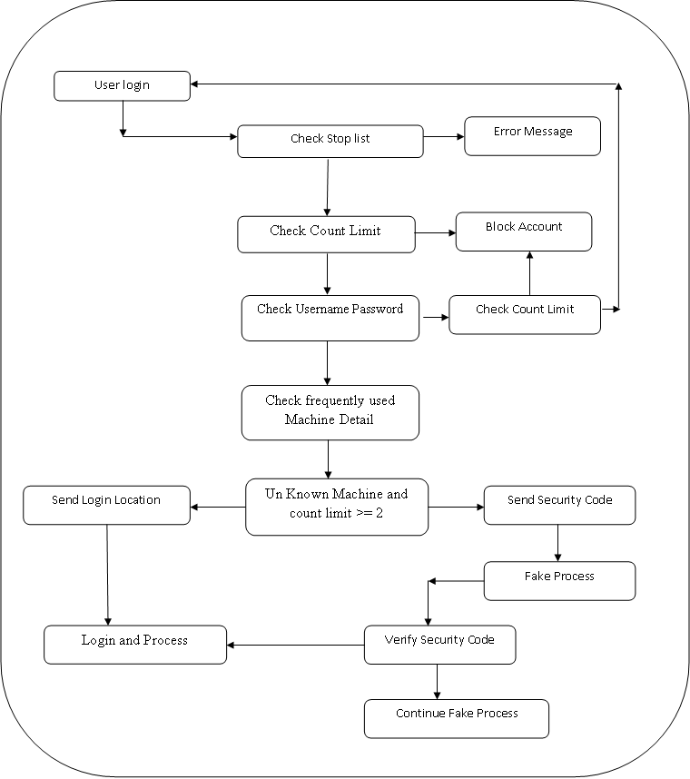

**Figure: 7 System Architecture**

**6. Conclusion and future work**

A major advantage of Persuasive cued click point scheme is its large password space over alphanumeric passwords. There is a growing interest for Graphical passwords since they are better than Text based passwords, although the main argument for graphical passwords are

that people are better at memorizing graphical passwords than text-based passwords. Online password guessing attacks on password-only systems have been observed for decade’s .Present-day attackers targeting such systems are empowered by having control of thousand to million node botnets. In previous ATT-based login protocols, there exists a security-usability trade-off with respect to the number of free failed login attempts (i.e., with no ATTs) versus user login convenience (e.g., less ATTs and other requirements). In contrast, PGRP is more restrictive against brute force and dictionary attacks while safely allowing a large number of free failed attempts for legitimate users. PGRP is apparently more effective in preventing password guessing attacks (without answering ATT challenges), it also offers more convenient login experience, e.g., fewer ATT challenges for legitimate users. PGRP appears suitable for organizations of both small and large number of user accounts.