[VMware Technology](http://www.vmware.com/partners/alliances/programs/tap_access.html)

Archana Tiwaskar

Department of MCA

G.H Raisoni College of Engineering

(An Autonomous Institute under UGC Act 1956)

*Hingna Road, Digdoh Hills, Nagpur-16*

tiwaskar_archu.ghrcemca@raisoni.net

***Abstract* —** VMware's Virtual Platform is a software system that allows multiple operating systems environments to be run concurrently on a standard x86 PC. By adapting some new twists to 1960s virtual machine monitors, the Virtual Platform provides virtualization of the non-virtualizable Intel x86 processor. It also handles the large diversity of hardware available for the PC platform. The resulting system features both high performance and high portability and also ease of installation.

In this presentation I will describe the main challenges of implementing a virtual machine monitor for the commodity x86 PC as well as some of the solutions to these problems as implemented in VMware's Virtual Platform.

I. INTRODUCTION

**VMware, Inc.** is an American software company that provides cloud and virtualization software and services. It was founded in 1998.

Virtualization is the single most effective way to reduce IT expenses while boosting efficiency and agility—not just for large enterprises, but for small and midsize businesses too. VMware virtualization lets you:

* Run multiple operating systems and applications on a single computer
* Consolidate hardware to get vastly higher productivity from fewer servers
* Save 50% or more on overall IT costs
* Speed and simplify IT management, maintenance, and the deployment of new applications

Virtual machine software from VMware, Inc., Palo Alto, CA (www.vmware.com) that allows multiple copies of the same operating system or several different operating systems to run in the same x86-based machine. For years, VMware has been the leader in virtualization software

II. What is Virtualization?

Virtualization addresses IT’s most pressing challenge: the infrastructure sprawl that compels IT departments to channel 70% of their budget into maintenance, leaving scant resources for business-building innovation.

The difficulty stems from the architecture of today’s X86 computers: they’re designed to run just one operating system and application at a time. As a result, even small datacenters have to deploy many servers, each operating at just 5% to 15% of capacity—highly inefficient by any standard.

Virtualization software solves the problem by enabling several operating systems and applications to run on one physical server or “host.” Each self-contained “virtual machine” is isolated from the others, and uses as much of the host’s computing resources as it requires.

## III. How Virtualization Works

The heart of virtualization is the “virtual machine” (VM), a tightly isolated software container with an operating system and application inside. Because each VM is completely separate and independent, many of them can run simultaneously on a single computer. A thin layer of software called a hypervisor decouples the VMs from the host, and dynamically allocates computing resources to each VM as needed.

This architecture redefines your computing equation, to deliver:

* **Many applications on each server.** As each VM encapsulates an entire machine, many applications and operating systems can be run on one host at the same time.
* **Maximum server utilization, minimum server count.** Every physical machine is used to its full capacity, allowing you to significantly reduce costs by deploying fewer servers overall.
* **Faster, easier application and resources provisioning.** As self-contained software files, VMs can be manipulated with copy-and-paste ease. This brings unprecedented simplicity, speed, and flexibility to IT provisioning and management. VMs can even be transferred from one physical server to another while running, via a process known as live migration. You can also virtualize business-critical apps to improve performance, reliability, scalability, and reduce costs.

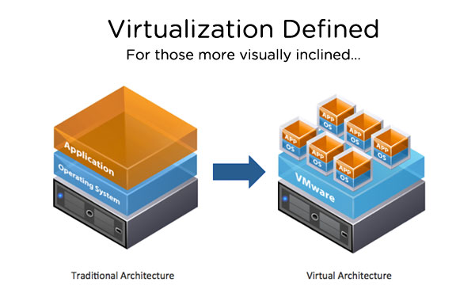

### IV. Levels of Virtualization

**Server Consolidation**   
Virtualizing one or two servers is just the beginning. The next step is to aggregate a server cluster into a single consolidated resource. For example, instead of 20 servers running at 15% of capacity each, you can reduce your hardware count—and associated costs—to 4 servers, each performing at 80%

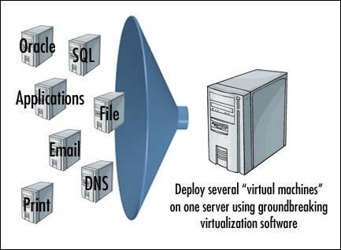

**Desktop Virtualization**   
VMware enables you to deliver secure virtual desktops as a managed service for remote and branch office employees. Our virtual desktop solutions increase business flexibility, simplify management, and reduce your costs.

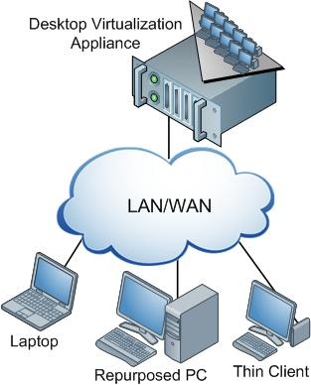

**Storage Consolidation**   
VMware offers an automated, easy-to-deploy solution that virtualizes storage—combining your existing server disks into a shared pool, without the cost and complexity of purchasing a SAN system. 

**Software-Defined Datacenter**   
Ultimately, you can attain the full efficiency and agility of cloud computing by virtualizing, pooling, and automating all datacenter resources—servers, storage, networking, security and availability—and tying everything together with policy-based provisioning and automated operations management. The result is a software-defined datacenter where:

* Capacity expands and contracts as needed
* Applications can be provisioned on-demand
* Every application is assured of the right levels of performance, compliance, and security
* IT can shift resources and budget away from infrastructure management and maintenance, toward creating innovations that give your company an edge

### V. VMware Advantages

* **The most mature, proven, and comprehensive platform.** VMware vSphere is fifth- generation virtualization—many years ahead of any alternative. It delivers higher reliability, more advanced capabilities, and greater performance than competing solutions. VMware’s virtualization pre-eminence is recognized universally by analysts and overwhelmingly by the marketplace, with more than 400,000
* **High application availability.** Purchased separately, high-availability infrastructure remains complex and expensive. But VMware integrates robust availability and fault tolerance right into our platform to protect all your virtualized applications. Should a node or server ever fail, all its VMs are automatically restarted on another machine, with no downtime or data loss.
* **Wizard-based guides for ease of installation.** VMware’s wizard-based guides take the complexity out of setup and configuration. You can be up and running in one-third the deployment time of other solutions.
* **Simple, streamlined management.** VMware lets you administer both your virtual and physical environments from a “single pane of glass” console right on your web browser. Time-saving features such as auto-deploy, dynamic patching, and live VM migration reduce routine tasks from hours to minutes. Management becomes much faster and easier, boosting productivity without adding to your headcount.
* **Higher reliability and performance.** Our platform blends CPU and memory innovations with a compact, purpose-built hypervisor that eliminates the frequent patching, maintenance, and I/O bottlenecks of other platforms. The net result is best-in-class reliability and consistently higher performance: for heavy workloads, 2-to-1 and 3-to-1 performance advantages over our nearest competitors.
* **Superior security.** VMware’s hypervisor is far thinner than any rival, consuming just 144 MB compared with others’ 3-to-10 GB disk profile. Our small hypervisor footprint presents a tiny, well-guarded attack surface to external threats, for airtight security and much lower intrusion risk.
* **Greater savings.** VMware trumps other virtualization solutions by providing 50 to 70 percent higher VM density per host—elevating per-server utilization rates from 15% to as high as 80%. You can run many more applications on much less hardware than with other platforms, for significantly greater savings in capital and operating costs.
* **Affordability.** VMware is highest in capabilities, but not cost. Starting at $165 per server, our small business packages consolidate more of your applications on fewer servers, with greater performance—delivering the industry’s lowest total cost of ownership (TCO).

VI. Conclusion

Virtualization is an evolving and mutating beast and while VMware may well have started out with the focus on server consolidation with ESX, you might remember their first commercial product back in 1998 was a desktop application called "VMware Workstation." So VMware has been there at the desktop from the very beginning. It is, however, fair to say the innovation of VDI was one that came originally from VMware's customer basis and some would say that the company was a bit slow to react to this, leaving their offering to be an initiative at first before acquiring what became VDM and later renamed as Viewer.

VMware virtualization solutions offer you many advantages. They are built on VMware vSphere, the world's most proven, robust, and reliable virtualization platform—the choice of more than 400,000 customers, including 100% of the Fortune 100. Our solutions cover the spectrum from desktop to datacenter, preserve your existing IT investments, and integrate with the management tools you already have. On top of all this, you'll enjoy the industry's lowest total cost of ownership.

As virtualization is now a critical component to an overall IT strategy, it is important to choose the right vendor. VMware is the leading business virtualization infrastructure provider, offering the most trusted and reliable platform for building private clouds and federating to public clouds.

VII. References

[1] VMware View

[2] Virtualization Overview

[3] Mware View Technical Resources

[4] Based on VMware Technology's Campus Network Cloud Platform Technology Research

[5] PTC® Windchill® 10 on VMware® vSphere 5.0 using HP Hardware

[6] http://www.vmware.com/files/pdf/view/VMware-Branch-Office-Desktop-How-to-Guide.pdf

[7] http://www.vmware.com/files/pdf/techpaper/vCloud_Director_Resource_Allocation-USLET.pdf

[8] http://www.vmware.com/virtualization/advantages/

[9] Virtualization technology and Process Control System upgrades

[10] Software Performance Testing Scheme Using Virtualization Technology