REVIEW PAPER ON IMAGE ANNOTATION

ASHWINI LOKHANDE, PRAGATI SATPUTE, PRACHI NITNAWARE

*DEPARTMENT OF INFORMATION TECHNOLOGY*

*YASHWANTRAO CHAVAN COLLEGE OF ENGINEERING, NAGPUR*

[**ashwinilokhande412@gmail.com**](mailto:ashwinilokhande412@gmail.com)

1. Abstract

Annotation is important for personal photo collection because acquired metadata plays a crucial role in image management and retrieval. There are three types of image annotation methods they are manual annotation, semi annotation and automatic annotation. This paper describes an approach creating meaningful image cluster for efficient bulk annotation, for identifying people image among many images or image album.

1. Introduction

Annotation is defined as process which involves labeling the semantic content of images with the set of keywords or semantic information. As the volume of images one person needs to handle increases it is most difficult to manage them on computers, there is therefore a demand for image management system for efficient image organization, search and browsing.

As a large number of family photos and other images of personal use have been accumulated, management tasks, including search,browse, and classification of these images are severe problems encountered by the users. Home photo images, which mainly come from scanners or digital cameras, are considered as having no initial annotation at all. Efficient image search requires the help of image annotation. Annotated images can be found using keyword-based search, whilst un-annotated image cannot. Since

content-based image retrieval is still at a low performance level, keyword-based image search is more preferable and image annotation is therefore unavoidable

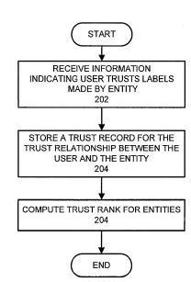

Figure .flowchart of image annotation

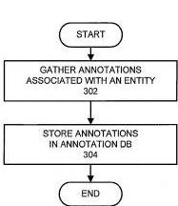

Figure flowchart of image annotation

1. TYPES OF ANNOTATION

The goal of photo annotation is to create semantically meaningful labels and associate them with the photo. Captions

(freestyle text like “Mom & Dad at their 25th anniversary”) can be used for full-text searches and enable storytelling and dialogue-based sharing, but do not allow meaning to be inferred. Categorization (assigning a word from a finite vocabulary to a picture, like “sunset”, or “Paris”), is better in the sense that searches are now possible on a finite set of words, but it still lacks the ability to bestow meaning (is Paris a place or the name of a person?). Without assigning independent semantic meaning to the labels, there is no way to ask for all people appearing in the photo collection, for example. Annotation can also be in a non-text form, such as a sketch that abstracts the photo’s contents for “looks like” searches where the input is drawn instead of typed . For audio annotation, a melody line could be used, in order to later search an audio collection by humming into a microphone. We focus on text, the predominant and most relevant annotation for interacting with photographs.

Annotation techniques can be grouped into three categories: Manual, Semi-Automated, and Automated. Each has advantages and disadvantages, and we will discuss them in order of increasing automation.

**1. Manual Annotation**

Most commercial software packages (Adobe Photoshop Album, ACDSee, Picasa, etc.) and web-based photo services (such as Yahoo, Snapfish and Ofoto) use manual annotation. They include the ability to set up a hierarchical list of categories (where depth of the hierarchy depends on the package), and add photos to those categories. They are an improvement over a regular file system in that a photo can exist in more than one place in the hierarchy. They also allow the addition of freetext captions, which while useful for online albums, can be difficult to search or to use for semantic extraction.

Manual annotation can provide the most accurate information, but it is also the most time intensive. The “group annotation” discussed below may mitigate the time requirement, but users still need to make one or more decisions for each picture. We describe two applications that support this kind of manual annotation, although there are many others as well. Adobe Photoshop Album is organized around a “Photo Well” into which photos are dropped when first imported. Users can define “Tags”, which are set up as a 2-level hierarchy, where either the tag name (“Al”, “Esther”) or the category (“Family”) can be dragged and dropped onto a picture in order to classify it.

1. **Semi-Automated Annotation**

Semi-Automated Annotation starts with a manual process, presumably one that is easy and natural like voice annotation. It then goes through the manual annotations and extracts higher-quality, searchable metadata, which it then re-associates with the picture.

For example, Smart Album assumes speech annotation of the photos has been done, and then proceeds to extract semantic information from the WAV file. It is limited by the accuracy of speech recognition, and will need to have some form of manual error correction, as the annotation algorithm uses heuristics to guess at event boundaries but is not guaranteed to succeed all the time.

Alternatively, the human-created caption can be parsed using a “Common Sense Knowledge Base” such as CYC or OMCS ,leveraging the implied context of a photo (i.e. recognizing a bride could let the engine infer that the photo is of a wedding) to create a semantically meaningful annotation for future use.

The MiAlbum system uses a feedback mechanism to iteratively improve annotations as part of the search process. The first search returns random results, which users grade for relevance, thus improving future searches. With each search and with extended use of the system,

the quality of the annotations improves in an iterative fashion.

Using the Mobile Media Metadata framework [34], camera phone users can annotate their photos while still in the physical environment of the photo, rather than waiting until they return to a desktop PC. Annotation is first done automatically using date and location information, and then users are given a chance to interact with the system’s automated annotations, selecting the correct choice from a drop down list of pre-populated answers in an XHTML browser on the phone.

1. **Automated Annotation**

Automated Annotation has the clear advantage that it happens with no user intervention, making it an attractive candidate. However, even in an ideal world, with perfect face recognition and shape detection, a computer will not be able to apply event labels, such as “Bill’s 21st birthday party”, or other heavily context-dependent annotations. Still, it behooves the designer to automate when possible, in order to minimize the amount of manual attention that is required.

The most basic type of automated annotation is done inside the digital camera by applying the time stamp, which newer cameras prompt users for if it is not set. In fact, date and time have been shown to be the most important piece of metadata to record, as 92% of the subjects in a recent study had a specific time association with certain photographs. An extension of this idea is to include a GPS receiver in the camera, and include a location stamp along with the time

stamp. Microsoft distributes the WWMX Track Download application that will use GPS data saved on a regular GPS Device (and associated with a particular date/time) to stamp photos after they have already been downloaded to a PC.

GPS receivers are attractive, but their inability to do location sensing in buildings requires some workaround, such as recording the last known location. Another technology senses location based on the strengths of packets on an IEEE 802.11b wireless Ethernet network. And finally there are proposals for getting geographic location by synchronization with cell phones that would be carried by the photographer. When the photographer uploads photos to a desktop or laptop that is Internet connected, a link to the cell phone company database would produce time-synchronized location data.

The methods mentioned above use technologies with low susceptibility to errors, and thus with a high accuracy rate. Other

approaches to automated annotation use methods that are more error-prone, but potentially yield more interesting data. Some applications choose to use surrounding text as a way to generate extra metadata for photos . Google, for example, uses this technique to automatically index vast numbers of images on the web in an automated fashion.

As with machine transcription, the user can stop at that point, and decide to live with whatever the success rate might be, but it is usually worthwhile to take a second pass and fix errors or add additional information. In the best case, automated annotation saves most of the work and requires only touch-ups, but in the worst case it can require more time to “edit” the result than it might have been to just do manual annotation from the beginning

There are many software packages available in market as follows:

1. Adobe Photoshop album is organized around “photo well” into which photos are dropped when first imported .Users can define “Tags”, which are set up as a 2-level hierarchy, where either the tag name(“AI”,”Esther”) or the

category(“family”) can be dragged and dropped onto a picture in order to classify it.

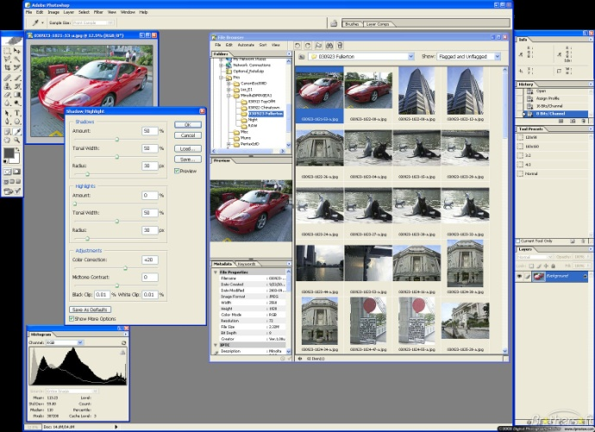

Figure Adobe Photoshop

1. Photonizer is an efficient application for creating your personal digital photo albums. It is the ideal application for attaching information to your digital photos like: persons appearing on photos, events that took place, the year photos were taken and extensive descriptions.

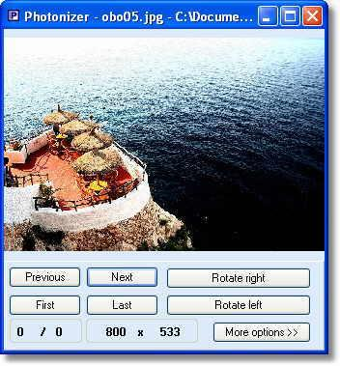

Figure .Photonizer

1. Brisk Album Creator 2.1 is a program that will allow you to organize your digital photos. It´s able to generate HTML albums

from his/her digital photos. Once user have created an album, he/she will access a menu of options by right-clicking on any image. Then, you can choose to play a slideshow that will show you every image in the album in full screen, export the photos to an HTML album, view the image information, or rotate the selected images.

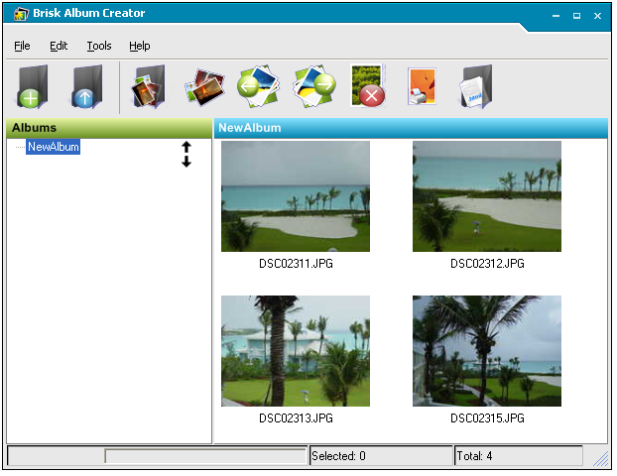

Figure 5.Brisk Album Creator

1. PhotoZig Albums: It offers a variety of features which are helpful to -create photo albums, for image transfer from other digital devices, view and print photos.

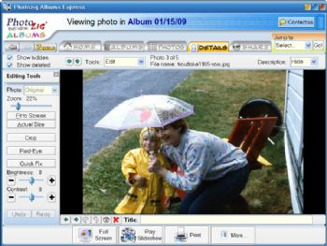

Figure .Photozig album

1. FotoOffice: Professional digital photo management. Archiving, editing and viewing photos. FotoOffice makes working with big photo collections easy. Created to help managing photos in business and for home use.

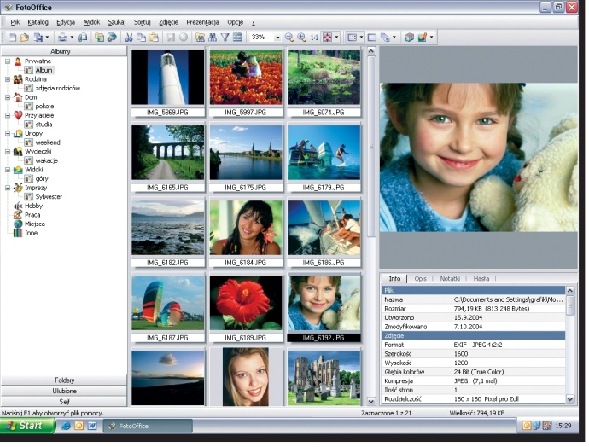

Figure 7.FotoOffice

Application:

* Digital Album is use for faster retrieval of images from collection of Image albums.
* It performs various functions such as add image, remove image, search image.
* It is a fun and effective since the task is being done voluntarily and the result is a valuable product.
* On the community level annotation increases the value of group photos, whether they are historical, biographical or projective. Hence it has wide range of application.

CONCLUSION:

Hence we have reviewed the types on image annotation. Now a day’s much software have been developed which uses annotation methods and it’s a growing field .As its applications are wide and regularly used by user for retrieval of images by following suitable type of annotation. As well as it is latest advancement in the field of multimedia retrieval.s

REFERENCES:

[1] Liu et al. (2000) A Semi-Automatic Image Annotation Strategy and Its Performance Evaluation. *Microsoft*

*Technical Report*.

[2] Lu Y et al. (2000) A Unified Framework for Semantics and Feature Based Relevance Feedback in Image Retrieval Systems. *To appear in Proc. ACM Multimedia2000*.

[3] Platt J (2000) AutoAlbum: Clustering Digital Photographs Using Probabilistic Model Merging. In: *Proc. IEEE*

[6] Epinions.com, http://www.epinions.com, Accessed on January 16, 2005.

[7] Flank, Sharon (2002). Multimedia Technology in Context. *IEEE Multimedia* 9(3): 12-17.

[8] Fotonotes, http://www.fotonotes.net, Accessed on January 16, 2005.

[9] Frohlich, David, Kuchinsky, Allan, Pering, Celine, Don, Abbe, and Ariss, Steven (2002). Requirements for Photoware.

*Computer-Supported Cooperative Group ’2002*, 166-175. ACM Press, New York.

[10] The GEDCOM Standard Release 5.5, http://www.gendex.com/gedcom55/55gctoc.htm, Accessed on January 16, 2005.

[11] Google Images FAQ, http://www.google.com/help/faq_images.html, Accessed on January 16, 2005.