**ABSTRACT ON CLOUD COMPUTING**

**INTRODUCTION:**

1. Slowly but steadily Cloud computing is finally making its presence felt in india
2. An interesting career option for IT aspirants, cloud computing is currently the talk of the town.

**DEFINITION:**

1. Cloud computing is a better way to run your business, Instead of running your apps yourself, they run on a shared data center.
2. The actual term "cloud" borrows from telephony in that telecommunications companies, who until the 1990s primarily offered dedicated point-to-point data circuits, began offering “VIRTUAL PRIVATE NETWORK (VPN)” services with comparable quality of service but at a much lower cost.
3. The cloud symbol was used to denote the demarcation point between that whichwas the responsibility of the provider from that of the user.
4. Cloud computing extends thisboundary to cover servers as well as the network infrastructure.

**DIAGRAM OF CLOUD COMPUTING:**

**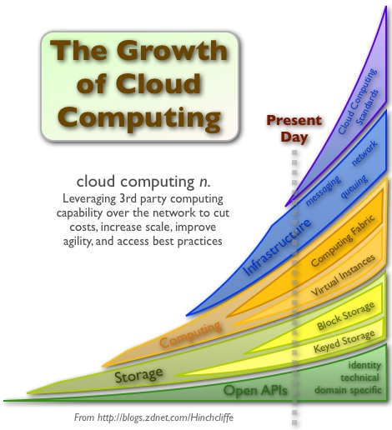  
TYPES OF CLOUD COMPUTING:**

1. **Community cloud** may be established anywhere several organizations have similar requirements and seek to share infrastructure so as to realize someof the benefits of cloud computing.
2. **Private cloud** and internal cloud are neologisms that some vendors have recently used to describe offerings that emulate cloud computing on private networks.Open standards are critical to the growth of cloud computing, and open source software has provided the foundation for many cloud computing implementations Open standards.

**Advantages:**

1. Today, businesses face a tough challenge of meeting growing demands with limited resources. To overcome these challenges, business owners are looking at cloud based services.
2. Cloud computing has something to offer every business. Right from application delivery to mobility solutions, cloud computing offers an intuitive methodology to influence resources and improve business performance.
3. In simpler words, cloud computing is a methodology that offers network services over the Internet. However, the hype created around cloud computing technology makes it difficult for business owners to choose the right cloud solution  for a specific business need.

**Disadvantages:**

1. **Security issues:** How safe is your data? Cloud computing means Internet computing. So you should not be using cloud computing applications that involve using or storing data that you are not comfortable having on the Internet.  That being said, established, reliable cloud computing vendors will have the latest, most sophisticated data security systems possible as they want your business and realize that data security is a big concern.
2. **Inflexibility:** Be careful when you're choosing a cloud computing vendor that you're not locking your business into using their proprietary applications or formats.  Make sure that you can add and subtract cloud computing users as necessary as your business grows or contracts.

**CONCLUSION**:

Finally, cloud apps don’t eat up your valuable IT resources, so your CFO will love it. This lets you focus on deploying more apps, new projects, and innovation. Cloud computing is a simple idea, but it can have a huge impact on your business.

**GROUP MEMBERS NAME**:

1. Prachi Pimpalkhute([prachi.pimpalkhute@gmail.com](mailto:prachi.pimpalkhute@gmail.com) mob no:9730261826)
2. Akanksha Bagade([akanksha.bagade02@gmail.com](mailto:akanksha.bagade02@gmail.com) mob no:8600237330)
3. MadhuriChute([madhurichute@ymail.com](mailto:madhurichute@ymail.com) mobno:9096796926)  
   (3RD year 6TH sem computer science and engineering J D COLLEGE OF ENGINEERING NAGPUR)