Overview on Feature Extraction Techniques for Devnagari Handwritten Character Recognition

Pranita P. Kanhegaonkar
Dept. of MCA
Raisoni College of Engineering Nagpur, India Pranitak.90@gmail.com

Abstract—

Devanagari is a script used for several major languages such as Hindi, Sanskrit, Marathi and Nepali, and is used by more than 500 million people. Unconstrained Devanagari writing is more complex than English. In this paper two different character recognition techniques are reviewed both following some common steps to achieve character recognition for devnagri script. In the OR method four feature extraction techniques namely, intersection, shadow feature, chain code histogram and straight line fitting features. Shadow features are computed globally for character image while intersection features, chain code histogram features and line fitting features are computed by dividing the character image into different segments. Weighted majority voting technique is used for combining the classification decision obtained from four Multi Layer Perception (MLP) based classifier

Index Terms—HCR,OCR .

I. INTRODUCTION
Handwritten Character Recognition has numerous applications in different areas like for security check, person identification, to personalize control for smart devices etc. character recognition is done in three main steps data collection, preprocessing and feature extraction. There are two basic types of recognition one is offline character recognition and another is online character recognition. Off-line handwriting recognition involves the automatic conversion of text in an image into letter codes which are usable within computer and text-processing applications. The data obtained by this form is regarded as a static representation of handwriting. On-line handwriting recognition involves the automatic conversion of text as it is written on touch sensor devices.Where a sensor picks up the pen-tip movements as well as pen-up/pen-down switching. That kind of data is known as digital ink and can be regarded as a dynamic representation of handwriting. The obtained signal is converted into letter codes which are usable within computer and text- processing applications.
Handwritten character recognition is the ability of a computer to receive and interpret intelligible handwritten input. In this paper I have summarized the various feature extraction techniques for character recognition for Devnagari script.

Devnagari script is most widely used script in India for languages like Sanskrit, Hindi, Marathi, Bengali, Nepali etc. Type Style and Fonts

II. METHODOLOGY

Character recognition process is accomplished through 4 to
5 steps. They are 1. Data Acquisition. 2. Pre-processing.
3.feature extraction 4.classification. In the OCR for Handwritten Devnagari Characters method[1] , first scaling of character bitmap is performed and after that three different features are extracted. First, 32 intersection features are extracted after performing thinning, generating one pixel wide skeleton of character image and segmenting the image into 16 segments. Second, 16 shadow features are extracted from eight octants of the character image. Third, 200 chain code histogram features are obtained by first detecting the contour points of original scaled character image, and dividing the contour image into 25 segments. For each segment chain code histogram features are obtained.

A.. Conversion of Handwritten Character to Bitmapped
Binary Images-
In images, background is not always of same contrast value. For this, we designed the Dynamic Threshold Value Identification algorithm. The goal of this algorithm is to distinguish between image pixels that belong to text and those that belong to the background. The algorithm mentioned below is applied on gray scale images:-
a) Take the threshold to be 128(Mid value of 0 to 255).
b) Take all the pixels with grayscale value above 128 as background and all those with value below 128 as foreground. c) Find the mean grayscale values of background pixels and foreground pixels.
d) Find the average of both mean values and make this the new threshold.
e) Go back to step (b) and continue this process of refining the threshold till the change of the threshold from one iteration to next becomes less than 2%.

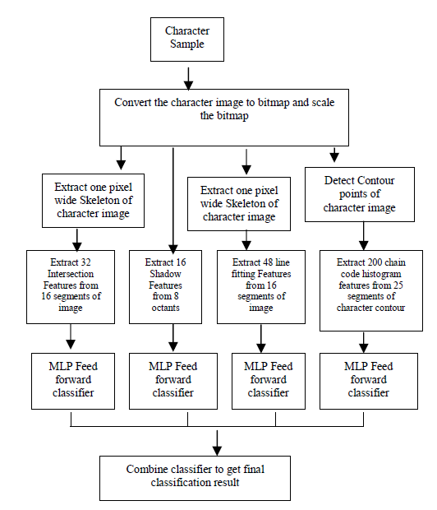
Fig.1.block diagram of OCR for Handwritten Devnagari
Characters method

B. Scaling of the binary character images-
Each character image is first enclosed in a tight fit rectangular boundary. The portion of the image outside this boundary is discarded. The selected portion of the character image is then scaled to the size 100 × 100 pixel using affine transformation. For smoothing the contours of the character images and also for filling in some holes, we perform some morphological operations like closing and dilation on the character image.

C. Feature Extraction-
In the following we give a brief description of the three feature sets used in our proposed multiple classifier system. Shadow features are extracted from scaled bitmapped character image. Chain code histogram features are extracted by chain coding the contour points of the scaled character bitmapped image. Intersection features are extracted from scaled, thinned one pixel wide skeleton of character image.

Shadow Features of character—
For computing shadow features [20], the rectangular boundary enclosing the character image is divided into eight octants, for each octant shadow of character segment is computed on two perpendicular sides so a total of 16 shadow features are obtained. Shadow is basically the length of the
projection on the sides as shown in figure 3. These features are computed on scaled image.
In this system 3 layers are used including one hidden
layer for four different feature sets consisting of 32 intersection features, 16 shadow features, 48 line fitting based features and 200 chain code histogram features. The experimental results obtained while using these features for recognition of handwritten Devnagari characters is presented in the next section. At this stage all characters are noncompound, single characters so no segmentation is required. The classifier is trained with standard Back propagation.
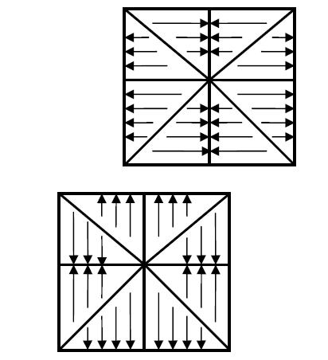

Fig.2.shadow feature
It minimizes the sum of squared errors for the training samples by conducting a gradient descent search in the weight space. As activation function we used sigmoid function. Learning rate and momentum term are set to 0.8 and
0.7 respectively. As activation function we used the sigmoid function. Numbers of neurons in input layer of MLPs are 32,
16, 48 or 200, for intersection features, shadow features, line
fitting features and chain code histogram features respectively. Number of neurons in Hidden layer is not fixed, we experimented on the values between 20-70 to get optimal result and finally it was set to 20, 30,40 and 70 for intersection features, shadow features, line fitting features and chain code histogram features respectively. The output layer contained one node for each class., so the number of neurons in output layer is 49. And classification was accomplished by a simple maximum response strategy.

A. Classifier Combination
The ultimate goal of designing pattern recognition system is to achieve the best possible classification
performance. This objective traditionally led to the development of different classification scheme for any pattern recognition problem to be solved. The result of an experimental assessment to the different design would then be the basis for choosing one of the classifiers as the final solution to the problem. It had been observed in such design studies, that although one of the designs would yield the best performance, the sets of patterns misclassified by the different classifiers would not necessarily overlap. This suggested that different classifier designs potentially offered complementary information about the pattern to be classified which could be harnessed to improve the performance of the selected classifier. So instead of relying on a single decision making scheme we can combine classifiers.
Combination of individual classifier outputs overcomes deficiencies of features and trainability of single classifiers. Outputs from several classifiers can be combined to produce a more accurate result. Classifier combination takes two forms:
combination of like classifiers trained on different data sets and combination of dissimilar classifiers. We have four similar Neural networks classifiers as discussed above, which are trained on 32 intersection features, 16 shadow features, 48 line fitting features and 200 chain code features respectively. The outputs are confidences associated with each class. As these outputs can not be compared directly, we used an aggregation function for combining the results of all four classifiers. The strategy used here is based on weighted majority voting scheme as described below
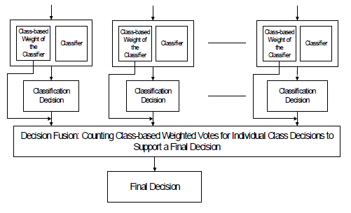
Fig.3 Weighted majority voting technique for combining classifiers

So if kth classifier decision to assign the unknown pattern to
the ith class is denoted by Oik with 1 ≤ i ≤ m, m being the number of classes, then the final combined decision di
cm
supporting assignment to the ith class takes the form of :-
di
com = Σ ωk * Oik …….1 ≤ i ≤ m
k=1,2,3,4
The final decision dcom is therefore :-
dcom = max di com
1 ≤ i ≤ m
dk
ωk = ------- ------------
4
Σ dk
k=1
where m = 50 and ω1, ω2, ω3 are 0.349, 0.197, 0.326 and
0.128 respectively as d1> d3> d2 > d4
d1=64.90% result of classifier trained with chaincode histogram features
d2=36.71% result of classifier trained with Intersection features
d3= 60.59% result of classifier trained with Shadow features. d4=24.83% result of classifier trained with straight line fitting features

a. Sample of a table footnote. (table footnote)

REFERENCES
[1] Sandhya Arora, Debotosh Bhattacharjee, Mita Nasipuri, Dipak Kumar Basu*, Mahantapas KunduG. “Combining Multiple Feature Extraction Techniques for Handwritten Devnagari Character Recognition” 10 Colloquium and the Third ICIIS, Kharagpur, INDIA December 8-10.
[2] Scott D. Connell R.M.K. Sinha Anil K. Jain “Recognition of Unconstrained On-Line Devanagari Characters” Department of Computer Science and Engineering,Michigan State University East Lansing, MI 48824

