E-cops (E-computerized Operation for Police Service)

Priyanka Nandanwar, Kalyani Thombre, Rachi Hajare,Rakhi Wajgi

*Dept. of Computer Technology, YCCE, Nagpur.*

*Priyu.n06@gmail.com*

***Abstract*** *-* **Citizens of India often have to face a common problem in making a complaint. To make a complaint they have to go to the police station. It is very problematic to them when a mid-night emergency comes.**

**The Internet now provides a very fast access to each and every resource throughout the world. Almost each and every educated citizen has knowledge about the usage of the Internet. For this reason, Police plans the make an online police station setup for the easy access and convenience of the citizens as well as police officers. This website is called E-cop. This website helps citizens in great extent to make complaints, report missing person, valuables and criminal information’s, request to approve licenses. Not only citizens, but the employee i.e. police officers get advantages from this website. This makes their daily duties such as FIR filing, license approvals easier and less error-prone.**

**Generally many crimes seen by the public will not reach to the police due to many reasons like fear, lack of time, ignorance. Due to this reason many cases are not even reaching the police station. Though some cases are registered they are not investigated properly due to lack of evidences and cooperation of the public. This software helps the public to report about the crimes to the police without any fear in correct time. This is helpful to police in solving the cases. This is also helpful for higher authorities of police to have an overview about the progress of the investigation.**

INTRODUCTION

E-cops is made available to public for interaction with police indirectly. This system registers the complaints from people through online and is helpful to the police department in catching criminals. In this system any person can give any complaint anytime. The aim of this project is to develop an E-cops reporting and management system which is easily accessible to the public, police department and the administrative department.

The objective is to develop a system that provides functionalities for efficient and effective management of information related to civil and criminal offences. The purpose is to provide tools and mechanisms using which police and law enforcement agencies can record offence related data and access the stored information from any location.

ECOPS is an online reporting service to which the internet user can report crimes committed on or through the Internet. The impact of IT and communications is traversing at a fast pace. As information for the department is crucial, an enterprise IT tool for enhancing the performance of the police officials became necessary called ECOPS or E-Computerized Operations for Police Services, the main purpose is to maintain information, monitor and enhance the performance of the department.

The focus of ECOPS is to computerize the activities of controlling crime, administration and support services across the state in an integrated fashion so as to enable the division heads and senior officers to obtain the relevant information. Besides, it is also envisaged to reduce dependence on paper and help in automatic maintenance of registers and generation of reports, data analysis, better planning and coordination, speedy detection of crimes and monitoring the prosecutions.

LITERATURE SURVEY

With ECOPS, the exchange of information within police stations and other senior police officers in the departments is faster. It also streamlines the workflow in police department machinery. A central database permits the police units to operate more efficiently leading to speedy detection of crime and prosecution monitoring. The senior police officers of the state can access the reports, which allow them to take quick and timely decisions. Crime analysis reports will nable the senior police officers to observe the crime trends and to guide the investigating officers. The technological benefits of ECOPS are to maintain information, monitor and enhance the performance of the department.

[1] This paper present Governments and public sector organizations around the world are facing to reform their public administration organizations and deliver more efficient and cost effective services, as well as better information and knowledge to their stakeholders. E-governance is the effective use of Information &Communication Technology (ICT) to improve the system of governance that is in place, and thus provide better services to the Citizens. E-Governance is considered as a high priority agenda in India,

[5]The Director General and Inspector General of Police proposed (March 2000) to take up a comprehensive project of computerization of the Police Department at a cost of Rs 96.63 crore. This was with a view to build an improved information infrastructure to enhance the operational efficiency at all levels of the Police Department. The Project was to be implemented in phases; first phase was to cover all District Police Offices, all Police Training Colleges, all AP Special Police Battalions, and all Police Stations within the jurisdiction of three Commissionerates and Srikakulam District.

The application comprises the following modules:

## Users

## Police Registration

1. Investigation

I. User

USER

LOGIN

VIEW STATUS & MESSAGES

SEND COMPLAINTS

GETS COMPLAINT ID

**Fig1**:User

1. Sign up-In order to apply for various certificates such as birth, community, income and ration card,
2. and end user must sign up by filling the sign up form and get it approved by admin.
3. Sign in-After getting the username and password, end users can log on to their account and can access the website.
4. View Profile**-** End user can view their profile which contains the personal details which he/she provided during signup.
5. Enter Details- End user who signed in can open the requisition form and enters the mandatory details required in that form.
6. Make a Complaint-End user who signed in can complaint a crime as a complainant or informant.

II. Police Registration

1. Sign in- First the Station House Officer has to login to his account to start his work
2. Investigation- He investigates grave crime and other complaint
3. Verify details-Admin authenticates all the end Users and officers by checking their username & password.
4. Maintaining case diary-He writes the investigation details in case diary that includes arrested criminal

POLICE

LOGIN

VIEW CAUTION

VIEW COMPLAINT

SEND STATUS

**Fig2**: Police login

III. Investigation

1. Documenting Crime Details- Complete crime details need to be recorded/documented in the system, which is very much essential for producing the culprit in court.
2. Property Search and Seizure- In most of the property related civil cases, the property/assets need to be seized. The information related the seizure will be done through this module.
3. Arrest and Court Surrender- Once the FIR is registered, the culprit need to be searched and he need to be surrendered to the court. Information related to the arrest and surrendering the culprit to court is recorded in this module
4. Court Disposal- Complete judicial information such as hearing information, next hearing date and evidence tracking will be done in this module
5. Result of Appeals- If the culprit appeals for further review of his case to higher court (s), this information will be tracked in this module**.**

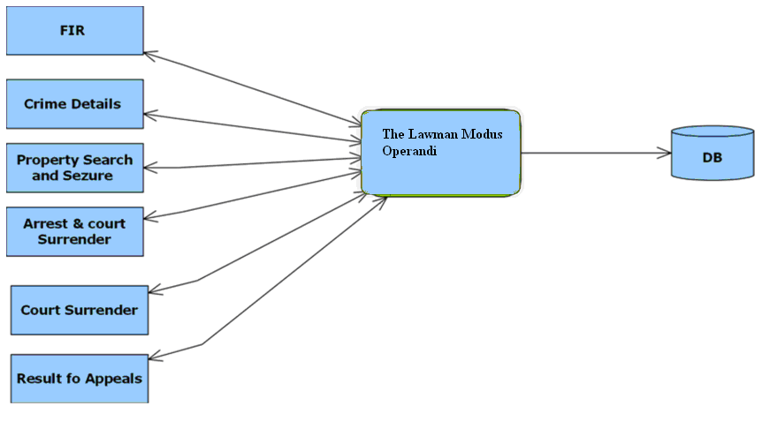

Fig3: Investigation

NeedforComputerization

1. Duplication of work avoided
2. Paper work is drastically reduced
3. Retrieval and access of data is easy

High**-**LevelProjectGoal

1. Improve efficiency in police department
2. Availability of online police service to citizens
3. Availability of data to senior officials for quick decision making
4. Better administration and co-ordination
5. Speedy detection of crimes
6. Duplication of work avoided
7. Retrieval and access of data is easy
8. Paper work is drastically reduced
9. Automatic maintenance of registers

CONCLUSION

E-policing is not about technical issues; it is more about cultural changes within police organizations. If we completed our project successfully then we will try for that it should be implement in police service.

REFERENCE

1. .“E-GOVERNANCE IN INDIA – PROBLEMS AND ACCEPTABILITY” Dr. Sanjay Kumar Dwivedi, Head, Department Of Computer Science, Babasaheb Bhimrao Ambedkar University, LucknowAjay Kumar Bharti Research Scholar, Department Of Computer Science, University, Lucknow (U.P.), India – 226025Journal of Theoretical and Applied Information Technology© 2005 - 2010 JATIT & LLS.
2. “INTRODUCING e-GOV:HISTORY, DEFINITIONS, AND ISSUES” Åke Grönlund Örebro University, Thomas A. Horan Claremont Graduate University, Communications of the Association for Information Systems (Volume 15, 2004)713-729
3. http://www.socitm.gov.uk/egovindex/policy. htm# strategies
4. Development Gateway (<http://www.developmentgateway.org/>)
5. “Information Technology Audit of E-Cops – an e-Governance initiative by Government” *Audit Report (Civil) for the year ended 31 March 2004*
   1. [www.fmexpense.com/quickstart/aspplus/default.com](http://www.fmexpense.com/quickstart/aspplus/default.com)
6. [http://msdn.microsoft.com/en- us/library/zw4w595w.aspx](http://msdn.microsoft.com/en-%20%20%20%20%20%20%20%20%20%20%20%20%20%20%20%20%20%20%20%20%20%20%20%20%20us/library/zw4w595w.aspx)
7. <http://msdn.microsoft.com/en-> us/library/gg145045.aspx