**Cloud Computing vs. Grid Computing**

Rinku Likhar

Department of MCA

G.H Raisoni College of Engineering

(An Autonomous Institute under UGC Act 1956)

*Hingna Road, Digdoh Hills, Nagpur-16*

[likhar_rinku.ghrcemca@raisoni.net](mailto:likhar_rinku.ghrcemca@raisoni.net)

***Abstract* — In this paper there is a lot of comparison over their relations to each other and there is also a similarities and differences between grid and cloud computing. Cloud computing is rapidly growing as an alternative to conventional computing. The purpose of this paper is to characterize and present a side by side comparison of grid and cloud computing.**

***Keyword----*grid computing; cloud computing; grid definition; cloud definition; comparison; similarities and differences**

I. INTRODUCTION

When it comes to comparing grid and cloud computing, there is a lot of debate on how the two are related to each other.As a background of this paper the descriptions of these two technologies are as follows. The term "cloud" originates from the world of telecommunications when providers began using virtual private network (VPN) services for data communications.Cloud computing deals with computation, software, data access and storage services that may not require end-user knowledge of the physical location and the configuration of the system that is delivering the services. Cloud computing is a recent trend in IT that moves computing and data away from desktop and portable PCs into large data centers.Grid computing is the ability to process information by utilizing a collection of networked heterogeneous information-processing components (hardware and software), all of which are provisioned from various geographical locations and across organizational boundaries. Grid computing is a network that is not in the same place but distributed resources such as computers, peripherals, switches, instruments, and data.Grid can be viewed as a special type of middleware that enable sharing and manage grid components based on user requirements and resource attributes.

In this paper, I talk about cloud computing service types and the similarities and differences between cloud and grid computing.Section II provides to make cloud computing work, what you need are three things: thin clients (or clients with a thick-thin switch), grid computing, and utility computing. Grid computing links separate computers to make a large infrastructure, use idle resources.

Section III provides the brief description of grid computing. With grid computing, you can provide computing resources as a utility that can be used or not.

Section IV provides the comparison between cloud and

grid computing . Cloud computing and grid computing are similar in many ways, what is the difference and relation between these two technologies?

II. GRID COMPUTING

Starting with GridComputing. A grid comprises of a set of loosely coupled computers that are networked together and form what appears a single coherent whole. It is analogous to the power grid. One of the main strategies of grid computing is to use middleware to divide and apportion pieces of a program among several computers. Grid computing involves computation in a distributed fashion, which may also involve the aggregation of large-scale cluster computing based systems. The size of a grid may vary from small a network of computer workstations within a corporation to large collaborations across many companies and networks.

Two key outcomes exist in grids: the Open Grid Service Architecture (OGSA) and the Globus Toolkit. The OGSA presented an open architecture on how grids are created and maintained. According to the OGSA all resources within a grid are exposed via grid services with reusable interfaces and presented a general set of services that manage (to name a few) the execution of applications, resource security, monitoring, data access and grid service interoperability across domains.

The Globus Toolkit is a software middleware package that aides in the creation and management of a grid and is the leading implementation of the OGSA. All that is required is to install and configure Globus and then create all required resources and services.

*A. Definition:* Grid as a type of parallel and distributed system that enables the sharing, selection, and aggregation of geographically distributed autonomous resources dynamically at runtime depending on their availability, capability, performance, cost, and users quality-of-service requirements.Grid as a system that coordinates resources which are not subject to centralized control, using standard, open, general-purpose protocols and interfaces to deliver nontrivial qualities of service.

Computing grids are conceptually not unlike electrical grids. In an electrical grid, wall outlets allow us to link to an infrastructure of resources that generate, distribute. And bill for electricity. Grid computing uses middleware to coordinate disparate IT resources across a network, allowing

them to function as a virtual whole. The goal of a computing grid, like that of the electrical grid, is to provide users with access to the resources they need, when they need them.

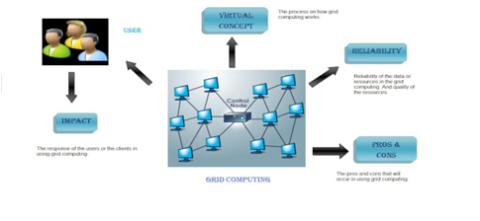

Figure 1.Grid Computing

Grid computing is an emerging computing model that provides the ability to perform higher throughput computing by taking advantage of many networked computers to model a virtual computer architecture that is able to distribute process execution across a parallel infrastructure. Grid Computing is a high performance level of a collection of resources.

*B. Objectives:*   
1. Impact. The response of the users or the clients in using grid computing.  
2.Reliability.Quality of resources.  
3. Advantage and disadvantage. The pros and cons that will occur in using grid computing.  
4. Virtual Environment concept. How do Grid Computing works.

III. CLOUD COMPUTING

The first question you will ask is what is cloud computing. It is the development of distributed computing, parallel computing and grid computing, in other words it is the business realization of all these concepts.This is a technology that allows anyone connected to the internet to use hardware and software on demand. The name comes from the use of a [cloud](http://en.wikipedia.org/wiki/Cloud)-shaped symbol as an abstraction for the complex infrastructure it contains in system diagrams. Cloud computing entrusts remote services with a user's data, software and computation.

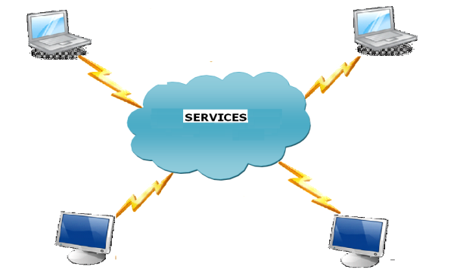

Figure 2.Cloud Computing architecture

Cloud computing system can be divided into two sections: the front end and the back end. They both are connected with each other through a network, usually the internet. Front end is what the client (user) sees whereas the back end is the cloud of the system. Front end has the client's computer and the application required to access the cloud and the back has the cloud computing services like various computers, servers and data storage.

Cloud computing refers to both the applications delivered as services over the Internet and the hardware and system software in the data centers that provide those services.

*A. Definition:*A cloud is a type of parallel and distributed system consisting of a collection of interconnected and virtualized computers that are dynamically provisioned and presented as one or more unified computing resources based on service-level agreement.

The basic principle of cloud computing is to distribute the computing tasks to many distributed computers, not local computer or remote servers. This can make enterprise pay attention to the application, and visit computer and storage system according to its requirement.

Cloud computing is achieved through a combination of virtualization, SOA, and Web services. This is the first distinction clouds have over grids: grids are currently governed by the open grid service architecture (OGSA) which serves as a reference for grid middleware implementations. Cloud Computing, which provides three levels of service. At one end is Software as a Service (**SaaS**), allowing a pay per use model to be applied to acquiring software with no on-premise hosting. Platform as a Service (**PaaS**) provides an elastically scalable compute platform including middleware for applications to be deployed to. Finally Infrastructure as a Service (**IaaS**) enables servers, storage, networks to be provisioned on demand and on a pay as you use basis with self administration of the infrastructure.IaaS is the most basic and each higher model abstracts from the details of the lower models.

[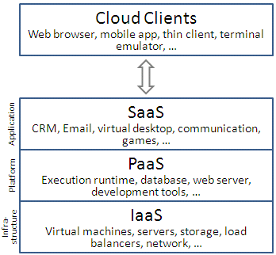](http://en.wikipedia.org/wiki/File:Cloud_computing_layers.png)

Figure 3. Service models

*1. Infrastructure services "Infrastructure as a Service (IaaS)"* provides the required infrastructure as a service. In this most basic cloud service model, providers offer computers, as physical or more often as virtual machines, and other resources.The client need not purchase the required servers, data center or the network resources.A user can get service from a full computer infrastructure through the Internet. This kind of service is called Infrastructure as a Service (IaaS). Internet-based services such as storage and databases are part of the IaaS. The IaaS divides into two types of usage: public and private.Private cloud is the cloud infrastructure is owned or leased by a single organization and is operated solely for that organization.Public cloud is the cloud infrastructure is owned by an organization selling cloud services to the general public or to a large industry group.

*2. Platform services "Platform as a Service (PaaS)"* this kind of cloud computing provide a development environment. PaaS cloud offer clients complete platforms: servers with pre-installed and pre-configured software stacks. The immediate advantage of PaaS clouds they are easier to use and clients can spend more time focusing on the creation and maintenance of their own services.

*3. A cloud application delivers "Software as a Service (SaaS)” in* this model, cloud providers install and operate application software in the cloud and cloud users access the software from [cloud clients](http://en.wikipedia.org/wiki/Cloud_clients). The cloud users do not manage the cloud infrastructure and platform on which the application is running.Over the internet, thus eliminating the need to installand run the application on the users system.

IV. COMPARISON BETWEEN CLOUD COMPUTING AND GRID COMPUTING

Grid computing is a form of distributed computing whereby a "super and virtual computer" is composed of a cluster of networked, loosely-coupled computers, acting in concert to perform very large tasks. This technology has been applied to computationally-intensive scientific, mathematical, and academic problems through volunteer computing, and it is used in commercial enterprises for such diverse applications as drug discovery, economic forecasting, seismic analysis, and back-office data processing in support of e-commerce and web services. While, cloud computing is a computing paradigm in which tasks are assigned to a combination of connections, software and services accessed over a network.Cloud computing is often used to sort through enormous amounts of data.

*A. Objectives:*   
1. impact of the grid and the cloud computing to the one that is accessing and using it.  
2. Reliability of the data that been stored in the cloud.  
3. The pros and cons of the cloud and the grid computing.  
4. Differentiate between grid computing and cloud computing.

Clouds generally refer to wide area networks (WANs) such as the Internet, but can also be used to depict local networks (LANs). Inside the cloud, there may be any number of routers, switches, trunks and other devices that make up the network infrastructure. Also, cloud computing it the concept of spreading computing processes over several resources through a network. Cloud computing is providing people with the capability to access powerful computing resources from devices like cell phones, laptops, and smart phones. While grid computing, it is where every computer can access the resources of every other computers belong in the network.

Grid computing is a special kind of distributed computing. In distributed computing, different computers within the same network share one or more resources. In the ideal grid computing system, every resource is shared, turning a computer network into a powerful supercomputer.

Both grid computing and cloud computing were wide in the area of networking and they provide authority to the user to be able to access several resources coming from the other computer.

Cloud computing can be considered an extension of Grid computing. The Cloud computing characteristically has provision for on demand IT resource allocation and instantaneous scalability. Unlike Grid computing that typically provides persistent and permanent use of all available IT resources, the cloud computing is very specific on the consumers demand, based on his current computing requirements and therefore eliminates over provisioning of available IT resources.

Comparing Grid with the Cloud Computing services, Grid computing most closely compares with PaaS in Cloud Computing. It provides a deployment environment for application software which will elastically scale its compute and storage capacity to best meet the applications immediate requirements, all autonomously. A grid may be considered as a private cloud delivering PaaS. There are however, a lot of differences between Grid and Cloud computing including:

Grids are normally on-premise, and owned by an organisation, whereas clouds are normally provided by vendors and utilised on an as needs, pay per use basis by many different organisations. Grids do not provide the ability to individually provision servers and the self administration including installing a variety of operating system and software applications on these servers like IaaS does.

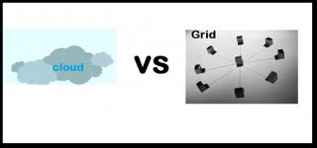

Figure 4.Cloud Vs Grid Computing

The 5 characteristics of cloud computing according to National Institute of Standards and Technology (NIST).

*B.The 5 mentioned characteristics are:*

***1. On-demand self-service.*** This is where you can provision computing capabilities based on your needs. Our needs may change from time to time. This is why it’s called “on-demand”.

***2. Broad network access*.** By using cloud, you have the option on whether to burden the end users laptop or in another word, thin or thick client. Thin client is where users have to download a small size file and they can access to all the resources and features available. For thick client, users will have to download a big size of files to their workstations before using the features.

***3. Resource pooling.*** This is another cool thing about cloud computing. Resource pooling is about assigning computing resources to multiple customers dynamically. It is something that can change from time to time based on users demands.

*4. Rapid elasticity*: consumers can increase or decrease capacity at will;

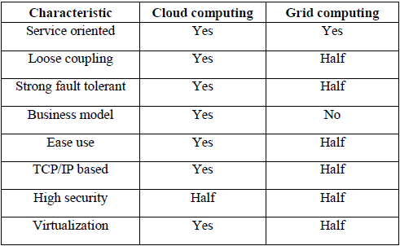

Table 1.Cloud Computing Vs Grid Computing

*C.Grid characteristics may be described as follows:*

*1. Large scale:* a grid must be able to deal with a number of resources ranging from just a few to millions.

*2. Geographical distribution:* grid’s resources may be located at distant places.

*3. Heterogeneity:* a grid hosts both software and hardware resources that can be very varied ranging from data, files, software components or programs to sensors, scientific instruments, display devices, personal digital organizers,

Computers, super-computers and networks.

*4. Resource sharing:* resources in a grid belong to many different organizations that allow other organizations (i.e. users) to access them.

*D.Advantages Of Grid* First advantage is Grid environments are much more modular and don't have single points of failure.Second is Policies can be managed by the grid software. The software is really the brains behind the grid.Third is Jobs can be farmed out to idle servers or even idle desktops. Many of these resources sit idle especially during off business hours. Policies can be in place that allows jobs to only go to servers that are lightly loaded or have the appropriate amount of memory/cpu characteristics for the particular application.

*E.Disadvantages of grid* Grid computing has great potential, but there are still absent features waiting for implementation. There are still particular disadvantages of grid computing.The first disadvantage concerns the relative immaturity of the concept. On the subject of software, some applications require modifications in order to use all the benefits of grid computing. The biggest disadvantage of grid computing though, concerns processes and their results. More specifically, the results of all processes are sent first on all nodes within the grid, and then collaboratively assessed. Before the final assessment is made, it is not possible to define or to declare a final outcome.

*F.Advantages of cloud* The advantages of cloud computing include reduced costs, easy maintenance and re-provisioning of resources, and thereby increased profits. Cloud also helps save the environment.

***1. Remote Accessibility*:** With cloud computing, your business is not restricted to a particular location. This applies to individuals also. You can access the services from anywhere.

***2. Easy Expansion:*** As of the characteristics of cloud computing is its flexibility, you can quickly access more resources if you need to expand your business. You need not buy extra infrastructure.

***3. Security:*** Though people doubt cloud computing, clouds tend to be more secure than the traditional business models.

***4. Environmentally Friendly:*** While you save on electricity, you also save on resources required to cool off computers and other components. This reduces the emissions dangerous to environment.

*F.Similarities and Differences:* Grid and cloud computing are relatively new concepts in the area of information technology which abstract multiple processing tasks. Abstraction masks the actual intricate processes taking place in systems and represents a user with a simplified interface by which they can manage processes easily.

Cloud computing is an internet based model of provisioning and marketing of IT services, whereby all the shared information and resources like databases, servers etc are provided to end users through the internet. Cloud computing incorporates software as a service (SaaS), platform as a service (PaaS) and infrastructure as a service (IaaS) as well as Web 2.0.

Grid computing is an innovative approach wherein system resources combine from multiple administrative domains to reach a common goal. It is designed for a mutual sharing of resources. In grid computing, programs divide and farm into pieces as one large system image to several end users.

1. In grid computing, computer resources are made available as a utility which can be turned on/off. Cloud computing is built on this concept and goes one step further to provide on-demand availability of resources.

2. In grid computing, a software is required which can divide a large program into smaller processing units and resources don't need to always be part of a cloud. In cloud computing the users don't need to worry about the infrastructure, service location and resource maintenance concepts.

There are many computing architectures within cloud computing and grid computing that have shared characteristics. The technologies are so similar that when making a decision it is extremely important to understand your business needs and requirements.

V. CONCLUSION

In this paper, we have presented a detailed comparison on the two computing models, grid and cloud computing.We show that Clouds and Grids share a lot commonality in their

vision, architecture and technology, but they also differ in various aspects such as security, business model.The described disadvantages of grid computing, this technology has many benefits and it seems likely that it will be used more and more in different computational grid projects, especially for biomedical, industrial and financial research, but also in chemistry and medicine.

Cloud computing has many advantages over grid computing, clouds will not replace grids. Grid computing helped create a certain technology reality which made clouds possible. Grid computing and Cloud computing have some similarities: scalable, on demand compute and storage. They also have some major differences: immediate self provisioning, pay per use and a wide variety of applications available via the cloud.

In a word, the concept of cloud computing is becoming more and more popular. Now cloud computing is in the beginning stage. All kinds of companies are providing all kinds of cloud computing service, from software application to net storage and mail filter. We believe cloud computing will become main technology in our information life.

REFERENCES

1. <http://www.brighthub.com/environment/green> computing/articles/107038.aspx
2. <http://it.toolbox.com/blogs/technews/grid-computing-advantages-and-disadvantages-23668>
3. <http://ccskguide.org/cloud-computing-vs-grid-computing/>
4. <http://it.toolbox.com/wiki/index.php/Comparison_of_Cloud_computing_with_Grid_computing>
5. Michael Brock and Andrzej Goscinski, *Grids vs clouds*.
6. Shuai Zhang, Shufen Zhang, Xuebin Chen and Xiuzhen Huo(2010),” The Comparison Between Cloud Computing and Grid Computing,” in 2010 International Conference on Computer Application and System Modeling (ICCASM 2010)
7. Naidila Sadashiv and S. M Dilip Kumar (2011) Cluster, Grid and Cloud Computing: A Detailed Comparison,” in The 6th International Conference on Computer Science & Education (ICCSE 2011) August 3-5, 2011. SuperStar Virgo, Singapore
8. Engr: Farhan Bashir Shaikh and Sajjad Haider(2011) Security Threats in Cloud Computing
9. Yashpalsinh Jadeja and Kirit Modi (2012) Cloud Computing - Concepts, Architecture and Challenges in 2012 International Conference on Computing, Electronics and Electrical Technologies [ICCEET].
10. http://arxiv.org/ftp/arxiv/papers/0901/0901.0131.pdf1,2,3Ian Foster, 4Yong Zhao, 1Ioan Raicu, 5Shiyong Lu, Cloud Computing and Grid Computing 360-Degree Compared
11. <http://www.ibm.com/developerworks/web/library/wa-cloudgrid/>
12. [http://www.cloudways.com/blog/cloud- computing-vs-grid-computing-differentiated/](http://www.cloudways.com/blog/cloud-%20%20computing-vs-grid-computing-differentiated/)
13. <http://www.siteground.com/tutorials/cloud/cloud_grid_computing.htm>
14. <http://en.wikipedia.org/wiki/Cloud_computing>
15. <http://www.thepicky.com/tech/difference-cloud-computing-vs-grid-computing/>
16. <http://nsfcac.rutgers.edu/TASSL/Papers/proc-ieee-intro-04.pdf>.
17. <http://crystal.uta.edu/~kumar/cse6306/papers/Sunil%20Term%20Paper.pdf>
18. <http://www.thepicky.com/tech/difference-cloud-computing-vs-grid-computing/>
19. <http://www.thewindowsclub.com/difference-cloud-computing-grid-computing>.
20. <http://blog.eukhost.com/webhosting/cloud-computing-vs-grid-computing/>
21. <http://cloudcomputing.learningtree.com/2010/11/03/comparing-cloud-computing-with-grid-computing/>
22. <http://stackoverflow.com/questions/1067987/what-is-the-difference-between-cloud-computing-and-grid-computing>
23. <http://www.cloudways.com/blog/cloud-computing-vs-grid-computing-differentiated/>
24. <http://enterprisefeatures.com/2010/07/what%E2%80%99s-the-difference-between-grid-and-cloud-computing/>
25. <http://it.toolbox.com/blogs/technews/grid-computing-advantages-and-disadvantages-23668>
26. <http://ccskguide.org/cloud-computing-vs-grid-computing/>
27. http://www.examiner.com/article/five-advantages-and-disadvantages-of-cloud-computing.