Intelligent Monitoring Sensor
Akshada Deshmukh
Dept.of Computer Science and Engineering
Dr. Babasaheb Ambedkar College of Engineering
Nagpur, Maharashtra
Harshalata Wadaskar
Dept.of Computer Science and Engineering
Dr. Babasaheb Ambedkar College of Engineering
Nagpur, Maharashtra

Harshalata Wadaskar
Dept.of Computer Science and Engineering
Dr. Babasaheb Ambedkar College of Engineering
Nagpur, Maharashtra

Leena Zade
Dept.of Computer Science and Engineering
Dr. Babasaheb Ambedkar College of Engineering
Nagpur, Maharashtra
Neha Dhakate
Dept.of Computer Science and Engineering
Dr. Babasaheb Ambedkar College of Engineering
Nagpur, Maharashtra

Authors Name/s per 2nd Affiliation (

Ms.Preetee Karmore
HOD Dept.of Computer Science and Engineering
Dr. Babasaheb Ambedkar College of Engineering Nagpur, Maharashtra

Harshalata Wadaskar
Dept.of Computer Science and Engineering
Dr. Babasaheb Ambedkar College of Engineering
Nagpur, Maharashtra

Abstract— An intelligent monitoring sensor is an application which is developed from the security point of view. The objective of this project is to develop a system that monitors the area in which it is being implemented.
An Intelligent Monitoring Sensor is applicable in the area where no one is permissible to enter, also where we need to detect if any motion has been done. For this a digital camera is used. By combining the software and camera we can use this system as an Intelligent Monitoring Sensor.
The Camera is used to catch the live images of the area in which it is being implemented, if any object is moving. The captured images are stored in a particular folder. The stored images will be then useful to work on. As the software detects the motion, it sends the signal from a transmitter, which is connected to the PC. The transmitter will send the wireless signal to the receiver out somewhere else, in the form of radio frequency. In this way the system will provide the security against any misdeed.

Introduction

Intelligent Monitoring Sensor is an application in which a digital camera is used as a powerful motion detector. Instead of using various ultra-sonic or other sensors, we are using camera as the sensor here. By combining the software and the camera we can use this system as a Intelligent monitoring Sensor.
An Intelligent Monitoring Sensor can be used for security in restricted areas, where no one is allowed to visit or enter the space during particular time. For this a digital camera is used. By combining the software and camera we can use this system as an Intelligent Monitoring Sensor.

If any changes has been found the camera capture the images at the rate of one image per 60msec and stores them in the folder. The stored images will be then useful to work on. As the changes have been detected, the transmitter which is connected to the PC sends the wireless signal to the receiver at the other end.

There are three security levels in the software to control the monitoring.

- High: This level will focus on the particular object only and can sense within the range of 1meter only
- Middle: In this level the security will be less as compared to High Level .here it will sense the human as well as object.
- Low: It’s the lowest level security. This mode is basically used for monitoring only.

II. LITERATURE REVIEW

There are many existing devices in market such as CCTv Cameras, IP camera, Infrared Sensor, Laser Sensor etc.

CCTv :
Implementation of CCTv cameras are very costly and has drawbacks since it require constant monitoring of every activity which is not as ease. Continuous manual visualization hampers the productivity and time. Criminals can penetrate into the CCTV system, thereby facilitating criminal acts.

IP camera :
Implementation of IP cameras are also very costly and not feasible. This system cause major problems as it becomes open to hackers via internet(false bomb threats, called in hoaxers while watching the cameras.) .

Infrared Sensor and Laser Sensor:
These devices are quite economic in comparison to above devices however they have some drawbacks too. These devices are difficult to install and rarely available. One of the major disadvantages of infrared sensors is the size required to provide good resolution to the the signal.

III. FLOWCHART

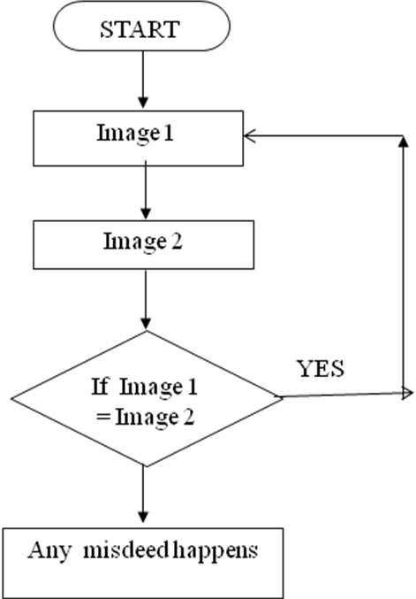

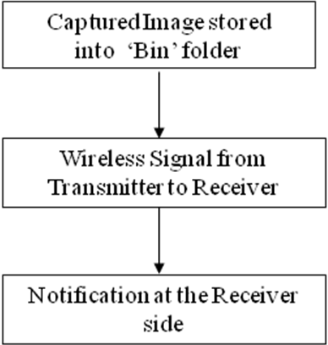

IV.PROJECT MODULES

      - Main Form designing
      - Camera Interfacing
      - Image Capturing & storage
      - Motion Detection
      - Hardware Interfacing

1. First Module :- Main form designing.
Initially the Login form is designed to provide authentication. If the login is successfully done, then it will switch to Main form. In the main form, there are three options-
1. Motion Detection Form
2. Image List Form
3. Exit

2. Second Module :- Camera Interfacing.
There are two picture boxes in the form where we compare the images.The form also contains the list box where the list of all the camera devices connected to the software are displayed .After selecting the device from the above list the camera interfacing is done.Then we have to select the mode of its working There are three modes-
- High
- Middle
- Low
3.Third Module :- Image Capturing & storage.
Whenever any changes between the images of the picture boxes is detected,the application starts capturing the images and they are stored into the folder using AVICAP32.dll class.
AVICap routes video and audio stream data from a captured window to a file named CAPTURE.AVI in the root directory of the current drive. AVICap window class provides applications with a message-based interface to access video and waveform-audio acquisition hardware and to control the process of streaming video capture to disk. AVICap window is efficient enough to control the process of streaming video capture to disk.

4.Fourth Module :- Motion Detection.
The basic working of motion detection module is comparison between two images. The first image is the one when we activate the application and the second is timely monitoring image. When the application recognizes any changes between two images or motion, it calls the next module i.e Image Capturing.

5.Fifth Module :- Hardware Interfacing
When the software will detect any movement in the image, it will send a signal (hex value) to LPT port. A transmitter will be connected to the LPT port of the PC. The transmitter will transmit the signal to the receiver and it will play the buzzer at the receiver’s end. Then the further actions will be taken by user.

IV. REFRENCES

- Bramberger, Pflugfelder, Maier, Rinner, Strobl, Schwabach, A Smart Camera for Traffic Surveillance (2000)
- Trans. on systems, man, and cybernetics part C: Applications and Reviews, Vol.34, NO.3, AUGUST 2004.
- Trans. on systems, man, and cybernetics part C: Applications and Reviews, Vol.34, NO.3, AUGUST 2004.
- Mohemed F Abdelkader, Integrated Motion Detection & Tracking for Visual Surveillance (ICVS 2006).
- Raman Maini & Dr. Himanshu Aggarwal,International Journal of Image Processing (IJIP), Volume (3) :
Issue (1)
- An Improved Motion Detection Method for Real-Time Surveillance Nan Lu, Jihong Wang, Q.H. Wu and Li Yang(19 February 2008).
- W. Hu,T. Tan,L.Wang, and S. Maybank. A survey on visual surveillance of object motion and behaviors, IEEE
- N.R.Mokhtar, Nor Hazlyna Harun,M.Y.Mashor, 2H.Roseline , 1Nazahah Mustafa, R.Adollah ,H. Adilah, N.F.Mohd Nasir,” Image Enhancement Techniques Using Local,Global, Bright, Dark and Partial Contrast Stretching For Acute Leukemia Images” Proceedings of the World Congress on Engineering 2009 Vol I WCE 2009.
- Implementation of webcam based sytem for surveillance monitoring,Brahmanandha Prabhu R,Arul Prabhar A,Garima Bohra,Proceeding of ASCNT-2010,CDAC,Noida,India.
- G. D. Hager, and P. N. Belhumeur. Efficient region tracking with parametric models of geometry and illumination, IEEE Trans. PAMI, vol. 20.
- W. E. L. Grimson, C. Stauffer, R. Romano, and L. Lee. Using adaptive tracking to classify and monitor activities in a site, in Proc. IEEE Conf. CVPR, Santa Barbara, CA.
- Book: Mastering Visual Basic 6.0 by Evangelos Petroutsos
- Book: Visual Basic Bible by Douglas Herger

