A
PROJECT REPORT
ON

“BIOMETRICS”
A Project Report Submitted In Partial Fulfillment Of
Requirement For Bachelor Of Computer Science
& Information Technology.

SUBMITTED BY

Miss. Jenny Meshram.
Miss. Kaminee Ghatolkar.
Miss.Danu Waghamare.

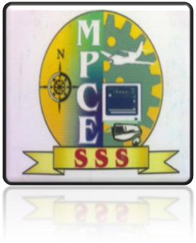

GUIDANCE BY

MR. PRANAY GHODE

DEPARTMENT OF COMPUTER ENGINEERING.

M.P.C.E., BHILEWADA BHANDARA
2013-2014

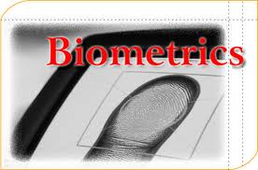

Contents:-

Abstract

- Introduction

- Why the Interest in Biometrics?

- Biometrics in Detail

- Biometric functionality

History of Biometrics

- Advantages of Biometrics

Disadvantages of BIOMETRICS:-

- Uses Of Biometrics :-

Abstract

The terms "Biometrics" and "Biometry" have been used since early in the 20th century to refer to the field of development of statistical and mathematical methods applicable to data analysis problems in the biological sciences. Statistical methods for the analysis of data from agricultural field experiments to compare the yields of different varieties of wheat, for the analysis of data from human clinical trials evaluating the relative effectiveness of competing therapies for disease, or for the analysis of data from environmental studies on the effects of air or water pollution on the appearance of human disease in a region or country are all examples of problems that would fall under the umbrella of "Biometrics" as the term has been historically used.

The journal "Biometrics" is a scholarly publication sponsored by a non-profit professional society (the International Biometric Society) devoted to the dissemination of accounts of the development of such methods and their application in real scientific contexts. Recently, the term "Biometrics" has also been used to refer to the emerging field of technology devoted to identification of individuals using biological traits, such as those based on retinal or iris scanning, fingerprints, or face recognition. Neither the journal "Biometrics" nor the International Biometric Society is engaged in research, marketing, or reporting related to this technology. Likewise, the editors and staff of the journal are not knowledgeable in this area.
Introduction

Biometrics involves using the different parts of the body, such as the fingerprint or the eye, as a password or form of identification. Currently, Federal Bureau of Investigation use the fingerprints from a crime scene to find a criminal. However, biometrics is becoming more public. Iris scans are used in United Kingdom at ATM's instead of the normal codes.
This web site reviews the different forms of biometrics available and some that are being developed.Practically all biometric system work in the same manner. First, a person is enrolled into a database using the specified method. Information about a certain characteristic of the human is captured. This information is usually placed through an algorithim that turns the information into a code that the database stores. When the person needs to be identified, the system will take the information about the person again, translates this new information with the algorithim, and then compares the new code with the ones in the database to discover a match and hence, identification.
Example : -Guy's fingerprint is scanned. An algorithm turns the fingerprint into a code which is stored in the database. Later, a person needs to be identified to do gain access into an area. His/Her fingerprint is scanned again. The system turns the fingerprint into a code. The code is compared with the other codes in the database. Look, the new code matches the code of Guy. The person must be Guy! Hence, Guy is identified and allowed into the area. Algorithm :-A program/a system of calculations used to turn the raw information(a person's characterisitics) into a stream of code that the computers have an easier time handling. Identification :-involves figuring out who is a certain person is. PIN :- stands for Personal Identification Number. PIN's are the standard form of identification. The most popular is the Social Security number. Speaker Verification: It is different than voice recognition. A speaker claims who he/she is. He/She then supplies the raw information: a sample of his/her voice. The sample must match the information that the system has about the claimed person. System: It is refers to the database of information, the method of receiving raw information, the algorithim, collectively. Verification: It is not identification, though it is slightly similar. A person claims they are Guy. Verifying involves figuring out if he/she is Guy. Unlike identification, the person provides makes a claim to who they are. Sometimes, the claim is made with PIN's, bar code, etc.
Two People Basic characteristics of BIOMETRIC Technologies: Universality :-Every person should have the characteristic .People who are mute or without a fingerprint will need to be accommodated in some way. Uniqueness :- Generally, no two people have identical characteristics. However, identical twins are hard to distinguish. Permanence :-The characteristics should not vary with time. A person's face, for example, may change with age. Collectability :- The characteristics must be easily collectible and measurable. Performance :- The method must deliver accurate results undervaried environmental circumstances. Acceptability : -The general public must accept the samplecollection routines. Nonintrusive methods are more acceptable. Circumvention :- The technology should be difficult to deceive have identicalcharacteristics. However, identical twins are hard to distinguish. Permanence :- The characteristics should not vary with time. A person's face, for example, may change with age. Collectibility :- The characteristics must be easily collectible and measurable. Performance . The method must deliver accurate results undervaried environmental circumstances. Acceptability :- The general public must accept the samplecollection routines. Nonintrusive methods are more acceptable. Circumvention :- The technology should be difficult to deceive
Why the Interest in Biometrics?
- Convenient :-
  - Passwords are not user-friendly
  - Perceived as more secure
  - May actually be more secure
  - May be useful as a deterrent
  - Passive identification
- Biometrics :-
- Something that you know
- Something that you have
- Something that you are
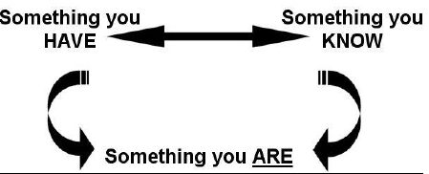

- Verification :-
- Compare a sample against a single stored
- templateTypical application: voice lock

- Identification :-
- Search a sample against a database of templates.
- Typical application: identifying fingerprints
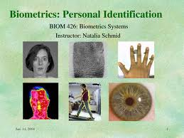
Biometrics Today :-
- Fingerprints
- Face Prints
- Iris Recognition
- Voice Prints
- Hand Scan
- DNA Identification Etc…

Biometrics in Detail :-
- Fingerprint Recognition :-
Henry Faulds letter to Nature (1880)
Fingerprints might be useful for crime scene investigations
For fingerprint Recognition look at

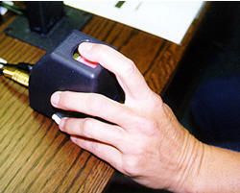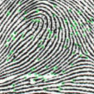

- Facial Scan :-
Based on video Images :
Templates can be based on previously-recorded images
Technologies:

Neural Network
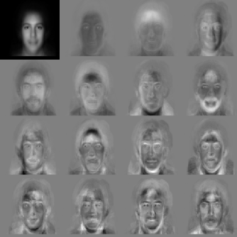

- Strengths:
- Database can be built from driver’s license records, visas, etc.
- Can be applied covertly (surveillance photos).
- Few people object to having their photo taken
- Attacks:
- Surgery
- Facial Hair
- Hats
- Turning away from the camera
- Defenses:
- Scanning stations with mandated poses

- Iris Recognition:
It is the colouredarea of the eye thatsurrounds the pupil.
Itis a protected internal organ whoserandom texture is stable throughoutlife.
The iris patterns are obtained through avideo-based image acquisition system
Image Acquisition → Image Processing → Template Creation → Template Matching
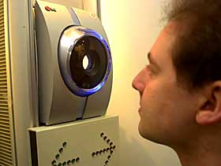

- Voice Recognition:
- Voice recognition is not the same asspeech recognition, it is speakerrecognition.
- Considered both physiological andbehavioral.
- Popular and low-cost, but less accurateand sometimes lengthy enrollment. Strengths:
- Most systems have audio hardware
- Works over the telephone
- Can be done covertly
- Lack of negative perception

Weaknesses:
- Background noise (airplanes)
- No large database of voice samples
Attacks:
- Tape recordings
- Identical twins / soundalikes
- Hand Scan
Typical systems measure 90 different features:
  - Overall hand and finger width
  - Distance between joints
  - Bone structure
Primarily for access control:
  - Machine rooms
  - Olympics
Strengths:
  - No negative connotations – non-intrusive
  - Reasonably robust systems
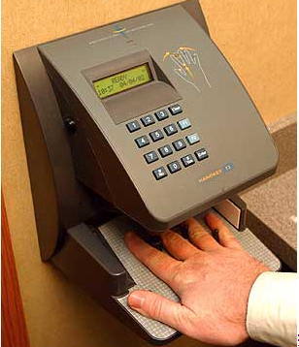

- DNA Identification
- RFLP - Restriction Fragment Length Polymorphism
- Widely accepted for crime scenes

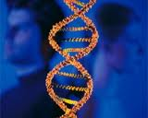

Biometric functionality :-
Many different aspects of human physiology, chemistry or behavior can be used for biometric authentication. The selection of a particular biometric for use in a specific application involves a weighting of several factors. Jain et al. (1999) identified seven such factors to be used when assessing the suitability of any trait for use in biometric authentica. The basic block diagram of a biome in the following two modes In verification mode the system performs a one-to-one comparison of a captured biometric with a specific template stored in a biometric database in order to verify the individual is the person they claim to be. Three steps involvedin person verification. In the first step, reference models for all the users are generated and stored in the model database. In the second step, some samples are matched with reference models to generate the genuine and impostor scores and calculate the threshold. Third step is the testing step. This process may use a smart card, username or ID number (e.g. PIN) to indicate which template should be used for comparison. 'Positive recognition' is a common use of verification mode, "where the aim is to prevent multiple people from using same identity"
In Identification mode the system performs a one-to-many comparison against a biometric database in attempt to establish the identity of an unknown individual. The system will succeed in identifying the individual if the comparison of the biometric sample to a template in the database falls within a previously set threshold. Identification mode can be used either for 'positive recognition' (so that the user does not have to provide any information about the template to be used) or for 'negative recognition' of the person "where the system establishes whether the person is who she (implicitly or explicitly) denies to be" The latter function can only be achieved through biometrics since other methods of personal recognition such as passwords, PINs or keys are ineffective.

History of Biometrics
The earliest form of Biometrics appeared on the scene back in the 1800's. Alphonse Bertillon, a Perisian anthropologist and police desk clerk, developed a method for identifying criminals that became known as Bertillonage. Bertillonage was a form of anthropometry, a system by which measurements of the body are taken for classification and comparison purposes. Bertillons system of anthropometry required numerous and percise measurements of the bony parts of a humans anatomy for identification. It also involved recording shapes of the body in relation to movements and differential markings on the surface of the body such as scars, birth marks, tattoos, etc. Bertillon estimated that the odds of duplicate records were 286,435,456 to 1 if 14 traits were used. This was the primary system of criminal identification used during the 19th century . Bertillons system of identification was not without fault. For example, it relied heavily on precise measurements for identification purposes, and yet two people working on measurements for the same person would record different findings. The measurements taken were also only thought to be unique and accurate in adulthood. Therefore, someone who committed a crime prior to adulthood would not have their measurements on record. Additionally, it turned out to be the case that the features by which Bertillon based his identification system were not unique to any one individual. This led to the possibility of one person being convicted of another person’s crimes. This possibility became abundantly clear in 1903 when a Will West was confused with a William West. Though it would later turn out to be the case that the two were identical twins, the issues posed by the Bertillonage system of identification were clear.
Because of the amount of time and effort that went in to painstakingly collecting measurements and the overall inaccuracy of the process, Bertillonage was quickly replaced when fingerprinting emerged on the scene as a more efficient and accurate means of identification. Fingerprinting, as a means of identification, proved to be infallable. It was accepted that each individual possessed a uniquely identifiable and unchanging fingerprint. This new system of identification was accepted as more reliable than Bertillonage.
.
Principle:
The movement of the pen during the signingprocess rather than the static image of thesignature.Many aspects of the signature in motioncan be studied, such as pen pressure, the soundthe pen makes

Working principle

Biometric devices consist of a reader or scanningdevice software that converts the gathered informationinto digital form, and a database that stores thebiometric data with comparison with existing records.

Enrollment Mode.

Verification Mode

Modes:

Enrollment Mode:

A sample of the biometric trait is captured,processed by a computer, and stored for latercomparison

Verification Mode:

In this mode biometric system authenticates a person’s claimed identity from their previously enrolled pattern

Advantages of Biometrics:

Biometric identification can provide extremelyaccurate, secured access to information; fingerprints,retinal and iris scans produce absolutely unique datasets when done properly

Current methods like password verification havemany problems (people write them down, they forgetthem, they make up easy-to-hack passwords) .

Automated biometric identification can be done veryrapidly and uniformly, with a minimum of training .

Your identity can be verified without resort todocuments that may be stolen, lost or altered.

Disadvantages of BIOMETRICS:-

The finger print of those people working in Chemicalindustries are often affected. Therefore thesecompanies should not use the finger print mode of authentication.

It is found that with age, the voice of a persondiffers. Also when the person has flu or throatinfection the voice changes or if there there are toomuch noise in the environment this method maynotauthenticate correctly. Therefore this method of verification is not workable all the time

For people affected with diabetes, the eyes getaffected resulting in differences.

Biometrics is an expensive security solution

BIOMETRICS SECURITY

Security personnel look for biometric data thatdoes not change over the course of your life;that is, they look for physical characteristicsthat stay constant and that are difficult to fakeor change on purpose

Uses Of Biometrics :-
Simple:
  - Verification – Is this who he claims to be?
  - Identification – who is this?
Advanced:
  - Detecting multiple identities
  - Patrolling public spaces

Reference:-

1. http://vvww.biometricgroup.com
2. http://biometricsxse.msu.edu
3. http://www.biometricpartners.com

