**MADHUKARRAO PANDAV COLLEGE OF ENGINEERING**

**BHILEWADA, BHANDARA**

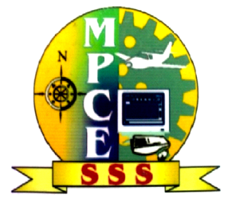

**Seminar Report**

**On**

**“ CLOUD COMPUTING ”**

**Presented By**

**Tejaswini S. Akulwar**

**Vaishanavi J. Mishra**

**Rajshree P. Sakhare**

**Guided by**

**Prof. Satish Pusdekar**

**CONTENTS:-**

**1. Introduction**

**2. What is cloud computing?**

**3. Why move to the cloud?**

**4. Service models**

**5. Development models**

**6. Architecture of cloud computing**

**7. Benefits of cloud computing**

**8. Advantages**

**9. Disadvantages**

**10. Conclusion**

**11. References**

**CLOUD COMPUTING**

**ABSTRACT**

This paper describes cloud computing, a computing platform for the next generation of the Internet. The paper defines clouds, explains the business benefits of cloud computing, and outlines cloud architecture and its major components.

***Cloud computing*** is Internet based development and use of computer technology, whereby dynamically scalablevirtualised resourcesare provided “servicesover the internet. Users need not have knowledge of, expertise in, or control over the technology infrastructure that supports them. The concept incorporates software as a service (SaaS), Web 2.0 and other recent, well-known technology trends, in which the common theme is reliance on the Internet for satisfying the computing needs of the users. An often-quoted example is Google Apps, which provides common business applications online that are accessed from a web browser, while the software and data are stored on Google servers. The *cloud* is a metaphor for the Internet, based on how it is depicted in computer network diagrams, and is an abstraction for the complex infrastructure it conceals.

**INTRODUCTION:-**

**Cloud computing** is the use of computing resources (hardware and software) that are delivered as a service over a network (typically the Internet). The name comes from the use of a cloud-shaped symbol as an abstraction for the complex infrastructure it contains in system diagrams. Cloud computing entrusts remote services with a user's data, software and computation.

The origin of the term cloud computing is obscure, but it appears to derive from the practice of using drawings of stylized clouds to denote networks in diagrams of computing and communications systems. The word cloud is used as a metaphor for the Internet, based on the standardized use of a cloud-like shape to denote a network on telephony schematics and later to depict the Internet in computer network diagrams as an abstraction of the underlying infrastructure it represents.

The ubiquitous availability of high-capacity networks, low-cost computers and storage devices as well as the widespread adoption of hardware virtualization, service-oriented architecture, autonomic, and utility computing have led to a tremendous growth in cloud computing.

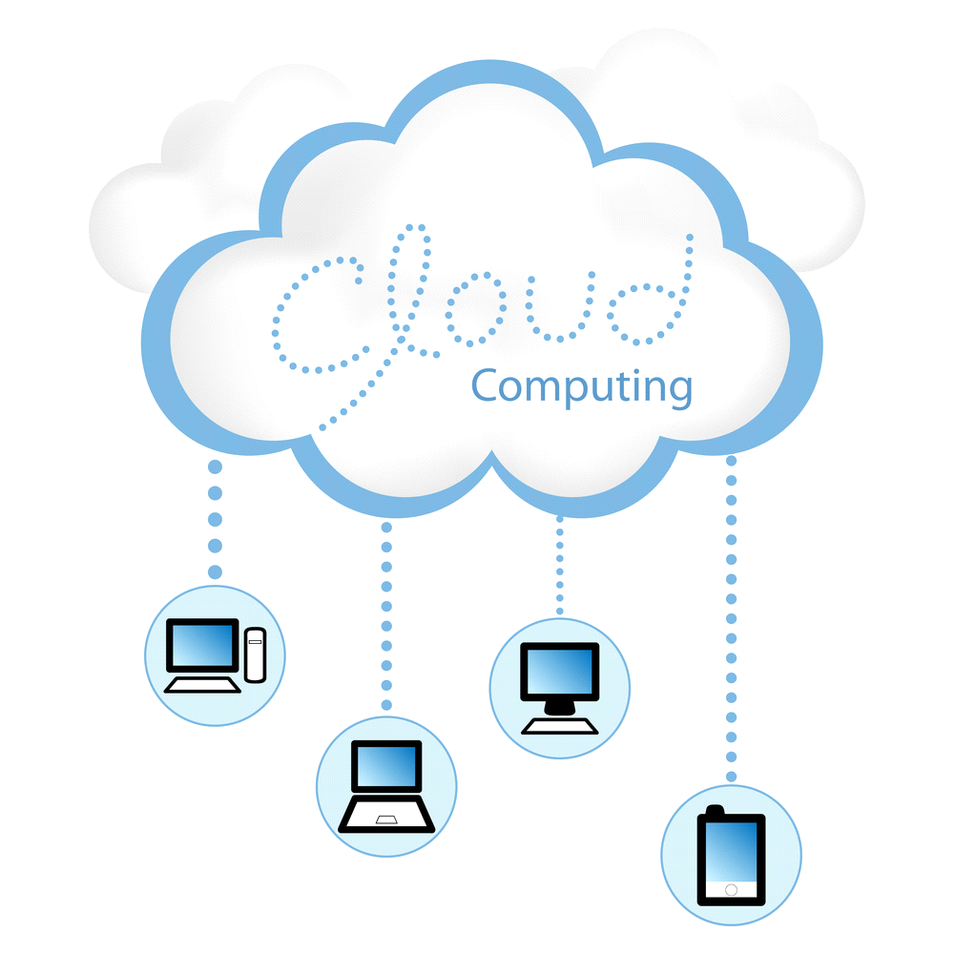

**WHAT IS CLOUD COMPUTING?**

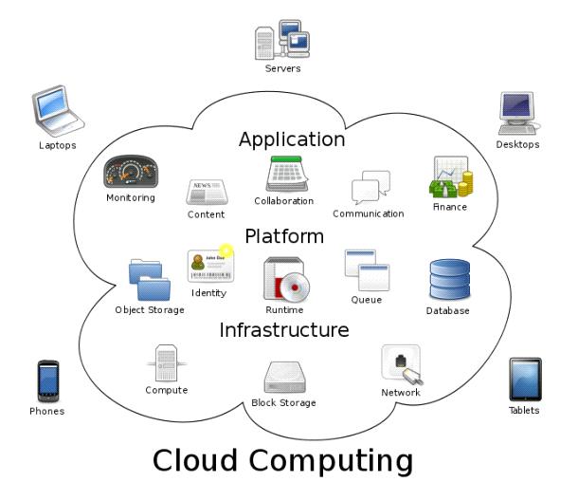

Cloud computing is the next stage in the Internet's evolution, providing the means through which everything — from computing power to computing infrastructure, applications, business processes to personal collaboration — can be delivered to you as a service wherever and whenever you need.

The “cloud” in cloud computing can be defined as the set of hardware, networks, storage, services, and interfaces that combine to deliver aspects of computing as a service. Cloud services include the delivery of software, infrastructure, and storage over the Internet based on user demand.

Cloud computing has four essential characteristics: elasticity and the ability to scale up and down, self-service provisioning and automatic deprovisioning application programming interfaces (APIs), billing and metering of service usage in a pay-as-you-go model. This flexibility is what is attracting individuals and businesses to move to the cloud.

Cloud computing can completely change the way companies use technology to service customers, partners, and suppliers. Some businesses, such as Google and Amazon, already have most of their IT resources in the cloud. They have found that it can eliminate many of the complex constraints from the traditional computing environment, including space, time, power, and cost.

**WHY MOVE TO CLOUD COMPUTING?**

Simply put, cloud computing is computing based on the internet. Where in the past, people would run applications or programs from software downloaded on a physical computer or server in their building, cloud computing allows people access the same kinds of applications through the internet. It is a solution growing in popularity, especially amongst SMEs. The CRN predicts that by 2014, small businesses will spend almost $100 billion on cloud computing services.

**Service Models**

Cloud computing providers offer their services according to several fundamental models: infrastructure as a service (IaaS), platform as a service (PaaS), and software as a service (SaaS) where IaaS the most basic and each higher model abstracts from the details of the lower models. In 2012, network as a service (NaaS) and communication as a service (CaaS) were officially included recognised by ITU (International Telecommunication Union) as part of the basic cloud is computing models service categories of a telecommunication-centric cloud ecosystem.

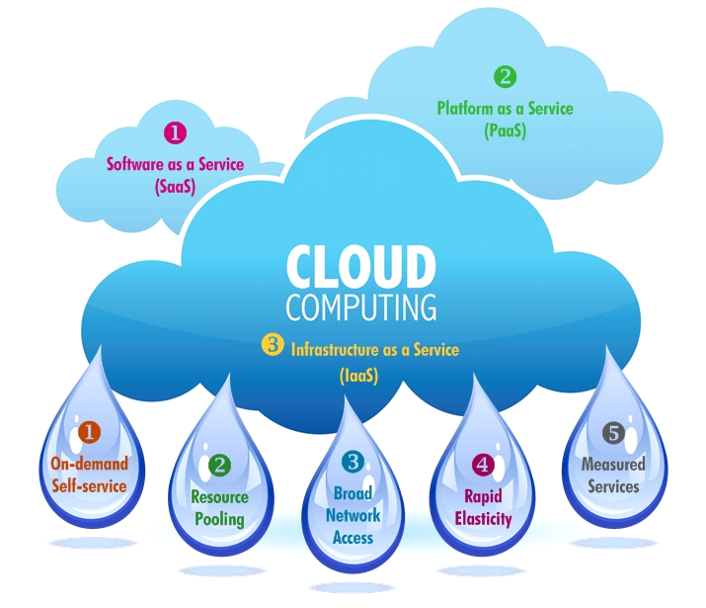

**a.Infrastructure as a service (Iaas)**

Infrastructure as a service is taking the physical hardware and going completely virtual (e.g. all servers, networks, storage, and system management all existing in the cloud). This is the equivalent to infrastructure and hardware in the traditional (non-cloud computing) method running in the cloud. In other words, businesses pay a fee (monthly or annually) to run virtual servers, networks, storage from the cloud. This will mitigate the need for a data center, heating, cooling, and maintaining hardware at the local level.

**b. Platform as a service (PaaS)**

. In the PaaS model, cloud providers deliver a computing platform typically including operating system, programming language execution environment, database, and web server. Application developers can develop and run their software solutions on a cloud platform without the cost and complexity of buying and managing the underlying hardware and software layers. With some PaaS offers, the underlying computer and storage resources scale automatically to match application demand such that cloud user does not have to allocate resources manually

**c. Software as a service (SaaS)**

In the SaaS model, cloud providers install and operate application software in the cloud and cloud users access the software from cloud clients. The cloud users do not manage the cloud infrastructure and platform on which the application is running. This eliminates the need to install and run the application on the cloud user's own computers simplifying maintenance and support. What makes a cloud application different from other applications is its scalability. This can be achieved by cloning tasks onto multiple virtual machines at run-time to meet the changing work demand. Load balancers distribute the work over the set of virtual machines. This process is transparent to the cloud user who sees only a single access point. To accommodate a large number of cloud users, cloud applications can be multitenant, that is, any machine serves more than one cloud user organization. It is common to refer to special types of cloud based application software with a similar naming convention: desktop as a service, business process as a service, test environment as a service, communication as a service.

**DEVELOPMENT MODELS**

* **Public cloud**

Public cloud applications, storage, and other resources are made available to the general public by a service provider. These services are free or offered on a pay-per-use model. Generally, public cloud service providers like Amazon AWS, Microsoft and Google own and operate the infrastructure and offer access only via Internet (direct connectivity is not offered).

* **Community cloud**

Community cloud shares infrastructure between several organizations from a specific community with common concerns (security, compliance, jurisdiction, etc.), whether managed internally or by a third-party and hosted internally or externally. The costs are spread over fewer users than a public cloud (but more than a private cloud), so only some of the cost savings potential of cloud computing are realized.

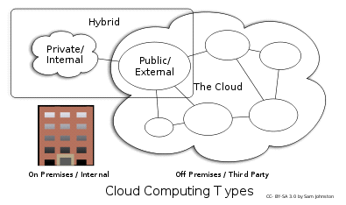

* **Hybrid cloud**

Hybrid cloud is a composition of two or more clouds (private, community or public) that remain unique entities but are bound together, offering the benefits of multiple deployment models.

By utilizing "hybrid cloud" architecture, companies and individuals are able to obtain degrees of fault tolerance combined with locally immediate usability without dependency on internet connectivity. Hybrid cloud architecture requires both on-premises resources and off-site (remote) server-based cloud infrastructure.

Hybrid clouds lack the flexibility, security and certainty of in-house applications. Hybrid cloud provides the flexibility of in house applications with the fault tolerance and scalability of cloud based services.

* **Private cloud**

Private cloud is cloud infrastructure operated solely for a single organization, whether managed internally or by a third-party and hosted internally or externally. Undertaking a private cloud project requires a significant level and degree of engagement to virtualize the business environment, and it will require the organization to reevaluate decisions about existing resources. When it is done right, it can have a positive impact on a business, but every one of the steps in the project raises security issues that must be addressed in order to avoid serious vulnerabilities.

**ARCHITECTURE OF CLOUD COMPUTING**

The Cloud architecture, the systems architecture of the software systems involved in the delivery of cloud computing, typically involves multiple cloud components communicating with each other over a loose coupling mechanism such as a messaging queue. Elastic provision implies intelligence in the use of tight or loose coupling as applied to mechanisms such as these and others.

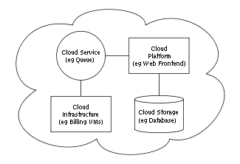

* **Intercloud**

The Intercloud is an interconnected global "cloud of clouds" and an extension of the Internet "network of networks" on which it is based.

* **Cloud engineering**

Cloud engineering is the application of engineering disciplines to cloud computing. It brings a systematic approach to the high-level concerns of commercialization, standardization, and governance in conceiving, developing, operating and maintaining cloud computing systems. It is a multidisciplinary method encompassing contributions from diverse areas such as systems, software, web, performance, information, security, platform, risk, and quality engineering.

**Benefits of cloud computing**

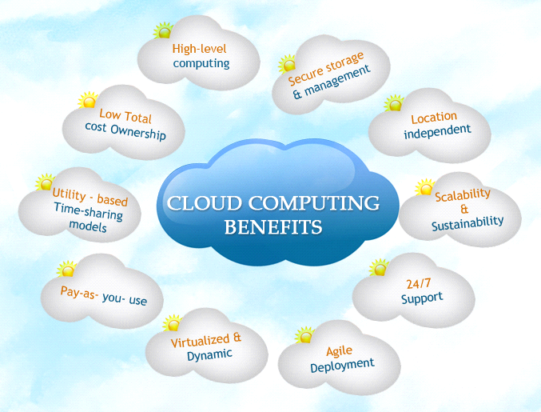

* Achieve economies of scale – increase volume output or productivity with fewer people. Your cost per unit, project or product plummets.
* Reduce spending on technology infrastructure. Maintain easy access to your information with minimal upfront spending. Pay as you go (weekly, quarterly or yearly), based on demand.
* Globalize your workforce on the cheap. People worldwide can access the cloud, provided they have an Internet connection.
* Streamline processes. Get more work done in less time with less people.
* Reduce capital costs. There’s no need to spend big money on hardware, software or licensing fees.
* Improve accessibility. You have access anytime, anywhere, making your life so much easier!
* Monitor projects more effectively. Stay within budget and ahead of completion cycle times.
* Less personnel training is needed. It takes fewer people to do more work on a cloud, with a minimal learning curve on hardware and software issues.
* Minimize licensing new software. Stretch and grow without the need to buy expensive software licenses or programs

**ADVANTAGES OF CLOUD COMPUTING**

* **Cost Efficient**

Cloud computing is probably the most cost efficient method to use, maintain and upgrade. Traditional desktop software costs companies a lot in terms of finance. Adding up the licensing fees for multiple users can prove to be very expensive for the establishment concerned. The cloud, on the other hand, is available at much cheaper rates and hence, can significantly lower the company’s IT expenses. Besides, there are many one-time-payment, pay-as-you-go and other scalable options available, which makes it very reasonable for the company in question.

* **Almost Unlimited Storage**

Storing information in the cloud gives you almost unlimited storage capacity. Hence, you no more need to worry about running out of storage space or increasing your current storage space availability.

* **Backup and Recovery**

Since all your data is stored in the cloud, backing it up and restoring the same is relatively much easier than storing the same on a physical device. Furthermore, most cloud service providers are usually competent enough to handle recovery of information. Hence, this makes the entire process of backup and recovery much simpler than other traditional methods of data storage.

* **Automatic Software Integration**

In the cloud, software integration is usually something that occurs automatically. This means that you do not need to take additional efforts to customize and integrate your applications as per your preferences. This aspect usually takes care of itself. Not only that, cloud computing allows you to customize your options with great ease. Hence, you can handpick just those services and software applications that you think will best suit your particular enterprise.

* **Easy Access to Information**

Once you register yourself in the cloud, you can access the information from anywhere, where there is an Internet connection. This convenient feature lets you move beyond time zone and geographic location issues.

* **Quick Deployment**

Lastly and most importantly, cloud computing gives you the advantage of quick deployment. Once you opt for this method of functioning, your entire system can be fully functional in a matter of a few minutes. Of course, the amount of time taken here will depend on the exact kind of technology that you need for your business.

**Disadvantages of Cloud Computing**

* **Technical Issues**

Though it is true that information and data on the cloud can be accessed anytime and from anywhere at all, there are times when this system can have some serious dysfunction. You should be aware of the fact that this technology is always prone to outages and other technical issues. Even the best cloud service providers run into this kind of trouble, in spite of keeping up high standards of maintenance. Besides, you will need a very good Internet connection to be logged onto the server at all times. You will invariably be stuck in case of network and connectivity problems.

* **Security in the Cloud**

The other major issue while in the cloud is that of security issues. Before adopting this technology, you should know that you will be surrendering all your company’s sensitive information to a third-party cloud service provider. This could potentially put your company to great risk. Hence, you need to make absolutely sure that you choose the most reliable service provider, who will keep your information totally secure.

* **Prone to Attack**

Storing information in the cloud could make your company vulnerable to external hack attacks and threats. As you are well aware, nothing on the Internet is completely secure and hence, there is always the lurking possibility of stealth of sensitive data.

**CONCLUSION:-**

A new kind of application platform doesn’t come along very often. But when a successful platform innovation does appear, it has an enormous impact. The old world doesn’t go away, a new approach can quickly become the center of attention for new applications. Cloud platforms don’t yet offer the full spectrum of an on-premises environment. For example, business intelligence as part of the platform isn’t common, nor is support for business process management technologies such as full-featured workflow and rules engines. This is all but certain to change, however, as this technology wave continues to roll forward.

Cloud platforms aren’t yet at the center of most people’s attention. The attractions of cloud-based computing, including scalability and lower costs, are very real. If you work in application development, whether for a software vendor or an end user, expect the cloud to play an increasing role in your future. The next generation of application platforms is here.

Like everything else, cloud computing too has its pros and cons. While the technology can prove to be a great asset to your company, it could also cause harm if not understood and used properly.

**REFERENCES:-**

* <http://en.wikipedia.org/wiki/Cloud_computing>
* http://www.google.co.in/search?q=cloud+computingHYPERLINK "http://www.google.co.in/search?q=cloud+computing&hl=en&tbm=isch&tbo=u&source=univ&sa=X&ei=VrVGUZ-jJof8rAe1o4HoAw&ved=0CI0BELAE&biw=1366&bih=652"&HYPERLINK "http://www.google.co.in/search?q=cloud+computing&hl=en&tbm=isch&tbo=u&source=univ&sa=X&ei=VrVGUZ-jJof8rAe1o4HoAw&ved=0CI0BELAE&biw=1366&bih=652"hl=enHYPERLINK "http://www.google.co.in/search?q=cloud+computing&hl=en&tbm=isch&tbo=u&source=univ&sa=X&ei=VrVGUZ-jJof8rAe1o4HoAw&ved=0CI0BELAE&biw=1366&bih=652"&HYPERLINK "http://www.google.co.in/search?q=cloud+computing&hl=en&tbm=isch&tbo=u&source=univ&sa=X&ei=VrVGUZ-jJof8rAe1o4HoAw&ved=0CI0BELAE&biw=1366&bih=652"tbm=ischHYPERLINK "http://www.google.co.in/search?q=cloud+computing&hl=en&tbm=isch&tbo=u&source=univ&sa=X&ei=VrVGUZ-jJof8rAe1o4HoAw&ved=0CI0BELAE&biw=1366&bih=652"&HYPERLINK "http://www.google.co.in/search?q=cloud+computing&hl=en&tbm=isch&tbo=u&source=univ&sa=X&ei=VrVGUZ-jJof8rAe1o4HoAw&ved=0CI0BELAE&biw=1366&bih=652"tbo=uHYPERLINK "http://www.google.co.in/search?q=cloud+computing&hl=en&tbm=isch&tbo=u&source=univ&sa=X&ei=VrVGUZ-jJof8rAe1o4HoAw&ved=0CI0BELAE&biw=1366&bih=652"&HYPERLINK "http://www.google.co.in/search?q=cloud+computing&hl=en&tbm=isch&tbo=u&source=univ&sa=X&ei=VrVGUZ-jJof8rAe1o4HoAw&ved=0CI0BELAE&biw=1366&bih=652"source=univHYPERLINK "http://www.google.co.in/search?q=cloud+computing&hl=en&tbm=isch&tbo=u&source=univ&sa=X&ei=VrVGUZ-jJof8rAe1o4HoAw&ved=0CI0BELAE&biw=1366&bih=652"&HYPERLINK "http://www.google.co.in/search?q=cloud+computing&hl=en&tbm=isch&tbo=u&source=univ&sa=X&ei=VrVGUZ-jJof8rAe1o4HoAw&ved=0CI0BELAE&biw=1366&bih=652"sa=XHYPERLINK "http://www.google.co.in/search?q=cloud+computing&hl=en&tbm=isch&tbo=u&source=univ&sa=X&ei=VrVGUZ-jJof8rAe1o4HoAw&ved=0CI0BELAE&biw=1366&bih=652"&HYPERLINK "http://www.google.co.in/search?q=cloud+computing&hl=en&tbm=isch&tbo=u&source=univ&sa=X&ei=VrVGUZ-jJof8rAe1o4HoAw&ved=0CI0BELAE&biw=1366&bih=652"ei=VrVGUZ-jJof8rAe1o4HoAwHYPERLINK "http://www.google.co.in/search?q=cloud+computing&hl=en&tbm=isch&tbo=u&source=univ&sa=X&ei=VrVGUZ-jJof8rAe1o4HoAw&ved=0CI0BELAE&biw=1366&bih=652"&HYPERLINK "http://www.google.co.in/search?q=cloud+computing&hl=en&tbm=isch&tbo=u&source=univ&sa=X&ei=VrVGUZ-jJof8rAe1o4HoAw&ved=0CI0BELAE&biw=1366&bih=652"ved=0CI0BELAEHYPERLINK "http://www.google.co.in/search?q=cloud+computing&hl=en&tbm=isch&tbo=u&source=univ&sa=X&ei=VrVGUZ-jJof8rAe1o4HoAw&ved=0CI0BELAE&biw=1366&bih=652"&HYPERLINK "http://www.google.co.in/search?q=cloud+computing&hl=en&tbm=isch&tbo=u&source=univ&sa=X&ei=VrVGUZ-jJof8rAe1o4HoAw&ved=0CI0BELAE&biw=1366&bih=652"biw=1366HYPERLINK "http://www.google.co.in/search?q=cloud+computing&hl=en&tbm=isch&tbo=u&source=univ&sa=X&ei=VrVGUZ-jJof8rAe1o4HoAw&ved=0CI0BELAE&biw=1366&bih=652"&HYPERLINK "http://www.google.co.in/search?q=cloud+computing&hl=en&tbm=isch&tbo=u&source=univ&sa=X&ei=VrVGUZ-jJof8rAe1o4HoAw&ved=0CI0BELAE&biw=1366&bih=652"bih=652
* <http://en.wikipedia.org/wiki/Cloud_computing_architecture>
* Anthony T. Velte, Toby J. Velte, Robert Elsenpeter ; Tata Mc Graw-Hill Edition 2010.
* Babcock, Charles (June 22, 2011.) ["'Engineering Cloud' Promises To Modernize Manufacturing](http://www.informationweek.com/news/cloud-computing/software/231000147)
* Madden, B. (May 19, 2012) (2010-05-19). "Wyse hopes to shake up the thin client industry with a new zero client platform. Will it work?". Retrieved 2012-05-27.