###### “Monitoring system for Distribution Transformer Using GSM Technology”

Abhilesh S Saxena Ram H Adware

Student, Electrical Department Asst .Professor, Electrical Department

G.H .Raisoni College of Engineering G.H .Raisoni College of Engineering

Nagpur, India Nagpur, India

abhilesh.saxena@gmail.com (9860447924) ram. adware@gmail.com (9766832639)

Abstract - In normal ways all the Industrial or Electrical machineries are controlled by the manual operation. Hence there is step by step progress but most of the time there is not actually instant co-operation between system and operator in case of emergency or fault type situation .Therefore we are designing a system where there exits communication between system and operator. For this we are using Transformer, microcontroller, analog to digital converter, and GSM i.e. global system for mobile communication modem. This GSM modem helps to monitor transformer health by sending massage to the system. As we know Distribution transformer is a major component of power system and its correct functioning is vital to system operations. To reduce the risk of unexpected failure and the ensuring unscheduled outage, on-line monitoring has become the common practice to assess continuously the condition of the transformer with. This paper presents design and implementation of a mobile embedded system to monitor and record key operation of a distribution transformer like overvoltage, over current, temperatures, certain gas evolved and rise or fall of oil level. Also it is important to keep an eye on transformer health when operator is not present actually at transformer site so we are introducing system named as two way communication systems between transformer and operator through GSM modem where person can ask any related parameter value of transformer health by sending massage to the system. This system can be designed to send SMS alerts whenever the circuit tips or related parameter value exceeds the predefined limits.

Keywords: Distribution transformer, Faults in transformer, Microcontroller, ADC converter, GSM modem, Two way communication

# I.INTRODUCTION

It is very important to closely monitor the transformer in-service behavior to avoid costly outages and loss of production. It is well known that to maintain the system reliability it is necessary to protect the transformer from different abnormality condition i.e. faults. Distribution Transformers have a long service life if they are operated under rated conditions. However, their life is significantly reduced if they are overloaded, resulting in unexpected failures and loss of supply to a large number of customers thus effecting system reliability. Online monitoring of key operational parameters of distribution transformers can provide useful information about the health of transformers which will help the utilities to optimally use their transformers and keep the asset in operation for a longer period. This will also help identify problems before any catastrophic failure which can result in a significant cost savings and greater reliability.

II.BACKGROUND AND LITERATURE SURVEY

1. Most power companies use Supervisory Control and Data Acquisition (SCADA) system for online monitoring of power transformers but extending the SCADA system for online monitoring of distribution transformers is an expensive proposition.

2. Distribution transformers are currently monitored manually where a person periodically visits a transformer site for maintenance and records parameter of importance. This type of monitoring cannot provide information about occasional overloads and overheating of transformer oil and windings. All these factors can significantly reduce transformer life. A number of techniques are currently being used for offline as well as online monitoring of power transformers.

3. In other conventional system, the protection relay equipment serves as a server, the PC in an office serves as a client, and the PC and relay equipment communicate by 1 to 1. We can perform and follows some personal computer in an office; download of the voltage and current data stored in the relay equipment when relay equipment is activated by some power failure; checking and changing the setting values of the protection relay; detecting an abnormal occurrence and the relay activation caused by power system faults. As an excellent information terminal which can acquire the real time data from a power system. It is important that the information in a relay can be easily accessed from an office and of which mechanism for performing the function described above is simple. The PC and protection relay equipment are connected with the relations of 1 to 1, and while operating this system, it is necessary that the operator looks at the PC browser continually all the time. Moreover, in order to acquire information from a numbers of relay equipment, an operator must specify the address of each relay to access them in turn, which is complicated and time consuming. Furthermore, in this system, even when relays are connected within the same network, the relays cannot communicate and cooperate with each other. That is to say, relay equipment works only as a server providing data to PCs located in the remote office. Following fig shows such methods.

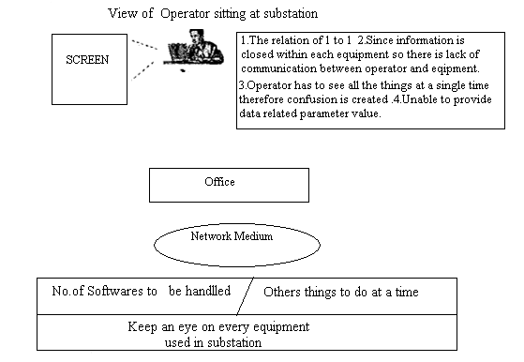

Fig.1.Conventional System

III.BLOCK DIAGRAM

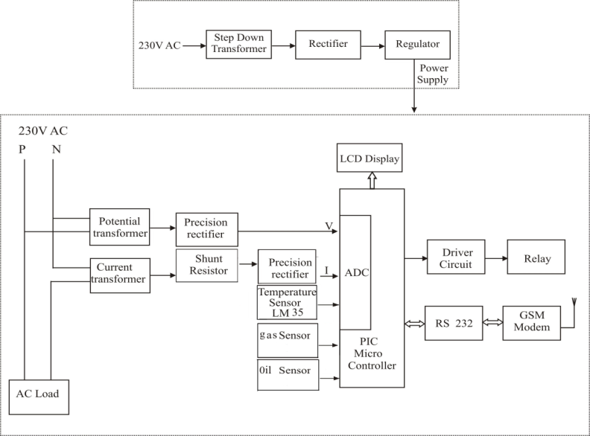

Fig.2.Block Diagram

IV.PROPOSED TECHNOLOGY

The proposed methodology is based on Robust GSM technology meets safety reliability and fastest in operation. It consists of a sensing system, signal conditioning electronic circuit, microcontroller 16F877A processor, and GSM modem. It is installed at the transformer site and the finding parameters recorded using the analog to digital converter (ADC) of the embedded system. The acquired parameters are processed and recorded in the system memory. If there is any abnormality or an emergency situation the system sends SMS (Short Message Service) messages to designated mobile telephones containing information about the abnormality. This mobile system will help the system to run under reliable condition and identify problems before any failure. For above result we are using a small step down transformer of 12 V, 1 Amps rating and small bulb are connected as a load. In this project we are using CT transformer for measuring load current. Also we are using Temp. Sensor LM32 for giving any rise of temperature, Gas sensor which sense gas particularly for this used gas is methane, one level sensor is also used which detects any fall of oil level. The values of voltage, current and temperature and level of oil of the transformer is directly applied to one of the input ports of the microcontroller. Along with this, a display is connected in the input port of the microcontroller. The GSM transmitting section and the load variation control are connected to the one of the output ports in the microcontroller. The microcontroller at the substation monitors and captures the current, voltage and temperature values for a particular period of time interval. The captured values are stored in the data register and displayed using the LCD display. All these parameter are converted into digital value by using ADC. If the parameter value of the transformer is exceed their predefined value then the transformer will automatically shut down and in this way transformer life will be increased. We also designed Two-way communication here by which we can ask system about given parameter value just by sending SMS to it so that we can have watch over transformer .For this it is not necessary for the operator to sit in the system premises which was the case at conventional system.

V.ADVANTAGES

1. Devices can be operated from anywhere in the world.

2. Efficient and low cost design.

4. Low power consumption.

5. Real time monitoring.

VI.DISADVANTAGES

1 Depends on the network signal strength.

2 Sometimes it may happened that due to weak signal massage cannot be send at quick instant. But this problem is not for so much time period.

VII.APPLICATIONS

1. This system can be implemented in industries.

2. This system can be used to monitoring and controlling the home appliances.

VIII.REASULT

The project GSM Based SCADA Monitoring and Control System Substation Equipment was designed such that the devices can be monitored and also controlled from anywhere in the world using GSM modem connected to mobile phone.

IX.CONCLUSION

Due to increased load of power system it is necessary to maintain communication between transformer health and operator so that any kind of abnormality doesn’t cause large harm to the system. All data transfer must be important to keep transformer healthy and power system reliability too. Use of Automation system makes such things possible very easily. Also automation system has less manual operation more accurate. Use of GSM technique provides speed of communication with distance independentancy also it enables bidirectional communication as a massage.

X.FUTURE SCOPE

This system can be used for mobile reporting application only. However this system can be used to interface with computer to record and data base

XI.REFERENCES

XI.REFERENCES

[1] Prof. M. S. Sujatha, Dr. M Vijaykumar on Line Monitoring and Analysis of Faults in transmission and Distribution lines using GSM technique ISSN: 1992-8645 Journal of Theoretical and Applied Information Technology 30th November 2011. Vol. 33 No.2

[2] Mr. D.Radhakrishnan , V.Seenivasan Power Distribution system monitoring and control using GSM Modem and RF International Conference on Computing and Control Engineering (ICCCE 2012), 12 & 13 April, 2012.

[3] Amit Sachan GSM Based SCADA Monitoring and control system substation equipment International Journal of Engineering Research & Technology (IJERT) ISSN: 2278-0181 Vol. 1 Issue 5, July – 2012

[4] Abdul-Rahman AI-Ali, Abdul Khaliq & Muhammad Arshad, “GSM-Based Distribution Transformer Monitoring System ’’Dubrovnik, Crotia MELECON 2004

[5] Constantine Daniel Oancea, Member, IEEE GSM Infrastructure Used for Data Transmission’ The 7 th international symposium on advanced topic in electrical engineering, Bucharest May 11-14 2011

[6] Anuradh Kumar , Ashish Raj , Balwant Kumar Method for Monitoring of Distribution Transformer Dr. M.G.R, Educational and Research Institute, University, Chennai-600095 Undergraduate Academic Research Journal (UARJ), ISSN: 2278 – 1129, Volume-1, Issue-3,4, 2012

[7] Ritesh Gupta, Mukti Awad PIC Controller based process control system using GSM ISSN: 2278 – 1323 International Journal of Advanced Research in Computer Engineering &Technology Volume 1, Issue July 2012

[8]Amit Sachan Microcontroller Based Substation Monitoring and Control System with GSM Modem IOSR Journal of Electrical and Electronics Engineering (IOSRJEEE) ISSN: 2278-1676 Volume 1, Issue 6 (July-Aug. 2012), PP 13-21 www.iosrjournals.org.

