I II III
P.A.SHINDE T.WANKEDE R.Kr.RAM
K.D.K.C.E. Nagpur, Maharashtra.
payal.shinde.21101991@gmail.com rs05119@gmail.com

Abstract-Winding machine is an essential system in industries and shops locally situated. Different ranges of machines are available from motor winding to ceiling fan winders also transformer winders .All those require a steady hand to lay down the wire on the coil. The winder really has no idea of number of windings to be wound on the coil. We wanted to have an automatic coil winder that could be set up and finished coil even if unattended. Moreover winding coil on any machine be it a simple solenoid to motors and transformers need great precision and accuracy. If done with human effort, it demands even more concentration to skillfully wind each turn and remember the number of turns wound out of the required turns and so is time consuming and prone to errors. A solution to these problems is the Automatic Winding Machine that automates the entire process using components like microcontroller, dc motors, drivers , sensors, etc. and intelligently stops winding if a coil breaks in the course and is cost effective.

Keywords -Microcontroller , Dc motors, Driver, Sensors.

I. INTRODUCTION

Automatic coil winding machine works effectively for all type of domestic motors and induce such a feature in the machine so that it has no risk of the wires snagging and breaking. We are using components that facilitate our purpose by employing a memory circuit which set the number of turns required automatically and it also controls the circuit.
We have incorporated components like memory circuit to take care of the counting of turns. Studies has been conducted to decide the sensors to be used according to their utility which empowered us to select the sag sensor ,the magnetic and proximity sensor to avert trespassing frame by the wining and the machines response in case of breakage. on similar grounds of quality are used the drivers to adjust the required speed of the winders .thus the automatic coil winding machine is a smart device assisting speedy and efficient winding of coil along with the benefits of low initial and maintenance cost.
A deliberate effort has been made to inhibit the wastage of energy in case of breakage or end of a coil. To

take care of the designing aspect from economic point of view we have worked to reduce the maintenance cost and adjusting into today s energy deficient scenario the device consumes less electricity.

II. BLOCK DIAGRAM
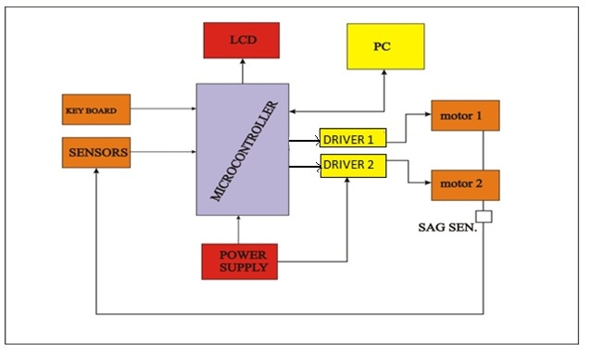
Fig1:.Block Diagram of Multipurpose Automatic Coil Winding Machine

A. BLOCK DIAGRAM DESCRIPTION:

The various components used in the block diagram are Microcontroller, Driver IC, DC Motor as motor-1, and Stepper motor as motor-2, Sensors, LCD, Keyboard and PC as input devices and power supply. The above components with their features are discussed below:

A.1 8-bit Microcontroller with 8K Byte In-System Programmable Flash AT89C51

A.1.1.. Features:
• Compatible with MCS-51® Products
• 8K Bytes of In-System Programmable (ISP) Flash
– Endurance: 1000 Write/Erase Cycles
• 4.0V to 5.5V Operating Range
• Fully Static Operation: 0 Hz to 33 MHz
• Three-level Program Memory Lock
• 256 x 8-bit Internal RAM
• 32 Programmable I/O Lines
• Three 16-bit Timer/Counters
• Eight Interrupt Sources
• Full Duplex UART Serial Channel
• Low-power Idle and Power-down Modes
• Interrupt Recovery from Power-down mode
• Watchdog Timer
• Dual Data Pointer
• Power-off Flag

A.1.2 Description:
The AT89S52 is a low-power, high-performance CMOS 8-bit microcontroller with 8K bytes of in-system programmable Flash memory. The device is manufactured using Atmel’s high-density nonvolatile memory technology and is compatible with the industry-standard 80C51 instruction set and pinout. The on-chip Flash allows the program memory to be reprogrammed in-system or by a conventional nonvolatile memory programmer. By combining a versatile 8-bit CPU with in-system programmable Flash on a monolithic chip, the Atmel AT89S52 is a powerful microcontroller which provides a highly-flexible and cost-effective solution to many embedded control applications.

Fig2: AT89S51 Microcontroller 40 pin IC
The AT89S52 provides the following standard features: 8K bytes of Flash, 256 bytes of RAM, 32 I/O lines, Watchdog timer, two data pointers, three 16-bit timer/counters, a six-vector two-level interrupt architecture, a full duplex serial port, on-chip oscillator, and clock circuitry. In addition, the AT89S52 is designed with static logic for operation down to zero frequency and supports two software selectable power saving modes.The Idle Mode stops the CPU while allowing the RAM, timer/counters, serial port, and interrupt system to continue functioning. The power-down mode saves the RAM contents but freezes the oscillator, disabling all other chip functions until the next interrupt or hardware reset.

A.2 8-bit A/D and D/A converter

3.2.1 Features:
• Single power supply
• Operating supply voltage 2.5 V to 6 V
• Low standby current
• Serial input/output via I2C-bus
• Address by 3 hardware address pins
• Sampling rate given by I2C-bus speed
• 4 analog inputs programmable as single-ended
• Auto-incremented channel selection
• Analog voltage range from VSS to VDD
• On-chip track and hold circuit
• 8-bit successive approximation A/D conversion
• Multiplying DAC with one analog output.

A.2.2 Discription:
The PCF8591 is a single-chip, single-supply low power 8-bit CMOS data acquisition device with four analog inputs, one analog output and a serial I2C-bus interface. Three address pins A0, A1and A2 are used for programming the hardware address address, allowing the use of up to eight devices connected to the I2C-bus without additional hardware. Address, control and data to and from the device are transferred serially via the two-line bidirectional I2C-bus.

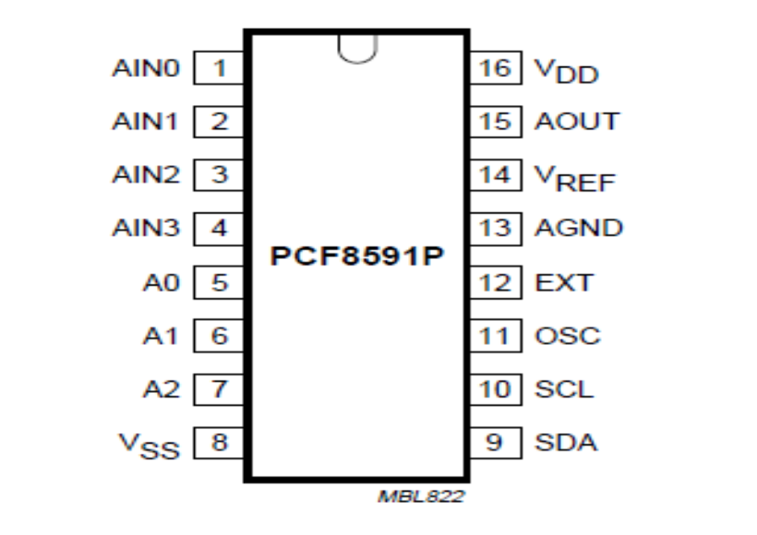
Fig 3: PCF8591 8 Bit A/D & D/A converter 16 Pin IC

The functions of the device include analog input multiplexing on-chip track and hold function, 8-bit analog-to-digital conversion and an 8-bit digital-to-analog conversion. The maximum conversion rate is given by the maximum speed of the I2C-bus.

A.3: PUSH-PULL Four Channel driver with diodes

A.3.1 Features:
• 600mA output current capability per channel
• 1.2A Peak output current (non repetitive) per channel
• Enable facility
• Over temperature protection
• Logical 0 input voltage upto1.5 V (High noise immunity)
• Internal clamp diodes

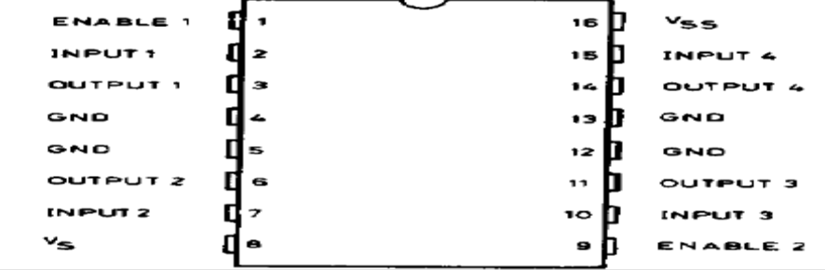

Fig 4: Push-Pull Four Channel Driver 16 Pin IC

A.3.2 Description:
The Device is a monolithic integrated high voltage, high current four channel driver designed to accept standard DTL or TTL logic levels and drive inductive loads (such as relays solenoides, DC and stepping motors) and switching power transistors. To simplify use as two bridges each pair of channels is equipped with an enable input.
A separate supply input is provided for the logic, allowing operation at a lower voltage and internal clamp diodes are included. This device is suitable for use in switching applications at frequencies up to 5 kHz. The L293D is assembled in a 16 lead plastic package which has 4 centre pins connected together and used for heat sinking The L293DD is assembled in a 20 lead surface mount which has 8 Centre pins connected together and used for heat sinking.

A.4: Positive voltage regulator:

A.4.1 Features:
• Output current upto1.5A
• Output voltages of 5; 5.2; 6; 8; 8.5; 9; 12;15; 18; 20; 24V
• Thermal overload protection .
• Short circuit protection
• Output transistor SOA protection

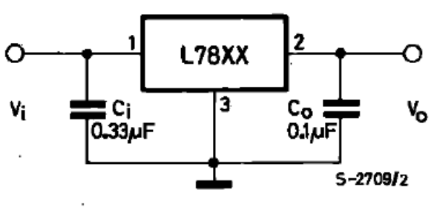

Fig 5: Positive voltage regulator

A.4.2 Description:
The L7800 series of three-terminal positive regulator is available in TO-220, ISOWATT220 and TO-3 packages and with several fixed output voltages making it useful in a wide range of applications.These regulators can provide local on-card regulation, eliminating the distribution problems associated with single point regulation.
Each type employs internal current limiting, thermal shut-down and safe area protection, making it essentially indestructible. If adequate heat sinking is provided, they can deliver over 1A output current. Although designed primarily as fixed voltage regulators, these devices can be used with external components to obtain adjustable voltages and currents.

A.5 Receiver IC or MAX-232:

A.5.1 Features:
• Meets or exceeds TIA/EIA-232-F and ITU recommendati-
on V.28
• Operates From a Single 5-V Power supply with charge-
pump capacitors
• Operates Up To 120 Kbits
• Two Drivers and Two Receivers
• ±30-V Input Levels

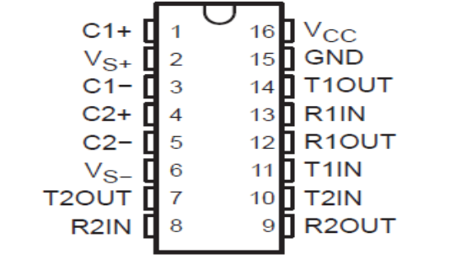 Fig 5: Receiver 16 pin IC

A.5.2Discribtion:
The MAX232 is a dual driver/receiver that includes a capacitive voltage generator to supply TIA/EIA-232-F voltage levels from a single 5-V supply. Each receiver converts TIA/EIA-232-F inputs to 5-V TTL/CMOS levels. These receivers have a typical threshold of 1.3 V, a typical hysteresis of 0.5 V, and can accept ±30-V inputs.Each driver converts TTL/CMOS input levels into TIA/EIA-232-F levels. The driver, receiver, and voltage-generator functions are available as cells in the Texas Instruments LinASIC library.

A.6 Sensors:

A.6.1. Proximity Sensor :
A proximity sensor is a sensor able to detect the presence of nearby objects without any physical contact. A proximity sensor often emits an electromagnetic field or a beam of electromagnetic radiation (infrared, for instance), and looks for changes in the field or return signal. The object being sensed is often referred to as the proximity sensor's target. Different proximity sensor targets demand different sensors. For example, a capacitive photoelectric sensor might be suitable for a plastic target; an inductive proximity sensor always requires a metal target.
The maximum distance that this sensor can detect is defined "nominal range". Some sensors have adjustments of the nominal range or means to report a graduated detection distance Proximity sensors can have a high reliability and long functional life because of the absence of mechanical parts and lack of physical contact between sensor and the sensed object.

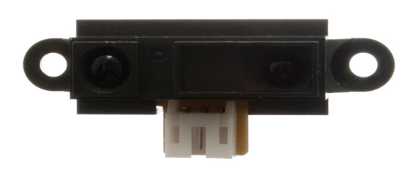
Fig 6: Proximity Sensor

Proximity sensors are also used in machine vibration monitoring to measure the variation in distance between a shaft and its support bearing. This is common in large steam turbines, compressors, and motors that use sleeve-type bearings. A proximity sensor adjusted to a very short range is often used as a touch switch.

A.6.2 LIMIT SWITCH:
In electrical engineering a limit switch is a switch operated by the motion of a machine part or presence of an object. They are used for control of a machine, as safety interlocks, or to count objects passing a point.

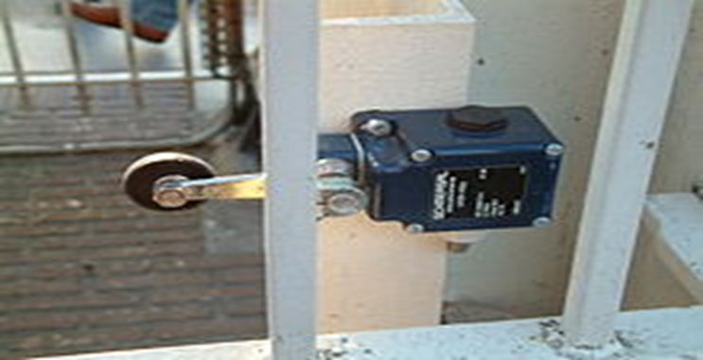

Fig 7: Limit Switch

A limit switch with a roller-lever operator; this is installed on a gate on a canal lock, and indicates the position of a gate to a control system.standardized limit switches are industrial control components manufactured with a variety of operator types, including lever, roller plunger, and whisker type. Limit switches may be directly mechanically operated by the motion of the operating lever. A reed switch may be used to indicate proximity of a magnet mounted on some moving part. The class of proximity switches operates by the disturbance of an electromagnetic field, by capacitance, or by sensing a magnetic field (e.g., a Hall-effect sensor).Rarely, a final operating device will be directly controlled by the contacts of an industrial limit switch, but more typically the limit switch will be wired through a control relay, a motor contactor control circuit, or as an input to a programmable logic controller.
Miniature snap-action switch may be used for example as components of such devices as photocopiers or computer printers, to ensure internal components are in the correct position for operation and to prevent operation when access doors are opened. A set of adjustable limit switches are installed on a Garage door opener to shut off the motor when the door has reached the fully raised or fully lowered position. A numerical control machine such as a lathe will have limit switches to identify maximum limits for machine parts or to provide a known reference point for incremental motions.

A.7: D.C. MOTOR:

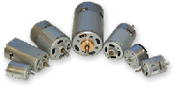
Fig 8: 12V D.C. Motor

The small Brush 12v DC Motor was designed for high volume OEM applications with low cost being the primary objective. The Small Brush 12v DC Motor comes in sizes from 0.29" to 3.6" diameter. Anaheim Automation also offers a line of quality Permanent Magnet 56C 12v DC Motor products available in many different Horsepower levels, ranging from 1/2 all the way to 1 horsepower with various operating voltages. Larger in size, these motors can deliver torque from 288 to 576 oz-in. Custom options include optimizing the maximum speed, torque, current, voltage, cabling, wiring, connectors, and shaft modifications.
With our Brush 12v DC Motor products you get great quality, great customer service, and competitive prices. Please note that not all small dc motors are stock items, and that minimum purchases will be required for most part numbers listed. However, for most applications, going to another dc motor series, or just a size larger, may provide the solution for your requirements.
A.8 Stepper Motor:
A stepper motor (or step motor) is a brushless DC electric motor that divides a full rotation into a number of equal steps. The motor's position can then be commanded to move and hold at one of these steps without any feedback sensor (an open-loop controller), as long as the motor is carefully sized to the application.Switched reluctance motors are very large stepping motors with a reduced pole count, and generally are closed-loop commutated. DC brush motors rotate continuously when voltage is applied to their terminals.
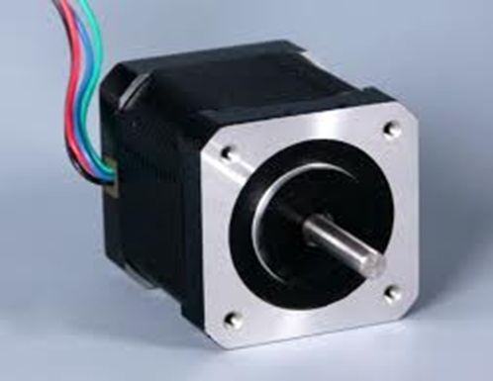
Fig 9: 12V Stepper Motor

Stepper motors, on the other hand, effectively have multiple "toothed" electromagnets arranged around a central gear-shaped piece of iron. The electromagnets are energized by an external control circuit, such as a microcontroller. To make the motor shaft turn, first, one electromagnet is given power, which makes the gear's teeth magnetically attracted to the electromagnet's teeth. When the gear's teeth are aligned to the first electromagnet, they are slightly offset from the next electromagnet. So when the next electromagnet is turned on and the first is turned off, the gear rotates slightly to align with the next one, and from there the process is repeated. Each of those slight rotations is called a "step", with an integer number of steps making a full rotation. In that way, the motor can be turned by a precise angle.

III.CIRCUIT DIAGRAM

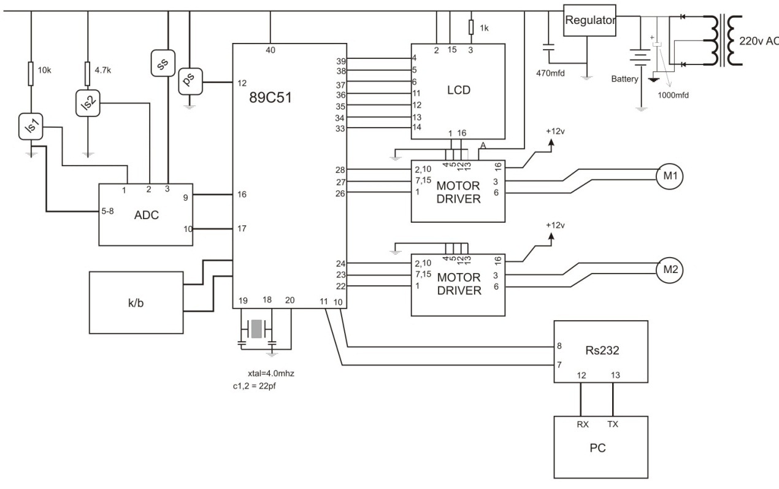
Fig10: Circuit Diagram of Multipurpose Automatic Coil
Winding Machine
The aim of our project is to automatically wind the coil. To do this we use DC motors, ADC,LCD Initially we load Number of turns required to the microcontroller, further microcontroller give ON command to the motor1 which is main winding motor, a speed sensor(ps) counts the number of rotations, limit switch 1 and 2(ls1,2) monitors left and right limits of horizontal transverse motor, if left switch pressed the microcontroller reverse the direction of transverse motor(m2) and if right switch pressed the microcontroller reverse the direction again. Slag sensor (ss) keeps monitoring on any wire breakages. If at any moment the winding conductor ‘ENDs’ or ‘BREAK’ microcontroller suddenly stopped all the executions .As microcontroller is not able to read analog signals,We used ADC to monitor all the sensor outputs which is in analog state and these analog signals will converted into digital format by ADC and give it to the microcontroller. All the operations are displayed on LCD. We used alpha numeric LCD. 1) number of counts elapsed
2) number of counts to be load
3) traverse motor limit switch
4) main motor running status(START OR STOPPED)

Keyboard:- Keyboard is used to load number of counts into the Microcontroller.0 – 9 ,set,clear.

Motor driver :- As microcontroller cannot drive a heavy load like motors directly, because microcontroller can give upto 3.3volt and 20ma maximum at its port output, hence driver IC convert this low strength signal to sufficient level signals. In our project we used to motor driver one is for winding motor and other is for transverse motor.

RS-232:- This IC is used to interface microcontroller and PC. RS232 is acts as a buffer and amplifier. We cannot keeps PC very near to winding machine because in winding machine there are active inductive loads which results hysteresis , this hysteresis may affect the working of PC , hence if we keep a large distance between both of this it causes voltage losses, hence to overcome this losses RS232 is used.
The buffer circuit is used to protect both the devices from either side faults, means if microcontroller fails it will not affect the operation of PC and vice versa.

Regulator :- As microcontroller is low voltage device and all the digital circuits works on 0 & 5 volts DC, hence regulator IC converts a 12 volt DC to a stabilized 5 volt DC.

Transformer :- This is used to convert 220v AC to 12V AC Further this 12 V AC is converted to 12 v DC by using a diode as rectifier.

Battery:- Battery is used to keep alive all the system in case of main power supply failure.
IV.ADVANTAGES

1. This device works effectively for all type of domestic
motors like fan motors ( i.e. ceiling , table and cooler),
transformers , mixer-grinder etc.
2. It has the facility to restart from the same count where it
stopped.
3. No risk of the wires snagging and breaking.
4. Any untrained person can operate.
5. It also has a memory circuit in which it is possible to set
the number of turns required before hand and which
automatically stops after completion of the desired
number of rounds/turns.
6. Can do efficient and qualitative work for sufficient long
time.
7. Controls the wastage of energy in case of breakage or end
of a coil.
8. Continuity of operation can be maintained even though
there is power failure.
9. The maintenance cost is very low and the device
consumes less electicity.
10. Saves the time.

V.APPLICATIONS

1. This device works effectively for all type of domestic
motors like fan motors (i.e. ceiling fan, table fan,coolers)
transfrmers, mixer grinders etc.

2. It is equally useful for large factories as well as small
Indivisual binders.

VI.CONCLUSION

The proposed automatic coil winding machine serves as a key element for winding the coil efficiently and accurately for all types of motors and transformers. It is advantageous over the other existing time consuming coil winding methods wherein the winding gets coiled in a reduced amount of time. It also has the advantage of minimized cost and minimal maintenance cost. The power is saved in case of anomaly. The entire automated process being user friendly increases the utility manifold. The potential displayed by this machine to free child labour and human effort is most praiseworthy.

VII.REFERENCES

[1]. Kailash Srivastav, National Innovation Foundation-India, An autonomous body of department of science and technology, Govt. of India. “Automatic Motor Winding Machine”.

[2]. Robert Lang, “High Stepping Automatic Coil Winder”,
NUTS & VOLTS.

[3]. Dr. P.S Bimbhra, “Electrical Machinery”, Khanna
Publications.

[4]. Ray A.K. & Bhurchandi K.W., “Advanced Microprocessors and Peripherals”, Tata McGraw Hill Publications.

 

