1 2
K.A.AMBHORKAR S.S.FAGNE
K.D.K.C.E. Nagpur, Maharashtra.
komal.ambhorkar14@gmail.com sampadafagne@gamail.com

Abstract-. There is a strong trend in the photovoltaic inverter topology to use transformerless topologies in order to acquire higher efficiencies combining with very low ground leakage current. The relative weight of the energy generated by means of renewable sources is constantly increasing. Among all these sources, the photovoltaic systems present the higher and more stable relative growth. However, the PV system is still too expensive and a significant effort is being done to increase the efficiency and reduce the cost. In this paper we are compared different topology on a basis of efficiency curve. The proposed topology will give high efficiency and low leakage current of PV inverter.This paper is to analyze and compare the most common single-stage transformerless PV inverter topologies for single-phase with respect to the leakage current generation.

Keywords — Photovoltaic inverter, Galvanic isolation, Ground leakage current, parasitic capacitance.

I. INTRODUCTION

Photovoltaic (PV) inverters become more and more widespread within both private and commercial circles. These grid-connected inverters convert the available direct current supplied by the PV panels and feed it into the utility grid. According to the latest report on installed PV power, during 2007, there has been a total of 2.25GWof installed PV systems, out of which the majority (90%) has been installed in Germany, Spain, U.S., and Japan. At the end of 2007, the total installed PV capacity has reached 7.9 GW of which around 92% is grid connected. There are two main topology groups used in the case of grid-connected PV systems, namely, with and without galvanic isolation[1].
Galvanic isolation can be on the dc side in the form of a high-frequency dc–dc transformer or on the grid side in the form of a big bulky ac transformer. Both of these solutions offer the safety and advantage of galvanic isolation, but the
efficiency of the whole system is decreased due to power losses in these extra components. In case the transformer is omitted, the efficiency of the whole PV system can be increased with an extra 1%–2%. For safety reasons gridconnected PV systems include galvanic isolation. In case of transformerless inverters, the leakage ground current through the parasitic capacitance of the PV panels, can reach

very high values[2]. The most important advantages of transformerless PV systems is its higher efficiency and smaller size and weight compared to the PV systems that have galvanic isolation (either on the dc or ac side [3].
In Section II of this paper, the working of photovoltaic inverter is discussed. Section IV, gives a comparison of different transformerless topologies and their working. Section V, presents the efficiency curve of the compared topologies.

II. PHOTOVOLTAIC INVERTER

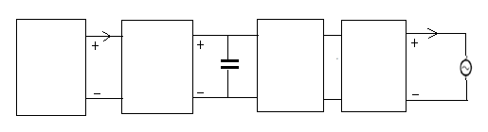
The general conception of pv inverter can be illustrated in the Fig.1, where the PV generator composed of dc-dc boost converter and associated to a dc ac inverter followed by harmonic filter are given as block diagrams.Solar panels produce direct current (DC). To connect the solar panels with the electricity grid, direct current has to be transformed in alternating current (AC), which, in time and amplitude has a sine shape.
$\text{Ipv}$
Boost
Dc Dc
converter

Single phase ac dc inverter
Pv
Array
LCL Filter
Ac
Utility grid
$\text{Vpv}$

Fig. 1. Overview of photovoltaic inverter

Alternating current has the advantage that it can be transmitted through wires over long distances, with far less losses than direct current. There are two type of solar panel monocrystlline and polycrystlline available solar panel is polycrystalline, there rating are 14 to16%.[3]
The ratings of photovoltaic array(YMOTEK) is having short circuit current is 0.71Amp,open circuit current is 20volt, Tolerance of solar panel is ±5% .The maximum synchronous voltage and maximum power is 800volt,10watt, voltage at maximum power is 17volt.
To be made alternating, load of direct current has to pass through a device called an “inverter.” Its takes the current directly from the solar panel, stores it into a buffer capacitor, passes it through an inverter bridge consisting of four semiconductor switches that “chop up” the direct current through rapid on/off switching. So far,the alternating

current’s wave has a square-like shape. To transform it into a sine shape it passed through an inductor(10mH). It was realizing that losses in this circuit are caused by the return of current between the output inductor and the input capacitor.

III. MPPT ALGORITHM

In MPPT operation, the PV-array produces maximum power under variable conditions of the solar irradiance and environmental temperature. The maximum power point tracking (MPPT) algorithm that is used, is based on the differentiation of PV power and on condition of zero slope of PV curve.
P = V × I ….. (1)
Differencing the eq. 1 gives:
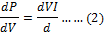
In condition of zero slope of PV curve where:
, we have:
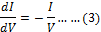
the voltage must be reduced in order to achieve MPP operation.the voltage must be raised in order to achieve the maximum power point of the PV generator as shown in Fig.2. A dc/dc PWM converter is used for that reason.

Fig. 2. Flow chart of used MPPT algorithm
Fig 3.HB With Unipolar Switching

IV. INVERTER TOPOLOGIES

In photovoltaic inverter technology we use transformerless topologies in order to acquire higher efficiencies combining with very low ground leakage current.As discussed above, the common-mode voltage generated by a topology and modulation strategy can greatly influence the ground leakage current that flows through the parasitic capacitance of the PV array. Generally, the utility grid does not influence the common-mode behavior of the system, so it can be concluded that the generated common mode voltage of a certain inverter topology and modulation strategy can be shown using a simple resistor as load. For safety reasons most PV systems have a galvanic isolation, either in the DC-DC boost converter in the form of a high frequency transformer, or on the AC output side, in the form of a bulky low frequency transformer. Both of these added galvanic isolations increase the cost and size of the whole system and decrease the overall efficiency. A higher efficiency, smaller size & weight and a lower price for the inverter is possible in the case where the isolation transformer is omitted. These transformerless solutions offer all the aforementioned advantages, but there are some safety issues caused by the solar panel parasitic capacitance to ground, which is formed between the PV array terminals and the frame, which is normally grounded[4].Voltage fluctuations of the two terminals would cause leakage currents flowing from the panel terminals to the ground. The level of the leakage current depends on the amplitude and frequency content of the voltage fluctuations, as well as the value of the parasitic capacitance, also called leakage capacitance.[5]This resulting leakage capacitance value depends on many factors; some of these are PV panel and frame structure, surface of cells, distance between cells, module frame,weather conditions, humidity, dust or salt covering the PV panel and type of EMC filter.

A. HB With Unipolar Switching

Most single-phase HB inverters use unipolar switching in order to improve the injected current quality of the inverter, which is done by modulating the output voltage to have three levels with twice the switching frequency Moreover, this type of modulation reduces the stress on the output filter filter and decreases the losses in the inverter. The positive active vector is applied to the load by turning on S1 and S4, as shown in Fig. 2. The negative active vector is done similarly, but in this case, S2 and S3 are turned on. The zero-voltage state is achieved by short circuiting the output of the inverter for the case of the unipolar switching pattern. and the output voltage has three levels: +V, 0, and −V due to the unipolar switching pattern. In the case of a transformerless PV system using this type of topology and modulation, the high frequency common-mode voltage,

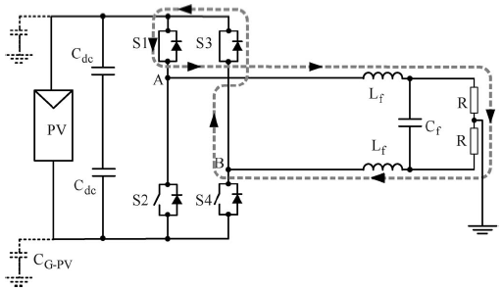

Fig. 4. HERIC topology

Fig 3. HB With Unipolar Switching

measured across CG−PV, will lead to a very high leakage ground current,as shown in fig[6].

Fig.6. HB-topology: ground leakage current

making it unsafe and therefore not usable (recommended) for transformerless PV applications.[1]

B. HERIC topology

This topology, shown in Fig. 4, combines the advantages of the three-level output voltage of the unipolar modulation with the reduced common-mode voltage, as in the case of bipolar modulation. This way, the efficiency of the inverter is increased, without compromising the common-mode behavior of the whole system. The zero-voltage state is realized using a bidirectional switch shown with a gray background in Fig. 3. This bidirectional switch is made up of two insulated-gate bipolar transistors (IGBTs) and two diodes (S5 and S6).

Fig.7.HERIC topology: ground leakage current

Fig 5.HB-ZVR topology.

During the positive half wave of the load (grid) voltage, S6 is switched on and is see during the freewheeling period of S1 and S4. On the other hand, during the negative half-wave, S5 is switched on and is used during the freewheeling period of S2 and S3. This way, using S5 or S6 as shown in Fig 3, the zero-voltage state is realized by short-circuiting the output of the inverter, during which period the PV is separated from the grid, because S1–S4 or S2–S3 are turned off. . The output voltage of the inverter has three levels and the load current ripple is very small, although, in this case, the frequency of the current is equal to the switching frequency.
Fig 7, shows the ground leakage current in HERIC topology. The output voltage of the inverter has three levels and the load current ripple is very small, although, in this case, the frequency of the current is equal to the switching frequency .The inverter generates no common-mode voltage; therefore, the leakage current through the parasitic capacitance of the PV would be very small.[1]

C. HB-ZVR Topology

Another solution for generating the zero-voltage state can be done using a bidirectional switch made of one IGBT and one diode bridge. The topology is detailed in Fig. 5, showing midpoint of the dc-link capacitors in order to fix the potential of the PV array also during the zero-voltage vector when S1–S4 and S2–S3 are open. An extra diode is used to protect from short-circuiting the lower dc-link capacitor. During the positive half-wave, S1 and S4 are used to generate the active state, supplying a positive voltage to the load. The zero-voltage state is achieved by turning on S5 when S1and S4 are turned off. The gate signal for S5 will be the complementary gate signal of S1 and S4, with a small deadtime to avoid short-circuiting the input capacitor. By using S5, it is possible for the grid current to flow in both directions; this way, the inverter can also feed reactive power to the grid, if necessary. During the negative half-wave of the load voltage, S2 and S3 are used to generate the active vector and S5 is controlled using the complementary signal of S2 and S3 and generates the zero voltage state, by

short-circuiting the outputs of the inverter and clamping them to the midpoint of the dc-link.
Fig.8.HB-ZVR topology: ground leakage current

During the deadtime, between the active state and the zero state, there is a short period when the freewheeling current finds its path through the antiparallel diodes to the input capacitor while all the switches are turned off. This leads to higher losses, compared to the HERIC topology, where the freewheeling current finds its path through the bidirectional switch, either through S5 or S6, depending on the sign of the current.
Fig 8. shows the ground leakage current in HB-ZVR topology. The output voltage of the inverter has three levels, taking into account the freewheeling part during dead time. In this case also, the load current ripple is very small and the frequency is equal to the switching frequency.[1]

V. EFFICIENCY ANALYSIS

In the case of a single-phase grid connection, the required minimum dc-link input voltage of the inverter, has to be at least 350 V; otherwise, a boost stage is required. The HERIC topology, as also suggested by its name, has very high conversion efficiency throughout the whole working range and has the best efficiency within the compared topologies, as detailed in Table I and also shown in Fig.9.The HB-ZVR topology has a slightly lower efficiency, due to the fact that the bidirectional switch is controlled with the switching frequency, while in the case of the HERIC topology, the bidirectional switch is only switched with the mains frequency.

TABLE I

EFFICIENCY AT DIFFERENT INPUT POWER WITH Vdc= 350 V

 | _{500W} | _{1000W} | _{1500W} | _{2000W} | _{2500W} | _{2800W}
_{HB BIP} | _{84.3%} | _{90.27%} | _{92.4%} | _{93.66%} | _{94.28%} | _{94.51%}
_{HERIC} | _{93.4%} | _{94.71%} | _{95.3%} | _{95.6%} | _{95.85%} | _{95.94%}
_{HBZVR} | _{90.3%} | _{92.79%} | _{93.7%} | _{94.39%} | _{94.79%} | _{94.88%}
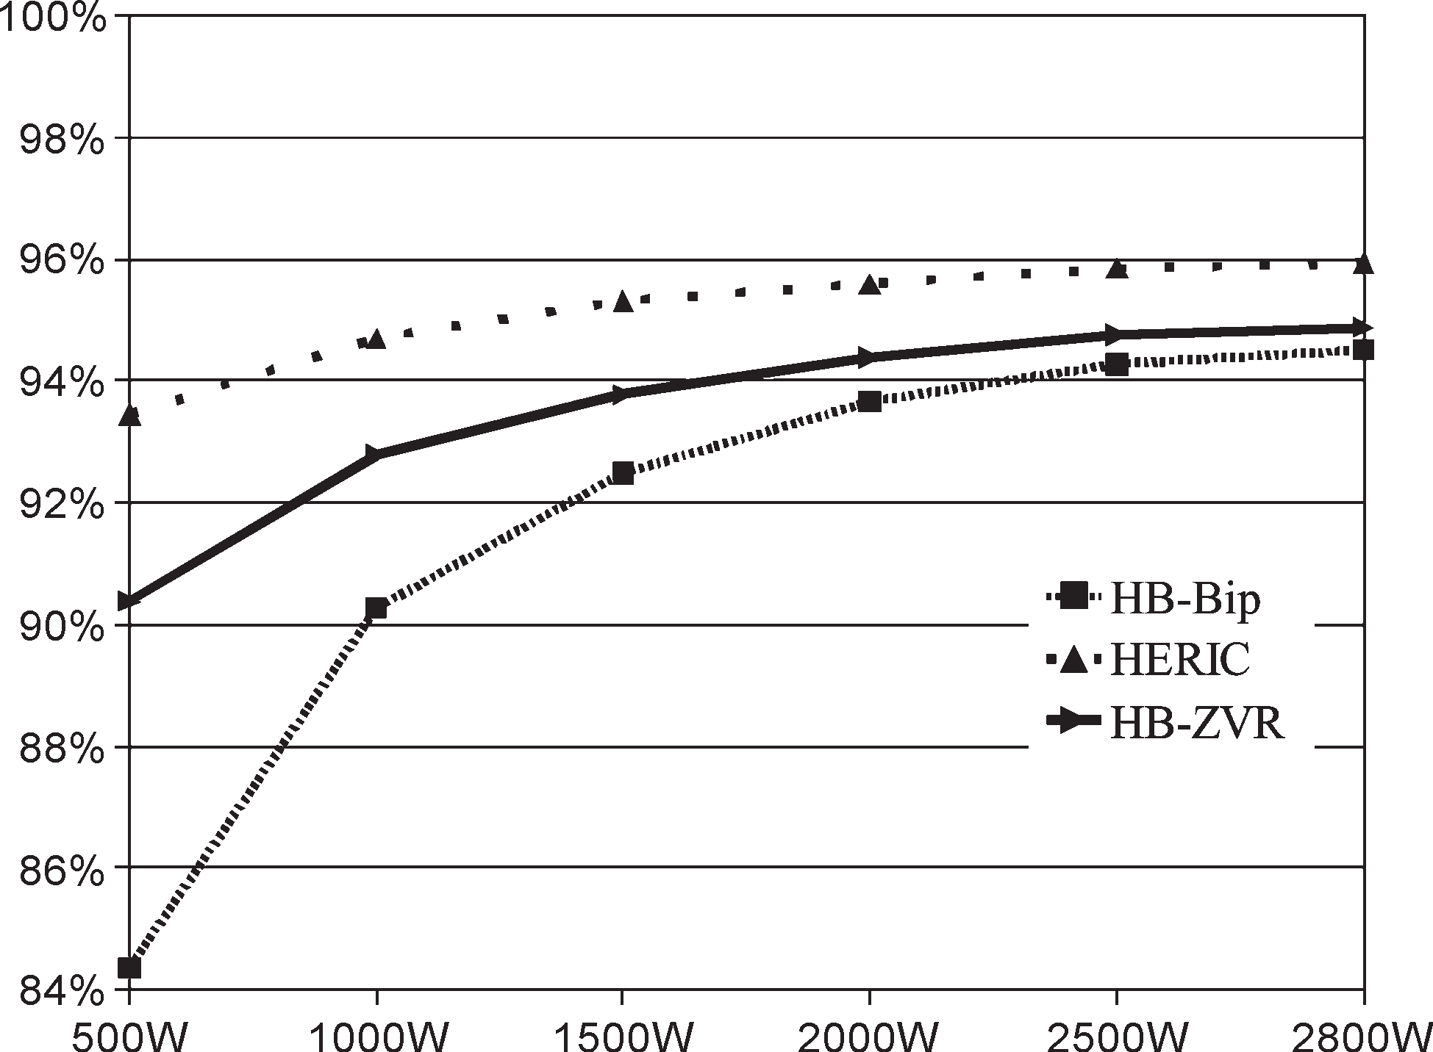

Fig. 9. Efficiency curve of the different topologies (Vdc = 350 V).

With a maximum efficiency of 94.88%, it is a very attractive solution for transformerless PV systems. The HB-Bip topology has the lowest efficiency, due to the high losses as a result of the two-level voltage output. The efficiency of the HB-Unip topology has not been included in the efficiency comparison of the transformerless.

V. CONCLUSION

It has been found that transformerless inverters offer better efficiency, compared to those inverters that have a galvanic isolation. In case the transformer is omitted, the generated common-mode behavior of the inverter topology greatly influences the ground leakage current through the parasitic capacitance of the PV inverter.
The ground leakage current in HERIC topology is less as compared to HB and HB-ZVR topology. This paper has given the alternative solution for the bidirectional switch, used to generate the zero-voltage state.The constant common-mode voltage of the HERIC topology and its high efficiency make it an attractive solution for transformerless PV applications.

REFERENCES

[1]. TamasKerekes, R. Teodorescu, G.Vazquez,and E.Aldabas,”A New High-Efficiency Single-Phase Transformerless PV Inverter Topology,” IEEE transactions on industrial electronics, vol. 58, no. 1, january 2011
[2]. T.Kerekes ,R. Teodorescu and U.Borup, “Transformerless photovoltaic inverters connected to the grid,” in Proc. APEC, Feb. 25–
Mar. 1, 2007 pp.1733–1737.
[3] T. Kerekes, R. Teodorescu, and M. Liserre, “Common-mode voltage in case of transformerless PV inverters connected to the grid,” in Proc. ISIE,Jun. 29–Jul. 1, 2008, pp.2390–2395.
[4] E. Gubía, P. Sanchis, A. Ursúa, J. Lopez, and L. Marroyo,“Ground currents in single-phase transformerless photovoltaic systems,” Prog.Photovolt., Res. Appl., vol. 15, no.7,pp.629–650,2007.

[5] S. Kjaer, J. Pedersen, F. Blaabjerg, A review of single-phase grid connected inverters for photovoltaic modules, IEEE Transactions on Industry Applications, Vol.41, Nr.5.
Sep/Oct2005

[6] S.Rao “Energy Technology” third edition 2007 Khanna Publication.

[7] K.B.Khanchandani “power Electronics” 2011 Tata McGraw publishing company limited.

 

