Ac Chopper Fed Single Phase Induction Motor

##### AmitkumarMandal, Manish Raut, PrafulThamke

##### *Department of Electrical Engineering*

*KarmaveerDadasahebKannamwar College of Engineering, R.T.M.N.U., Nagpur(M.H.), India*

Mob.No.8551959173

*Email id:* manishraut001@gmail.com

***Abstract—*Toimprove the performance of motor drives, there is a need to improve the quality and reliability of the drive system. Withthe high power handling capability of IGBT, pulse width modulated AC chopper can be used in high power applications. AC chopper using pulse width modulation provides substantial advantages overconventi- onallinecommutated AC controllers. To alleviate the problems associated with the conventional AC voltage controllers, pulse width modulatedACchopperfed induction motor drive is developed and presented in this paper with an appropriate control circuit. FFT analysis for voltage and current is performed for the developed system. It is proved that total harmonic distortion obtained from the developed circuit is less than that of phase controlled AC chopper system**.

***Keywords***—**AC Chopper, Total Harmonic Distortion, Pulse Width Modulation**

1. INTRODUCTION

Single Phase Induction Machine (SPIM) is most widely usedthanother machinesdue to theiradvantages such as simplicity in construction,reliability in operation, lightness and cheapness. Thespeed control of such motors can be achieved bycontrolling the applied voltage on motor by theuse of power electronic devices. The AC linecommutated phase angle control or integral cyclecontrol withthyristortechnology has been widelyused in the voltage regulators. Theysufferfromseveral disadvantages such as retardation of firingangle, enormous harmonics in motorandsupply current, discontinuity of powerflowto the motor.The symmetrical pulse width modulated controltechnique for AC choppers control the motor voltageby varying the duty cycle . The ACpower isadjustedbyacircuit which uses fourswitches. A novel drive for single phaseinduction motor has an attractive feature that iteffects both frequency and phase anglesimultaneously .

1. FOUR SWITCH PWM AC CHOPPER

The shownin Fig.1 is a PWM AC Chopperfor single phase system. It consists of four switches.The series switches S1 and S2 are used to connect anddisconnect the motor terminals to the supply. The parallel switches S3 and S4provideafreewheelingpath. A diode connected in anti- parallel(body diode)with each parallel switch is used to complete the freewheelingcurrent paths. Gating oftheseswitches based onequal PWMtechnique or constantpulse widthmethod is efficient and simple to implement.

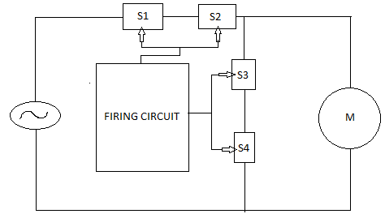

Fig.1. Block diagram of ac chopper fed single phase induction motor

1. MODES OF OPERATION

The operation modes are divided into two modes:

1.Active mode

2. Freewheeling mode

Fig.2shows an equivalent circuit foractive mode ofthe positiveand negative cycle.During this the motor is connected to supply through switches S1 and S2.This represents the on stateperiod of switches S1 and S2. Current Im flows through S1, body diode of S2, and induction motor as shown in figure 2.

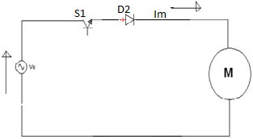

Fig.2. Equivalent circuit for Active Mode

The equivalent circuit of freewheeling mode

is shown in Fig. 3.

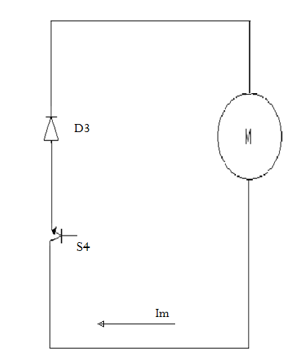

Fig.3. Equivalent circuit for Free-wheeling Mode.

This moderepresentsthe off-state periodsof theswitches S1 and S2. During this mode, the motor terminals are isolatedfrom the supply and stator isshort circuited.During freewheeling mode Switches S3 and S4 are conducting.Themotor terminalvoltageis zero and the current naturally decays throughfreewheeling switches.

1. PULSE WIDTH MODULATION

Pulse width modulation can be achieved by several ways such as comparison of sine wave with saw-tooth waves using op-amp.But in this paper it is achieved by generating saw tooth pulse using IC555,the generated pulse is compared with referance DC signal by comparator. This gives the required pulses as shown in figure (4).

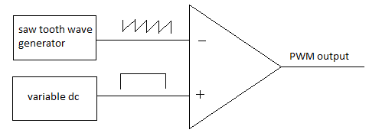

Fig.4.PWM generator

A PWM signal is not constant. Rather, the signal is on for part of its period, and off for the rest. The **duty cycle**, D, refers to the percentage of the period for which the signal is on. The duty cycle can be anywherefrom 0 to 100%. A 50% D results in a perfect squarewave. (Figure 5)



Fig 5: PWM signals of varying

duty cycles

Charging and discharging property of the capacitor results in the generation of saw tooth waveform and thus pwm is generated.(fig.6)

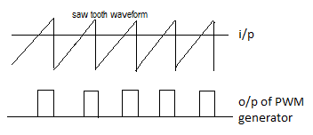

Fig.6.output of PWM generator

1. CIRCUITDIAGRAM

The combination ofIC555 and op-amp can be used to generate PWM.

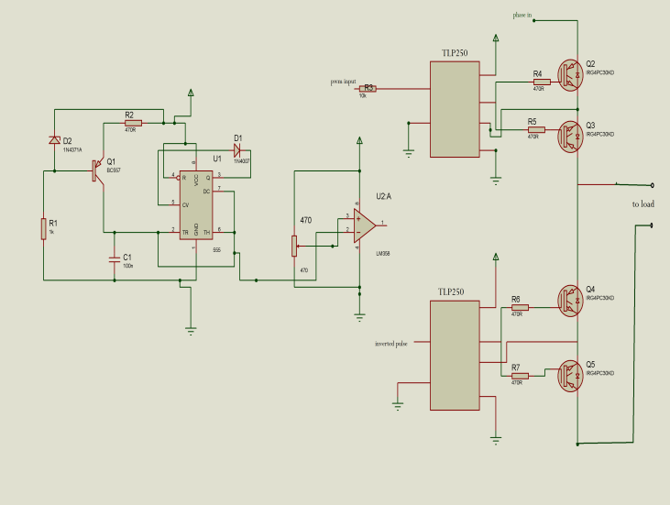

Fig.7schematic for ac chopper

For the generation of sawtooth pulses, IC555 is used asastablemultivibrator.But In astable mode, capacitor does not discharge suddenly so that to overcome this, a diode is used between pin 5 and 3 of IC555 as shown in figure 7. And the output of the astablemultivibrator is connected to the inverting terminal of op-amp. Non-inverting terminal of op-amp is connected to variable terminal of the potentiometer which is reference value. The op-amp used as a comparator which compare the input and gives the output with reference to input. These pulses are given to the gate of IGBT through driverIC.One driver IC drives two switchs at a time and the other one drives the remaining two switches which are connected parallel to the motor.This is done to avoid any chance of short circuit.

1. APPLICATION

*A. modern line conditioners*

Many factors, such as energy sources, supply lines andloads, disturb the distribution network voltage quality.The energy producer has to maintain at standard valuesthe voltage amplitude and frequency. However switching in voltage sources, natural phenomena(thunderbolts) or accidental phenomena (broken line)lead to modify the voltage quality, by generatingimportant and unforeseeable disturbances. Also, highloads variations produce more or less local voltagesource changes. The use of power electronic inindustrial and household applications generatesharmonic pollution to the power supply system:harmonic currents absorbed by the nonlinear loadsmodify the voltage through the input impedance. Line conditioners have been used in industry to,provide and to protect sensitive loads. There is a largevariety of line conditioners which absorb one or more

types of disturbances, like line conditioners with or without energy storage. Line conditioners with energy storage, for example uninterruptible power supply (UPS), protect the equipments against a high number of disturbances, including short disconnections which are the most expensive. The line conditioner’s without energy storage category includes compensators, which stabilize the voltage source by reactive power control and active filters. In the same category are included line conditioners made by basic AC choppers. They work at high commutation frequency and allow a fast and continue output voltage control. There are direct and indirect types of line conditioners without energy storage. In the direct type case one or more AC choppers are connected between the voltage source and the load . The indirect type is made up of a PWM AC chopper and a transformer for series voltage compensation. In the case of direct line conditioners differential AC choppers topologies are preferred, while indirect line conditioners use differential or non-differential AC choppers topologies. The serial voltage (*uc*) given by the transformer is controlled by AC chopper in order to compensate the voltage source fluctuations. As a result, a constant load voltage with the indirect line conditioner is obtained. The serial voltage (*uc*) is only a small part of the voltage source, which allows the line conditioner to absorb a reduced power. The AC chopper output voltage is in phase with the voltage source. The relative sign between the primary and the secondary of the series transformer (indicated by blackened points) allows to increase or to decrease the voltage delivered to the load ( *us* = *ur*+ *uc*), depending on the connection mode. To reduce the PWM AC chopper absorbed power the use of buck topologies is recommended.To allow the compensation of voltage variations in both directions a serial boost line conditioner with a buck one are associated. There are many possibilities to associate basic AC choppers with serial transformers. Presents a line conditioner with voltage up/down capability made by two nondifferential AC choppers. The first structure delivers the voltage *us1,* which have an increase voltage effect, while the second one delivers the voltage*us2* with a decrease voltage effect. As a difference between the two previous voltages (*us1, us2*) a compensation voltage is obtained, which is serialinjected through a transformer with the voltage source. The voltage delivered to the load can be obtained as a function of the voltage source *ur*and the AC choppers input voltages (*ua1*, *ua2*) by taking into account their duty cycles ( α*1*, α*2*):

*us*= *ur*+ *m*⋅(α1 ⋅*ua*1 −α 2 ⋅*ua*2 )

1. CONCLUSION

A conduction angle control technique, which was popular for a long time in industrial and home appliances, does not comply with new standards. The presented circuits are aimed to be such asolution. Thesame as in triaccontrol, it is able to supply a single –phase induction motor of all kinds (or general ac inductive/resistive loads) with varying ac voltage. The voltage applied to the load can be varied from zero to maximum value.

The proposed circuits overcome drawbacks of conduction angle control-harmonic pollution, lowefficiency, and acoustic noise caused by non-sinusoidal motor current. The PWM modulation considerably reduces the harmonic content of the line current. Current of the load remains sinusoidal throughout the range of output voltage.

The THD ofoutput voltage and current in this system is less thanthat of phase controlled chopper circuit. The heatingof the motor is reduced due to the reduction in THD.Hence the performance of drive system is improved.PWM AC Chopper is a viable alternative to the phasecontrolled converter for the control of inductionmotors. From the investigations, it is observed thatthe energy can be saved and harmonics can bereduced using PWM AC Chopper.

REFERENCES

1. R. ArunSagar, B. Vasanth Reddy,“ Comparative Analysis of SPWM And APWM Techniques For Three Phase AC Chopper”, International Journal Of Emerging Trends In Engineering And Development Issue 2, Vol 4(May 2012)
2. M.Narendra Kumar, P.Sujatha, K.S.R.Anjaneyulu, ”Experimental Verification of Four Switch PWM AC Chopper Fed Single Phase Induction Motor”, Journal of Theoretical and Applied Information Technology (2005-2009)
3. Dan Floricau,MarianaDumitrescu,LoanPopa ,SergiuIvanov, ” Basic Topologies Of Direct PWM AC Choppers”,Annals of the University of Craiova , Electrical Engineering Series, No.30,2006
4. MD Singh ,KB Khanchandani ,”Power Electronics”, Tata McGraw-hill publications(2012)