**Inspection of Transmission Lines Using Robot**

**Mayur Sonar**

***(***[mayurajw@gmail.com](mailto:mayurajw@gmail.com) *)*

*(Electrical Engg Department, KDKCE, RTMNU, INDIA*)

**Ashish Meshram**

**(**[**bhagat.sudeep@gmail.com**](mailto:bhagat.sudeep@gmail.com)**)**

(*Electrical Engg Department, KDKCE, RTMNU, INDIA*)

***Abstract-*** *This project describes fault detection & maintenance in transmission line by using robot. This technique is very much efficient to detect the fault. As it’s very risky to work with high transmission line manually but by using robot we can overcome this problem. While using the robot we are facing three obstacles like counterweights, anchor clamps and torsion tower and we discuss about to overcome it. The robot walks on overhead ground wires tower. Its ultimate purpose is to automate to inspect the defect of power transmission line. An AVR microcontroller is chosen as the core of control system. Visible light and infrared cameras are installed to obtain the video and temperature information, and the communication system is based on wireless CC2500 module. In it we compare with the oldest technology to search problems in transmission lines and how can we make easy with robot.*

Keywords— *robot, power transmission lines, inspection*

**I INTRODUCTION**

Transmission lines cross thousands of Kilometers in remote and sometimes hazardous environments. Their preventive maintenance is of extreme importance to large urban and industrial areas. Power transmission line has been usually inspected manually by workers riding in gondolas that travel suspended from the transmission lines or watching with telescope in the ground. Helicopter is also used for maintenance of transmission line. In recent years, it has become increasingly necessary to perform inspection work with the autonomous inspection robot in power transmission line. A mobile robot that can crawl along the overhead ground wires to perform part of power line inspection tasks is developed. This is the efficient process for fault detection and maintenance purpose.

**II**  **WHY THE ROBOTS ARE EFFICIENT?**

1. Before this technology people use to walk on cables. It is a high-risk job, performed by people moving o the cables. This is very costly method ad also risky. Companies deploy teams call “linemen” who are each paid about Rs25, 000 monthly plus a dearness allowance of Rs 7,500 totalling, about Rs 1lakh expensive per month.

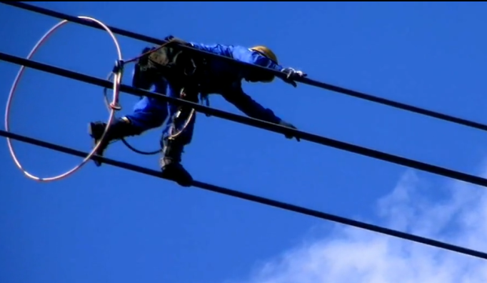

Fig.2.1. Linemen inspecting the transmission line

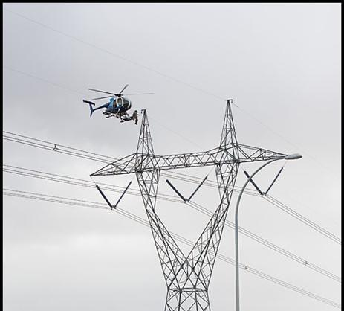

Fig2.2.Fault detection and maintenance using helicopter

1. Using helicopters for fault detection and maintenance is also too costly & risky. Helicopters hovering over live 400-800kv lines can, at time, be extremely dangerous.
2. Thermal Binoculars and special attire are used that can cost between Rs 22-25 lakh a piece. Compared to this, the robot will cost Rs 6, 25,000 and will have a payback period of merely two years.
3. On hilly reasons it is very difficult to go there for maintenance so Robot is easier to use on that line.
4. It is also work on the night time because of using infrared cameras.
5. We also get the information of temperature.
6. We also get exact location of fault for repairing.

**III FAULTS OCCURS IN TRANSMISSION LINE**

**Line-to-line -** a short circuit between lines, caused by ionization of air, or when lines come into physical contact, for example due to a broken insulator.

**Line-to-ground -** a short circuit between one line and ground, very often caused by physical contact, for example due to lightning or other storm damage

**Double line-to-ground -** two lines come into contact with the ground (and each other), also commonly due to storm damage.

**IV HOW TO OVERCOME THESE FAULTS:-**

All faults can be detected by using robot. This faults detected by using cameras and sensors on it and it will take visual recording of that position. This information is send to the server and then it will be solved. Robot can detect the fault that occur due to the variation in temperature, short circuiting of line, fault due to environmental damages to line, string damage, corrosion of tower. It gives exact location of fault to the server for manual maintenance.

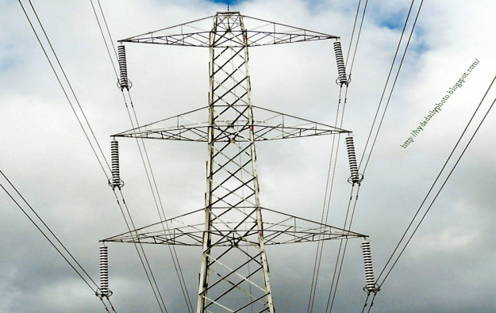

**Fig. 3. A 500KV tower total appearance,**

**V CONFIGURATIONS**

5.1 Mechanical Configurations

The robot’s mechanical structure is designed as a cable car for navigating on the wires. The robot has two arms. A set of wheel‐claw mechanism is mounted on the end of each arm. The robot can climb on the wires with its arms and claws. The control system and the inspection devices are installed in the control box which is suspended under the body of the robot. The control box can move along the body of the robot which can balance the robot and improve the stability. The robot is 1.2m long, 0.8m high and weighs 30kg including the control box. It can climb on the wires with the maximum inclination angle 60°.

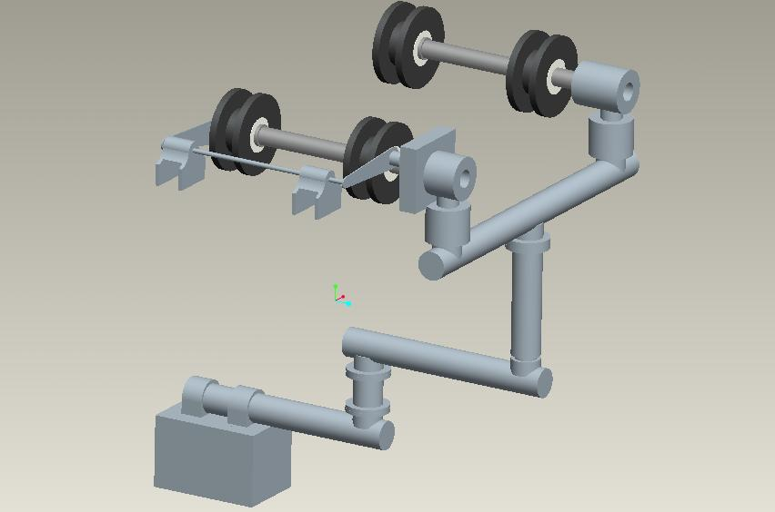

Fig.5. The mechanical structure of the inspection robot

5.2Electrical Configurations

5.2.1DC Geared Motor**:**

1) Operation Voltage: 12 V 2)

2) Operating Current is: 800mA

3) Torque Rate is: 10KgCm

5.2.2 Wireless Communication

1) Baud Rate: 38400. Serial UART Mode   
2) Packet Length: Variable (0 to 40) or Fixed (1 packet).   
3) 60+ meters range Line of Sight / 30 meters range indoors   
4)Multiple channel selection enabling up to 255 different pairs to work in the same area   
5) Direct Replacement for wired Serial Cable for and serial communication   
6) Working with CC2500 Wireless Transceiver module.

**VI APPLICATIONS:**

1. Low cost than other detection and maintenance system.

2. It works in hilly region where human cannot reach personally.

3. Efficient to work at night time because of using infrared cameras.

4. The performance of robot cannot be affected with respect to climate change.

5. It reduces the human efforts.

6. It gives the exact location of fault.

7. Danger in other system is reduced in it.

**VII CONCLUSION:**

This paper presents the work environment of the inspection robot in detail. According to the special characteristic of the overhead power transmission wires the inspection robot is composed of two arms, two wheels, two claw, two wrists, etc Transmission line required frequent maintenance and by using robot we can working for transmission line maintenance with easy way and we also get efficient work. It reduces human effort so then we reduce cost for worker .We work with high voltage without any dangerous effect.

**REFERENCES**

[1]. Autonomous Inspection Robot for Power Transmission Lines Maintenance While Operating on the Overhead Ground Wires by Zheng Li1, 2 and Yi Ruan2.

[2]. Wang Ludan, Wang Hongguang, et al (2007). Visualservo‐based line‐grasping control for power transmission line inspection robot, robot, vol.29, no.5,pp. 451–455, 2007.

[3]. Intelligent robotics and applications by Ming Xie Youlun Xiong, Caihua Xiong Honghai Liu, Zhencheng Hu (Eds.)

[4] Future Intelligent Information Systems by Dehuai Zeng.