Adjustable Speed Drive for Single Phase AC Applications
Pavan Gadade^{#1}, Vicky Kullarkar^{*2}
Department of Electrical Engineering,
K.D.K. College of Engineering,
R.T.M. Nagpur University,
Nagpur, India
¹gadade.pavan@gmail.com
Mob. No. 879 333 7542

Abstract— The world today is facing severe energy crisis, the golden rule is “energy saved is energy generated.” Use of variable speed drive for industrial application is one way to generate energy and lots of it. With wide options which are open to engineers for selecting proper drive system, one can look forward to an era where every application in the industry will be driven by highly efficient and reliable drives. Most of the drives used in the industries today are electrical. Depending on the application, some of them are fixed speed and some of them variable speed. The variable speed drives, till a couple of decades back, had various limitations such as poor efficiencies, larger space, lower speeds, etc. However, the advent of power electronics transformed the scene completely and today we have variable drive systems which are not only smaller in size but also very efficient, highly reliable and meeting all the stringent demands of various industries of modern era. This Seminar deals with another drive setup where single phase inverter is employed. The presented solution introduces a new low cost drive utilizing a single phase induction machine with speed control capability suitable for a great deal of single phase applications. The proposed drive is specially aimed at applications that do not have high demands on dynamic properties of drive.
- Introduction
Heating, Ventilation, and Air Conditioning account for significant percentage of electric energy consumed especially in residential areas. Most of these applications utilize single phase induction machines for driving fans and compressors. Increase in the efficiency of these devices can be achieved by introduction of adjustable or multispeed drives. Continuous decrease in the cost of current semiconductor components makes this solution commercially viable and attractive.
This work introduces an approach to design a drive system using PWM inverter technique. Multiple pulse width modulation technique is used to eliminate lower order harmonics. The firing pulses to MOSFET are generated using EPROM and Counter. The pulse positions are stored in EPROM. The main objective is to design compact and highly reliable drive with speed control capability.
- Related WORK
- Speed drive of single phase induction machine:
In this work, the performance of closed loop adjustable speed drive for single phase induction machine using voltage amplitude control. A microcontroller M68HC11E-9 has been used to implement such techniques. The microcontroller senses the speed feedback signal and consequently provides the pulse width variation signal that sets the gate voltage of the chopper, which in turn provides the required voltage for the desired speed. A buck type chopper has been used to control the input voltage of fully controlled single phase IGBT bridge inverter. PWM technique has been employed in this inverter to supply the motor with ac voltage. The simulation and laboratory results proved that the drive system can be used for the speed control of a single phase induction machine with wide speed range.

- Variable frequency drive:
A variable frequency drive is a type of adjustable speed drive used in electro-mechanical drive systems to control AC motor speed and torque by varying motor input frequency and voltage. VFDs are used in applications ranging from small appliances to the largest of mine mills drives and compressors. However, about a third of the world’s electrical energy consumed by electric motors in fixed speed centrifugal pump, fan and compressor applications is still relatively small. This highlights especially significant energy efficiency improvement opportunities for retrofitted and new VFD installations.

- Variable speed drive of a single phase induction motor using Frequency control method:
Single phase induction machines are widely used in home appliances and industrial control. Variable speed drive of induction machine using frequency method is to develop the solid the solid state control systems to be reliable and economically feasible to use with fractional horsepower motors. The proposed variable speed drive includes power conversion sections. The switching elements (MOSFETs) are used as H-bridge inverter to provide the alternating current to the machine. There are two power supplies in this drive. The 12V power supply is used for frequency control circuit and driver the H-bridge inverter. In this drive, pulse width modulation is used to control the frequency.

- Circuit diagrams
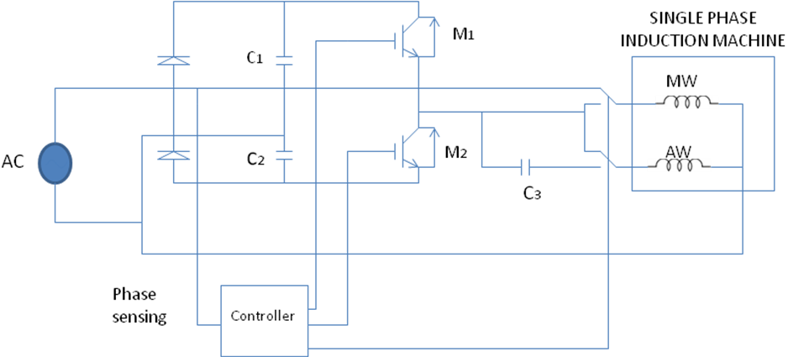
Fig.1. Circuit diagram for adjustable speed drive with single phase induction machine

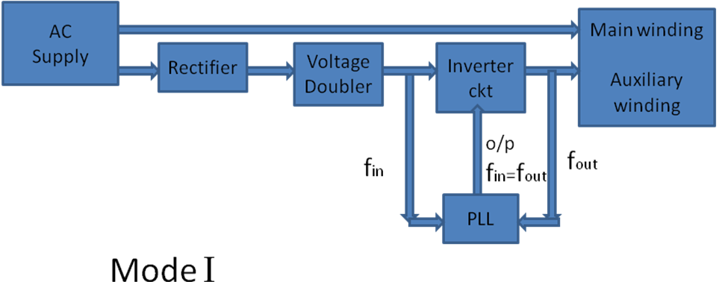
Fig.2. Operation of single phase induction machine under full speed mode
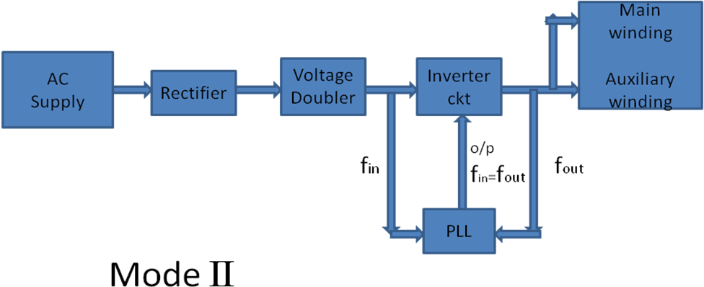Fig.3. Operation of single phase induction machine under reduced speed mode
- Operation
The scheme of the system under investigation is shown. The drive consists of voltage doublers followed by a one phase inverter with two MOSFET or IGBT switches. The drive is designed to run primarily in two modes of operation. In full speed mode, the main winding of the machine is fed with sinusoidal voltage waveform with suitable magnitude and phase shift in relation to the mains for the auxiliary winding. The operation of single phase induction machine is shown in figure 2. During reduced speed operation, both the windings are fed from the inverter. The phase shift between the currents in the main and auxiliary winding is then achieved by the connection of the ac capacitor of a proper value and rating in series with the auxiliary winding. The operation of single phase induction machine under reduced speed mode is shown in figure 3. Such configuration of the drive contains only two solid state switches, which may be rated just for a fraction of the nominal power of the machine for a fen type load. This significantly reduces the overall losses in the semiconductor components and results in the smaller size of heat sink and, therefore of the whole drive which may also have decreasing manufacturing costs of the final products. The proposed design can also improve reliability of the drive by enabling temporary operation with the supply of machine directly from the mains in the case of inverter failure. This would, however, require use of an ac capacitor with an increased voltage rating. The circuit diagram for adjustable speed drive with induction machine is shown in figure1.
References
- Miroslav Chomat, Thomas A. Lipo, “Adjustable speed drive with single phase induction machine for HVAC applications”, IEEE Trans. On Power electronics, vol. 03, pp. 1446-1451, June 2001.
- M. D. Singh, K. B. Khanchandani, “Power electronics”, Second Edition, Fourteenth Reprint, McGraw Hill Publications, pp. 903-917, 2012.
- G. K. Dubey, S. R. Doradla, A. Joshi, R. M. K. Sinha, “Thyristorized Power Controllers”, First edition 1986, Reprint 2005, New Age International Private Limited Publishers, pp. 356-358.
- R. P. Jain, “Modern Digital Electronics”, Fourth edition, sixth reprint, McGraw Hill Publications, pp. 93-94.
- Albert Paul Malvino, Donald P. Leach, “Digital Principles and Applications”, Fourth edition, McGraw Hill Publications, pp.327-394, 1988.
- B. L. Theraja , A. K. Theraja, “A Textbook of Electrical Technology”, vol. 02, First Multicolour Edition 2005, Reprint 2007, S. Chand Publications, pp. 1264-1265.

