**REVIEW ON WINDING METHODOLOGY IN AUTOMATIVE ALTERNATOR**

Payal Walde, Anup Kedar, Ishant Shahu, B.E. Students, Electrical Engg. Department, K.D.K. College of Engg. Nagpur, India 440 009

**Abstract- This paper review the various methods to design the alternator in Lundell alternator, which substantial improves efficiency and therefore gaining widespread industry acceptance. The output power generated depends on the type of winding. Here both single layer and multilayered windings has been compared and found that formal gives better performance. 42V automotive alternator is used for driving the hybrid electrical vehicle. In automotive alternator, claw-pole type rotor is used because of its compactness and high mechanical strength. The large numbers of electrical sub-systems in today’s 14 Volt vehicles make it extremely challenging for manufacturers to make a direct transition to single 42 V electrical systems, therefore (42V) automotive electrical systems are attracting considerable interest.**

**Keyword: - Automotive alternator, claw-pole rotor**

1. **INTRODUCTION**

There is an emerging need for automotive generators that can provide higher output power and power density, improved efficiency. To achieve this, a multi section winding and interleaved rectifier arrangement is made that enables high power levels to be achieved using small semiconductor devices, which greatly reduces the output filter capacitor requirements [1]. Due to its simplicity and low manufacturing costs, the Lundell or claw pole alternator resists a competition as an electromechanical source of the electrical energy in vehicles. Lundell alternators are today built in a power range up to 5KW and in a speed range up to 18000rpm [2]. Here we introduce a new design and control approach that allows the maximum load-matched power to be attained at all speeds. The new alternator system utilizes both field control and a simple switched mode rectifier to achieve substantially higher power and performance than conventional systems, particularly at speeds above idle [3]. The Lundell generator AC output is rectified through a three- or four-leg diode rectifier and connected to the on board battery. Today 42V*dc* batteries are used, but 42 Vdcbatteries are now adopted as the new standard for automotive application loads [4]. Automotive applications are mostly designed to low costs. Efforts to reduce noise, increase efficiency, and expand life time call for optimized machine designs. Nowadays the utilization of computational analysis allows for the substitution of expensive prototype cons-truction at early design stages [5]. Auto-motive alternators are usually belt driven at 2-3 times crankshaft speed. The alternator runs at various RPS (which varies the frequency) since it is driven by the engine. Automotive alternators require a voltage regulator which operates by modulating the small field current in order to produce a constant voltage at the battery terminals [6].

When modified, auto alternators can provide variable direct current at 0 to 120 volts for battery charging, hot charging, light arc welding, or for running AC-DC appliances and lights. The simple modification provides AC power to run some transformer-operated appliances. [7].

1. **PRINCIPLE OF AUTOMOTIVE ALTERNATOR (LUNDELL ALTERNATOR)**

The principle of working is exactly the same as that of a DC generator. In fact, all DC generators are alternators in which alternating voltages are set up and it is the commutator which converts this AC into DC. In the DC generator, it is essential for the armature to rotate in the magnetic field produced by the stationary magnetic field to give the unidirectional voltage. However, in an alternator it is not essential for the armature to rotate and either the armature or field can be made to rotate while the other is kept constant. Now-a-days armature is kept stationary and the field rotates under it.

The three separate stationary windings of the typical auto alternator produce three-phase alternating current rather than use a commutator to mechanically convert AC to DC. The automotive alternator consists of two major parts. One part is stationary part which is called as “stator” and another part is moving part which is called as “rotor”.

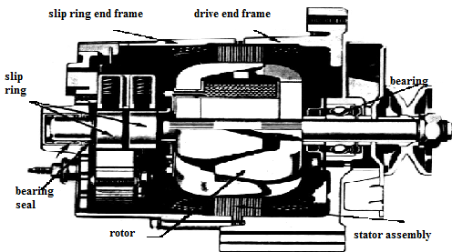

Fig.1 Construction Of Claw Pole Alternator

1. **STATOR**

The stator is made with three sets of windings. Each set of winding is placed is a different position compared with the others. A laminated iron frame concentrates the magnetic field. Stator lead ends that output to the diode rectifier bridge. The stampings are also there which are made up of silicon steel.



Fig. 2. Stator Of Conventional Alternator

The stator winding in alternators are different from those used in DC machines have closed circuit winding but alternator windings are open, in the sense that there is no closed path for the winding which is joined to the neutral point and other is brought out ( for a star connected stator). This arrangement has the advantage that the winding has to be insulated to earth for the phase voltage and not the line voltage. Star connection also has the advantage that it eliminates all triple frequency harmonics from the line voltage.

1. **ROTOR**

A basic rotor consists of a iron core, coil winding, two slip rings and two claw-shaped finger pole pieces. Some models include support bearings and one or two internal cooling fans. The rotor is driven or rotated inside the alternator by an engine driven belt. The rotor contains the field winding wound over an iron core which is part of the shaft surrounding the field coil and is of two claw-type finger poles. Each end of the rotor field winding is attached to a slip ring. Stationary brushes connect the alternator to the rotor. The rotor assembly is supported by bearings one on the shaft and the other in the drive frame.

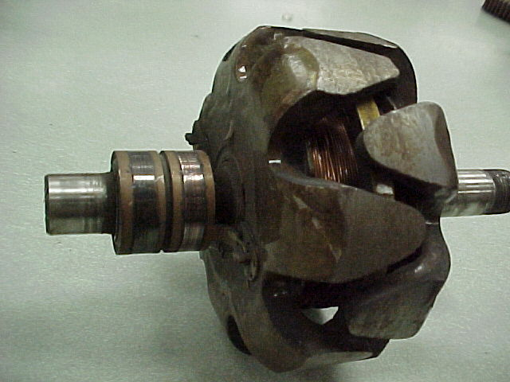

Fig 7. Rotor Of An Automotive Alternator.

The rotor winding of the automotive alternator is just like the shell type transformer core winding. Simply wound around the core in round shape type. Also in the automotive type alternator windings are wound to the bobbin. This bobbin is placed inside the claw-pole rotor. When rotor field winding

1. **SINGLE LAYER WINDING**

The two types of stator winding most commonly used for three-phase alternator are single-layer winding and double- layer winding.

A single layer winding is one in which one conductor or one coil side is placed in each armature slot. The sequential arrangement of coils around the armature is different for both these types of windings 1.1 Single Layer Winding. In this type of winding, the complete slot is containing only one coil side of a coil. This type of winding is not normally used for machines having commutators. It is shown in the Fig. 3. In single layer windings permit the use of semi-enclosed and closed types of slots. Also the coils can be pushed through the slots from one end of the core and are connected during the process of windings at the other end. Here the insulation can be properly applied and consolidated which is advantageous in large output machines with high voltage.

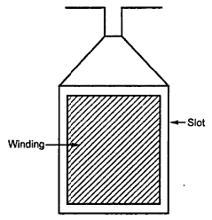

Fig. 3. Single Layer Winding Of Alternator.

The single layer windings used in high voltage machines use small groups of concentrically placed coils. The interlinking between these coils is in such a way so as to minimize the space taken up outside the slot and in the overhang connections. 1.2 Double Layer Winding It is shown in the Fig. 2. It consists of identical coils with one coil side of each coil in top half of the slot and the other coil side in bottom half of another slot which is nearly one pole.

1. **DOUBLE LAYER WINDING**

But in automotive alternator double- layer winding with closed loop circuit is used. Double-layer windings are universally used for stator of synchronous generator and induction motor of large and medium size. The coil used in the double layer winding of AC machine is invariably. Therefore, number of coils is equal to number of slots.

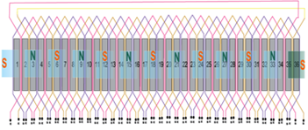

Fig. 4. Double Layer Winding Of An Alternator

1. **MULTI LAYER WINDING**

The double layer winding can be divided into separate sections by dividing the slots of the stator. This is called as multi-section of double layer winding. The multi-section winding is as shown in fig. 5. The implementation of multi-section winding employs use of interleaved switched mode rectifier.

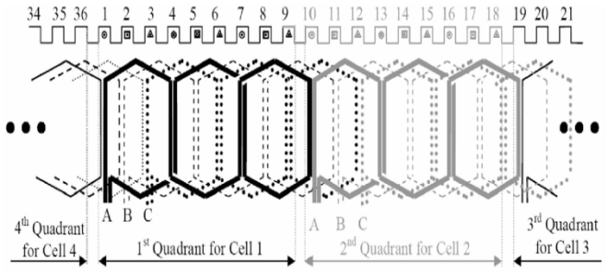

Fig. 5. Stator Winding Configuration For The Four SMR Cell Alternator System.

The described here is based on a modified Delco/Remy 92319 alternator (12-V, 130-A rating). The stator of the machine has 36 slots, into which the original three phase winding was wave wound [1]. Here the alternator of VOL-GATE (12V, 60-A rating) is used. The stator has 36 slots, in which we are doing original machine comprised two parallel 16- SWG wires wound for a total of 72 series turn yielding six turns (12 wires) per slot, with some slots containing an additional two wires for terminating the winding multi-section winding. Each phase of the original machine comprised two parallel 16- SWG wires wound for a total of 72 series turn yielding six turns (12 wires) per slot, with some slots containing an additional two wires for terminating the winding.

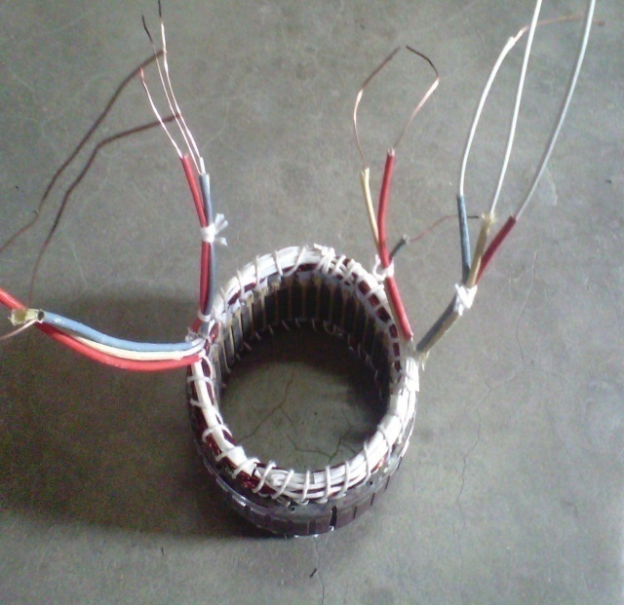

Fig. 6. Stator Of Alternator With 12 Output Terminals.

The stator was rewound for proposed interleaved SMR system at 42-V output. Rewinding of the machine focused on realizing the multiple three-phase sets for an interleaved system. A four cell system was implemented having four separate sets of three- phase windings. Because our design incorporates a boost rectifier, the same number of turns (in each phase set) as the original 14-V alternator was used for 42-V output .the machine was rewound with each phase conductor comprising one strand of 22 SWG wire, yielding a copper packing factor close to that of the original machine.

Two slip rings are located on one end of the rotor assembly. Two slip rings are located on rotating portion of the rotor.



Fig. 8. Slip Ring

Each end of the rotor field winding is attached to a slip ring. Thereby, allowing current to flow through the field winding. Two stationary carbon brushes ride on two rotating slip rings. Brushes are either soldered or bolted. The function of brushes is to collect the current from commutator, is usually made of carbon or graphite and is in the shape of rectangular block. These brushes are housed in brush-holders usually are of box type variety.



Fig. 9. Brushes

As shown in fig.9 the brush-holder is mounted on a spindle and the brushes can slide in the rectangular box open at both ends. The brushes are made to bear down on the commutator by a spring whose tension can be adjusted by change in position of lever in the notches. A flexible copper pigtail mounted at top of the brush conveys current from brushes to holders. Brushes are stationary which rides over the slip rings.

1. **WORKING OF AUTOMOTIVE ALTERNATOR**

Alternators generate electricity by the same principle as DC generators. When the magnetic field around a conductor changes, a current is induced in the conductor. Typically, a rotating magnet called the rotor turns within a stationary set of conductors wound in coils on an iron core, called the stator. The field cuts across the conductors, generating an electrical current, as the mechanical input causes the rotor to turn. The rotor magnetic field may even be provided by stationary field winding, with moving poles in the rotor. Automotive alternators invariably use a rotor winding, which allows control of the alternator generated voltage by varying the current in the rotor field winding.

The rotor magnetic field may be produced by induction, by permanent magnets, or by a rotor winding energized with direct current through slip rings and brushes. When the rotor is rotated in anticlockwise direction by prime mover, the starter or armature conductors are cut by the magnetic flux of rotor poles. Hence emf is induced in the armature conductor due to electromagnetic induction .The induced emf is alternating since N and S poles of rotor alternately passes through the armature conductors. E.M.F. induced in conductor opposite to an N-pole is in reverse direction to that in a conductor opposite to S-pole. Moreover, the magnitude of the emf induced in a conductor situated at the centre of a pole is maximum, since flux density is maximum at this position. On the other hand emf induced in the conductor situated in the inter-pole gap is zero. In between these positions of maximum and minimum flux density, the magnitude of emf in the conductor will vary according to flux density. Hence, alternating emf is induced in armature conductors.

1. SWITCHED MODE RECTIFIER

The Diode Rectifier Bridge is responsible for the conversion or rectification of AC voltage to DC voltage. Six or eight diodes are used to rectify the AC stator voltage to DC voltage. Half of these diodes are use on the positive side and the other half are on the negative side.

Two diodes are connected to each stator lead one positive and the other negative, because a single diode will block only half the AC voltage. Six or eight diodes are used to rectify the AC stator voltage to DC voltage.

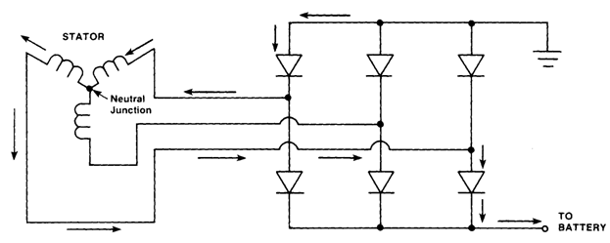

Fig. 10. Full Wave Bridger Rectifier

Diodes used in this configuration will redirect both the positive and negative polarity signals of the AC voltage to produce DC voltage. This process is called ‘Full-Wave Rectification’. Conventional three-phase Lundell alternators employ a diode bridge to rectify the generated ac voltages, and regulate the output voltage via field control. By exchanging the diodes in the bottom half of the rectifier bridge for active devices such as power MOSFETs, a semi-bridge switched-mode rectifier (SMR) is obtained. The switched-mode rectifier provides additional means of controlling the alternator. By modulating the switches with an appropriate duty ratio (at a high frequency compared to the machine electrical frequency), the alternator output characteristics can be matched to the output in a manner that provides greatly increased power capability and efficiency across speed and power.

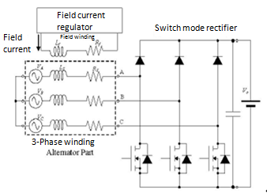

Fig. 11. Alternator With A Semi Bridge SMR.

While the use of switched mode rectification offers major opportunities, it also possess some practical challenges. One issue to be addressed is the pulsating ripple current at the output of the switched-mode rectifier.

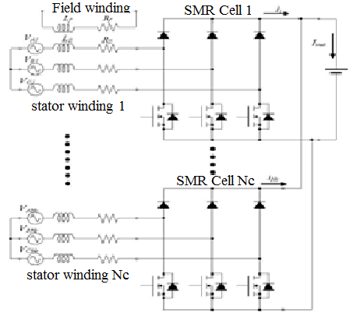

Fig. 12. Schematic Of Multiwinding Machine And Interleaved SMR.

Low equivalent-series-resistance (ESR) capacitors with high ripple current rating are, therefore, required to absorb this ripple current and contribute to EMI filtering. This is certainly achievable in a small volume using film or multi-layer ceramic capacitors, but does represent a significant cost element. A second challenge relates to sizing of the semiconductor switches. At 14V output, reasonably high-power alternator can be implemented with single- die plastic- packaged devices owing to the wide availability of low resistance 30V and 20V MOSFETS for low voltage applications. At 42 V output, however, it is more difficult to realize the circuit of (Fig. 11.) without resorting to paralleled devices or devices modules, especially when seeking to achieve high output power and temperature ratings.

Here we demonstrate a design strategy that addresses both of the above challenges. Instead of the design of (Fig. 11.), we employ an interleaved machine and rectifier configuration, as illustrated in approach (Fig. 12.), the system is constructed from a number Nc of small rectifier cells connected in parallel, with each cell fed from a separate isolated three phase stator winding.

1. **CONCLUSION**

This paper reviews the various methods to design the alternator. The comparison of single layer, double layer and multi-section winding has been done. To achieve the higher output power, power density and improved efficiency the multi-section winding arrangement is made. By the use of interleaved switched mode rectifier power, power density and efficiency are improved. Thus it is used in high power applications like hybrid electrical vehicles, military vehicles, for transportation purpose, marine boats, etc.

**REFERENCES**

[1] Sai Chun Tang, Member, IEEE, David M. Otten, Thomas A. Keim, and David J. Perreault, Senior Member, IEEE “Design and Evaluation of a 42-V Automotive Alternator With Integrated Switched-Mode Rectifier” IEEE Transactions on Energy Conversion, vol. 25, no. 4, December 2010.

[2] D. Stoia and M. Cernat Faculty of electrical engg., ‘Transilvania’,university of Brasov, Romania, , IEEE “Design and Evaluation of a 42-V Automotive Alternator With Integrated Switched-Mode Rectifier” Electromotion 2009-EPE chp(Electric drives1-3july 2009,lile, france.

[3] David J. Perreault, Vahe Caliskan, Massachusetts Institute of Technology, “A New Design for Automotive Alternators”, 2000-01-C084.

[4] Anthony Gimeno, St´ephane Vivier, Guy Friedrich, IEEE University of Technology of Compi`egne Laboratory of Electromechanics BP20529 60205 Compi`egne Cedex, France, “Improvement of an automotive alternator using the Experimental Design Method.”

**Books**:-

[5] A. K. Sawhney “Electrical Machine Design” Sixth Edition.

[6] B. L. Thereja VOL 2 “Electrical Technology”.

**Internet Sites**:-

[7] [www.alternatorparts.com](http://www.alternatorparts.com)

[9] [www.alternatorsecrete.com](http://www.alternatorsecrete.com)