TITLE OF PAPER
AUTOMATIC SPEED CONTROL SYSTEm

MR.PIYUSH JODHE
EMAIL ID PIYUSH.JODHE@GMAIL.COM
UCOE,UMRER

ABSTRACT: -
Every life that alive in this universe likes to enjoy the beauty in the nature. In this human beings also one kind. Towards achieving these enjoyments human beings invented & created the vehicles. But actually what happens, they are satisfying their needs by using these, but also suffering with accidents and losing valuable lives & property due to rash driving of drivers especially in highly populated regions.
So to avoid rash driving and to prevent loosing of valuable property we need some safety systems in the vehicles. We can make this true by using sensors and other electronic components. But those have more cost which causes increase in cost of the vehicle. With out using those electronic components also we can achieve this by using mechanical arrangements. To achieve this I designed a simple mechanical system for providing safety, for avoiding rash driving in highly populated regions.
I designed this by assuming that driver will apply the brake for more no of times in highly populated regions. Depending on these no of brake movements the system will control the maximum speed limit of the vehicle. Lower limit of the vehicle will be the same. If the no of brake applications are more, then the upper limit of the speed of the vehicle will be decreased proportionately.
So by providing speed breakers in highly populated regions like school zones, in village’s side by the high ways we can reduce the speed of the vehicle (Lorries, autos) to avoid rash driving or to decrease effect of the accidents.

INTRODUCTION: -
For avoiding rash driving of the drivers we have to provide safety systems with in the vehicles mainly for 4-wheelers. We can make this by using sensors and electronic circuits, which costs more. Rather than providing such high cost equipment we can achieve the same thing by mechanical means.
In this system there is one power source (battery) as input, one controlling element (toroidal coil with controlling rod arrangement), and small modifications in the already existing conventional design of S.I &C.I engines and connections with brake, which simply acts as a switch.
By using simple system we can control automatically the speed of the vehicle in highly populated regions with out interference of the human. The vehicle will move with designed speed (low speed) of the control system only even though the driver wants to move the vehicle with high velocities. About the working and description of the components, which I am using, will have in following discussion

DESCRIPTION: -
It is the system, which mainly uses the electrical power source and electronic circuits for controlling of the vehicle speed. It is mainly have the following components. It has the connections with brake, carburetor incase of S.I. engine and fuel injection pump in case of C.I. engine. 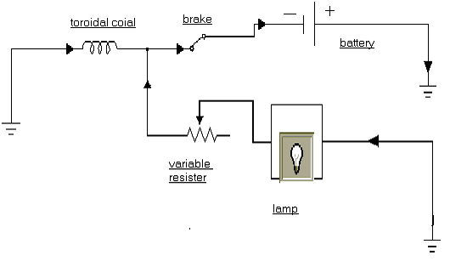

TOROIDAL COIL: -
It is an electromagnetic coil, which is used for pulling the controlling bar. It is energized by the electrical energy, which is gained from battery. It stores the energy and generates magnetic field around it. This attracts the controlling bar with some force. This movement of bar is used for controlling other components.
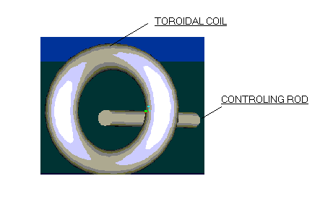
The stored energy will be consumed by a lamp, which is connected to this lamp in circular shape, which will generate magnetic field in circular manner, which is easy to pull the controlling road.

VARIABLE RESISTOR: -
Variable resistor is used for varying the amount of current, which is entered into the toroidal coil. By varying this we can also control the time in which the coil is charging and time in which coil is discharging the current. By adjusting this we can also control the force, which is applied on the controlling leaver.

LAMP: -
It is the main device, which is used for consuming the stored energy in the toroidal coil due to this only the system will be isolated after some time from the fuel supply system. It is also used for giving indication for the driver.

BRAKE WITH SWITCH: -
Brake is provided with an electrical connection that is used as a switch. When brake is applied the connections will be engaged (switch will be in on state) and the current will flow through the circuit so the number of brakes movements are high then the amount of charge flowing will be high. When brake is removed then the circuit will be braked (switch will be in off state).

BATTERY: -
It is the main power source, which will give the required power supply to the toroidal coil for activating it. It will have high voltage and current values. Depending on the resistant values the amount of current value will be depended. It will discharge current only when the switch is in “on " state other wise it will not supply the current.

CONTROLING ROAD: -
It is the plain metal road of some diameter, which is used for controlling the fuel flow rate in S.I. engine carburetor or C.I. fuel induction pump. It just attracted by the magnetic field in toroidal coil with some force. This force will give a movement to the controlling road. This controls the other equipment.

MODIFYCATIONS IN FUEL SUPPLY SYSTEM: -
We are giving small modifications to the all ready existing fuel supply system in S.I. engine and also in C.I. engine. But these modifications are very small.

- IN S.I. ENGINE: -
In this fuel supply system I am just using the control rod movement to force a metering rod element in to the main jet pipe that will restrict the flow area. So for given pressure depression in the carburetor the flow area decreased means, the amount of fuel entering also decreases. Which eventually reduce the speed of the vehicle.
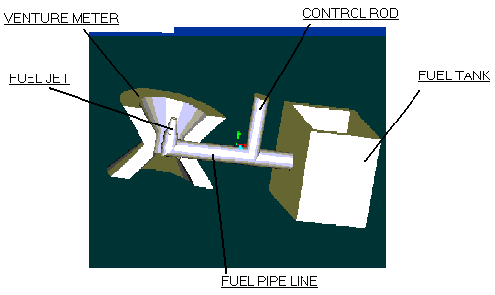

To achieve this we are providing a needle through a hole in to the main jet pipe for this we have to make a hole in the main jet pipe and we have to provide sealing arrange mantes

- IN C.I. ENGINE: -

All of us know that how helical groove will help us in fuel induction pump I am just using the same helical groove with another circular ring with a hole. This ring is provided on the upper side of the spill port. This ring is connected to the controlling rod. Controlling rod movement will help us to rotate this circular ring.
In this circular ring we will provide a hole which will act as same as spill port by rotating this ring the position at which the helical groove will open will be varied and at the same time the amount of fuel injected also varied.
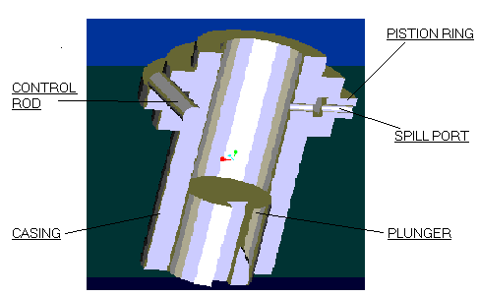

WORKING: -
The system will start working only when we apply the brake for number of times. The brake will act like a switch. When the brake is pressed the circuit will be completed the. Battery will start conducting the charge, which will be stored in the toroidal coil.
Due to high valued resister in the parallel circuit and low resistance of coil 95% of charge will be entered and stored with in the coil. This charge will create magnetic field around the coil that will pull the controlling rod. This controlling rod movement will be used for controlling the fuel supply system for varying the fuel rate entered into the combustion chambers.
In case of S.I. engine the controlling rod will force or move another needle, which will obstruct the flow area in main fuel nozzle so with this effect the quantity of fuel entered will be decreased. It cannot affect the airflow rate or any other thing it only reduces the quantity of fuel entered.
In case of C.I. engine the controlling rod movement will be used for rotating the circular ring on fuel induction pump, which will control the opening of hole through the port, when the hole is opened the fuel will be spilled out.
Due to opening of spill port in circular ring before the actual spill port (due to helical groove arrangement) the quantity of fuel injected will be varied. It will rotate in opposite direction to that of plunger rotation. If the controlling rod is moved to a full extent then the quantity of fuel injected will be very small irrespective of the actual spill port position.
Due to opening of brake the circuit will be disconnected with the battery. During this energy that is stored in the toroidal coil will be discharged through the variable resistor and the lamp. So there is no power or energy input to the toroidal coil. To discharge the all the energy stored with in the Coil will take some time due to higher resistance in the path. During this period the system will continuously control the fuel flow. This time period we can vary by varying the resistance value of the resister.
The lamp will be used as power consuming device and also for providing indicating signal for driver that he is in the highly populated road so he has to move slowly. So after some time the vehicle will be came to its normal state due to discharging of the stored power in toroidal coil. It will run as in normal way.

SALIENT FEATURES OF THE SYSTEM: -
→ We used the low voltage battery which is safe to operate and easy to charging.
→ Controlling of force acting on the controlling rod is very easy. It is simply by varying the variable resistor.
→ Energy consuming device which we are used i.e. a lamp is a less costly and it is also used for giving indication for the driver.
→ The modifications given for the conventional carburetor or fuel injection pump are very small and simple.
→ The costs of the system will of very less vary in between Rs. 1000/- to Rs. 3000/- only.
→ This system can be more effectively used for Lorries and automobiles, which are the main cause for accidents.

LIMITATIONS: -
→ There is a chance of disconnecting the battery with the system when driver wants. So to reduce this there is requirement of frequent checking’s of the complete system by some external government employees.
→ In case of C.I. engine the system will be little complicated which is difficult to manufacture.
→ The system will start working only when there is application of brake other wise it will not start working.

CONCLUSION: -
So finally we can use this system for S.I. engines, C.I. engines and also for gas engines. We can vary the value of variable résistance as per our requirements. For busses and Govt. vehicles we will place this resistance of having low value. So for these vehicles the time for, which the system is in active condition, is very small. So the time for which the vehicle will move slowly will also very small.
But for Lorries and autos we can use higher values of variable resistance. So it will take more time to consume the charged energy. These vehicles need more time to come back the system to its normal state.
So by using this system we can reduce rash driving and accidents up to somewhat and we can save many lives and many valuable properties. We can reduce the rash driving with in cities, with in the regions of school zones, villages that are near to the high ways and beside the high ways.
To make this system activate we need speed breakers in more number where we supposed to avoid rash driving. We can decrease the speed of the vehicle proportionately by increasing number of speed breakers. So by using this system we are reducing the upper limit of the speed of vehicle to a lower value for the required time with out altering any other thing.

BIBLOGRAPHY: -

- Electro magnetic waves and radiating systems by Jordan –Keith &G. Balman
- Internal combustion engines by Ganeshan
- Thermal Engineering by Yadav
- Automobile engineering by Kripal Singh

