FACTS & IT’S APPLICATIONS

Ajinkya V. Meshram
Department of Electrical Engineering,
K.D.K.C.E,
Nandanvan, Nagpur.
Ajinkyamesh8956@gmail.com
Yugeshwari V. Brahmanker
Department of Electrical Engineering,
K.D.K.C.E,
Nandanvan, Nagpur.
yuga.brahmankar8@gmail.com

Abstract- The philosophy of FACTS is to use power electronics controlled devices to control power flow in transmission network, thereby allowing transmission line systems to be loaded to its full capacity. The benefits of utilizing FACTS devices increase the better utilization, reliability and availability of transmission systems. It increases the quality of supply systems. FACTS devices are environmentally friendly. They contain no hazardous materials and produce no waste or pollutants. At the distribution level, flexible control strategies involve computerized automation of system control devices such as capacitor banks, under load tap changing transformers (Ultc’s) and voltage regulators. In the transmission system, a new method of achieving this control is through the use of power electronics based Flexible AC Transmission System (FACTS) devices. This paper provides a comprehensive guide to FACTS, covering all the major aspects in research and development of FACTS technologies. . The FACTS is not a single high power controller, but rather a collection of controllers, which can be applied individually or in co-ordination with others to control one or more of the interrelated system parameters.

Keywords— FACTS, compensators,STATCOM, SVC,TCSC.
- INTRODUCTION

Over the years, it has become clear that the maximum safe operating capacity of the transmission system is often based on voltage and angular stability rather than on its physical limitations. So rather than constructing new lines, industry has tended towards the development of technologies or devices that increase transmission network capacity while maintaining or even improving grid stability. Many of these now established technologies fall under the title of FACTS (Flexible AC Transmission Systems). They not only improve the capacity of power transmission systems, but flexibility is also greatly enhanced. The FACTS is not a single high power controller, but rather a collection of controllers, which can be applied individually or in co-ordination with others to control one or more of the interrelated system parameters. A well-chosen FACTS controller can overcome the specific limitations of a designated transmission line or a corridor. Because all FACTS controllers represent applications of the same basic technology, there production can eventually take advantage of technologies of scale. Just as a transistor is a basic element for a whole variety of micro-electronic chip and circuits, the thyristor or high power transistor is the basic element for a variety of high power electronic controllers.
The opportunities arising through the ability of FACTS controllers to control the inter-related parameters that govern the operation of transmission systems including series impedance, shunt impedance, current, voltage, phase angle and the damping of oscillations at various frequencies below the rated frequency.

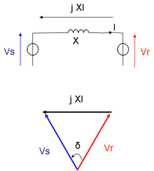

Fig1. Transmission on a no-loss line

There are number of stability issues that limit the transmission capability which include:
1. Transient stability
2. Dynamic stability.
3. Steady state stability
The FACTS technology can be used to overcome any of the stability limits, thus enhancing the transmission ability and load capability of the system.

- BASIC TYPES OF FACTS CONTROLLERS
FACTS devices are integrated in a system for a variety of reasons, such as power flow control, reactive power (VAR) compensation, loop flows or auxiliary functions like damping of oscillations. These devices can be applied in shunt, in series, and in some cases, both in shunt and series. Series devices include Thyristor-controlled series capacitors (TCSC) and fixed series capacitors (SC). Shunts devices include static VAR compensators (SVC), and SVC Light® (otherwise known as STATCOM.

  - STATIC SERIES COMPENSATORS

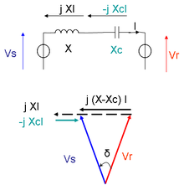

Fig2. Series compensation

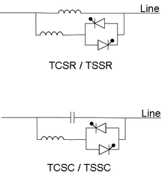
Fig3.TCSR & TCSC

- FIXED SERIES CAPACITORS (SC)
The series controller can be a variable impedance, such as capacitor, reactor. Or power electronics based variable source of min frequency, sub synchronous and harmonic frequencies (or a combination) to serve the desired need .In principle all controllers inject voltage in series with the line. Even variable impedance multiplied by the current flow through it, represents an injected series voltage in the line. as long as the voltage is in phase quadrature with line current, the series controller only supplies or consumes variable reactive power . Any other phase relationship will involve handling of real power as well. Static series compensation is used in order to decrease the transfer reactance of a power line at power frequency. The result is improved functionality of the power transmission system through:
1. Increased angular stability of the power corridor.
2. Roved voltage stability of the corridor.
3. Optimized power sharing between parallel circuits.

- Various types of Static series compensators are:

1. Static synchronous series compensator (SSSC)
2. Thyristor-controlled series capacitor (TCSC): a series capacitor bank is shunted by a thyristor-controlled reactor
3. Thyristor-controlled series reactor (TCSR): a series reactor bank is shunted by a thyristor-controlled reactor
4. Thyristor-switched series capacitor (TSSC): a series capacitor bank is shunted by a thyristor-switched reactor
5. Thyristor-switched series reactor (TSSR): a series reactor bank is shunted by a thyristor-switched reactor.
Among these types, TCSC is the most useful and has many applications. Thus we shall be proceeding with the explanation of TCSC (Thyristor-controlled series capacitor).
TCSC - Thyristor-controlled series capacitor:
Thyristor Controlled Series Capacitors (TCSC) provide a proven technology that addresses specific dynamic problems in transmission systems. TCSC's are an excellent tool to introduce if increased damping is required when interconnecting large electrical systems. Additionally, they can overcome the problem of Sub synchronous Resonance (SSR), a phenomenon that involves an interaction between large thermal generating units and series compensated transmission systems.

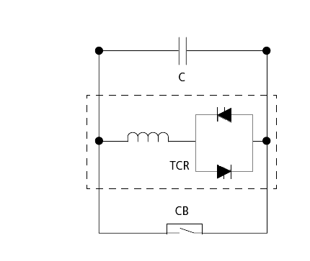

Fig4. TCSC

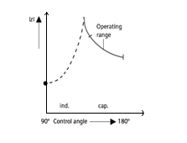
Fig5. Operating range of a TCSC

- STATIC SHUNT COMPENSATOR

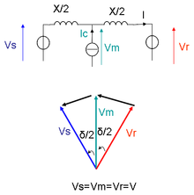
Fig6. Shunt compensation

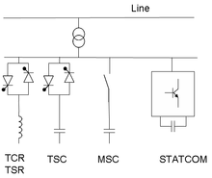

Fig7. FACTS for shunt compensation

As in the case of the series controller, the shunt controllers may have variable impedance, variable source, or a combination of these. In principle, all shunt controllers inject current into the system at the point of connection. Even variable shunt impedance connected to the line voltage causes a variable current flow and hence represents injection of current into the line. As long as the injected current is in phase quadrature with the line voltage, the shunt controller only supplies or consumes variable reactive power. Any other phase relationship will involve handling of real power as well.

- Various types of static shunt compensators are:
¬ SVC -Static Var Compensation
¬ STATCOM–Static Compensator.

- Static Var Compensation(SVC)
Electrical loads both generate and absorb reactive power. Since the transmitted load varies considerably from one hour to another, the reactive power balance in a grid varies as well. The result can be unacceptable voltage amplitude variations, a voltage depression, or even a voltage collapse. A rapidly operating Static Var Compensator (SVC) can continuously provide the reactive power required to control dynamic voltage swings under various system conditions and thereby improve the power system transmission and distribution performance. Installing an SVC at one or more suitable points in the network can increase transfer capability and reduce losses while maintaining a smooth voltage profile under different network conditions. In addition, an SVC can mitigate active power oscillations through voltage amplitude modulation.
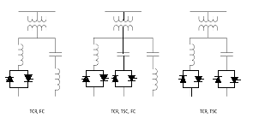
Fig8. Types of SVC configuration

- Most common SVCs are:

1.Thyristor-controlled reactor (TCR): reactor is connected in series with a bidirectional thyristor valve. The thyristor valve is phase-controlled. Equivalent reactance is varied continuously.
2.Thyristor-switched reactor (TSR): Same as TCR but thyristor is either in zero- or full- conduction. Equivalent reactance is varied in stepwise manner.
3.Thyristor-switched capacitor (TSC): capacitor is connected in series with a bidirectional thyristor valve. Thyristor is either in zero- or full- conduction. Equivalent reactance is varied in stepwise manner.
4.Mechanically-switched capacitor (MSC): capacitor is switched by circuit-breaker. It aims at compensating steady state reactive power. It is switched only a few times a day.

- STATCOM
STATCOM (Static Compensator) has a characteristic similar to the synchronous condenser, but as an electronic device, it has no inertia and is superior to the synchronous condenser in several ways - better dynamics, a lower investment cost, and lower operating and maintenance costs. STATCOM is to be selected when the technical performance in a specific application so requires. However, utilizing thyristors with turn-off capability (GTO or IGCT), which is the common approach in the industry, does not allow the full potential of a STATCOM concept to be obtained.
STATCOM are based on voltage source converter technology equipped with IGBT (Insulated Gate Bipolar Transistor).With the advent of STATCOM, better performance & Ability to control active as well as reactive power can be obtained.

- Applications of FACTS in Power Systems
FACTS can confine or neutralize electrical disturbances such as voltage sags and fluctuations, flicker, harmonic distortion, and phase unbalance in three-phase systems. In addition, improved economy of the process or processes in question will also be achieved. FACTS are designed to remove such constraints in a fast and intelligent way so that planners', investors' and operators' goals are met without them having to undertake major system additions.FACTS solutions enable power grid owners to increase existing transmission network capacity while maintaining or improving the operating margins necessary for grid stability. As a result, more power can reach consumers with very little impact on the environment, project implementation times are shorter, and investment costs are lower when compared with the alternative of building new transmission lines or power generation facilities. Flexibility is provided as FACTS can influence several parameters in the grid, such as active and reactive power flows.

The fast var capabilities of SVC make it highly suitable for:
  - Steady-state as well as dynamic voltage stabilization. This means that power transfer capability is increased and voltage variations are reduced.
  - Synchronous stability improvements. This in turn leads to increased transient stability and improved power system damping.
  - Dynamic balancing of unsymmetrical loads.
1. Power quality improvement
Power quality includes many aspects: sags, disruptions, harmonics, flicker and fluctuations are just some of the phenomena involved. Voltage sags, for example, result from faults in the grid and may be caused by lightening strikes, insulation breakdowns or flash-over to ground. Whatever the reason, maintaining or improving power quality in transmission and distribution networks is very important. FACTS have more than proven itself when it comes to power quality problems. as the following example will illustrate.
Suppose a region or a country decides to build a much needed steel plant. A suitable location is determined in terms of potential GNP growth and employment. However, the ability of the supplying grid is, in many cases, overlooked. The factory is built but the grid is often found to be weak or even insufficient. The result is unsatisfactory plant performance as well as added "pollution" to the grid that spreads and affects other industries connected to it.
In such cases, FACTS can confine or neutralize electrical disturbances such as voltage sags and fluctuations, flicker, harmonic distortion, and phase unbalance in three-phase systems. In addition, improved economy of the process or processes in question will also be achieved.

2. Long distance AC power transmission
In cases of long distance AC power transmission, maintaining synchronism as well as stable system voltages, particularly in conjunction with system faults is very important. With series compensation, safe bulk AC power transmissions over distances of more than 1,000 km are very much a reality today. With the advent of thyristor-controlled series compensation, greater capability as well as flexibility is added to the AC power transmission concept.
Fig9.long transmission line
3. Power oscillation damping in India
In India, two TCSCs have been installed on a double circuit 400 kV power transmission inter-connector between the Eastern and Western regions of the grid. The total inter-connector length is 412 km. This AC inter-connector is needed so that surplus energy is exported from the Eastern to the Western regions of India during normal operating conditions and during contingencies.
The use of TCSC ensures that inter-area power oscillations between the regions are damped. Without it, it is highly probable that power transfer over the inter-connector would be limited. Dynamic simulations proving the effectiveness of the TCSC as power oscillation dampers were performed during the design stage and these were subsequently confirmed at the commissioning and testing stage. A site view of the TCSC is shown in fig.

4. Increasing existing grid utilization
FACTS solutions are an attractive means to raise the capability or enhance the reliability of the grid. In many countries new transmission facilities are not permitted and transmission grids world-wide are as a consequence of load growth stressed closer to their power transfer limits. In many cases FACTS solutions appear as an attractive short term means to raise the transfer limit or to more generally enhance the reliability of the existing grid.
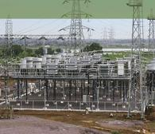

Fig10. Large grids
- Practical application of STATCOM in Steel Industry
Industry, as well as commercial and domestic groups of users, demands power quality. Flickering lamps are no longer accepted, nor are deratings or interruptions of industrial processes due to insufficient power quality. Demands for increased steel production and rules for network disturbances have, together with increasing cost of energy, made reactive power
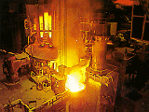

Fig11.Electrical arc furnace

compensation a profitable solution in the steel industry. A common trend among steel producers is to increase the rating of the Electrical Arc Furnace. Often, the power supply is poor and insufficient. A modern and cost efficient steel melting process demands a stable and steady voltage support for the Electric Arc Furnace. With dynamic reactive power compensation, the random voltage variations characterized by an arc furnace are minimized. The minimized voltage variations are achieved by continuously compensating the reactive power consumption from the arc furnace. The result is an overall improvement of the furnace operation, which leads to better process and production economy.
- conclusion
1.Control of power flow as ordered. The use of control of the power flow may be to follow a contract, meet the utilities own needs, ensure optimum power flow, ride through emergency conditions, or a combination thereof.
2.Increase the loading capability of lines to their thermal capabilities, including short term and seasonal. This can be accomplished by overcoming other limitations and sharing of power among lines according to their capability.
3.Increase the system security through raising the transient stability limit, limiting short-circuit currents and overloads, managing cascading blackouts and damping electro mechanical oscillations of power systems and machines.
4.Provide secure tie line connections to neighboring utilities and regions thereby decreasing overall generation reserve requirement on both sides.
5.Provide greater flexibility in sitting new generation.
6.Upgrade of lines.
7.Reduce reactive power flows, thus allowing the lines to carry more active power.
8.Reduce loop flows.
9.Increase utilization of lowest cost generation. One of the principle reasons for transmission interconnections is to utilize lowest cost generation. When this cannot be done, it follows that there is not enough cost effective transmission capacity. Cost effective enhancement of capacity will therefore allow increased use of lowest cost generation.

reference
[1].Narain G. Hingorani, Laszlo Gyugyi Understanding FACTS: Concepts and Technology of Flexible AC Transmission Systems.
[2].’Electrical power system’ by Ashfaq Husain.
[3]. http://www.abb.com.tw
[4]. www.diane.leonard@au.abb.com
[5].www.wikipedia.com

